**Project Report**

**On**

**“Weather Hub”**

**Submitted By**

**Student Name: Md. Rafsan Jaany**ID: 180222018

**Student Name: Md. Raihan Ali**ID: 180222024

**Student Name: Md. Razib Mondol**ID: 180222025

**Supervised by**

**Jasmin Akter**

Lecturer

Department of Computer Science and Engineering

**A project submitted in partial fulfillment of the requirements for the degree of Bachelor of Science in Computer Science and Engineering.**

**Department of Computer Science and Engineering**

**European University of Bangladesh**

2/4, Gabtoli, Mirpur, Dhaka-1216

October 2021

**CANDIDATES DECLARATION**

This is to certify that the work presented in this project, titled, “**Weather Hub**”, has been done by us under the supervision of Supervisor Name.

We also declare that neither this project nor any part of this project has been submitted anywhere else for the award of any degree, diploma or other qualifications.

Signature

-------------------- Md. Rafsan Jaany  
ID: 180222018

Signature

----------------------  
Md. Raihan Ali  
ID: 180222024

Signature

--------------------  
Md. Razib Mondol  
ID: 180222025

**CERTIFICATE OF APPROVAL**

This project titled, **“Weather Hub”**, submitted by the group as mentioned in the candidates’ declaration page has been accepted as satisfactory in partial fulfillment of the requirements for the degree B.Sc. in Computer Science and Engineering in 25thOctober 2021.

**Signature of Supervisor**

**---------------------------------------**

**Jasmin Akter**

**Lecturer**

**Department of Computer Science and Engineering**

**European University of Bangladesh, Dhaka, Bangladesh.**

**Signature of Chairman**

**---------------------------------------------**

**Md. Obaidur Rahman**

**Associate Professor and Chairman**

**Department of Computer Science and Engineering**

**European University of Bangladesh, Dhaka,**

**Bangladesh**

**ACKNOWLEDGEMENT**

We would like to express our gratitude and appreciation to all those who gave use the opportunity to complete this report. A special thanks to our final year project coordinator, **Jasmin Akter, Lecturer, Department of CSE, European university of Bangladesh**, whose help, stimulating suggestions and encouragement, helped us to coordinate our project especially in writing this report. We would also like acknowledge with much appreciation the crucial role of the staff of computer science and engineering lab, who gave the permission to use all required machinery and necessary material to complete the project. Last but not least many thanks go to the head of the project, **Md. Obaidur Rahman, Associate Professor and Chairman, Department of CSE, European University of Bangladesh**, who have given his full effortguiding the team in achieving the goal as well as his encouragement to maintain our progress in track. We would like to appreciate the guidance given by other supervisor as well as plan especially in our project presentation that has improved our presentation skills by their comment and tip.

Table of Contents

|  |  |  |  |  |
| --- | --- | --- | --- | --- |
| SL No. | Chapter Name | | | Page No. |
| 01 | Project Details Front Page | | | 1 |
| 02 | Candidates Declaration | | | 2 |
| 03 | Certificate of Approval | | | 3 |
| 04 | Acknowledgement | | | 4 |
| 05 | Table of Contents | | | 5 |
| 06 | List of Figures | | | 6 |
| 07 | Abstract | | | 7 |
| **Chapter 1: Introduction** | | | | |
| 1.1 | Introduction | | | 8 |
| 1.2 | Motivation | | | 9 |
| 1.3 | Objective | | | 9 |
| 1.4 | Expected Outcome | | | 9 |
| **Chapter 2: Background** | | | | |
| 2.1 | Introduction | | | 10 |
| 2.2 | Related Works | | | 10 |
| 2.3 | Comparative Studies | | | 10 |
| 2.4 | Challenges | | | 11 |
| **Chapter 3: Requirement Specification** | | | | |
| 3.1 | Requirement Collection Analysis | | | 12 |
| 3.2 | Use Case Modeling and Description | | | 13 |
| 3.3 | Logical Data Model | | | 13 |
| 3.4 | Design Requirements | | | 14 |
| **Chapter 4: Design Specification** | | | | |
| 4.1 | Front-End Design | | | 15 |
| 4.2 | Back-End Design | | | 15 |
| 4.3 | Interaction Design and UX | | | 16 |
| 4.4 | Implementation Requirements | | | 17 |
| **Chapter 5: Implementation and Testing** | | | | |
| 5.1 | Implementation of Database | | | 17 |
| 5.2 | Implementation of Front-end Design | | | 17-29 |
|  |  | | |  |
| **SL No.** | | **Chapter Name** | **Page No.** | |
| **Chapter 6: Impact on Society, Environment and Sustainability** | | | | |
| 6.1 | Impact on Society | | | 30 |
| 6.2 | Limitation | | | 30 |
| 6.3 | Obstacles & Achievements | | | 30 |
| **Chapter 7: Conclusion and Future Scope** | | | | |
| 7.1 | 1 Discussion and Conclusion | | | 31 |
| 7.2 | Scope for Further Developments | | | 31 |
| References | | | | 32 |

List of Figures

|  |  |  |
| --- | --- | --- |
| SL No. | Figure Name | Page No. |
| 3.1.1 | Requirement Collection and Analysis | 12 |
| 3.2.1 | Use Case Modeling and Description | 13 |
| 3.3.1 | Logical Data Model | 13 |
| 4.4.1 | Front-End Design | 15 |
| 4.3.1 | Interaction Design and UX | 16 |
| 5.2.1 | Dhaka View | 18 |
| 5.2.2 | Chittagong View | 19 |
| 5.2.3 | Mymensingh View | 20 |
| 5.2.4 | Khulna View | 21 |
| 5.2.5 | Rajshahi View | 22 |
| 5.2.6 | Rangpur View | 23 |
| 5.2.7 | Sylhet View | 24 |
| 5.2.8 | Weather prediction of 25th October (1) | 25 |
| 5.2.9 | Weather prediction of 25th October (2) | 26 |
| 5.2.10 | Weather prediction of 25th & 26th October (3) | 27 |
| 5.2.11 | Weather prediction of 28th & 29th October (4) | 28 |
| 5.2.12 | Weather prediction of 29th October (5) | 29 |

**ABSTRACT**

Human beings have attempted to predict the weather informally for millennia and formally since the 19th century. Weather forecasts are made by collecting quantitative data about the current state of the atmosphere at a given place and using meteorology to project how the atmosphere will change. Once a human only endeavor based mainly upon changes in barometric pressure, current weather conditions, and sky condition or cloud cover, weather forecasting. Now, we rely on computer-based models that take many atmospheric factors into account. Human input is still required to pick the best possible forecast model to base the forecast upon, which involves pattern recognition skills, tele connections, knowledge of model performance, and knowledge of model biases. The inaccuracy of forecasting is due to the chaotic nature of the atmosphere, the massive computational power required to solve the equations that describe the atmosphere, the error involved in measuring the initial conditions, and an incomplete understanding of atmospheric processes. Hence, forecasts become less accurate as the difference between current time and the time for which the forecast is being made increases. The use of ensembles and model consensus help narrow the error and pick the most likely outcome.

**Chapter 1**

**Introduction**

* 1. **Introduction**

Technology has become part and parcel of our daily life. Especially the availability of smartphone gave us the opportunity to carry advanced technology in our pocket. Almost every person checks their phone after waking up and plug the charger to charge the phone before sleeping. Because of technology, every single thing is becoming automated. Everything is becoming online from offline. Now a days, we are doing courses online, shopping via online and so on. There are a variety of end uses to weather forecasts. Weather Hub is android application which will help to detect weather of all divisions of Bangladesh and predict five days of weather (three hours interval). The system is planned to consist of various useful features for the said purpose. Weather warnings are important forecasts because they are used to protect life and property. Forecasts based on temperature and precipitation are important to agriculture, and therefore to traders within commodity markets.

The proposed system aims to develop a weather app is to fetch the data in the need of taking information about weather Bangladesh. Another purpose for developing this software is to predict five days of weather (three hours interval).

**1.2 Motivation**

Following are some of the motivations for this Weather Hub:

1. Rainfall Prediction.

2. Well organized weather forecast for Bangladesh.

3. No need to check google for weather over and over again.

**1.3 Objective**

1. Helps people prepare if they need to take extra gear to prepare for the weather (i.e., umbrella, rain coat, sun screen).

2. Helps people plan outdoor activities (i.e., to see if rain/storms/cold weather will impact outdoor event)

3. Helps curious people to know what sort of weather can be expected (i.e., severe storms).

4. Helps businesses plan for transportation hazards that can result from the weather (i.e., fog, storms, clouds as it relates to driving and flying for example).

5. Helps people with health-related issues to plan the day (i.e., allergies, asthma, heat stress).

6. Helps farmers and gardeners plan for crop irrigation and protection (irrigation scheduling, freeze protection).

**1.4 Expected Outcome**

Through the application, users can get current weather location, weather of all divisions and get a prediction of five days of weather of current location.

**Chapter 2**

**Background**

**2.1 Introduction**

Internet has changed the world in a significant way. In this modern world, we are becoming more and more dependent on online based technology. We rely on the internet for each and everything in life. We have tried to make an android application named “Weather Hub” which will can get current weather location, weather of all divisions and get a prediction of five days of weather of current location easily.

**2.2 Related Works**

Weather Hub is an android application which is implemented to provide service in environment & geography sector. In Bangladesh, some of the examples of similar applications of Weather Hub are: আবহাওয়া।

**2.3 Comparative Studies**

Usually, an application is made to fulfill a certain objective. Most comparison able applications like Kids Solutions are described below:

|  |  |  |
| --- | --- | --- |
| Name | Their Work Principle | Our Work Principle |
| আবহাওয়া। | Detect weather of today, tomorrow and four days of weather prediction. | Detect weather of today and five days (three hours interval) of weather prediction. |

**2.4 Challenges**

Every task has challenges. Some of the main challenges Weather Hub are:

1. Lack of internet connection might be our main challenge as Weather Hub is an online application.

2. We should build our application properly and make sure it works smoothly and also user friendly.

**Chapter 3**

**Requirement Specification**

**3.1 Requirement Collection Analysis**

Admin is the one with the highest power. He can call API and get weather of any area. A user can view today’s weather and five days (three hours interval) of weather prediction.

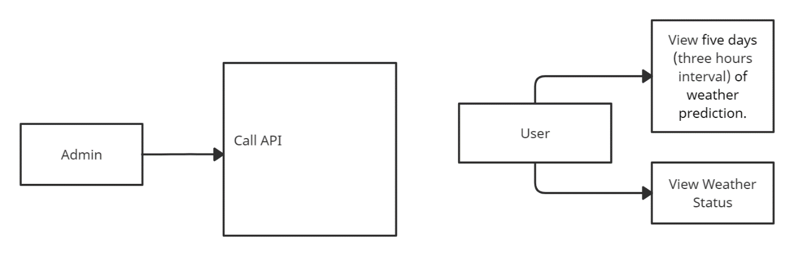

Figure 3.1.1: Requirement Collection and Analysis.

**3.2 Use Case Modeling and Description**

A use-case model is a model of how different types of users interact with the system to solve a problem.

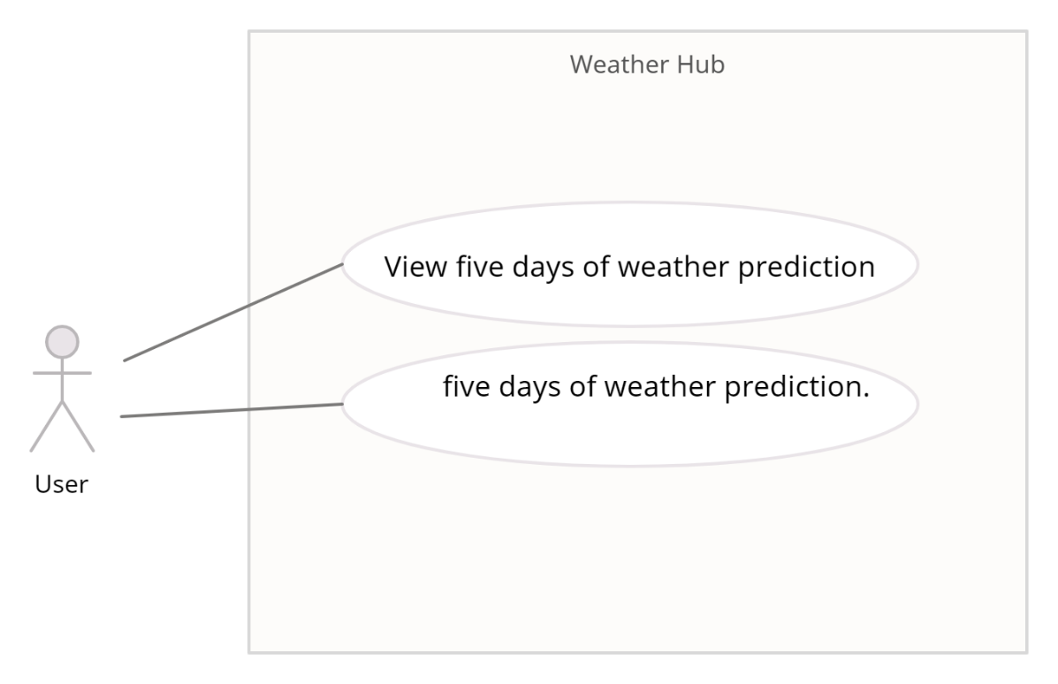

Figure 3.2.1: Use Case Modeling and Description

**3.3 Logical Data Model**

API will be called and the response will be sent to the application which is shown in Logical Data Model figure and it will be the current time responsible. Data will transfer from database to android application.

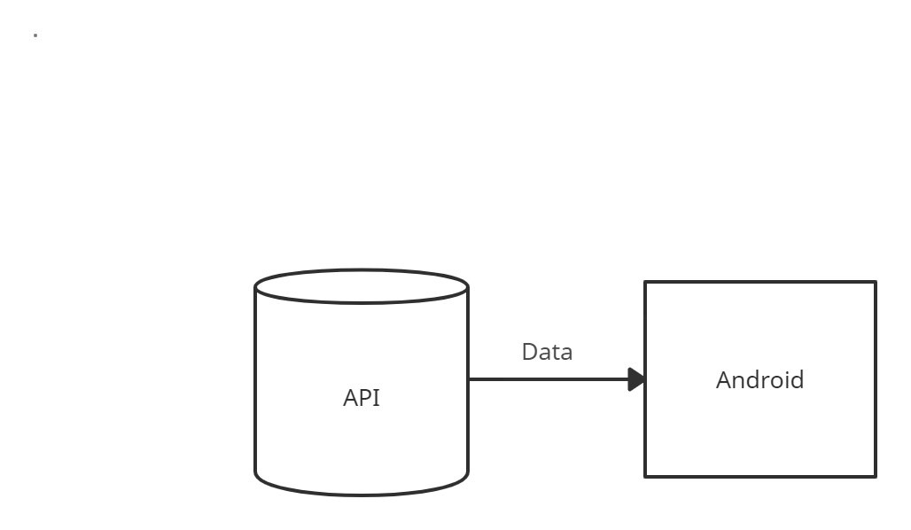

Figure 3.3.1: Logical Data Model

**3.4 Design Requirements**

Design requirements are very important for mobile application. It attracts the user to use. So, to complete the design, we must have mobile application design skills. For this, we have to know the various types of computer programming languages and design tools like adobeXd. Market analysis can be a good trick for the design. We have to give proper attention to design the database so that it works appropriately and easily.

**CHAPTER 4**

**Design Specification**

**4.1 Front-End Design**

Front-End is the place where the user interacts. So, considering this factor, we have created a user friendly and smooth design. Every user can easily use this application.

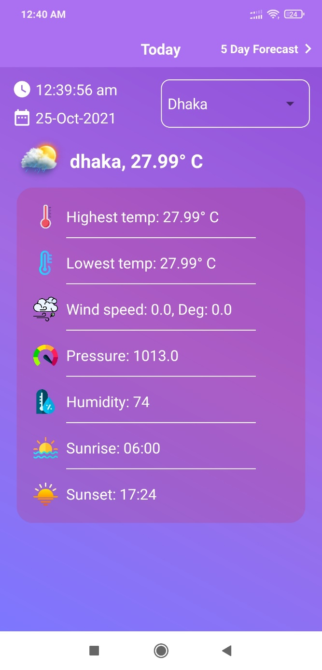

Figure 4.1.1: Front-End Design.

**4.2 Back-End Design**

Basically, in software development back-end means rendering server side. Usually, the backend programming consists of three parts: application, server and database. For backend we have used Openweather API and other implemented back-end technologies that are Java, Firebase Cloud Messaging, Android Networking libraries.

**4.3** **Interaction Design and UX**

We have tried to make our project UX design as simple as possible. Because we have researched on the internet and visit various site, used various android applications. Then we made the UX design of our application.

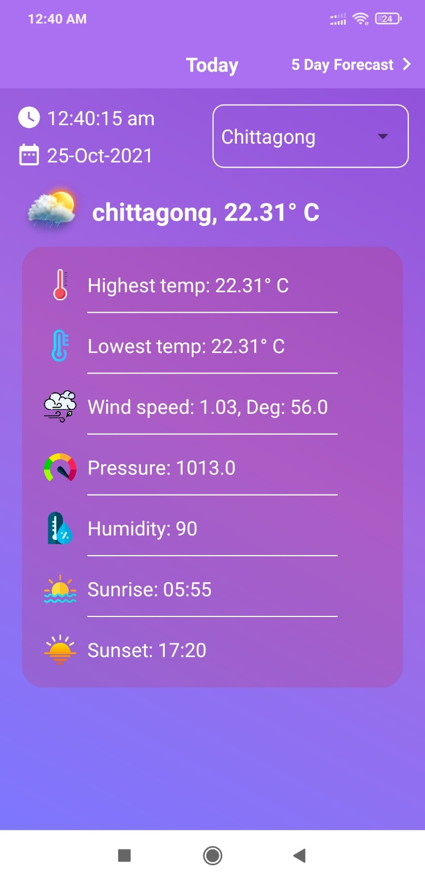

Figure 4.3.1: Interaction Design and UX

**4.4 Implementation Requirements**

It was our environment & geography related work. So, we had to learn a lot of new technologies and spent a huge time to fulfill all the requirements.

**Chapter 5**

**Implementation and Testing**

**5.1 Implementation of API**

Implementation of the API was fundamental for this application. In this project, we have used openweather api to get weather statistics in real time. The api returns efficient and good amount of data for its data model.

**5.2 Implementation of Front-end Design**

Front-end design is very essential because of its visualization to the users. Developing a design for an application, we have to consider user friendly and smooth front end. It is very difficult to make the perfect design that attracts all.

**Dhaka View**

User can get the highest, lowest, current weather, wind speed, wind pressure, humidity, sunrise, sunset of Dhaka.

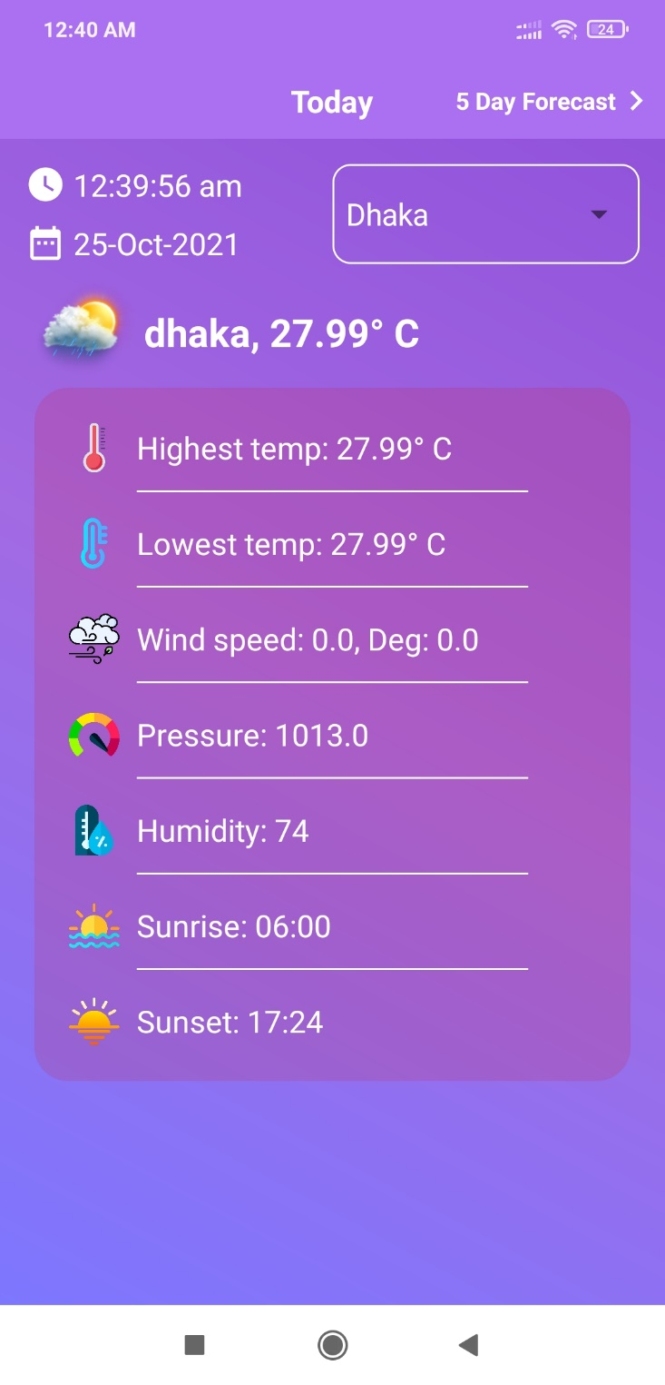

Figure 5.2.1: Dhaka View.

**Chittagong View**

User can get the highest, lowest, current weather, wind speed, wind pressure, humidity, sunrise, sunset of Chittagong.

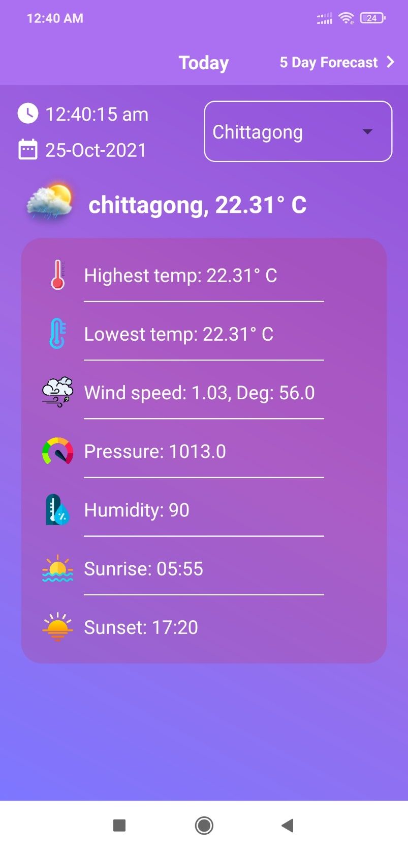

Figure 5.2.2: Chittagong View.

**Mymensingh View**

User can get the highest, lowest, current weather, wind speed, wind pressure, humidity, sunrise, sunset of Mymensingh.

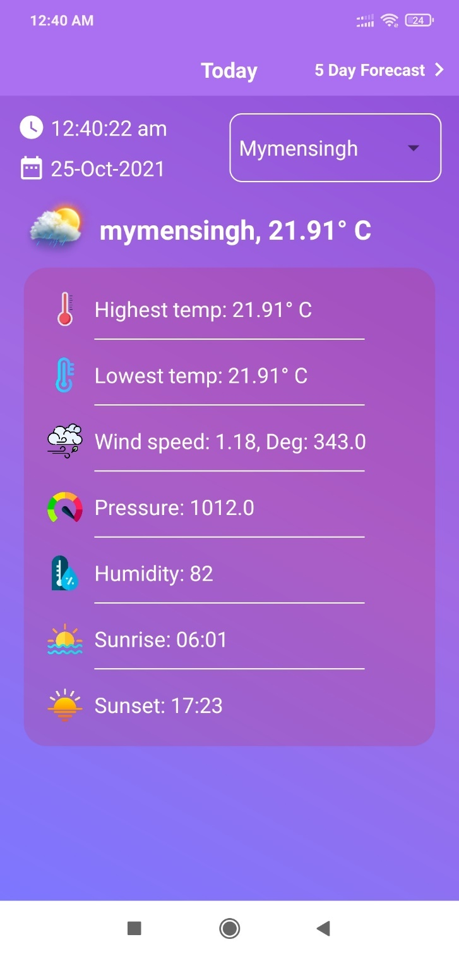

Figure 5.2.3: Mymensingh View.

**Khulna View**

User can get the highest, lowest, current weather, wind speed, wind pressure, humidity, sunrise, sunset of Khulna.

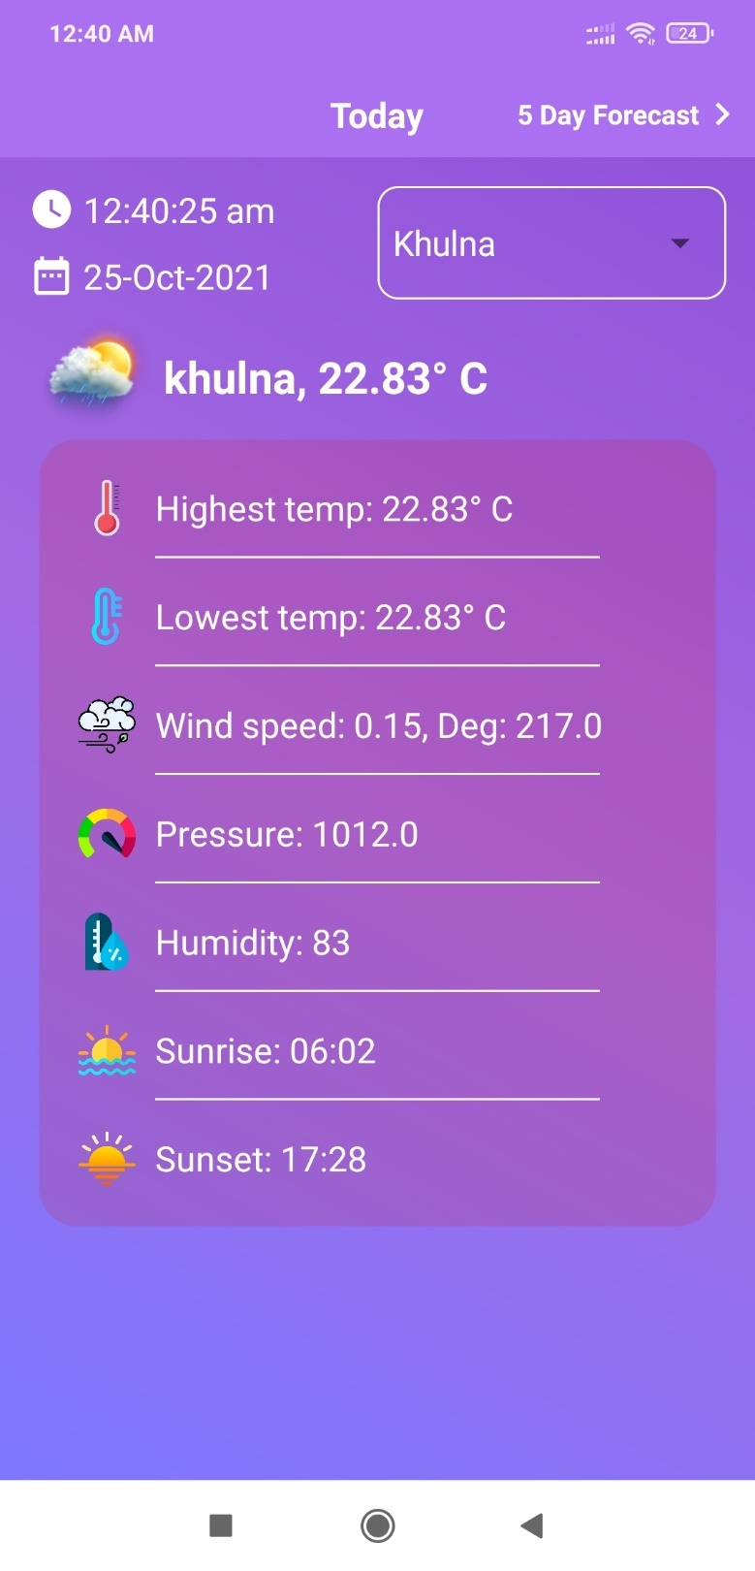

Figure 5.2.4: Khulna View.

**Rajshahi View**

User can get the highest, lowest, current weather, wind speed, wind pressure, humidity, sunrise, sunset of Rajshahi.

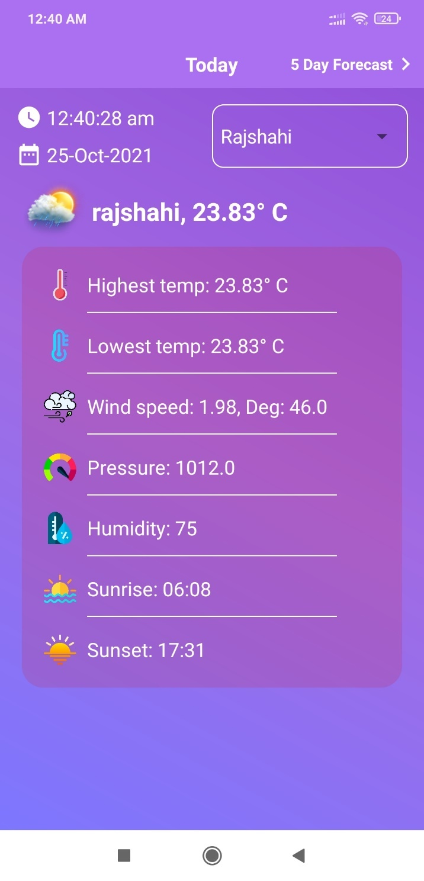

Figure 5.2.5: Rajshahi View.

**Rangpur View**

User can get the highest, lowest, current weather, wind speed, wind pressure, humidity, sunrise, sunset of Rangpur.

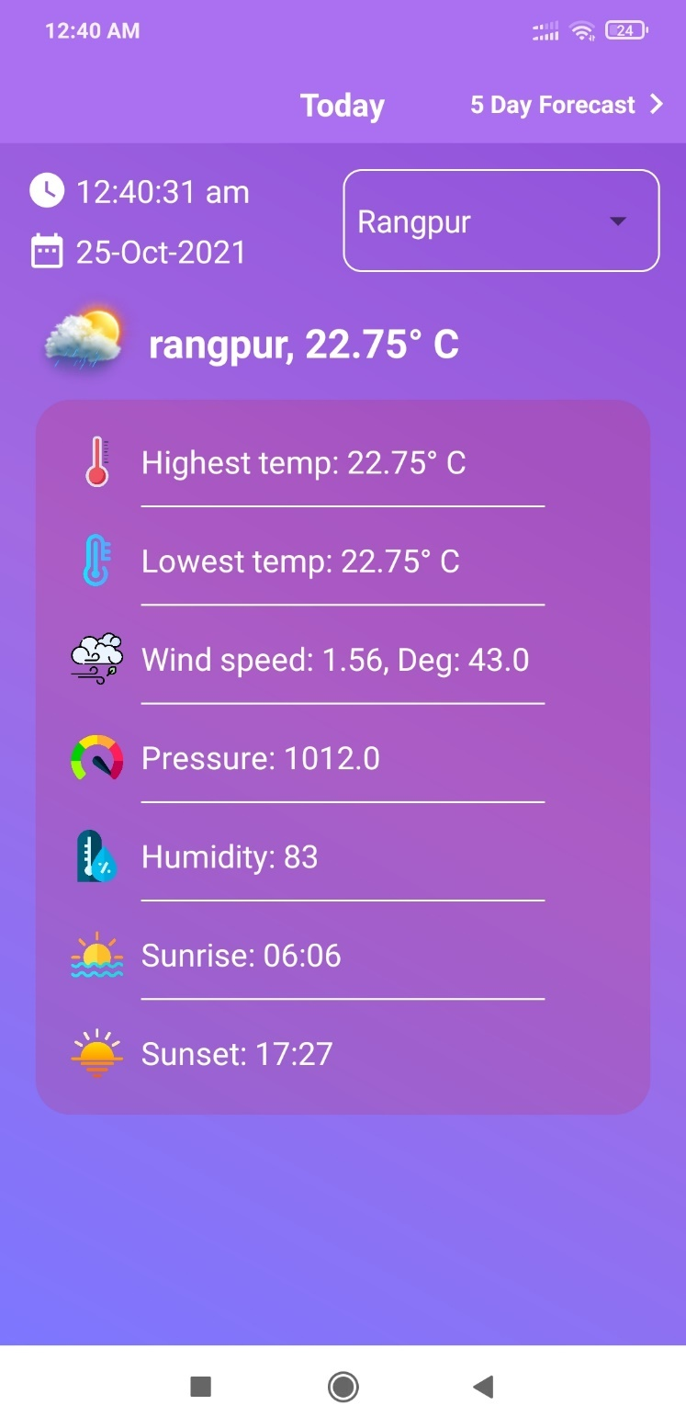

Figure 5.2.6: Rangpur View.

**Sylhet View**

User can get the highest, lowest, current weather, wind speed, wind pressure, humidity, sunrise, sunset of Sylhet.

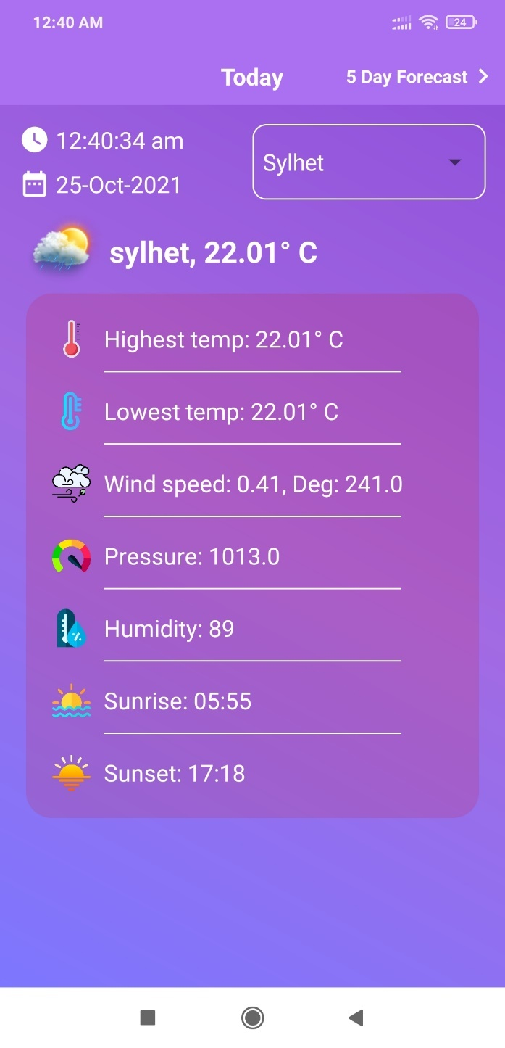

Figure 5.2.7: Sylhet View.

**5 Days Weather Forecast (3 Hours Interval)**

Weather prediction of 25th October.

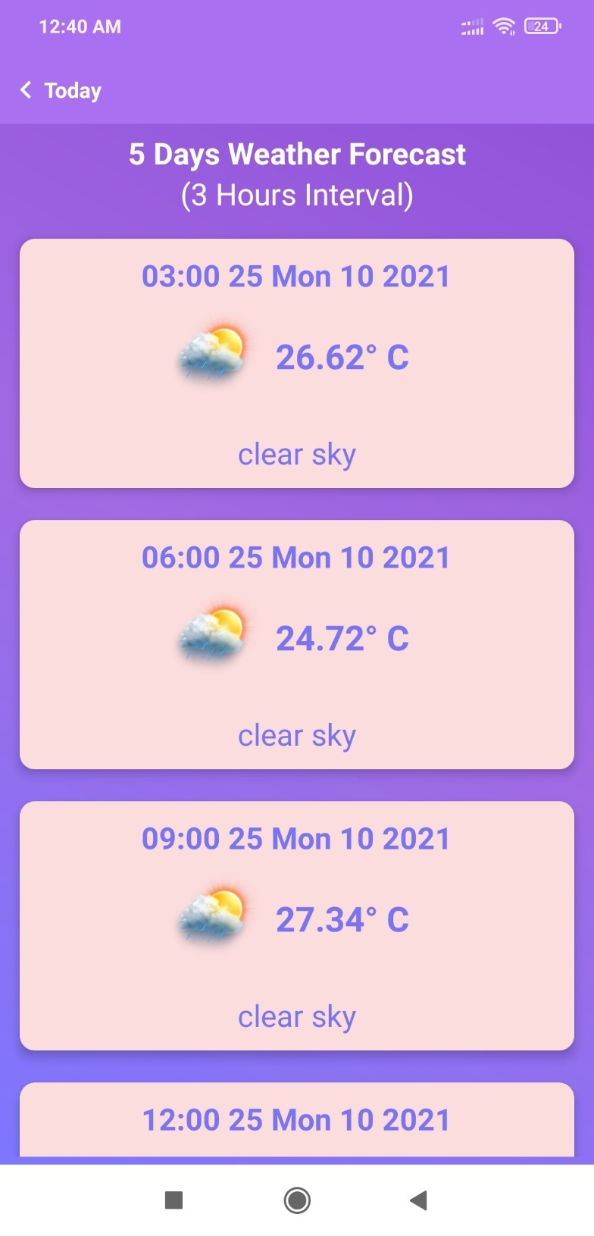

Figure 5.2.8: Weather prediction of 25th October (1).

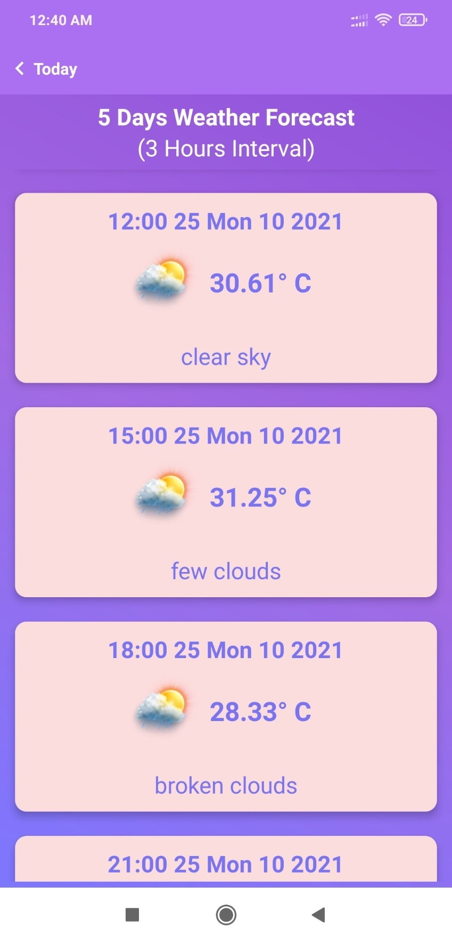

Figure 5.2.9: Weather prediction of 25th October (2).

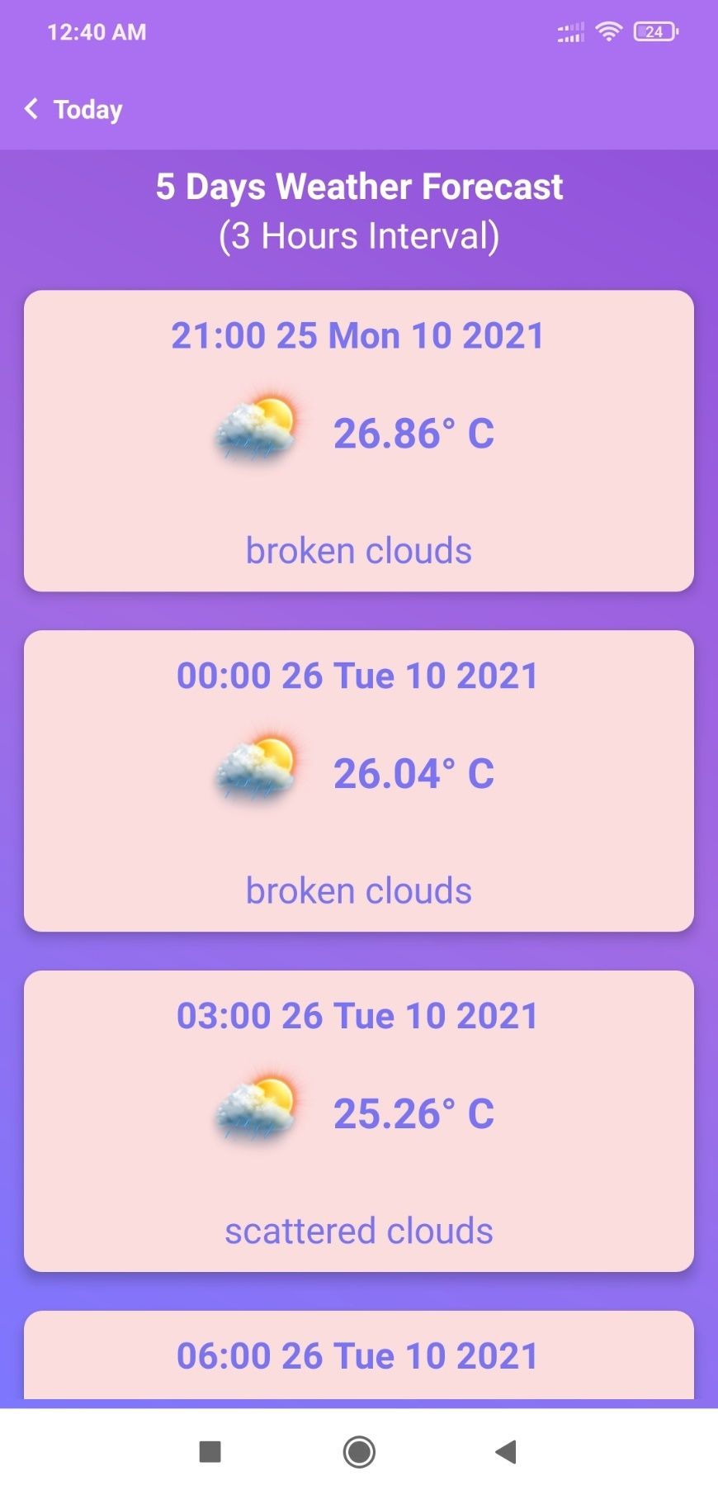

Figure 5.2.10: Weather prediction of 25th & 26th October (3).

**Continued…**

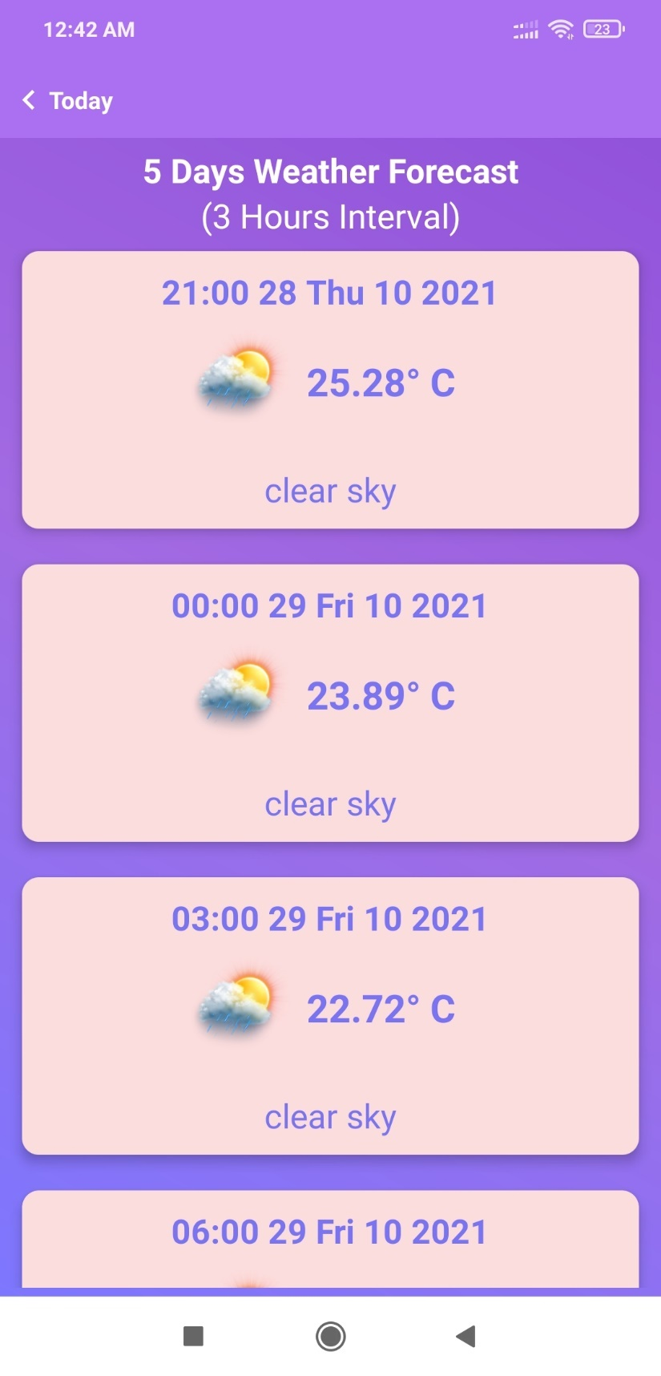

Figure 5.2.11: Weather prediction of 28th & 29th October (4).

.

**Continued…**

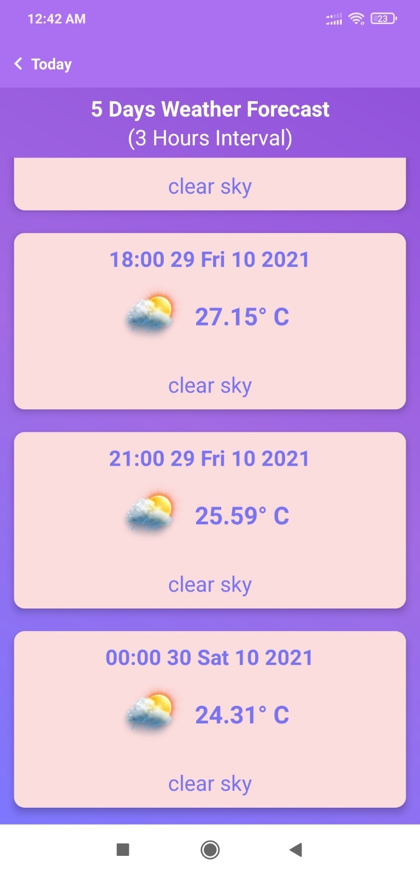

Figure 5.2.12: Weather prediction of 29th October (5).

**CHAPTER 6**

**Impact on Society, Environment and Sustainability**

**6.1** **Impact on Society**

This application will be beneficial for people of all occupations and ages. Users can be notified about the weather forecast easily through the app.

**6.2 Limitation**

No application is perfect. Every system has some limitations. The limitations of our project are written below:

* Bound to API.
* Can get only the weather of the divisions.

**6.3 Obstacles & Achievements**

During the development of the application, we have faced a lot of obstacles and successfully overcame most of them. Some of the obstacles were:

* Most of the weather APIs are paid. So, we had to use the free version.
* Getting the response from API and display according to the design of the app.

Finally, after developing the project, we have successfully achieved:

* Weather application which shows the weather of every division and weather prediction of five days.

**CHAPTER 7**

**Conclusion and Future Scope**

**7.1 Discussion and Conclusion**

To become a developed country, the country must rely on technology. Using technology in environment & geography will make a nation one step ahead to become a developed nation. If everyone uses a smart online based weather app, they will be benefitted in many ways as mentioned in the purpose of this application.

**7.2 Scope for Further Developments**

Due to limitation of time, knowledge and experience, we couldn’t develop some features of our project. In future, we want to develop those features one by one. Those features are:

* Push Notification to let the user know the prediction of the weather of the future.
* Publish the app on Play Store.

**References**:

[1] Stackoverflow for solving bugs, available at << >>, last accessed on 05-10-2021 at 12:00 P.M.

[2] Youtube for Android Tutorial at << <https://www.youtube.com/> >>, last accessed on 05-10-2021 at 10:00 P.M.

[3] Open weather api, available at << <https://openweathermap.org/api>>>, last accessed on 23-08-2021 at 01:00 A.M.

[4] Material Design for Android, available at << <https://material.io/develop/android> >>, last accessed on 10-08-2021 at 12:00 A.M.