VISVESVARAYA TECHNOLOGICAL UNIVERSITY

JNANASANGAMA, BELAGAVI-590018
A Proposed Mini Project Synopsis On
“Credit Card Fraud Detection using Machine Learning”
Submitted in the partial fulfilment of the requirements for the award of the Degree of
Bachelor of Engineering In
Computer Science and Engineering
Submitted By
Adarsha G C [1DB22CS003]
Dinesh S [1DB22CS040]
Sanketh N [1DB22CS193]
Sudarshan [1DB23CS415]
Under the Guidance of
Dr. Asha K H
Associate Professor, Department of CSE

Department of Computer Science & Engineering
Don Bosco Institute of Technology
Kumbalagodu, Mysuru Road, Bangalore-560074
2024-25

TABLE OF CONTENTS
SL.NO | CONTENTS
1. | ABSTRACT
2. | INTRODUCTION
3. | EXISTING SYSTEM
4. | AIM
5. | SOFTWARE AND HARDWARE REQUIREMENTS
6. | METHODOLOGY
7. | ARCHITECTURE DESIGN
8. | OBJECTIVE
9. | CONCLUSION
10. | REFERENCES

ABSTRACT
The Mini project "Credit Card Fraud Detection using Machine Learning" focuses on building a system that identifies fraudulent transactions in credit card payments. The primary goal is to apply machine learning algorithms to a publicly available dataset (creditcard.csv) to classify transactions as either normal or fraudulent. The system employs various algorithms including Logistic Regression, Decision Tree, Random Forest, Gradient Boosting, and AdaBoost to compare and evaluate their performance based on accuracy, precision, recall, and other metrics. The results from these models will be assessed and visualized using various performance evaluation techniques such as confusion matrices, ROC curves, and precision-recall curves. This Mini project aims to provide an efficient and scalable solution to fraud detection, a critical issue in financial transactions.

INTRODUCTION
Credit card fraud is one of the most prevalent and costly issues faced by financial institutions worldwide. Detecting fraudulent transactions in real-time is crucial for preventing significant financial losses. Traditional fraud detection methods rely on rule-based systems, which may not efficiently detect novel or sophisticated fraud patterns. This Mini project explores the application of machine learning (ML) techniques to automatically detect fraud based on historical transaction data.
The system uses a publicly available credit card transaction dataset, which contains both legitimate and fraudulent transactions. The challenge is to classify each transaction accurately as either "fraudulent" or "normal" based on features like transaction amount, time, and other variables. By applying machine learning algorithms, the model can generalize and identify patterns in unseen data, offering more robust and scalable fraud detection systems.

EXISTING SYSTEM
The existing fraud detection systems primarily rely on traditional rule-based or heuristic approaches. These systems often rely on hardcoded rules that categorize certain transactions as suspicious, based on predefined patterns. While these methods are helpful, they lack the ability to adapt to new or previously unseen fraudulent behaviour. In addition:
- Manual Review: Many financial institutions rely on manual review processes, which are time-consuming and prone to human error.
- Lack of Real-Time Detection: Traditional systems are often too slow to detect fraud in real-time, allowing fraudulent transactions to go unnoticed for hours or even days.
- Limited Accuracy: Rule-based systems might miss sophisticated fraudulent schemes due to the static nature of the rules.
Some existing fraud detection systems are starting to use machine learning, but they are often limited to a few specific algorithms or are tailored for large-scale enterprises with significant resources.

AIM
The aim of this Mini project is to:
- Apply various machine learning algorithms (Logistic Regression, Decision Tree, Random Forest, Gradient Boosting, and AdaBoost) to detect fraudulent credit card transactions.

- Compare the performance of these algorithms based on evaluation metrics such as accuracy, precision, recall, F1-score, ROC curve, and AUC.

- Provide a comprehensive performance evaluation of each model using confusion matrix, precision-recall curve, and ROC curve to visualize and compare the results.

- Develop a system capable of predicting fraudulent transactions based on historical transaction data, aiding in real-time fraud detection.

SOFTWARE AND HARDWARE REQUIREMENTS
Software Requirements:
- Operating System: Windows / Linux / MacOS
- Programming Language: Python
  - Pandas: For data manipulation and preprocessing.
- Scikit-learn: For implementing machine learning algorithms and performance evaluation.
- Python Libraries:

  - Matplotlib/Seaborn: For data visualization (confusion matrix, ROC curves, etc.).
  - Jupyter Notebook: For interactive development and analysis.
- Data Source: Credit card transaction dataset (available in CSV format).
Hardware Requirements:
- Processor: Intel i5 or higher (Multi-core preferred).
- Memory: Minimum of 4GB RAM (8GB or higher recommended).
- Storage: 1GB of free disk space for dataset and project files.
- Graphics: Standard GPU for visualizations (optional, not necessary for this Mini project).

METHODOLOGY
1. Data Collection:
- The dataset used is the Credit Card Fraud Detection dataset, which includes features like transaction amount and time.
2. Preprocessing:
- Data Cleaning: Handle missing values and drop irrelevant columns like "Time."
- Feature Scaling: Normalize features using StandardScaler for better performance with certain models.
- Train-Test Split: Split the data into 80% for training and 20% for testing.
3. Model Selection:
- Implement and train five machine learning algorithms: Logistic Regression, Decision Tree, Random Forest, Gradient Boosting, and AdaBoost.
4. Evaluation:
- Evaluate models using accuracy, precision, recall, and F1-score.
- Visualize the models' performance with ROC curves and precision-recall curves.

ARCHITECTURAL DESIGN
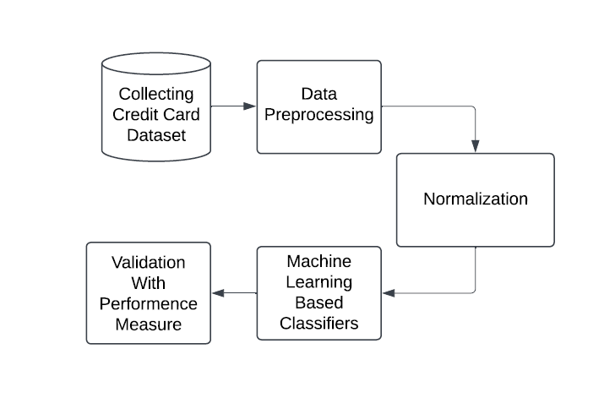
Fig: Architectural design of credit card fraud detection model

OBJECTIVE
The primary objective of this project is to develop a robust system that accurately identifies fraudulent credit card transactions in real-time or through batch processing. This system aims to minimize financial losses for both credit card issuers and customers by utilizing advanced machine learning techniques. The project focuses on:
- Data Analysis: Understanding transaction patterns to distinguish fraudulent from legitimate transactions.

- Model Development: Implementing a custom gradient boosting algorithm for accurate and efficient fraud detection.

- Scalability: Designing a solution that can adapt to increasing transaction volumes without compromising performance.

- Real-World Applicability: Integrating the model into practical systems to provide real-time fraud alerts and enable effective decision-making.

CONCLUSION
The credit card fraud detection project successfully demonstrates the potential of machine learning in combating financial fraud. By leveraging advanced algorithms and data preprocessing techniques, the model achieves high accuracy in detecting fraudulent transactions while minimizing false positives.
The system’s iterative design ensures continuous improvement through feedback analysis, enhancing its adaptability to evolving fraud patterns. This project not only highlights the importance of automated fraud detection in reducing financial risks but also provides a scalable foundation for further advancements in secure financial systems.
Future work may include:
- Incorporating ensemble learning for even better accuracy.
- Real-world deployment and integration with banking systems.
- Exploring deep learning models to capture more complex transaction patterns.

REFERENCES
[1] "Credit Card Fraud Detection using Machine Learning"
This GitHub repository implements various algorithms, including Logistic Regression, Support Vector Machine, Naive Bayes, K-Nearest Neighbors, Random Forest, AdaBoost, and XGBoost, to classify credit card transactions as fraudulent or non-fraudulent.
[2] "Ensemble Techniques for Credit Card Fraud Detection"
This research examines ensemble models, including Bagging (Random Forest, Extra Trees Classifier) and Boosting (AdaBoost, Gradient Boosting Machine, XGBoost), for fraud detection. The study concludes that stacking based on powerful machine learning algorithms results in higher performance than any individual model.
[3] "A Comparative Study of Decision Tree and Logistic Regression for Fraud Detection in Credit Card Transactions"
Authors: A. Dal Pozzolo et al.
Conference: 2014 IEEE Symposium on Computational Intelligence in Cyber Security (CICS)
Summary: This research compares the effectiveness of Decision Tree and Logistic Regression models in identifying fraudulent transactions, providing insights into their respective strengths and limitations.

