SAVE RIVERS !
Abstract:
Our project is about cleaning and saving rivers. Our project is for spreading awareness about garbage in rivers and we hope to encourage many people to not trash rivers.
Problem Statement:
Rivers are very fragile but important ecosystems. They provide water for millions of people in Tamil Nadu. However, they are increasingly being polluted by solid waste, paper waste and especially, plastics, which enter into the river by directly throwing, dumping or even floating into the river during heavy rains.

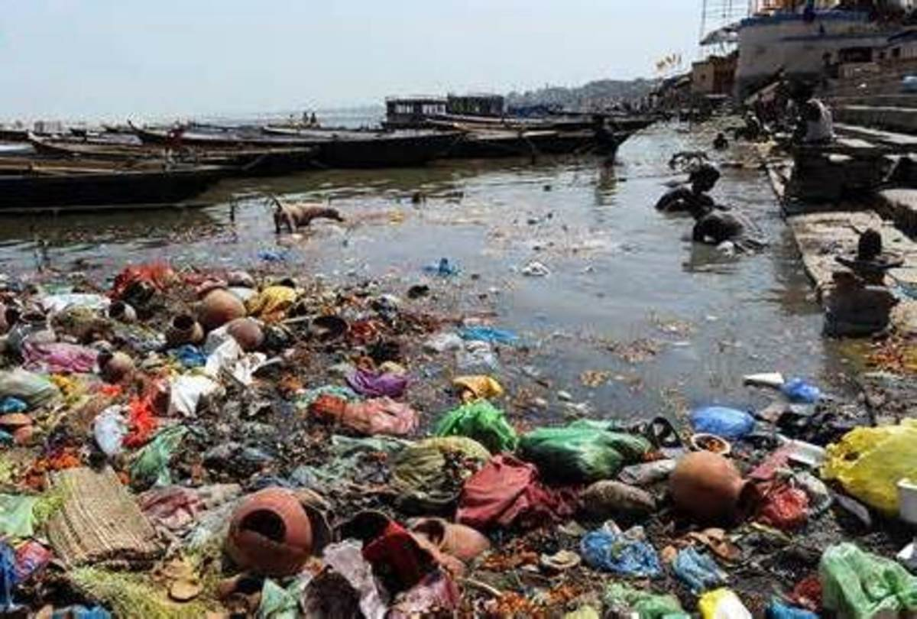

So, we should understand that no matter where we throw garbage, it could probably end up in a nearby river.
Due to the river being trashed, ignored and being used as a garbage dump, the insects living in and around the river will not be able to survive in the change of smell and environment.
The animals will not be able to drink fresh water and they would be forced to either abandon the river or die of disease or dehydration. The people who might live near it would be uncomfortable and unhappy with the smell and the unhygienic river.
Even floods might happen due to the garbage causing the river to overflow and make the buildings wet and possibly even destroy them.

Solution statement:
We have shown that by not doing these things such as trashing or bathing in rivers, we can expect a sustainable and great future.
As given as a statement, whenever we throw garbage anywhere, [roads, hills, etc.,] It can end up in a river nearby. So, if we dedicate ourselves to not throw garbage at random places, we can solve most of the garbage problem
Here are the things we did to spread more awareness about this topic:
We have started by showing the river with its garbage as it is a very bad problem that should be fixed.
We removed the garbage as to show that cleaning is a required process to ensure that the river does not lose all of its water and become a landfill. The people bathing and swimming in the river were restricted from going near the river as they are going to make the condition of the river worse.
The garbage trucks that were going to throw more trash into the rivers were restricted as to make sure that the river is clean. Then the person who was going to throw even more plastic trash into the river was stopped.

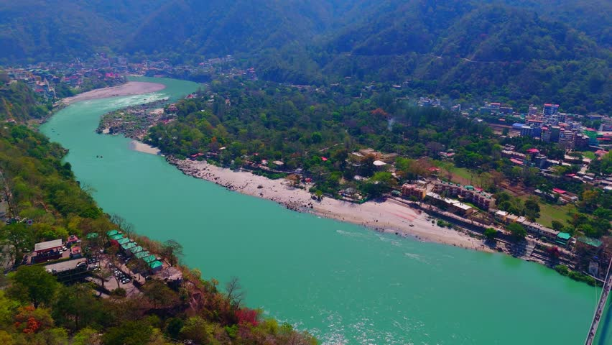

At the end, the river is very clean as the people had stopped to worsen the condition of the river. This project helps us to become aware of the water pollution caused by themselves.

Components:
We have created a simple background of a river and land that has a lot a garbage in it. There are people bathing and swimming and throwing plastics and paper into the river. There are signs telling the people to not trash the river, to not bathe or swim in it and to not pollute water. But the people do not follow it. Ultimately, it gets fixed and the ecosystem is clean or at least manageable.

