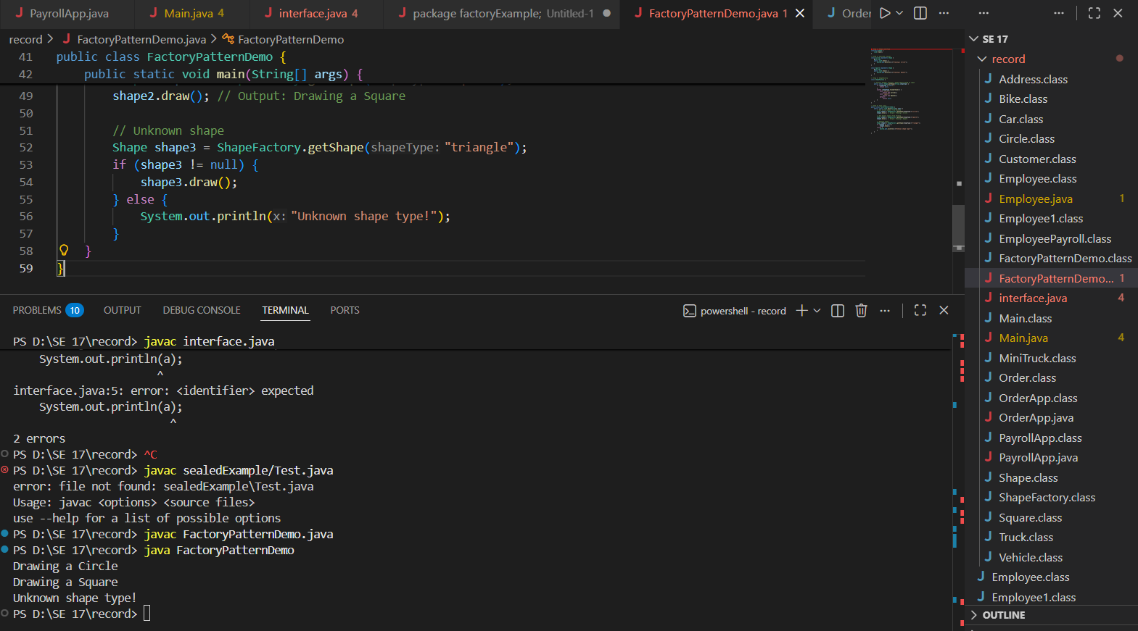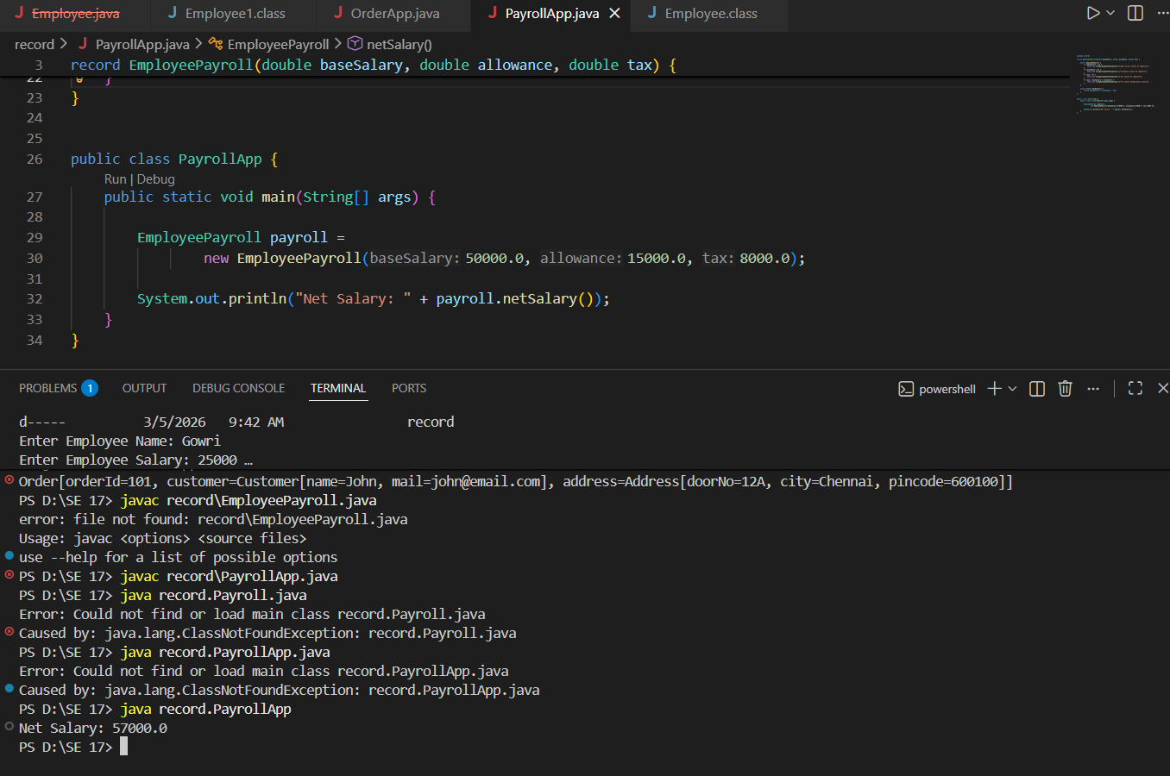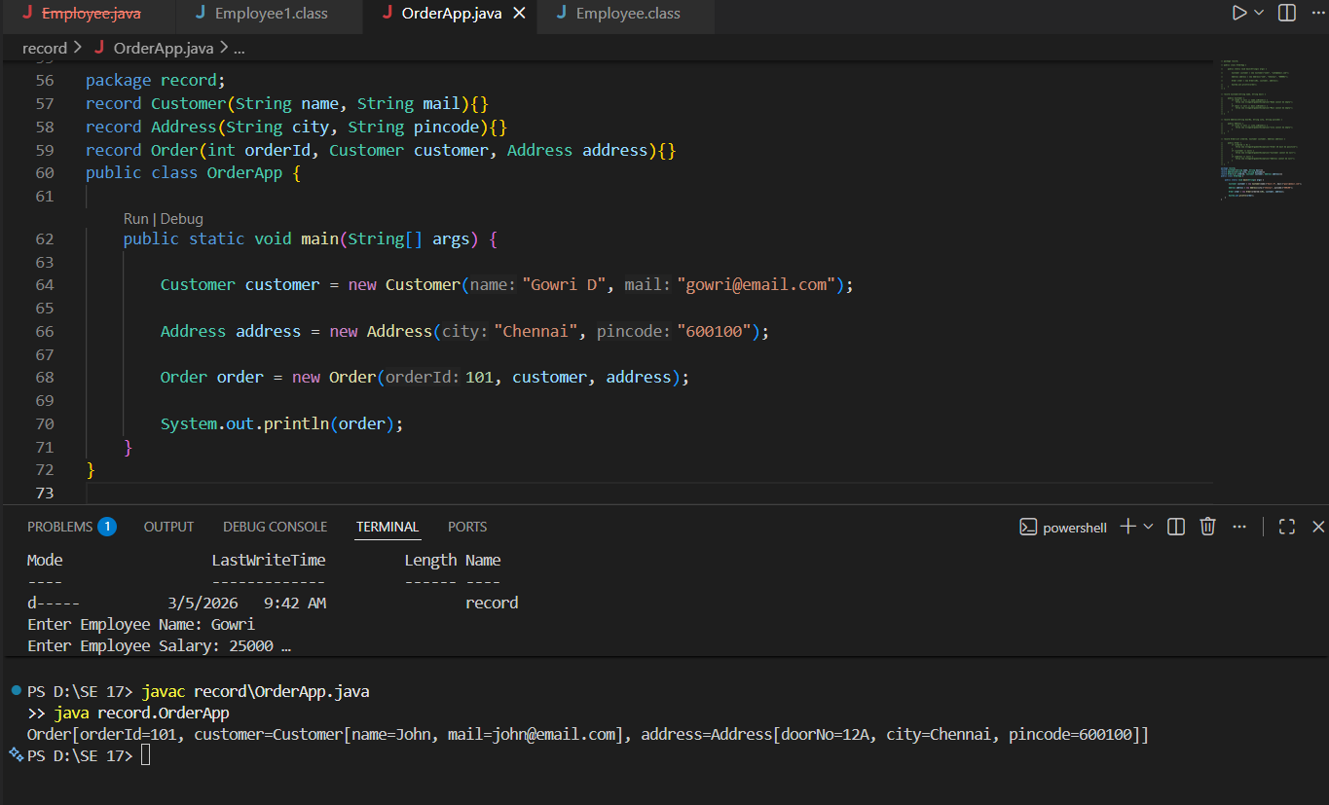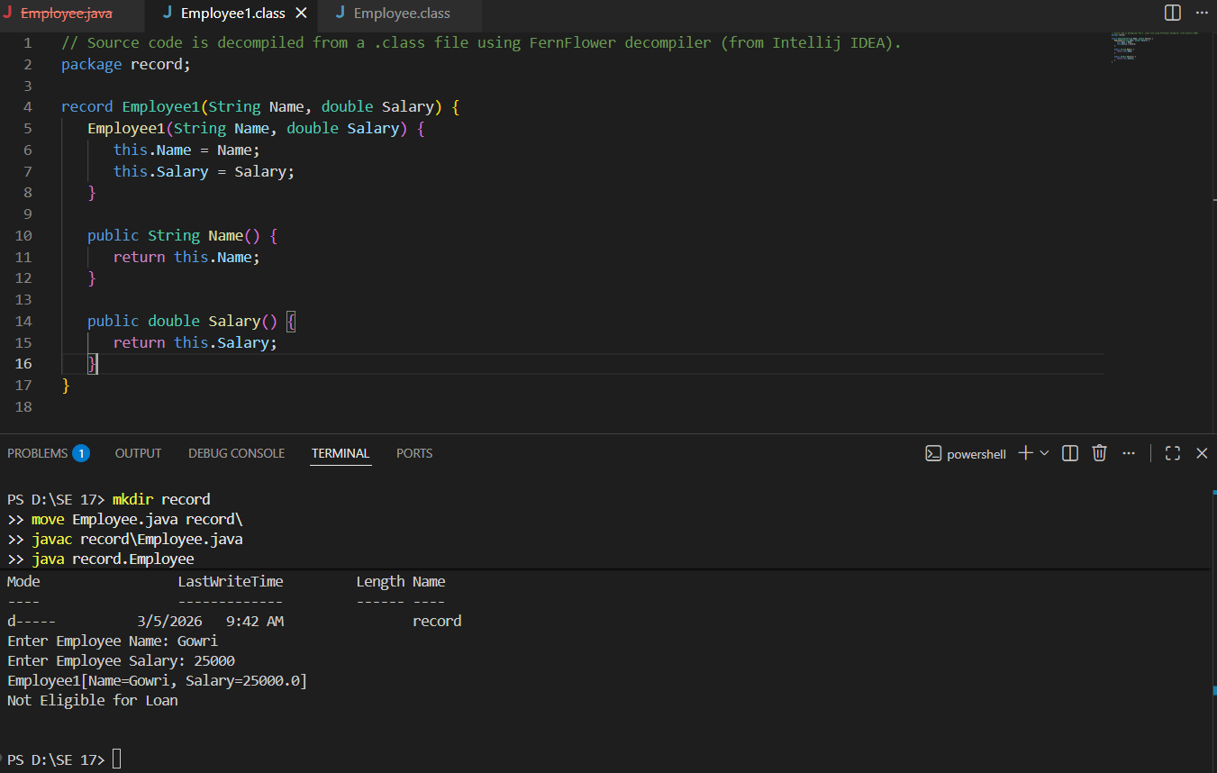
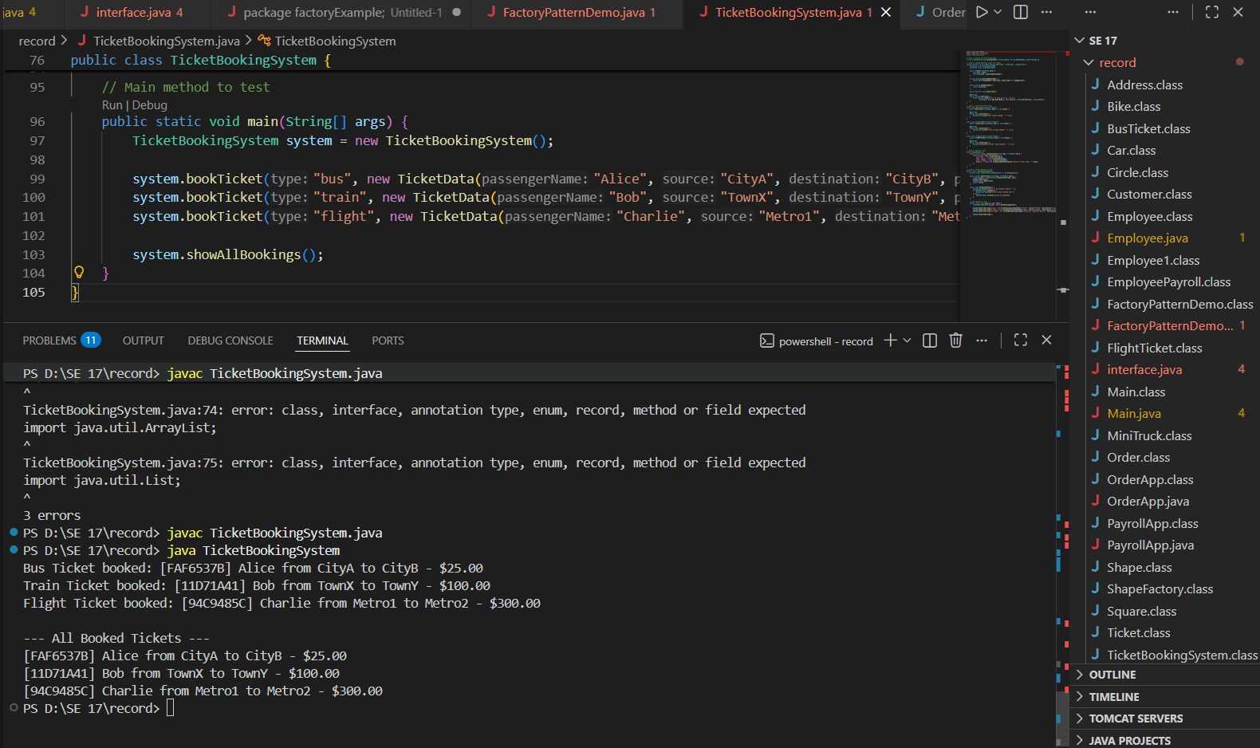

Day 2 : 9c95ec60320a2276c743992e8fe6ff68e159a99d (git commit id)
https://github.com/Gowri0504/Java-SE17-Certification-Training.git

Day 3 : 2668962aa63d712dcc8bdb4b06ac741682c80936

Submitted By:
- Gowri D [23ITR048]

