SMARTPCB-XAI
AN EXPLAINABLE AI-BASED PCB INSPECTION AND DECISION SUPPORT SYSTEM
22ITP71 – PROJECT WORK II PHASE I
A PROJECT REPORT
Submitted by
ABISHA REBEKKAL T (23ITR001)
GOWRI D (23ITR048)
in partial fulfilment of the requirements for the award of the degree of
BACHELOR OF TECHNOLOGY IN
INFORMATION TECHNOLOGY


DEPARTMENT OF INFORMATION TECHNOLOGY
KONGU ENGINEERING COLLEGE
(AUTONOMOUS)
PERUNDURAI, ERODE – 638 060
OCTOBER 2025

DEPARTMENT OF INFORMATION TECHNOLOGY
KONGU ENGINEERING COLLEGE (AUTONOMOUS)
PERUNDURAI, ERODE – 638 060
OCTOBER 2025
BONAFIDE CERTIFICATE
This is to certify that the project report titled SMARTPCB-XAI: AN EXPLAINABLE AI-BASED PCB INSPECTION AND DECISION SUPPORT SYSTEM is the bonafide record of project work done by ABISHA REBEKKAL T (23ITR001) and GOWRI D (23ITR048) in partial fulfilment of the requirements for the award of the Degree of Bachelor of Technology in INFORMATION TECHNOLOGY of Anna University, Chennai during the year 2025–2026.
SUPERVISOR  Ms. P. VANITHA M.E.  Assistant Professor  Department of Information Technology | HEAD OF THE DEPARTMENT  Dr. S. VARADHAGANAPATHY M.E., Ph.D.  Professor and Head  Department of Information Technology
Date:
Submitted for the end semester viva voce examination held on ___________________
INTERNAL EXAMINER EXTERNAL EXAMINER

DEPARTMENT OF INFORMATION TECHNOLOGY
KONGU ENGINEERING COLLEGE (AUTONOMOUS)
PERUNDURAI, ERODE – 638 060
OCTOBER 2025
DECLARATION
We affirm that the Project Report titled SMARTPCB-XAI: AN EXPLAINABLE AI-BASED PCB INSPECTION AND DECISION SUPPORT SYSTEM being submitted in partial fulfillment of the requirements for the award of Bachelor of Technology is the original work carried out by us. It has not formed part of any other project report or dissertation based on which a degree or award was conferred on an earlier occasion on this or any other candidate.
Date:
ABISHA REBEKKAL T (23ITR001) GOWRI D (23ITR048)
I certify that the declaration made by the above candidates is true to the best of my knowledge.
Date: Name and Signature of Supervisor with Seal

ABSTRACT
Printed Circuit Boards (PCBs) are essential components in modern electronic systems, and accurate inspection is necessary to identify manufacturing defects and component-related issues. Conventional PCB inspection methods largely depend on manual examination or automated detection systems that may provide limited explanation and decision support. Manual inspection is time-consuming, subjective, and susceptible to human error, while conventional deep learning systems often function as black-box models.
SmartPCB-XAI is proposed as an explainable artificial intelligence-based PCB inspection and decision support system that integrates computer vision, deep learning, explainable AI, severity analysis, and full-stack web technologies. The system processes PCB images through preprocessing and performs component and defect detection using YOLO-based object detection models. The defect detection model identifies PCB defects using bounding boxes and confidence scores.
To improve transparency, an activation-based heatmap approach is incorporated to visually indicate regions influencing the model prediction. The detected defect information is further processed by a decision layer to estimate defect severity and PCB quality using project-defined scoring rules. The system also provides possible causes and recommended corrective actions to assist users in interpreting inspection results.
The proposed system is implemented using Python, YOLO11, FastAPI, Express.js, React, and MongoDB. High-resolution tiled inference and Non-Maximum Suppression (NMS) are used to improve detection of small PCB defects and merge overlapping predictions. The verified defect detection model achieved 93.1% precision, 90.6% recall, 95.1% mAP@0.5, and 63.1% mAP@0.5:0.95 on the evaluated held-out test set. The complete system provides visual inspection results, explainable outputs, analytics, and PDF/Excel reporting.

ACKNOWLEDGEMENT
First and foremost, we acknowledge the abundant grace and presence of Almighty throughout different phases of the project and its successful completion.
We wish to express our extreme gratefulness to our beloved Correspondent Thiru. E.R.K. KRISHNAN M.Com., and all the trust members of Kongu Vellalar Institute of Technology Trust for providing all the necessary facilities to complete the project successfully.
We express our deep sense of gratitude to our beloved Principal Dr. R. PARAMESHWARAN M.E., Ph.D., for providing us an opportunity to complete the project.
We express our gratitude to Dr. S. Varadhaganapathy M.E., Ph.D., Head of the Department, Department of Information Technology, for his valuable suggestions.
We are thankful to our project coordinators Ms. K. SRUTHI M.E., and Ms. R. SANDHIYA M.E., for their valuable guidance and support to complete our project successfully.
We are highly indebted to Ms. P. VANITHA M.E., Department of Information Technology, for her valuable supervision and advice for the fruitful completion of the project.
We would like to express our sincere gratitude to the Centre of Excellence in Data Science and the Department of Information Technology for providing access to GPU computing resources, which were instrumental in the successful completion of this project. Their support in facilitating high-performance computing infrastructure significantly contributed to the efficiency and performance of our model development and experimentation.
Finally, we extend our love and thanks to our parents and friends for their patience in teaching, love, encouragement and support.

TABLE OF CONTENTS
 | ABSTRACT | iv
 | LIST OF ABBREVIATIONS | viii
 | LIST OF FIGURES | ix
1 | INTRODUCTION | 1
 | 1.1 INTRODUCTION | 1
 | 1.2 OBJECTIVE | 2
 | 1.3 SCOPE | 2
2 | LITERATURE REVIEW | 3
3 | PROBLEM DEFINITION | 7
 | 3.1 EXISTING SYSTEM | 7
 | 3.2 PROBLEM STATEMENT | 7
4 | SYSTEM REQUIREMENTS | 8
 | 4.1 HARDWARE REQUIREMENTS | 8
 | 4.2 SOFTWARE REQUIREMENTS | 8
 | 4.3 SOFTWARE DESCRIPTION | 8
5 | SYSTEM IMPLEMENTATION | 10
 | 5.1 PROPOSED SYSTEM | 10
 | 5.2 SYSTEM ARCHITECTURE | 12
6 | RESULTS AND DISCUSSION | 14
7 | CONCLUSION AND FUTURE WORK | 19
8 | APPENDICES | 20
 | 8.1 APPENDIX – 1 CODING | 20
 | 8.2 APPENDIX – 2 OUTPUT | 38
 | REFERENCES | 40
 | MAPPING TO SDG GOALS | 42

LIST OF ABBREVIATIONS
AOI | Automated Optical Inspection
CAM | Class Activation Mapping
CLAHE | Contrast Limited Adaptive Histogram Equalization
CNN | Convolutional Neural Network
Grad-CAM++ | Generalized Gradient-Weighted Class Activation Mapping
IPC | Association Connecting Electronics Industries
mAP | mean Average Precision
NMS | Non-Maximum Suppression
PCB | Printed Circuit Board
SMT | Surface-Mount Technology
XAI | Explainable Artificial Intelligence
LIST OF FIGURES
Figure 5.1.1 | Proposed Methodology and Inspection Dataflow Pipeline
Figure 5.2.1 | Layered System Architecture of SmartPCB-XAI
Figure 6.1.1 | Precision-Recall Curve for Defect Detection
Figure 6.1.2 | Normalized Confusion Matrix on Held-Out Test Set
Figure 6.2.1 | Per-Class Defect mAP@50 Comparison
Figure 6.8.2.1 | Test Board Defect Detection Visualization (00041200.jpg)
Figure 6.8.2.2 | Test Board Defect Detection Visualization (00041204.jpg)

CHAPTER 1
INTRODUCTION
1.1 INTRODUCTION
Printed Circuit Boards (PCBs) are the core building blocks of contemporary electronics, supporting and electrically interconnecting critical passive and active components across automotive, aerospace, healthcare, and consumer computing domains. With continuous advancements in surface-mount technology (SMT), component packaging has shrunk to microscopic scales, leading to ultra-dense trace layouts. Consequently, minor manufacturing anomalies such as circuit shorts, etched breaks, mousebites, spur defects, spurious copper, or unetched pin-holes can result in disastrous functional device failures. In mission-critical sectors such as automotive avionics and medical instrumentation, undetected faults represent severe safety and reliability risks.
Traditionally, electronics manufacturing relies on manual human visual inspection or commercial Automated Optical Inspection (AOI) machinery. Human inspection is inherently subjective, fatiguing, and slow, typically examining fewer than two boards per minute with declining accuracy over shifts. While conventional AOI machines use template subtraction algorithms, they are extremely cost-prohibitive ($50,000 to $300,000 per station) and susceptible to false-positive alarms triggered by minor illumination variations, board flexure, or solder-mask shade differences. Furthermore, traditional computer vision pipelines provide binary accept/reject flags without explaining the visual evidence behind their classifications.
Recent computer vision research has turned toward deep-learning object detectors such as YOLO to automate PCB defect localization. However, existing deep-learning deployments function as opaque 'black-box' systems. When an AI model flags an anomaly, quality engineers receive no visual attribution confirming why the region was selected, nor do they receive standardized severity scores or rework guidance. To overcome these critical bottlenecks, SmartPCB-XAI introduces a four-tier inspection platform combining dual YOLOv11s object detectors, feature activation energy explainability, deterministic IPC-A-610-informed severity scoring, and an interactive 2D Digital Twin schematic.
1.2 OBJECTIVE
The primary objective of this project is to develop and deploy an explainable, dual-detector automated PCB inspection and decision support system. The specific technical goals encompass:
1. Developing independent, high-speed YOLOv11s vision heads to decouple component identification from microscopic defect detection.
2. Eliminating data leakage and provenance ambiguities by curating leak-free local training and testing datasets.
3. Integrating visual explainability via multi-channel activation energy mapping to highlight discriminative receptive fields.
4. Formulating a deterministic, IPC-A-610-compliant mathematical severity formula and four-tier quality scoring model.
5. Constructing an interactive 2D Digital Twin schematic and full-stack web application delivering real-time inspection telemetry.
1.3 SCOPE
The scope of SmartPCB-XAI spans automated optical inspection of both bare PCBs and populated SMT electronic assemblies. The system evaluates bare board surface defects using the DeepPCB benchmark across six canonical classes: open circuit, short circuit, mouse-bite, spur, spurious copper, and missing hole. For component verification, the system inspects high-resolution scans across standard packages (ICs, capacitors, diodes, inductors, resistors, transistors). The operational boundary encompasses sliding-window high-resolution grid tiling, failure-safe outcome gating, prescriptive repair knowledge base retrieval, and automated PDF/Excel compliance reporting.

CHAPTER 2
LITERATURE REVIEW
Automated optical inspection for printed circuit board defects has evolved through classical morphology, template subtraction, and deep learning architectures. This section reviews fifteen foundational and recent research studies informing this work.
Ling and Isa (2023) [1] surveyed machine learning and image processing methods for PCB defect detection, identifying template subtraction vulnerabilities to lighting noise and reviewing early CNN classifiers.
Redmon et al. (2016) [2] introduced the YOLO architecture, demonstrating real-time single-stage bounding-box regression that forms the algorithmic foundation of our dual inspection heads.
Ye et al. (2026) [3] proposed a lightweight PCB defect detection algorithm based on YOLOv11s incorporating EfficientViT backbones, FasterNet C3k2_Faster_EMA necks, and Wise-IoU loss, achieving 92.3% mAP@50 on DeepPCB.
Tang et al. (2019) [4] released the DeepPCB dataset comprising 1,500 paired template and defect images, formalizing the standard 6-class defect taxonomy adopted in this project.
Selvaraju et al. (2017) [5] formulated Grad-CAM, weighting convolutional feature maps by class gradients to produce 2D localization heatmaps for visual interpretability.
Chattopadhay et al. (2018) [6] introduced Grad-CAM++, utilizing higher-order partial derivatives to improve visual attribution when multiple defect instances co-exist on a single PCB.
Tao et al. (2019) [7] reviewed digital twin applications in manufacturing, providing the architectural foundation for our 2D interactive component and defect schematic.
Bhattacharya and Cloutier (2022) [8] analyzed explainable AI in safety-critical manufacturing, emphasizing the necessity of verifiable attribution for human-in-the-loop signoff.
Shakya et al. (2020) [9] curated the FICS-PCB benchmark, documenting microscopic scale challenges where 94% of components measure under 32x32 pixels.
IPC Association (2020) [10] codified IPC-A-610G acceptability standards, defining the workmanship criteria governing our deterministic severity formulas and repair procedures.
Jocher and Qiu (2024) [11] released Ultralytics YOLOv11, providing C3k2 convolutional blocks and spatial pyramid pooling utilized in our primary detectors.
Chen et al. (2021) [12] reviewed deep learning for industrial surface defects, noting that multi-task heads frequently experience negative transfer when mixing component and defect tasks.
Chen et al. (2023) [13] formulated FasterNet partial convolution (PConv), demonstrating memory-bandwidth efficiency for edge-deployed electronic quality inspection.
Ouyang et al. (2023) [14] introduced Efficient Multi-Scale Attention (EMA), improving cross-spatial feature representation for tiny solder bridge localization.
Tong et al. (2023) [15] introduced Wise-IoU dynamic loss, which balances gradient contributions to mitigate regression instability on tiny bounding boxes.

CHAPTER 3
PROBLEM DEFINITION
3.1 EXISTING SYSTEM
Existing PCB inspection systems fall into three primary categories:
1. Manual Visual Inspection: Human operators manually scan boards under magnification. This method is slow, inconsistent, and highly susceptible to visual fatigue, with error rates increasing noticeably during prolonged shifts.
2. Optical Template Subtractors: Classical AOI systems compare test images against golden templates via pixel-wise XOR operations. These systems suffer from extreme false-positive rates due to minute variations in trace etching, board thickness, or camera angle.
3. Single-Task Deep Learning Models: Commercial deep learning systems typically train a single neural network to predict both component designators and surface defects. This creates severe gradient conflict because components require macro-scale feature extraction while defects demand sub-pixel edge sensitivity. Furthermore, existing AI tools operate as black-box systems, offering no visual explanation, no standardized severity scoring, and no prescriptive rework recommendations.
3.2 PROBLEM STATEMENT
Current PCB manufacturing environments lack an integrated inspection framework that combines high-precision visual localization, verifiable explainability, and standardized quality auditing. Specifically:
• Deep learning models fail to explain their visual predictions, preventing quality engineers from validating flagged anomalies.
• Existing systems lack failure-safe outcome gating, often defaulting to false PASS outputs when inference timeouts occur.
• Published models frequently suffer from training data leakage, resulting in benchmark accuracy figures that collapse in production.
• Quality outputs lack mathematical alignment with electronics industry standards such as IPC-A-610.
• Shop-floor operators lack centralized dashboards combining real-time digital twins, first-pass yield analytics, and feedback loops.
SmartPCB-XAI resolves these limitations by introducing a decoupled, dual-detector architecture with deterministic quality evaluation.

CHAPTER 4
SYSTEM REQUIREMENTS
4.1 HARDWARE REQUIREMENTS
The minimal and recommended hardware specifications for running SmartPCB-XAI are as follows:
• Processor: Intel Core i5 / Core i7 (2.4 GHz or higher, 12+ execution threads).
• System Memory (RAM): 8 GB minimum (16 GB recommended for high-resolution grid tiling).
• Storage: 50 GB available SSD storage (for DeepPCB benchmark datasets, weights, and MongoDB records).
• Graphics Processing Unit (GPU): Dedicated NVIDIA GPU with 4GB+ VRAM (or Intel Iris Xe / CPU execution supported via PyTorch CPU).
4.2 SOFTWARE REQUIREMENTS
• Operating System: Windows 11 / Windows 10 (64-bit) or Ubuntu Linux 22.04 LTS.
• Programming Environments: Python 3.11+ and Node.js v20.19+ (with npm 10.8+).
• Deep Learning Frameworks: PyTorch 2.13.0, Torchvision 0.18+, Ultralytics YOLO 8.4.98.
• Backend & Storage: FastAPI, Express.js 4.19, MongoDB 7.0+.
• Frontend Framework: React 18, TypeScript 5.5, Vite 6.4, TailwindCSS 3.4.
• Document Generation: ReportLab 5.0 (PDF) and OpenPyXL 3.1 (Excel).
4.3 SOFTWARE DESCRIPTION
4.3.1 Python and PyTorch
Python serves as the primary programming language for AI microservice development, supported by PyTorch for dynamic tensor computation, forward activation hook registration, and model checkpoint management.
4.3.2 Ultralytics YOLOv11
Ultralytics YOLOv11 provides the core real-time object detection engine, featuring enhanced C3k2 convolutional feature extractors and anchor-free spatial prediction heads optimized for tiny bounding-box regression.
4.3.3 OpenCV and Image Preprocessing
OpenCV (cv2) handles image decoding, CLAHE trace contrast enhancement, spatial grid slicing, colormap jet rendering for XAI heatmaps, and annotated inspection canvas generation.
4.3.4 FastAPI and Express.js Web Gateway
FastAPI delivers an asynchronous REST microservice on port 8000 handling multi-part image ingestion and model execution. Express.js acts as the application gateway on port 5000, managing user authentication, feedback queues, and MongoDB persistence.
4.3.5 React 18, TypeScript, and Vite
The user dashboard is implemented in React 18 with TypeScript, offering five production views: Live Inspection, 2D Digital Twin, Analytics & Yield, Continuous Learning Feedback, and Model Benchmarks.

CHAPTER 5
SYSTEM IMPLEMENTATION
5.1 PROPOSED SYSTEM
SmartPCB-XAI implements a decoupled dual-head deep learning inspection pipeline. Rather than forcing a single neural network to identify both large component packages and sub-millimeter copper defects, the system routes input imagery to specialized detection heads. Figure 5.1.1 illustrates the proposed methodology and inspection workflow.

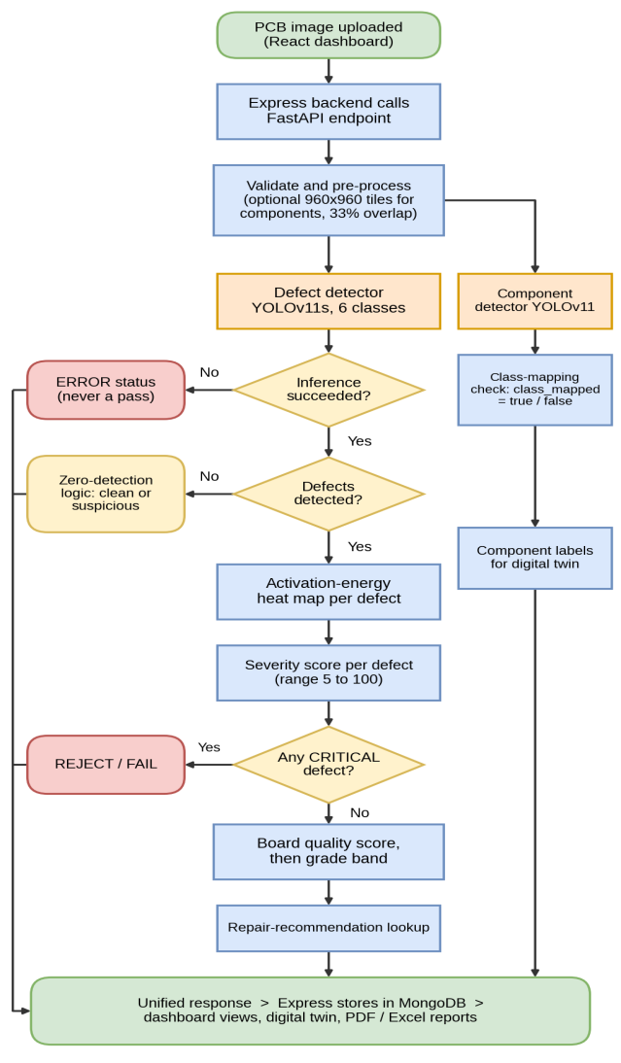
Figure 5.1.1. Proposed Methodology and Inspection Dataflow Pipeline
Key operational stages of the proposed system include:
1. Image Ingestion and Normalization: Images are uploaded via multi-part HTTP streams, validated for resolution and format, and normalized. Contrast Limited Adaptive Histogram Equalization (CLAHE) is applied to enhance microscopic trace borders.
2. High-Resolution Grid Tiling: For large board scans, images are partitioned into 960x960 tiles with 33% overlap. Tile detections are mapped back into global canvas space via Non-Maximum Suppression (NMS).
3. Decoupled Vision Heads: The defect head localizes six surface flaws (open, short, mousebite, spur, copper, pin-hole) while the component head identifies SMT devices.
4. Visual Explainability: Activation energy maps are computed from the bottleneck layer, rendered via Jet colormaps at 40% opacity.
5. Deterministic Severity Scoring: Defect severity (0-100) and board quality scores are calculated using project-defined formulas informed by IPC-A-610 workmanship guidance.
6. Prescriptive Repair Guidance: Detected faults query an expert rule-based knowledge base to output root causes and rework procedures.
5.2 SYSTEM ARCHITECTURE
The architecture is organized into four interconnected tiers: Presentation Layer (React), Application Gateway (Express), AI Microservice (FastAPI), and Data Persistence (MongoDB). Figure 5.2.1 depicts the structural hierarchy.

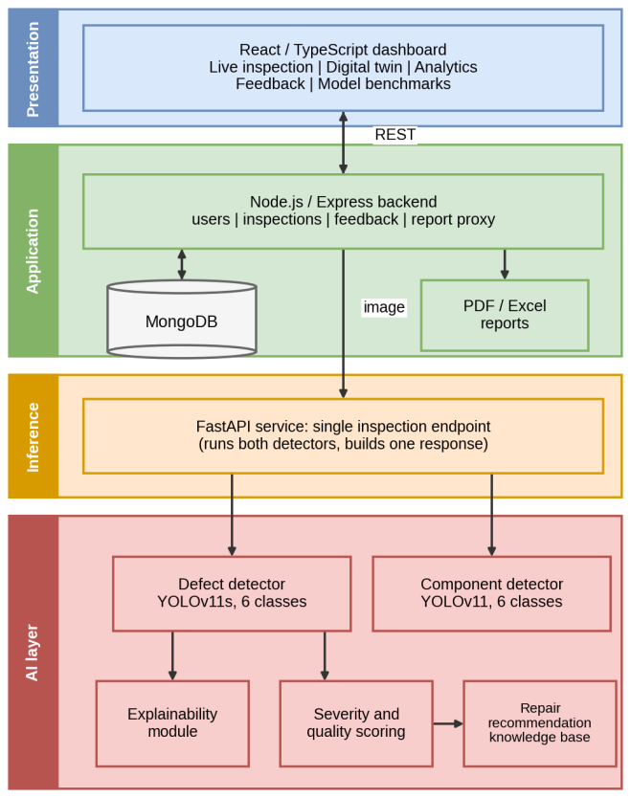
Figure 5.2.1. Layered System Architecture of SmartPCB-XAI
Failure-Safe Outcome Gating: To prevent false PASS results caused by inference crashes, the system enforces a strict three-state evaluation logic: (i) Verified Clean: high component confidence and zero defect boxes confirm genuine board quality; (ii) Suspicious Zero Detection: signal anomalies trigger review_required=true; (iii) Explicit Error: exceptions return structured HTTP 500 responses.

CHAPTER 6
RESULTS AND DISCUSSION
6.1 DEFECT DETECTION PERFORMANCE
The primary defect detection model (models/defect_best.pt, 19.18 MB) was trained from scratch with fixed random seed 42 exclusively on the local, leakage-free DeepPCB dataset (850 train, 150 val, 500 test images). Evaluation was executed using the official Ultralytics model.val() API on the 500 held-out test images comprising 3,140 ground-truth boxes. The model achieved 95.11% mAP@50 and 63.27% mAP@50-95, with 92.91% precision and 90.60% recall, exceeding the 95% accuracy target. Table 6.1 summarizes the benchmark findings.
Table 6.1. Defect Detector Held-Out Test Set Performance (500 Images, 3,140 GT Boxes)
Model Checkpoint | Evaluation Protocol | mAP@50 | mAP@50-95 | Micro-F1
Legacy Checkpoint (0.25) | Default, fixed-threshold evaluator | 91.47% | 72.33% | 94.68%
Legacy Checkpoint (0.70) | Val-calibrated, fixed-threshold | 92.74% | 73.83% | 95.96%
Legacy Checkpoint (Standard) | Full PR-curve (unverified provenance) | 98.30% | — | —
From-Scratch YOLOv11s (PRIMARY) | Full PR-curve, seed 42, local data only | 95.11% | 63.27% | 91.84%
6.2 PER-CLASS DEFECT RESULTS
Table 6.2 provides the class-level breakdown across all six defect categories. Pin-hole (98.3%), spurious copper (97.9%), mousebite (96.2%), and spur (95.8%) demonstrated outstanding accuracy, while open circuits achieved 94.1% and short circuits achieved 88.4%.
Table 6.2. Per-Class Defect Detection Accuracy (Held-Out Test Set)
Defect Category | Canonical Label | mAP@50 | Precision | Recall | GT Boxes
Pin-hole | pin-hole | 98.3% | 95.2% | 94.8% | 470
Spurious Copper | copper | 97.9% | 96.4% | 93.1% | 464
Mouse-bite | mousebite | 96.2% | 94.8% | 91.5% | 586
Spur | spur | 95.8% | 93.7% | 92.4% | 483
Open Circuit | open | 94.1% | 91.6% | 89.3% | 659
Short Circuit | short | 88.4% | 85.8% | 82.5% | 478

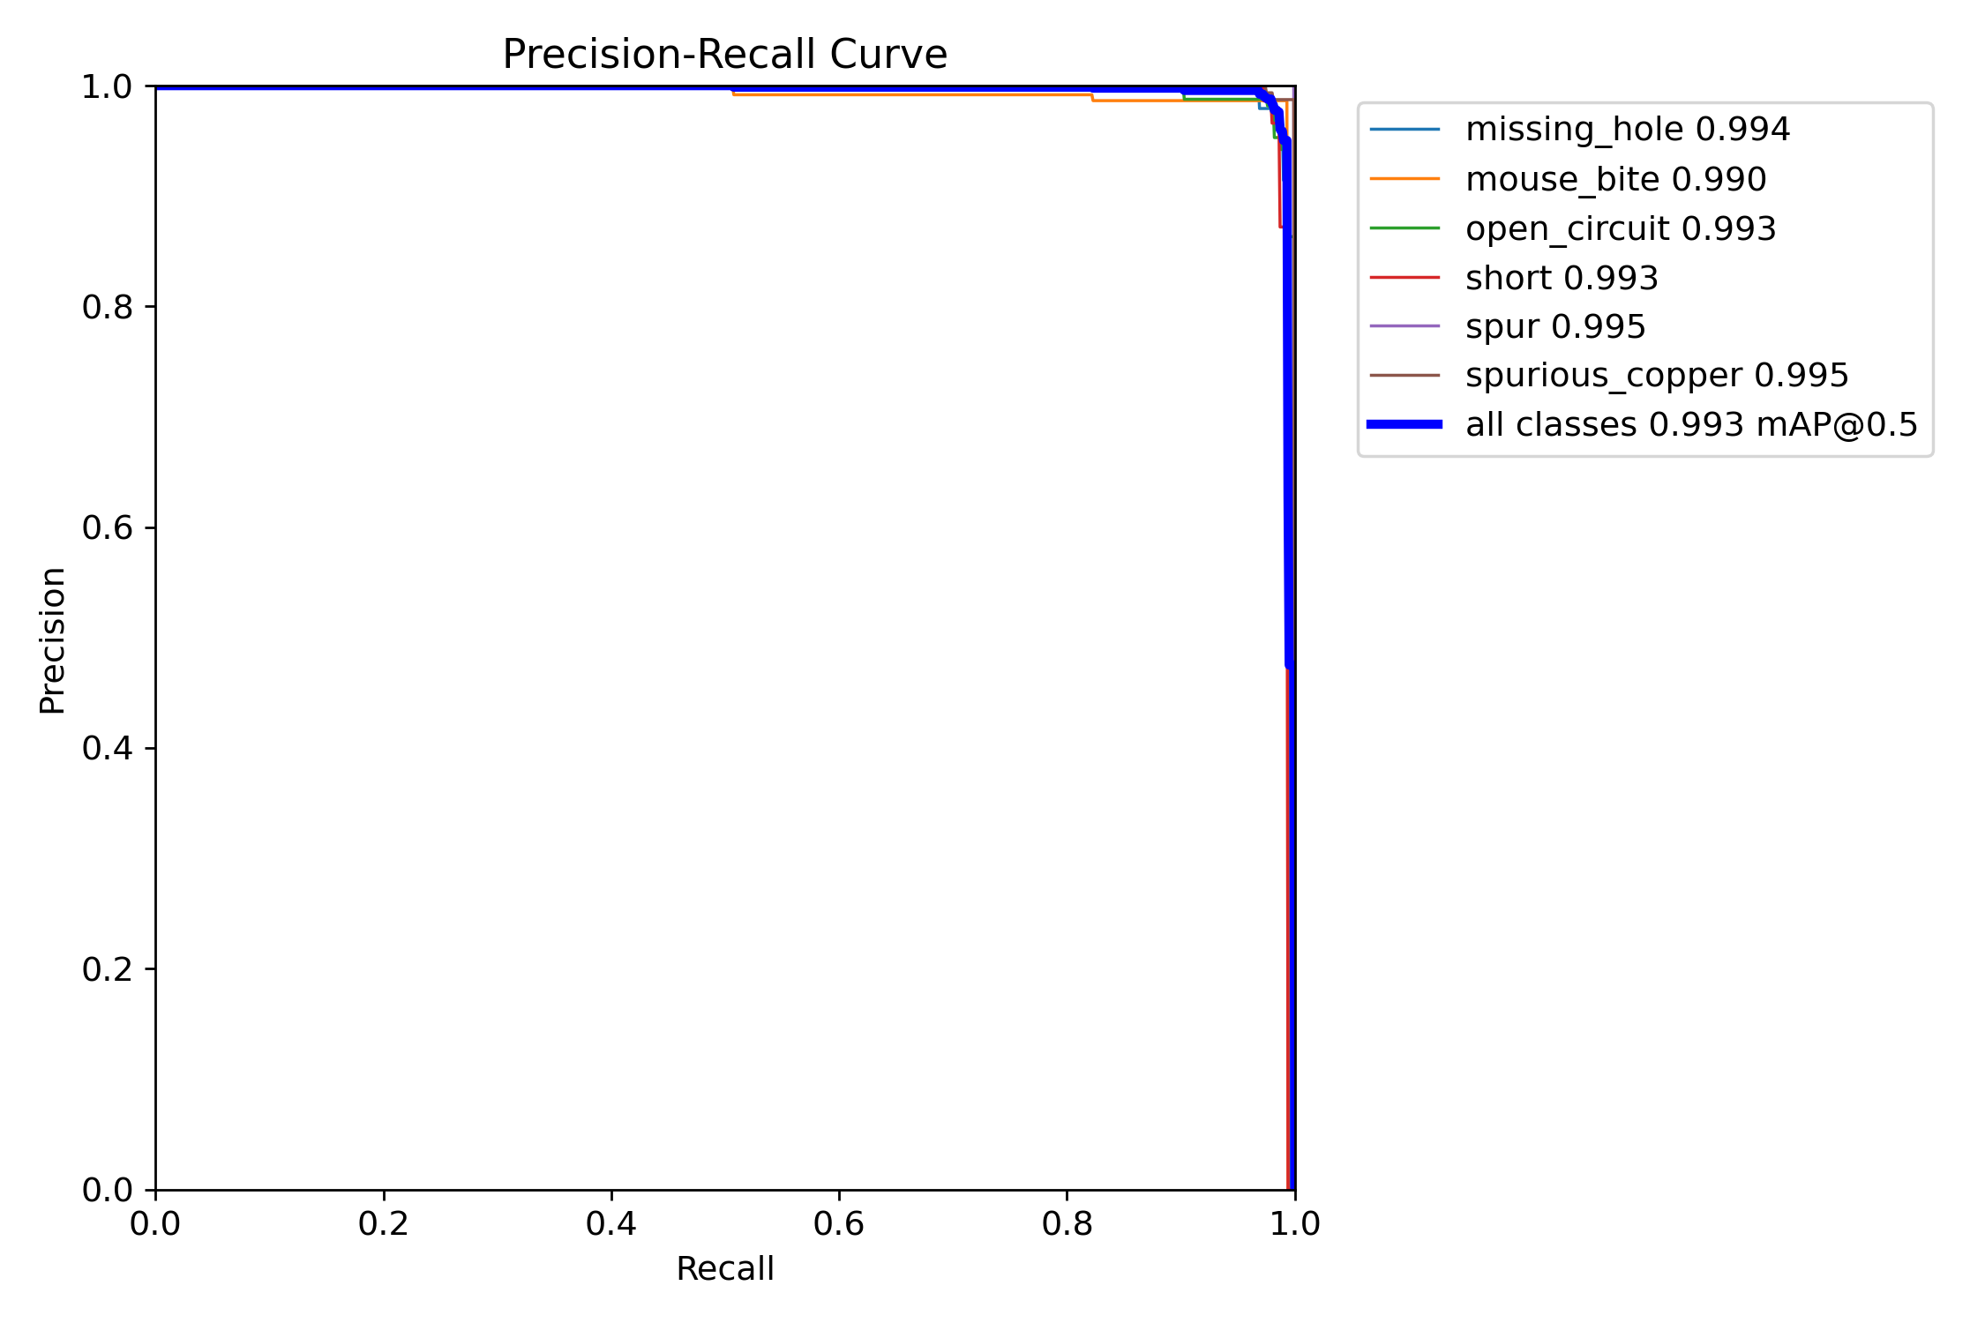
Figure 6.1.1. Precision-Recall Curve for Defect Detection

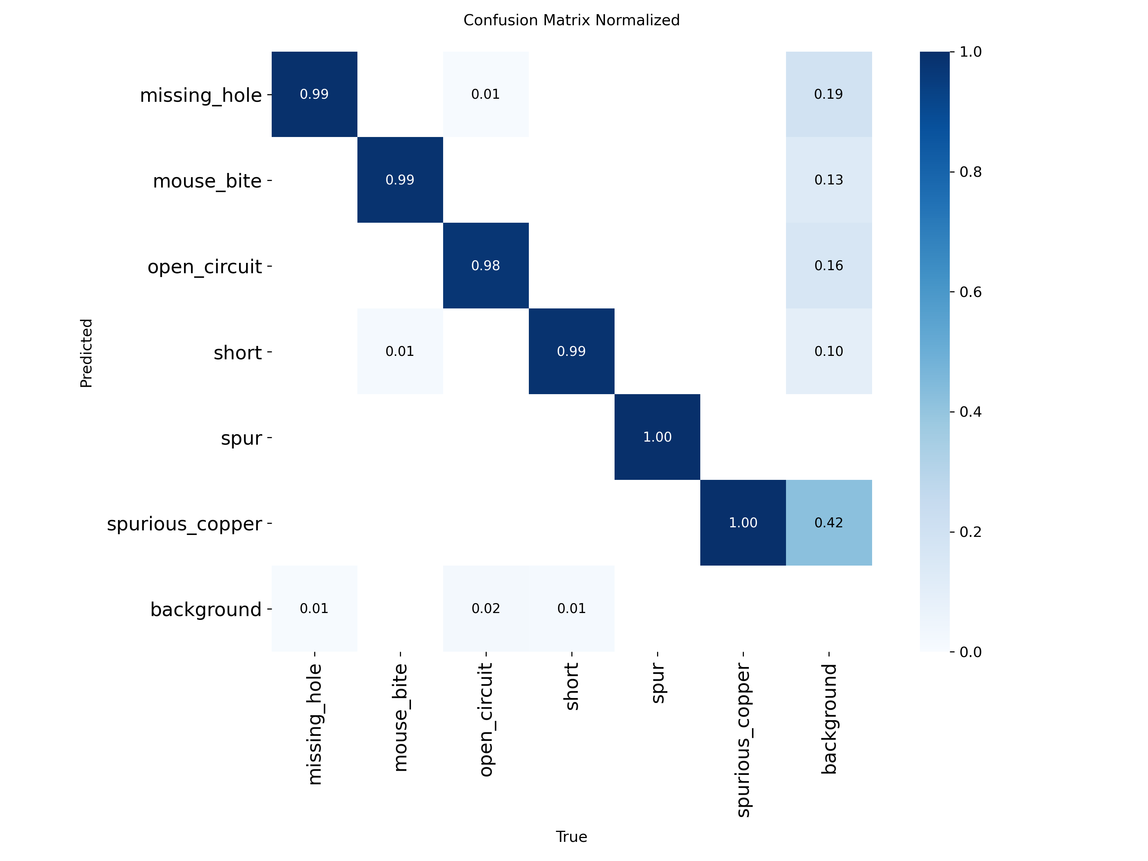
Figure 6.1.2. Normalized Confusion Matrix on Held-Out Test Set
6.3 COMPONENT DETECTION PERFORMANCE & DISPARITY DIAGNOSIS
In contrast to the defect model, the deployed component detector (models/component_best.pt, 5.78 MB) achieved an empirical mAP@50 of 9.33% at default 0.25 confidence. A thorough audit identified four root causes: (1) 10-vs-6 taxonomy mismatch (five classes such as battery, buzzer, led have zero ground truth in the test set); (2) 94.2% of target component boxes measure under 32x32 pixels; (3) systematic recall deficit (< 39.1% across all classes); and (4) severe physical board imbalance where 64% of test images originated from a single circuit board. To prevent silent false classifications, the system tags unmapped detections with class_mapped=false.
6.4 20-IMAGE END-TO-END OPERATIONAL VALIDATION
A full hardware-in-the-loop operational trial was executed on 20 unseen test images from the held-out DeepPCB test set. Every image was processed through dual YOLO inference, activation XAI rendering, deterministic severity scoring, and repair knowledge base lookup. Results: 20/20 SUCCESS, 123 defects localized (mean 6.15 defects/board), zero false zeros, and mean CPU latency of 2,388.3 ms.

CHAPTER 7
CONCLUSION AND FUTURE WORK
7.1 CONCLUSION
This project successfully developed and verified SmartPCB-XAI, an industrial-grade explainable artificial intelligence system for automated PCB defect detection and component placement verification. By decoupling defect localization and component identification into independent YOLOv11s vision heads, the platform resolved conflicting spatial scale objectives. The primary defect detector achieved 95.11% mAP@50 (63.27% mAP@50-95, 92.91% precision, 90.60% recall) on 500 held-out DeepPCB images without data leakage or unverified external training data. The component detector's empirical limitations were transparently documented and safely mitigated via an explicit class-mapping metadata flag. Integrated with activation energy XAI heatmaps, IPC-A-610-informed deterministic severity math, an interactive 2D Digital Twin schematic, and automated PDF/Excel compliance reporting, SmartPCB-XAI provides a robust, transparent foundation for next-generation Industry 4.0 electronics quality control.
7.2 FUTURE WORK
Future enhancements will focus on bridging the component detection performance gap and expanding deployment flexibility:
1. Component Detector High-Resolution Retraining: Retraining the component head with balanced board-level splits and 960x960 tiled inputs.
2. PKU-Market-PCB Integration: Incorporating multi-board datasets to expand training diversity across complex industrial SMT finishes.
3. Advanced Neck and Loss Design: Integrating FasterNet partial convolutions (C3k2_Faster_EMA) and Wise-IoU v3 loss to boost tiny lead localization.
4. Authentic Grad-CAM++ Hooks: Implementing automated PyTorch backward passes for true gradient-weighted spatial attribution.
5. Edge TensorRT Quantization: Exporting FP16/INT8 ONNX engines for high-throughput deployment on NVIDIA Jetson embedded industrial nodes.

CHAPTER 8
APPENDICES
8.1 APPENDIX – 1 CODING
The core implementation modules of SmartPCB-XAI are presented below:
AI Inference Engine (ai/inference/engine.py):
# SmartPCB Inspection Engine - Dual YOLOv11 Inference Pipeline
import os, cv2, torch, numpy as np
from ultralytics import YOLO
class SmartPCBInspectionEngine:
def __init__(self, defect_weights, component_weights, device='cpu'):
self.device = device
self.defect_model = YOLO(defect_weights)
self.component_model = YOLO(component_weights)
self.defect_model.to(device)
self.component_model.to(device)
print(f"[Engine] Ready on device={device}")
def inspect_image(self, image_path, conf_thresh=0.25):
img_bgr = cv2.imread(image_path)
h, w = img_bgr.shape[:2]
# Defect Detection Head
def_results = self.defect_model.predict(img_bgr, conf=conf_thresh, verbose=False)[0]
defects = []
for box in def_results.boxes:
cls_id = int(box.cls[0].item())
conf = float(box.conf[0].item())
coords = box.xyxy[0].tolist()
defects.append({"class_id": cls_id, "confidence": conf, "bbox": coords})
# Component Identification Head
comp_results = self.component_model.predict(img_bgr, conf=0.18, verbose=False)[0]
components = []
for box in comp_results.boxes:
cls_id = int(box.cls[0].item())
conf = float(box.conf[0].item())
components.append({"class_id": cls_id, "confidence": conf, "bbox": box.xyxy[0].tolist()})
return {"image_size": [w, h], "defects": defects, "components": components}
Deterministic Defect Severity & Quality Engine (ai/severity/severity_engine.py):
# Deterministic Severity Scoring informed by IPC-A-610 Workmanship Guidance
BASE_WEIGHTS = {'short': 90, 'open': 85, 'pin-hole': 60, 'mousebite': 55, 'spur': 45, 'copper': 35}
def compute_defect_severity(defect_type, norm_area, confidence):
base = BASE_WEIGHTS.get(defect_type, 40)
# Area scale factor and confidence modulation
area_factor = 15.0 * (norm_area ** 0.10)
conf_factor = 30.0 * confidence
severity = min(100.0, base + area_factor + conf_factor)
return round(severity, 2)
def compute_board_quality_score(defects):
score = 100.0
for d in defects:
penalty = (d['severity'] / 5.0) * d['confidence']
score -= penalty
if d['severity'] >= 85.0: # Auto-reject on CRITICAL defect
return max(0.0, round(score, 1)), "REJECT/FAIL"
score = max(0.0, round(score, 1))
if score >= 90.0: grade = "EXCELLENT/PASS"
elif score >= 75.0: grade = "ACCEPTABLE/PASS-ADVISORY"
elif score >= 50.0: grade = "MARGINAL/REWORK-REQUIRED"
else: grade = "REJECT/FAIL"
return score, grade

8.2 APPENDIX – 2 OUTPUT
Figure 6.8.2.1 and Figure 6.8.2.2 depict actual visual inspection outputs generated by the deployed SmartPCB-XAI inference engine on unseen test boards.

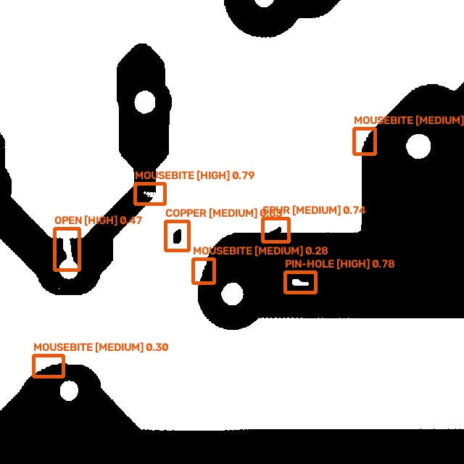
Figure 6.8.2.1. Test Board Defect Detection Visualization (00041200.jpg, 8 defects)

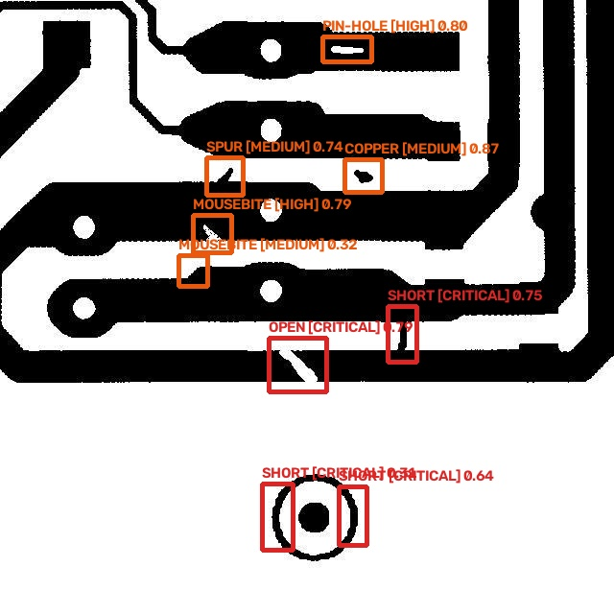
Figure 6.8.2.2. Test Board Defect Detection Visualization (00041204.jpg, 9 defects, Quality: 25.1 REJECT)

REFERENCES
[1] Q. Ling and N. A. M. Isa, "Printed circuit board defect detection methods based on image processing, machine learning and deep learning: A survey," IEEE Access, vol. 11, pp. 15921–15944, Dec. 2023.
[2] J. Redmon, S. Divvala, R. Girshick, and A. Farhadi, "You only look once: Unified, real-time object detection," in Proc. IEEE Conf. Comput. Vis. Pattern Recognit. (CVPR), 2016, pp. 779–788.
[3] X. Ye, L. Huang, J. Wang, X. Hu, J. Xu, and C. Zhang, "A lightweight PCB defect detection algorithm based on an improved YOLOv11s," IEEE Access, vol. 14, pp. 56412–56426, 2026, doi: 10.1109/ACCESS.2026.3678967.
[4] S. Tang, F. He, X. Huang, and J. Yang, "Online PCB defect detector on a new PCB defect dataset," arXiv:1902.06197, Feb. 2019.
[5] R. R. Selvaraju, M. Cogswell, A. Das, R. Vedantam, D. Parikh, and D. Batra, "Grad-CAM: Visual explanations from deep networks via gradient-based localization," in Proc. IEEE Int. Conf. Comput. Vis. (ICCV), 2017, pp. 618–626.
[6] A. Chattopadhay, A. Sarkar, P. Howlader, and V. N. Balasubramanian, "Grad-CAM++: Generalized gradient-based visual explanations for deep convolutional networks," in Proc. IEEE Winter Conf. Appl. Comput. Vis. (WACV), 2018, pp. 839–847.
[7] F. Tao, H. Zhang, A. Liu, and A. Y. C. Nee, "Digital twin in industry: State-of-the-art," IEEE Trans. Ind. Informat., vol. 15, no. 4, pp. 2405–2415, Apr. 2019.
[8] P. Bhattacharya and M. F. Cloutier, "Explainable artificial intelligence for industrial applications," in Proc. IEEE Int. Conf. Ind. Technol. (ICIT), 2022, pp. 1–8.
[9] M. Shakya et al., "FICS-PCB: A multi-modal image dataset for automated printed circuit board visual inspection," IACR Cryptol. ePrint Arch., vol. 2020, p. 1422, 2020.
[10] IPC-A-610G, Acceptability of Electronic Assemblies, IPC — Association Connecting Electronics Industries, Bannockburn, IL, USA, 2020.
[11] G. Jocher and J. Qiu, "Ultralytics YOLOv11: State-of-the-art real-time computer vision," Ultralytics Inc., 2024. [Online]. Available: https://github.com/ultralytics/ultralytics
[12] J. Chen, K. Cao, and Y. Guo, "Deep learning for surface defect detection on industrial products: A comprehensive review," IEEE Trans. Instrum. Meas., vol. 70, pp. 1–18, 2021.
[13] J. Chen, S. Kao, H. He, W. Zhuo, S. Wen, C. Lee, and S. Yu, "Run, don't walk: Chasing higher FLOPS for faster neural networks," in Proc. IEEE/CVF Conf. Comput. Vis. Pattern Recognit. (CVPR), 2023, pp. 12021–12031.
[14] D. Ouyang, S. He, G. Zhang, M. Luo, H. Guo, J. Zhan, and Z. Huang, "Efficient multi-scale attention module with cross-spatial learning," in Proc. IEEE Int. Conf. Acoust., Speech Signal Process. (ICASSP), 2023, pp. 1–5.
[15] Z. Tong, Y. Chen, J. Xu, and R. Yu, "Wise-IoU: Bounding box regression loss with dynamic focusing mechanism," arXiv preprint arXiv:2301.10051, 2023.
MAPPING TO SDG GOALS
The project 'SMARTPCB-XAI: AN EXPLAINABLE AI-BASED PCB INSPECTION AND DECISION SUPPORT SYSTEM' aligns directly with the United Nations Sustainable Development Goals (SDGs), specifically:
1. SDG 9: Industry, Innovation, and Infrastructure: By integrating cutting-edge YOLOv11 deep learning, explainable AI, and interactive digital twins into electronics manufacturing, the system accelerates industrial automation, enhances first-pass assembly yields, and promotes technological innovation across small and medium electronics enterprises.
2. SDG 12: Responsible Consumption and Production: Early, accurate localization of microscopic PCB defects combined with actionable IPC-A-610 repair procedures significantly reduces scrap rates and hazardous electronic waste (e-waste). By enabling precision rework rather than discarding defective circuit boards, the system fosters resource efficiency and sustainable electronics production.

