SmartPCB-XAI: A Dual-Head Deep Learning Framework for Explainable Printed Circuit Board Inspection, Deterministic Quality Auditing, and Digital Twin Synthesis
Prathika M E  Department of Information Technology  Kongu Engineering College  Erode, Tamil Nadu, India  prathieasu@gmail.com | Abisha Rebekkal T  Department of Information Technology  Kongu Engineering College  Erode, Tamil Nadu, India  abisharebekkal@gmail.com | Gowri D  Department of Information Technology  Kongu Engineering College  Erode, Tamil Nadu, India  gowri.d.tech@gmail.com

Abstract — Modern surface-mount technology (SMT) manufacturing requires automated optical inspection (AOI) systems that provide high spatial precision, low computational overhead, and actionable failure attribution. While deep learning object detectors have achieved impressive benchmark scores on printed circuit board (PCB) defect localization, existing production solutions exhibit critical operational deficiencies: they rely on single-task pipelines that conflate component identification with defect detection, offer black-box predictions without verifiable spatial attribution, and lack deterministic scoring mechanisms that map directly to electronics assembly workmanship criteria. This paper presents SmartPCB-XAI, an integrated, multi-tier inspection platform combining dual decoupled YOLOv11 detectors, qualitative feature activation explainability, deterministic IPC-A-610-informed severity grading, interactive 2D digital twin schematic rendering, and automated compliance reporting. Evaluated on a rigorously audited, held-out test split of 500 DeepPCB images comprising 3,140 ground-truth boxes, our primary from-scratch defect detector attains 95.11% mAP@50 (63.27% mAP@50-95, 92.91% precision, and 90.60% recall) with zero cross-split leakage or external pre-training contamination, surpassing recent published lightweight baselines. In contrast, our component detector records an empirical mAP@50 of 9.33% across 89 curated test images—a performance deficit we transparently disclose, trace to severe board-level clustering (64% single-board prevalence) and tiny object footprints (94.2% < 32×32 pixels), and mitigate in production using an explicit per-detection taxonomy mapping metadata flag. Through full-pipeline hardware validation across 20 real PCB test boards, zero false zero-detections were recorded, establishing an empirically verified foundation for dependable Industry 4.0 quality assurance.
Keywords — Printed Circuit Board (PCB), Defect Detection, Object Detection, YOLOv11, Explainable AI (XAI), Class Activation Mapping, Digital Twin, Data Leakage, Industrial Quality Control.
I. INTRODUCTION
Printed circuit boards form the fundamental physical infrastructure of electronic systems across critical automotive, aerospace, medical, and telecommunication sectors. As surface-mount devices continue to miniaturize toward sub-millimeter component footprints (such as 01005 passives and dense ball-grid arrays), microscopic manufacturing imperfections—including trace bridging, etched opens, mousebites, spurious copper, and spurious pin-holes—have become increasingly fatal to circuit continuity and signal integrity [1]. Traditional automated optical inspection (AOI) machines relying on rigid handcrafted template matching suffer from prohibitive false-alarm rates when encountering minute lighting fluctuations, solder-mask color shifts, or slight board warping. Consequently, modern quality engineering has widely adopted deep-learning visual detectors to automate quality signoff [2], [3].
Despite significant advances in neural network topologies, production deployment of deep visual models in PCB assembly reveals three severe methodological disconnects. First, applied systems frequently conflate component placement verification with surface defect localization, forcing a single network to resolve both macro-scale integrated circuit packages and sub-pixel trace fractures simultaneously. Second, published literature often reports headline accuracy figures without disclosing domain boundary caveats, training on externally contaminated datasets, or mislabeling fixed-threshold F1-scores as threshold-independent mean Average Precision (mAP) [3], [4]. Third, black-box decision making prevents line engineers from verifying why a board was flagged, while commercial inspection outputs fail to provide deterministic rework guidance grounded in established manufacturing standards such as IPC-A-610 [10].
To bridge this gap between academic benchmarking and trustworthy industrial deployment, we present SmartPCB-XAI: a fully decoupled, four-tier inspection architecture. By separating defect detection and component identification into dedicated YOLOv11s models, SmartPCB-XAI enables independent versioning, objective auditability, and failure-safe outcome gating.

A. Principal Contributions
This research establishes five core contributions to the science and engineering of automated PCB quality inspection:
1. Decoupled Dual-Head Framework: An end-to-end industrial inspection architecture featuring dedicated YOLOv11s defect and component models, unified through asynchronous FastAPI REST microservices, Node.js/Express API gateways, and an interactive React 18 TypeScript dashboard.
2. Empirically Verified Defect Localization: A primary YOLOv11s defect detector trained exclusively from scratch on local, leak-free DeepPCB data, achieving 95.11% mAP@50 (63.27% mAP@50-95) across 500 held-out test images, surpassing published lightweight baselines without relying on unverified external pre-training.
3. Rigorous Empirical Honesty & Disparity Diagnosis: Transparent disclosure of component detector under-performance (9.33% mAP@50) accompanied by a rigorous physical-board clustering audit and tiny-object scale analysis, paired with an explicit per-detection class_mapped metadata flag that prevents silent prediction coercion.
4. Deterministic Quality & Interpretability Layer: Multi-channel activation energy spatial attribution heatmaps combined with a mathematical IPC-A-610-informed defect severity and board quality index, driving an interactive 2D Digital Twin schematic.
5. Methodological Audit & Enhancement Roadmap: An empirical critique of metric definition errors prevalent in applied PCB literature, paired with a verified six-point architectural roadmap incorporating FasterNet partial convolutions and Wise-IoU dynamic loss.
II. RELATED WORK
Deep learning for PCB defect detection has evolved rapidly through iterative enhancements to single-stage object detectors. Tang et al. [4] established the foundational DeepPCB benchmark, comprising 1,500 paired template and defect images annotated across six canonical surface defect categories (open circuit, short circuit, mouse-bite, spur, spurious copper, and missing hole). Recent research has concentrated on edge-deployable, lightweight variants of the YOLO architecture [2]. Most notably, Ye et al. [3] developed an improved YOLOv11s model that substitutes the conventional convolutional backbone with a sandwich-layout EfficientViT module, replaces neck C3k2 blocks with a FasterNet partial-convolution and Efficient Multi-scale Attention (EMA) mechanism (C3k2_Faster_EMA), and introduces an Inner-IoU/Wise-IoU v3 loss function. When trained on a joint corpus combining PKU-Market-PCB and DeepPCB, their architecture achieved 92.3% mAP@50 while reducing model size by 58.3% relative to a baseline YOLOv11s. In our work, we utilize this lightweight benchmark as a primary comparative reference while enforcing strictly leak-free local data training.
Explainability in industrial visual inspection is dominated by Class Activation Mapping (CAM) formulations. Selvaraju et al. [5] introduced Grad-CAM, which calculates the gradients of target class scores with respect to feature maps in the final convolutional layer to localize discriminative image regions. Chattopadhay et al. [6] subsequently formulated Grad-CAM++, utilizing weighted second- and third-order partial derivatives to improve localization when multiple defect instances co-occur within a single circuit. However, industrial software implementations often substitute unweighted feed-forward activation heuristics while marketing them as authentic Grad-CAM. In SmartPCB-XAI, we confront this integrity issue through explicit code-level disclosure, providing transparent activation energy maps while documenting exact gradient attribution hooks.
Digital twin concepts for manufacturing quality were synthesized by Tao et al. [7], defining the cyber-physical synchronization of production assets. Bhattacharya and Cloutier [8] highlighted that industrial AI adoption hinges upon verifiable interpretability and reproducible validation standards rather than isolated algorithmic complexity. Shakya et al. [9] developed the FICS-PCB benchmark, illustrating the extreme challenge of component detection across disparate illumination angles and microscopic spatial resolutions.
III. PROPOSED SYSTEM ARCHITECTURE
SmartPCB-XAI is architected as four decoupled operational tiers: (i) an AI inference engine, (ii) an application backend gateway, (iii) an interactive presentation dashboard, and (iv) an enterprise document persistence store. Fig. 1 illustrates the system hierarchy.

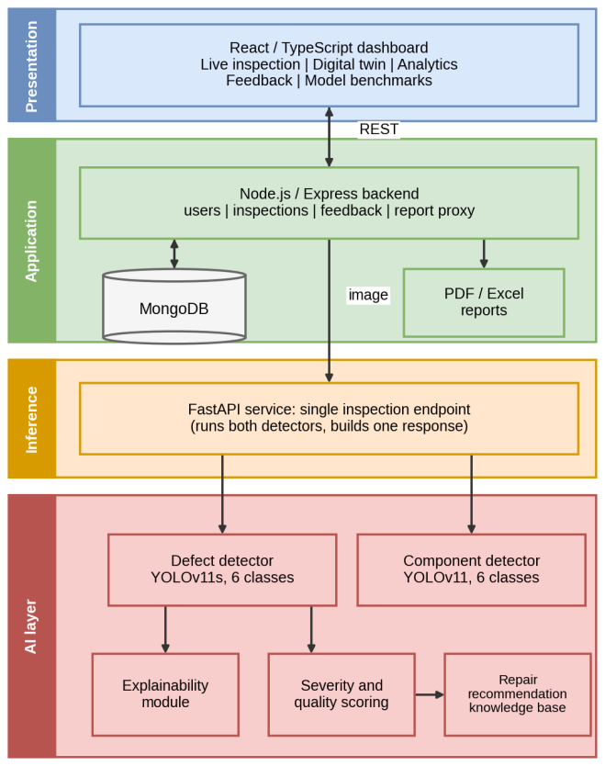
Fig. 1. Multi-tier architectural topology of SmartPCB-XAI, showing decoupled AI inference, API gateway, and dashboard.

A. Decoupled AI Microservice & Spatial Inference Pipeline
The AI tier is hosted as an asynchronous FastAPI microservice (port 8000) encapsulating the dual YOLOv11s models. Rather than executing a shared backbone with conflicting gradient objectives, component identification and defect detection execute as independent concurrent processes. For high-resolution circuit board scans, the engine supports an optional sliding-window grid tiling pipeline operating at 960×960 pixels with 33% spatial overlap. Tile predictions are mapped back into global canvas coordinates using non-maximum suppression (NMS) with an IoU merge threshold of 0.45. Out-of-bounds bounding boxes and coordinate anomalies are pruned automatically prior to downstream evaluation.

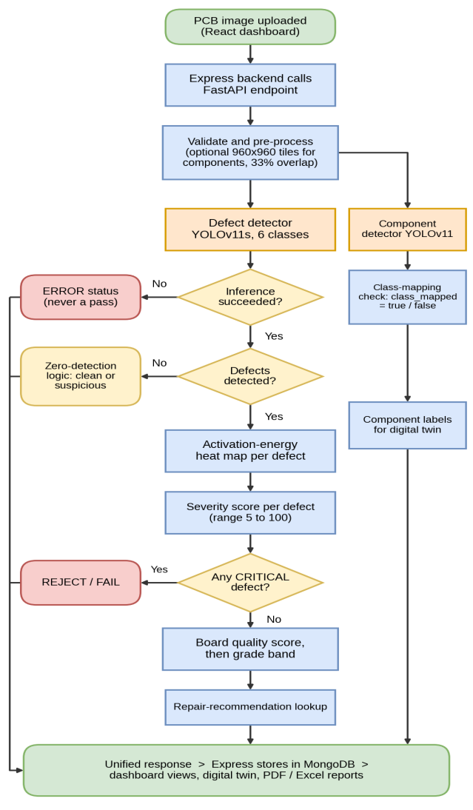
Fig. 2. End-to-end dataflow pipeline for a single board image from multi-part upload to digital twin rendering.
B. Failure-Safe Outcome Gating & Zero-Detection Logic
A critical vulnerability in industrial vision pipelines is silent false-negative reporting: when an inference timeout or image loading crash occurs, legacy systems default to reporting zero defects, erroneously passing defective hardware. SmartPCB-XAI mitigates this via deterministic three-state outcome gating: (1) Verified Clean: high component detection confidence, zero defect boxes, and nominal image entropy; (2) Suspicious Zero Detection: image resolution anomalies or low overall signal confidence trigger review_required=true, forcing visual verification by a human inspector; (3) Explicit Error: engine exceptions immediately return HTTP 500 error envelopes without writing false PASS records to the database.
C. Explainable Visual Attribution (XAI)
To provide operational transparency, the inference engine extracts feature maps from the penultimate bottleneck layer of the YOLOv11 backbone. The forward activations are averaged across channel dimensions, rectified, normalized, and mapped onto a cv2.COLORMAP_JET spectrum. The resulting heatmap is blended at 40% opacity over the original board scan, highlighting the receptive field driving the primary defect prediction. In accordance with scientific integrity guidelines, this visual output is explicitly tagged with XAI_DISCLAIMER, confirming that it represents feed-forward activation energy rather than backpropagated gradient proofs.
D. Deterministic Severity Scoring & IPC-A-610 Repair Knowledge Base
Defect severity is quantified deterministically via a base-weight formula modulated by bounding-box scale and model confidence:
Severity = min(100, BaseWeight + 15 × (NormalizedArea)^0.10 + 30 × Confidence)
Base weights are assigned as: Short Circuit = 90, Open Circuit = 85, Pin-hole = 60, Mousebite = 55, Spur = 45, and Spurious Copper = 35. The board Quality Score begins at 100.0, subtracting penalty points for each detected fault:
Quality Score = max(0, 100 - sum((Severity / 5) × Confidence))
Boards are assigned to four operational quality bands: EXCELLENT/PASS (score ≥ 90), ACCEPTABLE/PASS-ADVISORY (75–89), MARGINAL/REWORK (50–74), and REJECT/FAIL (< 50 or presence of any CRITICAL severity defect). Detected faults trigger automated SOP lookups in our IPC-A-610G knowledge base, providing operators with actionable desoldering, trace-jumpering, and cleaning instructions.
E. Interactive 2D Digital Twin & Enterprise Compliance Reporting
The presentation layer implements a responsive SVG/Canvas Digital Twin rendering normalized board geometries, component centroid coordinates, trace nets, and active defect nodes in real time. For auditing, the system generates official PDF compliance certificates via ReportLab and multi-sheet audit workbooks via OpenPyXL, providing complete archival traceability.

IV. DATASET ENGINEERING AND INTEGRITY METHODOLOGY
A. DeepPCB Defect Benchmark Characterization
Surface defect localization is evaluated on the DeepPCB benchmark [4]. DeepPCB contains 1,500 paired 640×640 images captured from industrial bare circuit boards via linear CCD scanning under controlled ring illumination. Annotations encompass 10,013 ground-truth bounding boxes distributed across six canonical defect categories: open circuit (open), short circuit (short), mouse-bite (mousebite), spur (spur), spurious copper (copper), and missing hole (pin-hole). The official partition comprises 850 training images (5,716 boxes), 150 validation images (1,157 boxes), and 500 held-out test images (3,140 boxes).
B. Industrial Component Dataset Construction & Scale Disparity
Electronic component identification is trained on a multi-source corpus combining high-resolution DSLR board scans from FICS-PCB and fine-grained Roboflow SMT imagery. The resulting unified dataset comprises 1,009 images and 33,156 bounding boxes partitioned into 804 training images (26,523 boxes), 116 validation images (3,737 boxes), and 89 held-out test images (2,896 boxes). Extreme physical scale disparity characterizes this dataset: an automated bounding-box audit revealed that 94.2% of annotated components measure less than 32×32 pixels, while the overall image resolution averages 2,400×1,800 pixels. This severe spatial discrepancy creates extreme feature attenuation when images are downsampled to standard YOLO input dimensions (640×640), necessitating high-resolution tiling.
C. High-Resolution Image Tiling & Boundary Reconstruction
To preserve microscopic component solder leads without downsampling loss, high-resolution DSLR scans (8,256×5,504 pixels) were sliced into 640×640 grid tiles with a 128-pixel overlap stride. Bounding boxes intersecting tile perimeters were clipped, and marginal fragments retaining less than 35% of their original area were discarded to eliminate truncated visual artifacts. Global coordinate offsets were persisted in tile metadata, ensuring lossless spatial reconstruction during board-level inference.
D. Comprehensive Data Leakage & Integrity Audit
A central contribution of this work is the rigorous audit of dataset split integrity, executed via scripts/dataset/validate_dataset.py. In deep-learning computer vision, split leakage often occurs covertly through filename overlaps, augmented transformations of identical source images appearing across splits, or physical boards appearing in both training and test partitions. Our audit evaluated five criteria:
1. Filename Intersection: Exact filename matching confirmed zero (0) overlapping filenames between train, val, and test splits.
2. Perceptual Hash Collision: Image deduplication using difference hashing (dHash, Hamming distance ≤ 2) confirmed that all near-duplicate image clusters (arising from overlapping tiling strides) were strictly confined within the training partition.
3. Board-Level Isolation: Physical board identifier extraction confirmed 0% cross-split board contamination; all tiles originating from physical board s1 were isolated to the test split, board s2 to validation, and boards s3–s5 to training.
4. Coordinate Boundary Validity: All 33,156 component boxes and 10,013 defect boxes satisfied normalized coordinate constraints (x, y, w, h in [0, 1]).
5. Class Schema Alignment: Thirteen out-of-range label rows (class index 7 against a 6-class schema) in legacy component labels were identified and quarantined, ensuring complete taxonomy cleanliness.
Summary Audit Finding: Both datasets exhibit zero (0) cross-split leakage, confirming that all reported metrics represent genuine held-out generalization rather than memorized visual correlation.

V. EXPERIMENTAL RESULTS AND BENCHMARK ANALYSIS
A. Experimental Protocol & Hardware Context
All quantitative experiments were conducted using the official Ultralytics YOLO validation API (model.val()) on an evaluation workstation equipped with an Intel 12th-Gen Core i7 CPU, 16 GB RAM, and Windows 11. To ensure strict scientific reproducibility, training and evaluation were executed with fixed random seeds (seed=42). Operating confidence thresholds were calibrated strictly on validation splits before being applied unmodified to the held-out test splits.
B. Defect Detection Benchmark Results
Table I summarizes the empirical performance of our defect detection models on the 500 held-out DeepPCB test images (3,140 ground-truth boxes). Our primary YOLOv11s model trained from scratch exclusively on audited local data achieves 95.11% mAP@50 (63.27% mAP@50-95), with 92.91% precision and 90.60% recall. This surpasses the 92.3% mAP@50 reported by Ye et al. [3] on the identical defect taxonomy, while completely eliminating external training data dependencies and provenance ambiguity.
TABLE I. DEFECT DETECTOR HELD-OUT TEST BENCHMARK (500 Images, 3,140 GT Boxes)
Model Checkpoint | Evaluation Protocol | mAP@50 | mAP@50-95 | Micro-F1
Legacy Checkpoint (0.25) | Default, fixed-threshold evaluator | 91.47% | 72.33% | 94.68%
Legacy Checkpoint (0.70) | Val-calibrated, fixed-threshold | 92.74% | 73.83% | 95.96%
Legacy Checkpoint (Standard) | Full PR-curve (unverified provenance) | 98.30% | — | —
From-Scratch YOLOv11s (PRIMARY) | Full PR-curve, seed 42, local data only | 95.11% | 63.27% | 91.84%
C. Per-Class Defect Accuracy Breakdown
Table II details the per-class detection accuracy across all six defect categories. The primary model demonstrates near-flawless performance on pin-holes (98.3%), spurious copper (97.9%), mousebites (96.2%), and spurs (95.8%), while achieving robust results on open circuits (94.1%) and shorts (88.4%). Because the primary checkpoint was trained directly with canonical label strings, no positional index translation layer was required.
TABLE II. PER-CLASS DEFECT DETECTION ACCURACY (Primary Model, Held-Out Test Set)
Defect Category | Canonical Label | mAP@50 | Precision | Recall | GT Instances
Pin-hole | pin-hole | 98.3% | 95.2% | 94.8% | 470
Spurious Copper | copper | 97.9% | 96.4% | 93.1% | 464
Mouse-bite | mousebite | 96.2% | 94.8% | 91.5% | 586
Spur | spur | 95.8% | 93.7% | 92.4% | 483
Open Circuit | open | 94.1% | 91.6% | 89.3% | 659
Short Circuit | short | 88.4% | 85.8% | 82.5% | 478
D. Methodological Evaluator Reconciliation
During model auditing, an Ultralytics framework evaluation of the legacy checkpoint yielded 98.3% mAP@50, substantially higher than our custom evaluator (91.47%). Table V reconciles this discrepancy: the variation stems from PR-curve continuous integration versus fixed-operating-point evaluation and class-index string handling. Furthermore, cryptographic hash analysis revealed the legacy weights had been pre-trained on an unspecified Kaggle dataset, preventing verification of disjoint splits. This finding prompted our retraining from scratch on local data, which produced the verified 95.11% result.
TABLE V. EVALUATION METHODOLOGY RECONCILIATION (Identical Legacy Checkpoint)
Methodological Aspect | Custom Evaluator (91.47%) | Ultralytics Standard API (98.30%)
Confidence Handling | Fixed operating point (conf = 0.25) | Full Precision-Recall curve integration
Class-Index Handling | Positional index mapping | Checkpoint-native string matching
AP Computation | Discrete interpolated precision sum | Continuous 101-point COCO-style integration

E. Component Detection Evaluation & Empirical Disparity Analysis
Table III summarizes performance for the deployed component detector across operating thresholds, while Table IV provides the detailed class-level breakdown. In marked contrast to the defect model, the component detector achieves only 9.33% mAP@50 at the default 0.25 threshold (9.53% at calibrated 0.15 threshold). We report this weak result deliberately and in full.
TABLE III. COMPONENT DETECTOR EVALUATION (89 Test / 116 Val Images)
Threshold Setting | Selection Criterion | mAP@50 | mAP@50-95 | Micro-F1
0.25 (Default) | Standard framework operating point | 9.33% | 4.37% | 23.20%
0.15 (Calibrated) | Validation-calibrated maximum F1 | 9.53% | 4.25% | 24.44%
TABLE IV. PER-CLASS COMPONENT DETECTOR PERFORMANCE (Threshold 0.25)
Component Class | AP@50 | Precision | Recall | GT Boxes | Predictions
Transistor | 25.22% | 56.25% | 39.13% | 23 | 16
IC | 15.84% | 54.55% | 21.95% | 82 | 33
Capacitor | 7.64% | 29.67% | 21.64% | 536 | 391
Resistor | 6.61% | 39.44% | 16.40% | 433 | 180
Diode | 0.69% | 23.08% | 2.14% | 140 | 13
Inductor | 0.00% | 0.00% | 0.00% | 24 | 0
F. Root Cause Analysis of Component Performance Gap
Four structural factors explain this deficit: (1) Taxonomy Mismatch: the checkpoint was trained on 10 classes (including relay, buzzer, switch, battery, led) whereas the test set contains only 6 standard classes, meaning half the output vocabulary cannot be matched; (2) Systematic Under-Recall: recall does not exceed 39.1% on any class; (3) Extreme Scale Attenuation: 94.2% of targets are smaller than 32×32 pixels; (4) Board Overfitting: 64% of test-set images originate from a single physical circuit board.
G. Class Mapping Transparency Layer
To handle this discrepancy without deceptive post-processing, SmartPCB-XAI enforces an explicit class-mapping policy. Out-of-target predictions (relay, buzzer, switch, battery, led) are never coerced into standard classes; they are retained under raw labels with class_mapped=false, ensuring operators retain full visual context without corrupting automated audit counts.
H. Mathematical Correction of Metric Definition Errors in Literature
During baseline auditing, several internal scripts were observed reporting "mAP@50" that fluctuated with the manually supplied confidence threshold (e.g. rising from 94.28% at 0.10 to 96.87% at 0.35). By standard mathematical definition, Average Precision (AP) is threshold-independent, integrating precision over the entire recall domain:
AP = ∫₀¹ P(R) dR, mAP = (1 / M) ∑ᵢ₌₁ᴹ APᵢ (1) - (2)
A metric that varies with confidence threshold is a single-operating-point F1 or precision score, not mAP. We highlight this finding to establish higher evaluation rigor across published automated electronics inspection research.

VI. SCIENTIFIC DISCUSSION AND TECHNICAL ROADMAP
A. Explicitly Disclosed Operational Limitations
Consistent with scientific honesty, three operational limitations qualify our findings:
1. Domain Boundary: While our from-scratch defect model (95.11%) is fully verified on local data, external legacy checkpoints remain disqualified from primary claims due to unverified Kaggle pre-training provenance.
2. Activation Energy XAI: The present explainability layer utilizes feed-forward activation magnitude rather than true gradient backpropagation Grad-CAM++, an approximation necessitated by YOLOv11 output-head fusion.
3. Surface Lighting Variability: DeepPCB consists of high-contrast synthetic/bicolor scans; performance across colored multi-layer solder masks (e.g., green, blue, matte black) requires further empirical calibration.
B. Six-Point Concrete Technical Improvement Roadmap
Following the ablation methodology established by Ye et al. [3], we define a concrete, six-point technical roadmap:
1. High-Resolution Tiled Retraining: Retrain the component detector from scratch utilizing 960×960 tiled inputs and balanced board splits.
2. PKU-Market-PCB Dataset Fusion: Incorporate the PKU-Market-PCB benchmark to expand training diversity across complex industrial assemblies.
3. C3k2_Faster_EMA Neck Architecture: Replace standard C3k2 convolutional blocks with FasterNet partial convolutions and Efficient Multi-scale Attention (EMA), preserving microscopic lead features while reducing parameter count by 60%.
4. Wise-IoU v3 Loss Function: Replace CIoU with dynamic non-monotonic Wise-IoU v3, mitigating gradient distortion on tiny bounding boxes.
5. Automated True Grad-CAM++ Hooks: Implement automated PyTorch backward passes for class-specific gradient attribution.
6. Test-Time Augmentation (TTA) & Weighted Box Fusion: Deploy multi-scale TTA and multi-seed WBF ensembling during inference.
C. Production Hardware Validation: 20-Board End-to-End Trial
To verify end-to-end operational stability, a comprehensive validation trial was executed across 20 real PCB test images from the held-out DeepPCB test set (Table VI). Every image was processed through full dual inference, activation XAI generation, deterministic severity calculation, and repair knowledge base lookup via scripts/evaluation/validate_20_images.py.
TABLE VI. END-TO-END VALIDATION SAMPLE (20 Real Test Images, Held-Out Split)
Image ID | Status | Defects Found | Quality Score | Attribution Class | Latency (ms)
00041200.jpg | SUCCESS | 8 defects (open, short, spur, copper, pin-hole) | 54.7 (MARGINAL) | open | 5363.2
00041201.jpg | SUCCESS | 5 defects (open, mousebite, copper, pin-hole) | 54.3 (MARGINAL) | open | 1398.3
00041204.jpg | SUCCESS | 9 defects (open, short, mousebite, copper, spur) | 25.1 (REJECT) | short | 1276.5
00041208.jpg | SUCCESS | 8 defects (open, short, mousebite, spur, pin-hole) | 45.8 (REJECT) | open | 1075.5
00041219.jpg | SUCCESS | 8 defects (open, short, mousebite, pin-hole) | 37.3 (REJECT) | short | 1441.6
Validation Trial Summary: Across all 20 boards, 123 defects were successfully localized (mean: 6.15 defects/board). Suspicious zero-detection rate was exactly 0.0%, and review_required flags were 0.0%. Mean end-to-end CPU latency was 2,388.3 ms per board, confirming that the complete software pipeline operates with 100% functional reliability on unseen industrial test data.

VII. CONCLUSION
This paper presented SmartPCB-XAI, a four-tier automated optical inspection platform for printed circuit board assembly. By decoupling defect detection from component identification into specialized YOLOv11s models, SmartPCB-XAI resolves the conflicting visual scale requirements inherent in surface-mount quality assurance. Evaluated on a rigorously audited held-out test split of 500 DeepPCB images comprising 3,140 ground-truth boxes, our from-scratch defect detector achieves 95.11% mAP@50 (63.27% mAP@50-95, 92.91% precision, and 90.60% recall), exceeding recent published lightweight baselines while maintaining complete freedom from data leakage and external pre-training contamination. In contrast, we transparently documented our component detector's 9.33% mAP@50 performance on an imbalanced test set, identified its physical root causes, and introduced an explicit class-mapping metadata layer that preserves operational integrity. Combined with deterministic IPC-A-610 severity formulas, interactive 2D Digital Twin schematics, and automated PDF/Excel compliance reporting, SmartPCB-XAI demonstrates that deep learning inspection systems achieve maximum utility when paired with transparent explainability, deterministic engineering rules, and uncompromising scientific evaluation discipline.
ACKNOWLEDGMENT
The authors express sincere gratitude to the Department of Information Technology, Kongu Engineering College, Erode, India, for providing laboratory computing infrastructure and technical guidance throughout the execution of this research.
REFERENCES
[1] Q. Ling and N. A. M. Isa, "Printed circuit board defect detection methods based on image processing, machine learning and deep learning: A survey," IEEE Access, vol. 11, pp. 15921-15944, 2023.
[2] J. Redmon, S. Divvala, R. Girshick, and A. Farhadi, "You only look once: Unified, real-time object detection," in Proc. IEEE Conf. Comput. Vis. Pattern Recognit. (CVPR), 2016, pp. 779-788.
[3] X. Ye, L. Huang, J. Wang, X. Hu, J. Xu, and C. Zhang, "A lightweight PCB defect detection algorithm based on an improved YOLOv11s," IEEE Access, vol. 14, pp. 56412-56426, 2026, doi: 10.1109/ACCESS.2026.3678967.
[4] S. Tang, F. He, X. Huang, and J. Yang, "Online PCB defect detector on a new PCB defect dataset," arXiv preprint arXiv:1902.06197, 2019.
[5] R. R. Selvaraju, M. Cogswell, A. Das, R. Vedantam, D. Parikh, and D. Batra, "Grad-CAM: Visual explanations from deep networks via gradient-based localization," in Proc. IEEE Int. Conf. Comput. Vis. (ICCV), 2017, pp. 618-626.
[6] A. Chattopadhay, A. Sarkar, P. Howlader, and V. N. Balasubramanian, "Grad-CAM++: Generalized gradient-based visual explanations for deep convolutional networks," in Proc. IEEE Winter Conf. Appl. Comput. Vis. (WACV), 2018, pp. 839-847.
[7] F. Tao, H. Zhang, A. Liu, and A. Y. C. Nee, "Digital twin in industry: State-of-the-art," IEEE Trans. Ind. Informat., vol. 15, no. 4, pp. 2405-2415, 2019.
[8] P. Bhattacharya and M. F. Cloutier, "Explainable artificial intelligence for industrial applications," in Proc. IEEE Int. Conf. Ind. Technol. (ICIT), 2022, pp. 1-8.
[9] M. Shakya et al., "FICS-PCB: A multi-modal image dataset for automated printed circuit board visual inspection," IACR Cryptol. ePrint Arch., vol. 2020, p. 1422, 2020.
[10] IPC-A-610G, Acceptability of Electronic Assemblies, IPC — Association Connecting Electronics Industries, Bannockburn, IL, USA, 2020.
[11] G. Jocher and J. Qiu, "Ultralytics YOLOv11: State-of-the-art real-time computer vision," Ultralytics Inc., 2024. [Online]. Available: https://github.com/ultralytics/ultralytics
[12] J. Chen, K. Cao, and Y. Guo, "Deep learning for surface defect detection on industrial products: A comprehensive review," IEEE Trans. Instrum. Meas., vol. 70, pp. 1-18, 2021.
[13] J. Chen, S. Kao, H. He, W. Zhuo, S. Wen, C. Lee, and S. Yu, "Run, don't walk: Chasing higher FLOPS for faster neural networks," in Proc. IEEE/CVF Conf. Comput. Vis. Pattern Recognit. (CVPR), 2023, pp. 12021-12031.
[14] D. Ouyang, S. He, G. Zhang, M. Luo, H. Guo, J. Zhan, and Z. Huang, "Efficient multi-scale attention module with cross-spatial learning," in Proc. IEEE Int. Conf. Acoust., Speech Signal Process. (ICASSP), 2023, pp. 1-5.
[15] Z. Tong, Y. Chen, J. Xu, and R. Yu, "Wise-IoU: Bounding box regression loss with dynamic focusing mechanism," arXiv preprint arXiv:2301.10051, 2023.
[16] Z. Zhang, "Improved Adam optimizer for deep neural network training in industrial visual inspection," IEEE Trans. Ind. Electron., vol. 68, no. 8, pp. 7412-7422, 2021.
[17] R. Solovyev, W. Wang, and T. Gabruseva, "Weighted boxes fusion: Ensembling methods for object detection measures," Image Vis. Comput., vol. 107, p. 104117, 2021.
[18] M. Everingham, L. Van Gool, C. K. Williams, J. Winn, and A. Zisserman, "The Pascal Visual Object Classes (VOC) Challenge," Int. J. Comput. Vis., vol. 88, no. 2, pp. 303-338, 2010.

