**Case_study_1**

**1. Import the dataset and do usual exploratory analysis steps like checking the structure & characteristics of the dataset:**

**1.Data type of all columns in the "customers" table**

select column_name, data_type

from `sinuous-anvil-396816.case_study_1.INFORMATION_SCHEMA.COLUMNS`

where table_name = 'customers'

order by ordinal_position

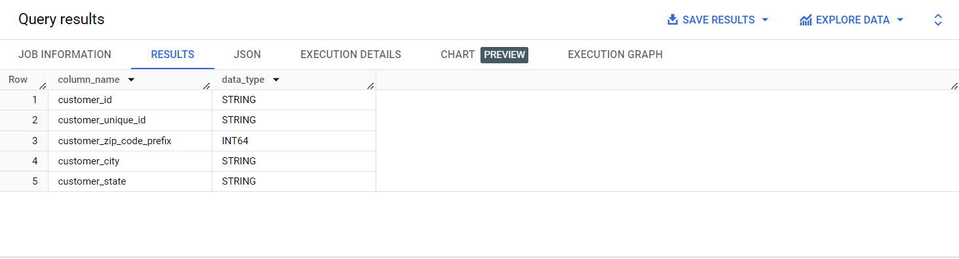**2.Get the time range between which the orders were place.**

select min(order_purchase_timestamp) as purchased_first_date,

max(order_purchase_timestamp) as purchased_last_date

from `case_study_1.orders`

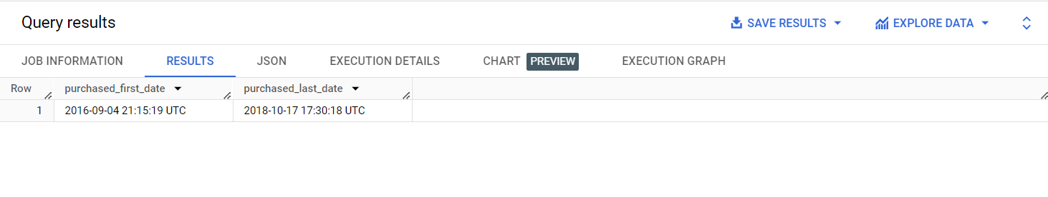

**Additional evaluation:-**

**Time diffrence between consecutive purchases happenedand to find maximum and minimum intervals.**

select order_id,order_purchase_timestamp,

(lag(order_purchase_timestamp)over(order by order_purchase_timestamp)-order_purchase_timestamp) as time_range

from `case_study_1.orders`

order by order_purchase_timestamp

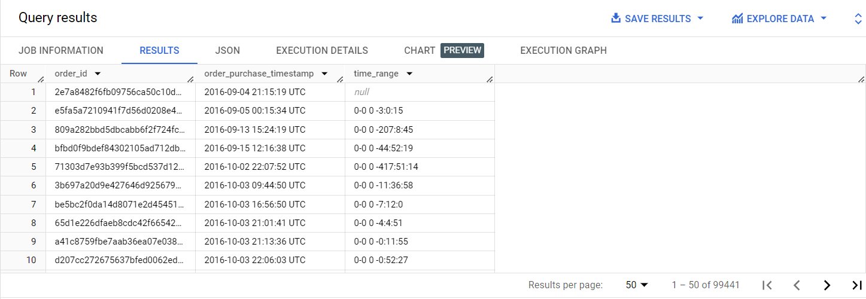

**Maximum and minimum time interval between purchases**

select max(time_range) as max_time_interval,min(time_range) as min__time_interval from (

select *, (lag(order_purchase_timestamp)over(order by order_purchase_timestamp)-order_purchase_timestamp) as time_range

from `case_study_1.orders`

order by order_purchase_timestamp

)

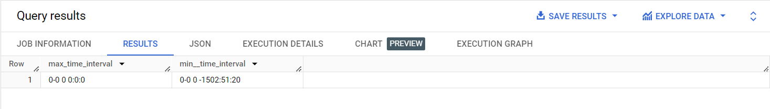  
**3.Count the Cities & States of customers who ordered during the given period.**

with cte_1b as(

select c.customer_id,

c.customer_zip_code_prefix,

o.order_purchase_timestamp,

g.geolocation_zip_code_prefix,

g.geolocation_city,g.geolocation_state

from `case_study_1.customers` c inner join `case_study_1.orders` o on c.customer_id=o.customer_id

inner join `case_study_1.geolocation` g on c.customer_zip_code_prefix=g.geolocation_zip_code_prefix

)

select count(distinct geolocation_city) as city_count,

count(distinct geolocation_state) as state_count

from cte_1b

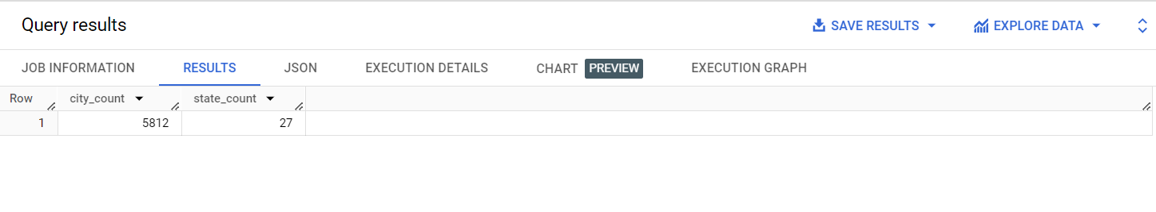

**2. In-depth Exploration:**

**1.Is there a growing trend in the no. of orders placed over the past year**

select count(*) as no_of_purchases,year

from (

select *, EXTRACT(year FROM order_purchase_timestamp) AS year

from `case_study_1.orders`)t

group by t.year

order by t.year

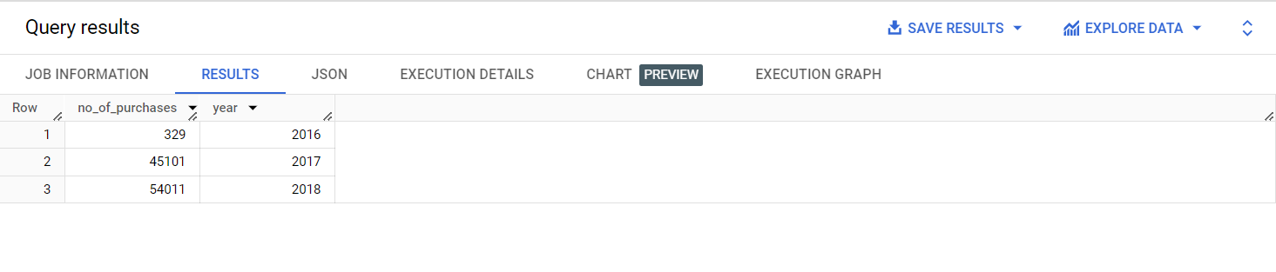

**2.Can we see some kind of monthly seasonality in terms of the no. of orders being placed?**

with cte_q2 as(

select *, EXTRACT(year FROM order_purchase_timestamp) AS year,

EXTRACT(month FROM order_purchase_timestamp) AS month

from `case_study_1.orders`

)

select year,month,count(*) as no_of_purchases,(count(*)-lag(count(*))over(order by year,month)) as change from cte_q2

group by year,month

order by year,month

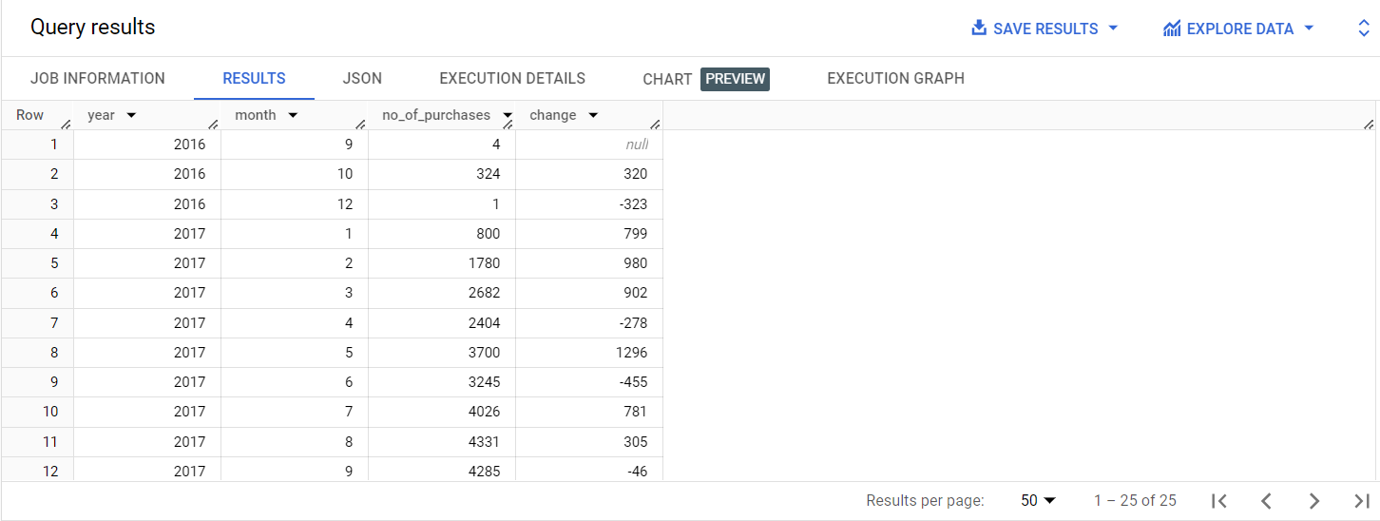

**3.During what time of the day, do the Brazilian customers mostly place their orders? (Dawn, Morning, Afternoon or Night)**

* **0-6 hrs : Dawn**
* **7-12 hrs : Mornings**
* **13-18 hrs : Afternoon**
* **19-23 hrs : Night**

with cte_q3 as(

select c.customer_id,o.order_purchase_timestamp,g.geolocation_state,

format_timestamp('%H',o.order_purchase_timestamp,"UTC") as time_range

from `case_study_1.customers` c inner join `case_study_1.orders` o on c.customer_id=o.customer_id

inner join `case_study_1.geolocation` g on c.customer_zip_code_prefix=g.geolocation_zip_code_prefix

where g.geolocation_state='BA'

)

select count(*) as num_of_purchases,

case

when time_range>='00' and time_range<='06' then 'Dawn'

when time_range>='07' and time_range<='12' then 'Mornings'

when time_range>='13' and time_range<='18' then 'Afternoon'

else 'Night'

end as time_of_day

from cte_q3

group by time_of_day

order by num_of_purchases desc

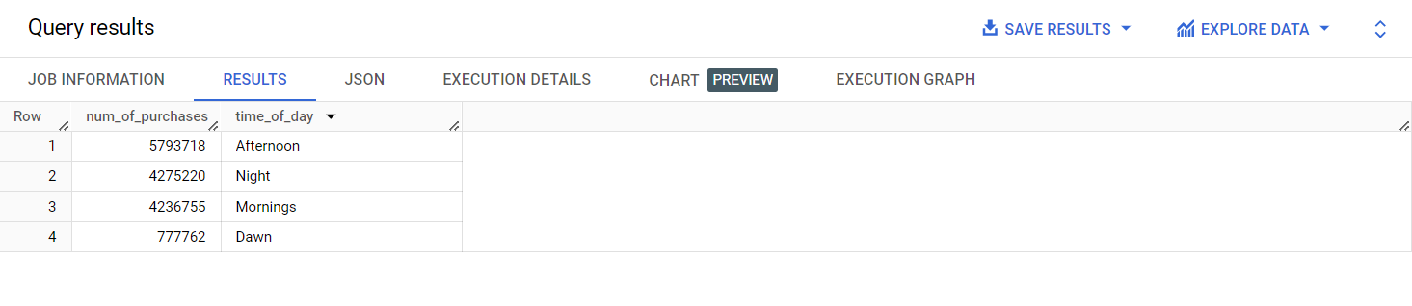**3. Evolution of E-commerce orders in the Brazil region:**

**1.Get the month on month no. of orders placed in each state.**

with cte_3a as (

select g.geolocation_state as STATE,

EXTRACT(month FROM order_purchase_timestamp) AS month,

o.order_purchase_timestamp

from `case_study_1.customers` c inner join `case_study_1.orders` o on c.customer_id=o.customer_id

inner join `case_study_1.geolocation` g on c.customer_zip_code_prefix=g.geolocation_zip_code_prefix)

select DISTINCT STATE,month,COUNT(*) AS NUM_OF_PURCHASES

from cte_3a

group by STATE,month

ORDER BY STATE,month

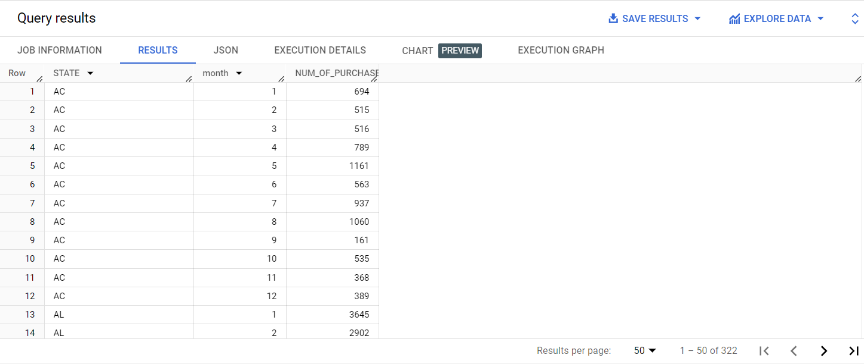

**Additional :-**

**To observe the pattern in the number of purchases with month for different states**

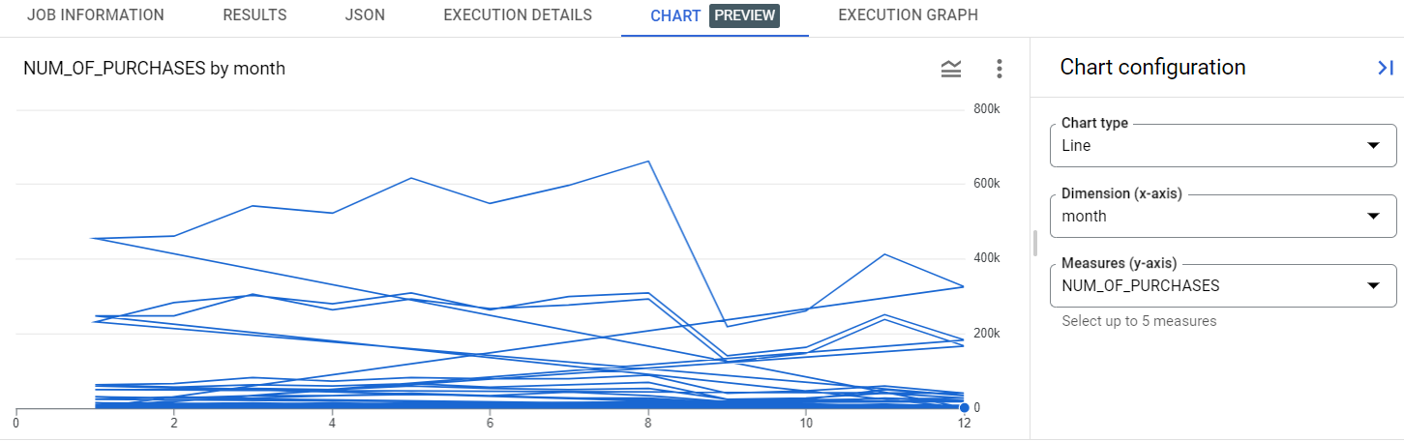

**2.How are the customers distributed across all the state**

select g.geolocation_state as STATE,

count(distinct c.customer_id) AS UNIQUE_CUSTOMERS

from `case_study_1.customers` c inner join `case_study_1.geolocation` g

on c.customer_zip_code_prefix=g.geolocation_zip_code_prefix

group by STATE

ORDER BY STATE

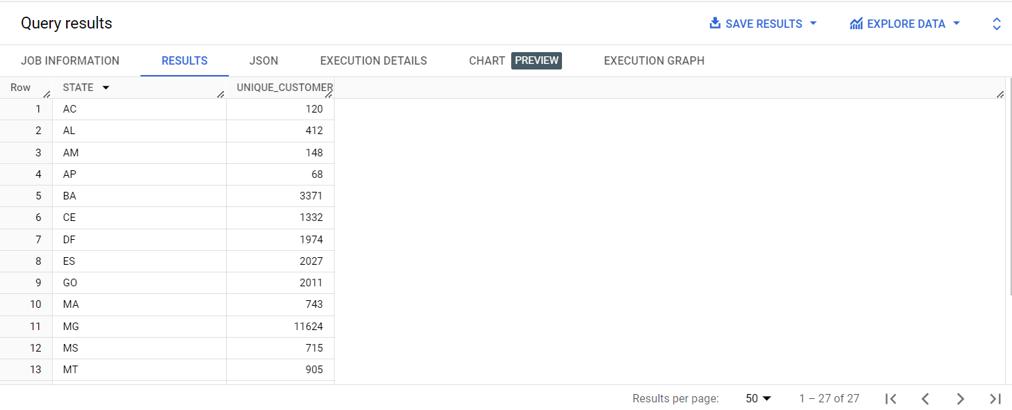**Additional:-**

**Arranging the above result to find states with highest number of unique customers.**

select g.geolocation_state as STATE,

count(distinct c.customer_id) AS UNIQUE_CUSTOMERS

from `case_study_1.customers` c inner join `case_study_1.geolocation` g

on c.customer_zip_code_prefix=g.geolocation_zip_code_prefix

group by STATE

ORDER BY UNIQUE_CUSTOMERS desc

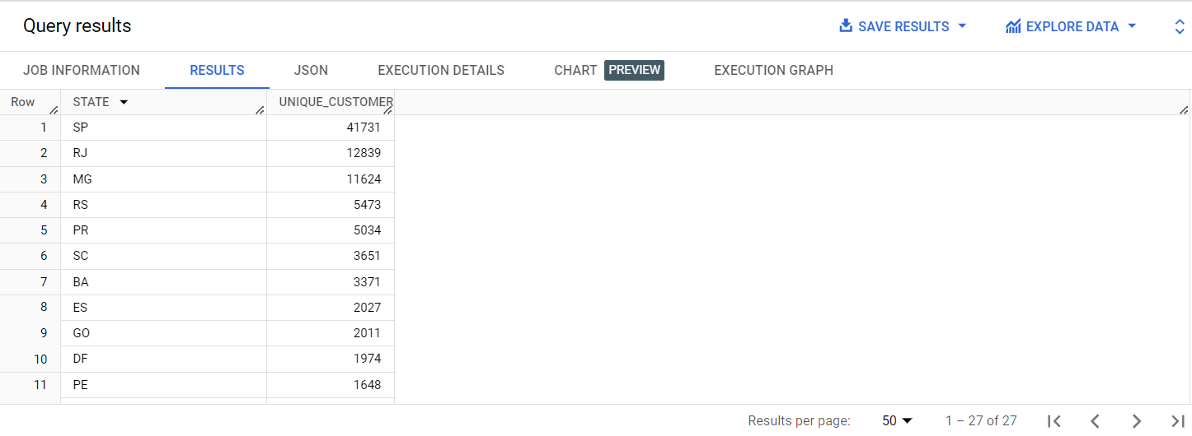

**4. Impact on Economy: Analyze the money movement by e-commerce by looking at order prices, freight and others.**

**1.Get the % increase in the cost of orders from year 2017 to 2018 (include months between Jan to Aug only).You can use the "payment_value" column in the payments table to get the cost of orders**

with cte_go as (

select sum(p.payment_value) as tot_val,

EXTRACT(year FROM o.order_purchase_timestamp) as year

from `case_study_1.payments` p inner join `case_study_1.orders` o using(order_id)

where EXTRACT(month FROM o.order_purchase_timestamp)>1 and EXTRACT(month FROM o.order_purchase_timestamp)<8

group by year

order by year)

select round(((tot_val-lag_tot_val)/lag_tot_val)*100,2) as per_increse_cost

from(

select tot_val,year,lag(tot_val) over(order by year) as lag_tot_val

from cte_go

order by year

)t

where year=2018

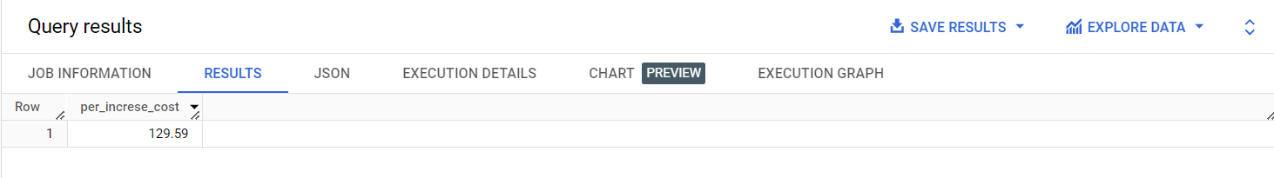

**2.Calculate the Total & Average value of order price for each state.**

select c.customer_state as State,

round(sum(i.price),2) as Total_order_value,

round(avg(i.price),2) as Average_order_value

from `case_study_1.order_items` i inner join `case_study_1.orders` using(order_id)

inner join `case_study_1.customers`c using(customer_id)

group by customer_state

order by customer_state

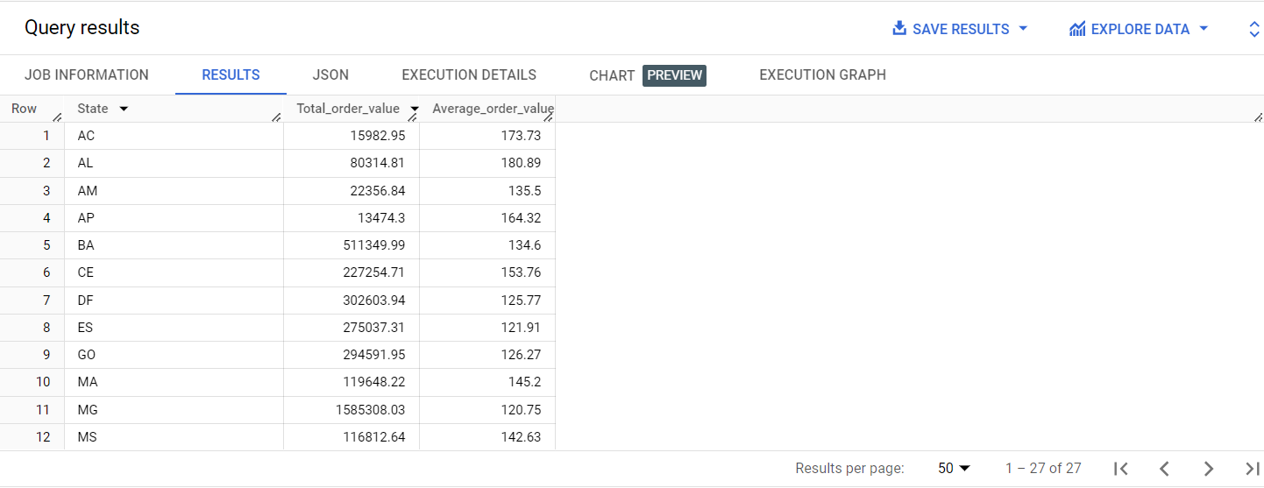

**Additional:-**

**Top 5 states with highest average order value**

select State from (select c.customer_state as State,

round(sum(i.price),2) as Total_order_value,

round(avg(i.price),2) as Average_order_value

from `case_study_1.order_items` i inner join `case_study_1.orders` using(order_id)

inner join `case_study_1.customers`c using(customer_id)

group by customer_state)t

order by Average_order_value desc

limit 5

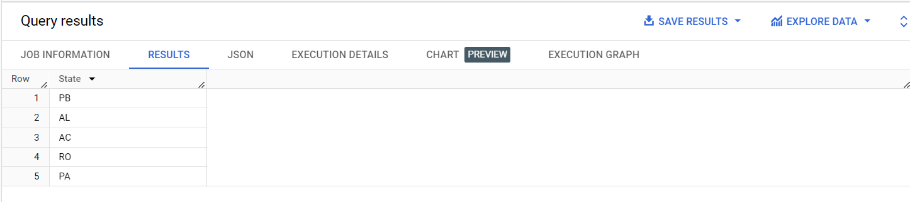

**Top 5 states with lowest average order value**

select State from (select c.customer_state as State,

round(sum(i.price),2) as Total_order_value,

round(avg(i.price),2) as Average_order_value

from `case_study_1.order_items` i inner join `case_study_1.orders` using(order_id)

inner join `case_study_1.customers`c using(customer_id)

group by customer_state)t

order by Average_order_value asc

limit 5

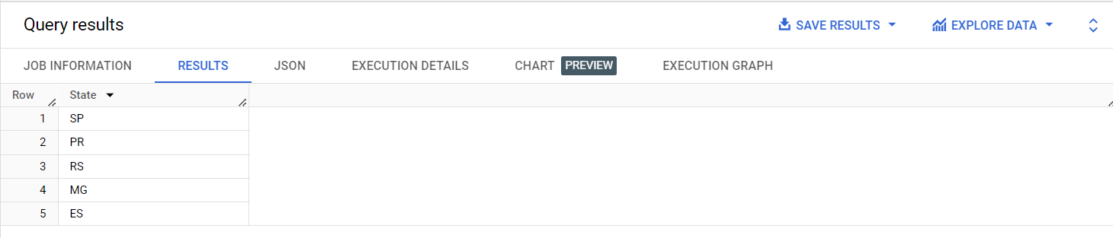

**3.Calculate the Total & Average value of order freight for each state.**

select c.customer_state as State,

round(sum(i.freight_value),2) as Total_freight_value,

round(avg(i.freight_value),2) as Average_freight_value

from `case_study_1.order_items` i inner join `case_study_1.orders` using(order_id)

inner join `case_study_1.customers`c using(customer_id)

group by customer_state

order by customer_state

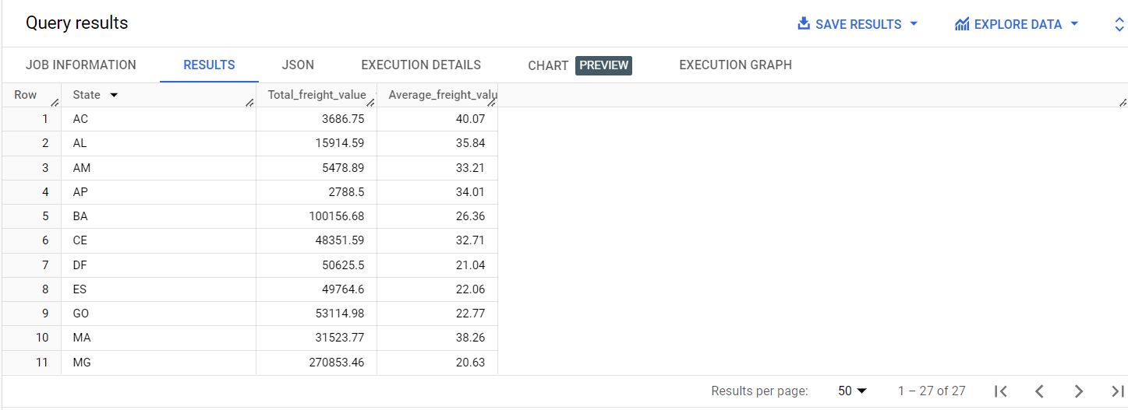

**5. Analysis based on sales, freight and delivery time.**

**1.Find the no. of days taken to deliver each order from the order’s purchase date as delivery time.**  
**Also, calculate the difference (in days) between the estimated & actual delivery date of an order.**  
**Do this in a single query.**  
  
You can calculate the delivery time and the difference between the estimated & actual delivery date using the given formula:

* time_to_deliver = order_delivered_customer_date - order_purchase_timestamp
* diff_estimated_delivery = order_estimated_delivery_date - order_delivered_customer_date

select order_id,

TIMESTAMP_DIFF(order_delivered_customer_date, order_purchase_timestamp, day) as time_to_deliver,

TIMESTAMP_DIFF(order_estimated_delivery_date, order_delivered_customer_date, day) as diff_estimated_delivery

from `case_study_1.orders`

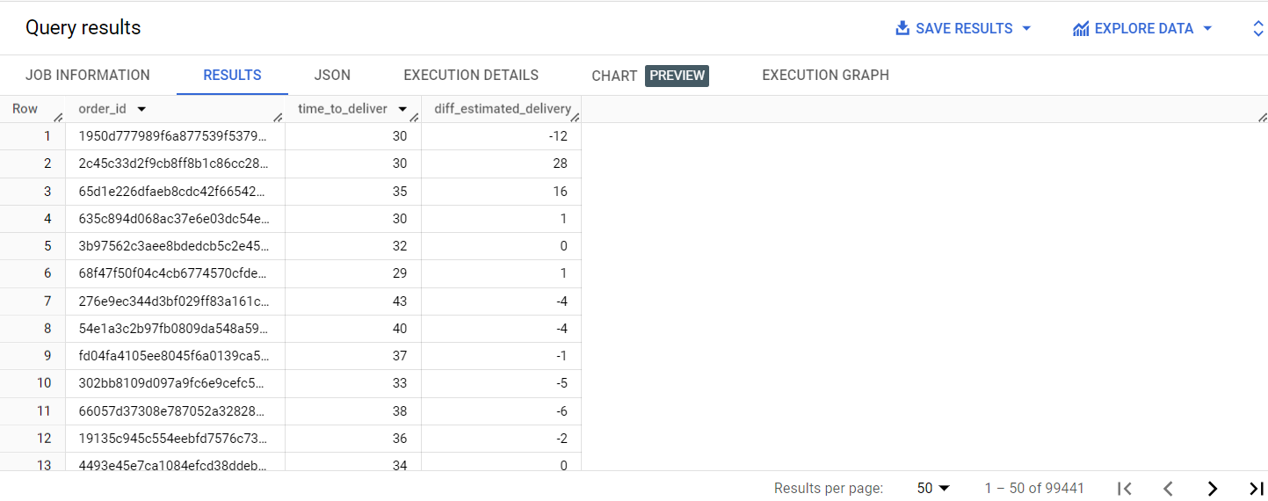

**2.Find out the top 5 states with the highest & lowest average freight value.**

**Heighest:-**

select State from (

select c.customer_state as State,

round(sum(i.freight_value),2) as Total_freight_value,

round(avg(i.freight_value),2) as Average_freight_value

from `case_study_1.order_items` i inner join `case_study_1.orders` using(order_id)

inner join `case_study_1.customers`c using(customer_id)

group by customer_state)t

order by Average_freight_value DESC

limit 5

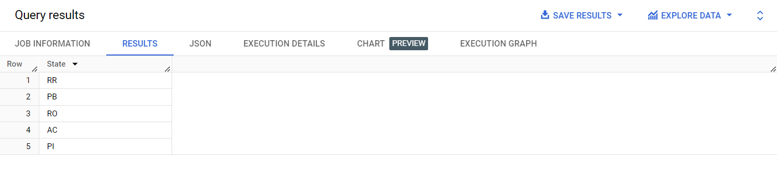

**Lowest:-**

select State from (

select c.customer_state as State,

round(sum(i.freight_value),2) as Total_freight_value,

round(avg(i.freight_value),2) as Average_freight_value

from `case_study_1.order_items` i inner join `case_study_1.orders` using(order_id)

inner join `case_study_1.customers`c using(customer_id)

group by customer_state )t

order by Average_freight_value asc

limit 5

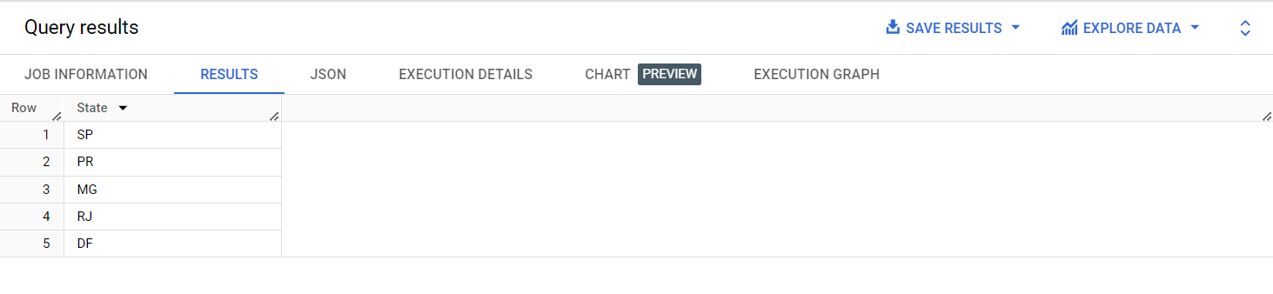  
**3.Find out the top 5 states with the highest & lowest average delivery time.**

**Heighest:-**

select State from(

select distinct c.customer_state as State,

round(avg(TIMESTAMP_DIFF(o.order_delivered_customer_date, o.order_purchase_timestamp, day)) over(partition by c.customer_state),2)

as avg_time_to_deliver

from `case_study_1.orders`o inner join `case_study_1.customers`c using(customer_id))t

order by avg_time_to_deliver desc

limit 5

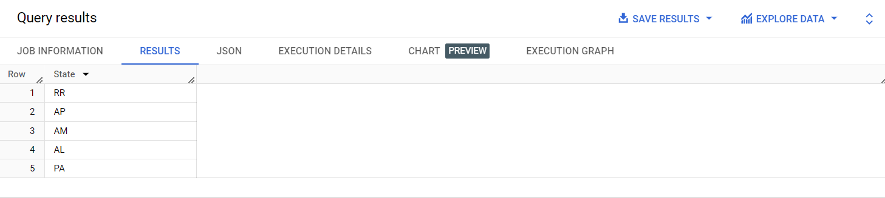

**Lowest:-**

select State from (

select distinct c.customer_state as State,

round(avg(TIMESTAMP_DIFF(o.order_delivered_customer_date, o.order_purchase_timestamp, day)) over(partition by c.customer_state),2)

as avg_time_to_deliver

from `case_study_1.orders`o inner join `case_study_1.customers`c using(customer_id))t

order by avg_time_to_deliver asc

limit 5

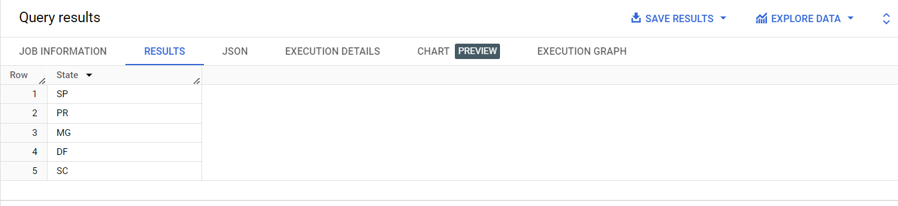

4.Find out the top 5 states where the order delivery is really fast as compared to the estimated date of delivery.  
You can use the difference between the averages of actual & estimated delivery date to figure out how fast the delivery was for each state.

with cte_5D AS(

select DISTINCT c.customer_state as State,

avg(TIMESTAMP_DIFF(o.order_delivered_customer_date, o.order_purchase_timestamp, day)) over(partition by c.customer_state)

as avg_time_to_deliver,

avg(TIMESTAMP_DIFF(o.order_estimated_delivery_date, o.order_delivered_customer_date, day)) over(partition by c.customer_state)

as avg_diff_estimated_delivery

from `case_study_1.orders`o inner join `case_study_1.customers`c using(customer_id)

)

SELECT State,

round((avg_time_to_deliver-avg_diff_estimated_delivery),2) as diff_actual_vs_expected

from cte_5D

ORDER BY diff_actual_vs_expected

limit 5  
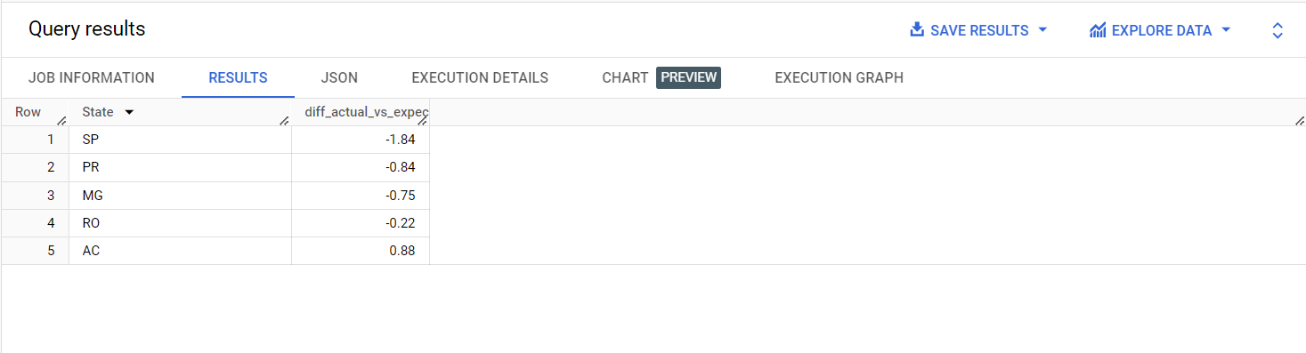

**6. Analysis based on the payments:**

**1.Find the month on month no. of orders placed using different payment types.**

with cte_6A as (

select p.payment_type,FORMAT_DATE('%B',o.order_purchase_timestamp) AS MONTH,

EXTRACT(month FROM o.order_purchase_timestamp) AS month_of_year,o.order_purchase_timestamp

from `case_study_1.orders` o inner join `case_study_1.payments` p on p.order_id=o.order_id

)

select payment_type,MONTH,NUM_OF_PURCHASES from

(select DISTINCT payment_type,MONTH,month_of_year,COUNT(*) AS NUM_OF_PURCHASES

from cte_6A AS NUM_OF_PURCHASES

group by payment_type,MONTH,month_of_year

ORDER BY payment_type,month_of_year)

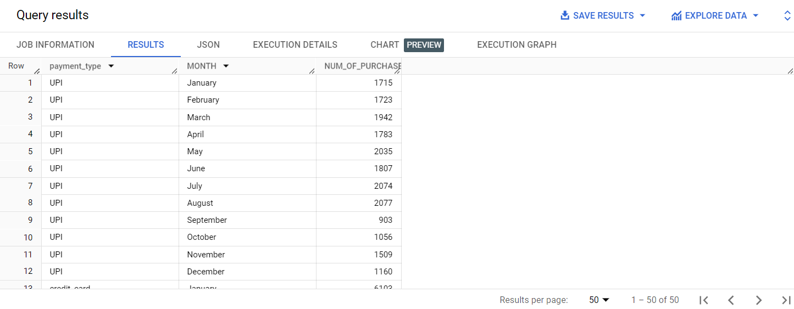  
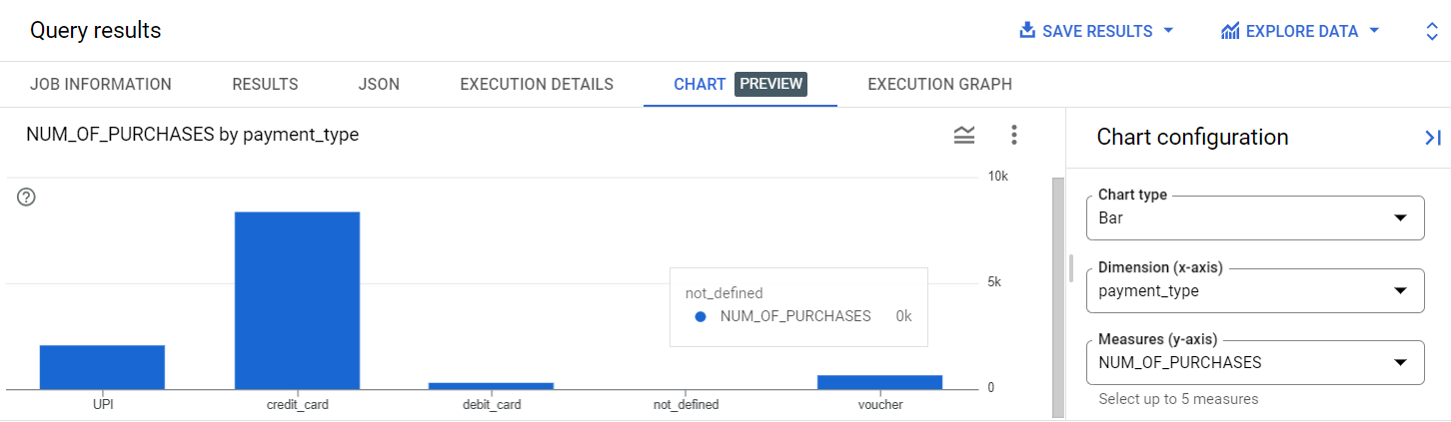

**2.Find the no. of orders placed on the basis of the payment installments that have been paid.**

with cte_6B as (

select p.payment_installments,o.order_purchase_timestamp

from `case_study_1.orders` o inner join `case_study_1.payments` p on p.order_id=o.order_id

)

select DISTINCT payment_installments,

COUNT(*) AS NUM_OF_PURCHASES from cte_6B

group by payment_installments

ORDER BY NUM_OF_PURCHASES desc

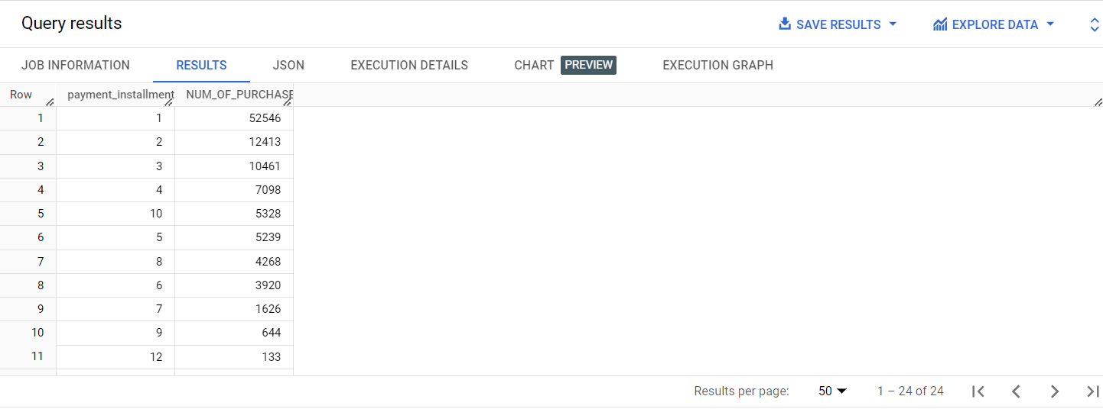

**7. Actionable Insights & Recommendations**

This is an analysis carried out on purchases made from 2016 september to 2018 october by customers distributed in 5812 cities of 27 states .

1. Over the years the purchases has increased from 2017 to 2018 (data of all months not available in year 2016).
2. Customers are more likely to make purchases on the afternoon time of the day and least active at Dawn.
3. Based on the month on month analysis of of all states.It is found that there exist a seasonal pattern in purchase for many states with nearly steady purchases on initial period of year and then rapidly decline in the month of september after that slowly increases.
4. In brazil the most customers are located in the states of SP,RJ,MG and least in RR and AP.
5. There is nearly 130% increase in cost price over the year 2017 to2018 considering only months between January and August.
6. State SP has the maximun total order value and least average order value.
7. State RR have heighest average freight value and SP has the least.
8. Most fastest delivery is happening in the sates of SP,PR,MG and delivery is longest in RR,AP,AM.
9. SP,PR,MG have fastest delivery when compared to estimated delivery time.
10. Credit card is most preffered payment then comes UPI and debit card is least opted.