***Earthquake Prediction Model Using Python***

**Abstract:**

The prediction of earthquakes remains a significant challenge, with potentially catastrophic consequences. This abstract introduces a design thinking approach for the development of an Earthquake Prediction Model using Python, emphasizing user-centricity, innovation, and problem-solving. The approach is structured into modular phases, each guided by design thinking principles.

***Data Source:***

- In this phase, the research team engages with stakeholders, including seismologists, disaster management authorities, and the general public, to gain deep insights into their concerns, information needs, and the impact of earthquakes on their lives.

***Feature Exploration:***

- A well-defined problem statement and clear project objectives are established. This phase includes identifying the target regions for earthquake prediction and the desired prediction timeframes.

***Visualization:***

- Creative brainstorming sessions are conducted to explore innovative ideas for building an Earthquake Prediction Model. This phase encourages considering various data sources, machine learning algorithms, and predictive features.

***Data Splitting:***

- A preliminary prototype of the Earthquake Prediction Model is developed using historical seismic data. This prototype serves as a proof of concept, allowing stakeholders to interact with and provide feedback on the system's functionality and usability.

- The prototype is tested with stakeholders, including seismologists, emergency response teams, and the public. User feedback is collected to identify model inaccuracies, usability issues, or other concerns. Iterative improvements are made based on this feedback.

***Model Development:***

- After refining the prototype, a full-scale Earthquake Prediction Model is developed using Python. The model incorporates a wide range of data sources, including seismic data, geological features, and meteorological information, and employs advanced machine learning techniques.

- The fully developed model is deployed into a real-time monitoring system that continuously assesses incoming seismic data. Alerts are generated and communicated to relevant authorities and the public when potential earthquake events are detected.

***Training and Evaluation:***

- Continuous monitoring of the model's performance is carried out, assessing prediction accuracy and user satisfaction. Regular updates and model retraining are scheduled to adapt to evolving seismic patterns and data characteristics.

- The design thinking process is iterative, and this module encourages the incorporation of user feedback and emerging technologies to continually evolve the Earthquake Prediction Model. New data sources, improved algorithms, and enhanced alerting mechanisms are explored.

This design thinking approach for developing an Earthquake Prediction Model using Python places user needs and real-world impact at the forefront. By integrating design thinking principles into each module, the development process becomes more empathetic and user-centric, ensuring that the prediction system addresses the specific concerns and requirements of stakeholders while continuously evolving to improve earthquake prediction capabilities.

import numpy as np

import pandas as pd

import matplotlib.pyplot as plt

import os

print(os.listdir("../input"))

output:

['database.csv']

Output:

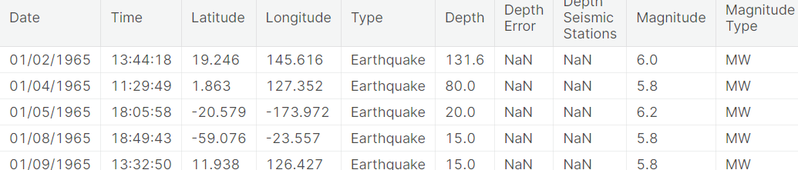

data.columns

output:

Index(['Date', 'Time', 'Latitude', 'Longitude', 'Type', 'Depth', 'Depth Error',

'Depth Seismic Stations', 'Magnitude', 'Magnitude Type',

'Magnitude Error', 'Magnitude Seismic Stations', 'Azimuthal Gap',

'Horizontal Distance', 'Horizontal Error', 'Root Mean Square', 'ID',

'Source', 'Location Source', 'Magnitude Source', 'Status'],

dtype='object')

data = data[['Date', 'Time', 'Latitude', 'Longitude', 'Depth', 'Magnitude']]

data.head()

output:

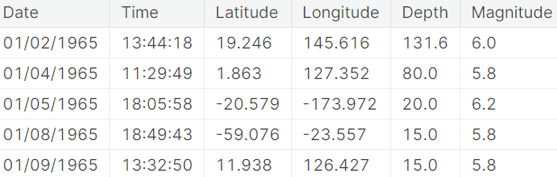

from mpl_toolkits.basemap import Basemap

m = Basemap(projection='mill',llcrnrlat=-80,urcrnrlat=80, llcrnrlon=-180,urcrnrlon=180,lat_ts=20,resolution='c')

longitudes = data["Longitude"].tolist()

latitudes = data["Latitude"].tolist()

*#m = Basemap(width=12000000,height=9000000,projection='lcc',*

*#resolution=None,lat_1=80.,lat_2=55,lat_0=80,lon_0=-107.)*

x,y = m(longitudes,latitudes)

from sklearn.ensemble import RandomForestRegressor

reg = RandomForestRegressor(random_state=42)

reg.fit(X_train, y_train)

reg.predict(X_test)

array([[ 5.96, 50.97],

[ 5.88, 37.8 ],

[ 5.97, 37.6 ],

[ 6.42, 19.9 ],

[ 5.73, 591.55],

[ 5.68, 33.61]])

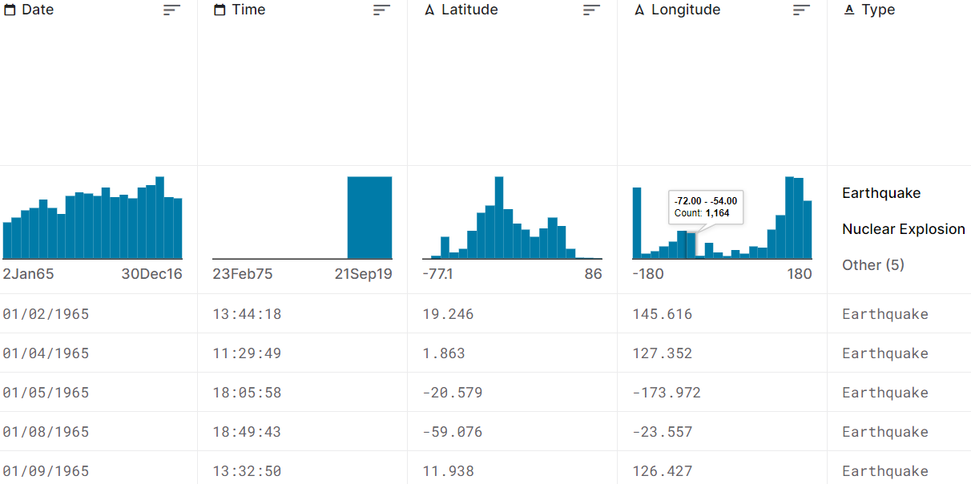

**Dataset Link:**[**https://www.kaggle.com/datasets/usgs/earthquake-database**](https://www.kaggle.com/datasets/usgs/earthquake-database)