# Project Report: Global ESG Governance Compliance & Risk Dashboard

## 1. Introduction

This project focuses on building a dynamic and interactive ESG (Environmental, Social, and Governance) dashboard leveraging global data from the World Bank. The purpose is to provide a consolidated view of ESG indicators across countries, enabling stakeholders to evaluate sustainability performance, compare trends over time, and identify high-risk regions needing policy intervention.

The dashboard serves as a valuable tool for analysts, researchers, and decision-makers by offering a comprehensive visual understanding of ESG metrics and risk levels globally.

## 2. Tools and Technologies

- Microsoft Excel – Used for initial data exploration, transformation, and formatting of raw datasets.  
- Power Query – Utilized to reshape wide-format year-based ESG data into a tidy long format for analysis.  
- Tableau Desktop – The primary tool for developing visualizations and building the interactive ESG dashboard.  
- CSV Format – The cleaned dataset was exported in `.csv` format to ensure compatibility and easy integration with Tableau.

These tools were selected for their accessibility, integration capability, and robust support for large-scale datasets.

## 3. Dataset Overview

The dataset originates from the World Bank’s ESG repository and encompasses a wide range of country-level ESG indicators from 1960 to 2020. Key attributes include:  
- Country Name  
- Country Code  
- Indicator Name  
- Indicator Code  
- Annual ESG Values (1960–2020)

Additional Columns Created During Preprocessing:  
- Year – Converted from column headers to a dedicated column (long format).  
- ESG Value – Numeric representation of ESG performance per year per indicator.  
- Category – Classified into “Environmental,” “Social,” or “Governance” based on keywords in indicator names.  
- Risk Level – Automatically assigned based on ESG Value thresholds:  
 - High Risk: ESG < 30  
 - Medium Risk: 30 ≤ ESG < 60  
 - Low Risk: ESG ≥ 60

## 4. Data Preparation & Cleaning Workflow

1. Opened the original dataset (`ESGData.csv`) in Microsoft Excel.  
2. Removed irrelevant or empty columns such as "2050" and "Unnamed".  
3. Applied Power Query to unpivot year columns into two attributes: `Year` and `ESG Value`.  
4. Derived the Category column by mapping indicator keywords to ESG pillars.  
5. Computed Risk Level based on ESG Value bands, enabling downstream visual categorization.  
6. Finalized and exported the cleaned data to `ESG_Cleaned.csv` for Tableau use.

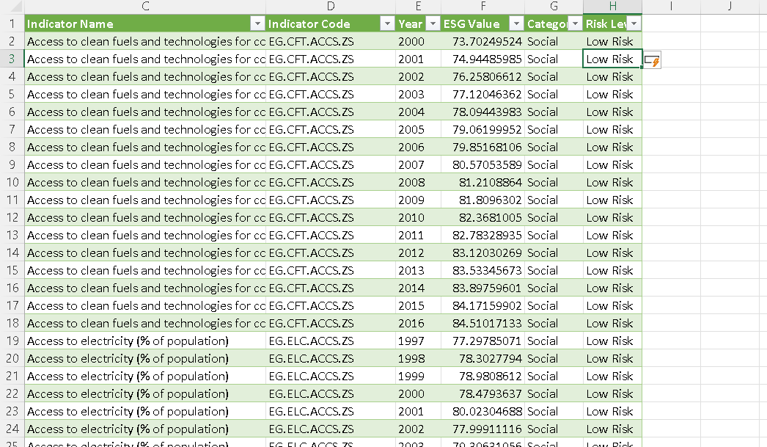

## 5. Tableau Dashboard Design

The dashboard was developed with a user-centric approach to allow flexibility in exploring and comparing ESG trends.

Core Components:  
- Choropleth Map – Displays country-level ESG performance, color-coded by value and filterable by category.  
- Bar Chart – Visual comparison of ESG values across selected countries.  
- Line Chart – Time-series view of ESG trends for one or multiple countries.  
- Pie Chart – Risk Level distribution across countries for a selected year or category.  
- Interactive Filters – Dropdown filters for Country, Category, Indicator Code, and Risk Level.  
- Tooltips – Provides contextual details on hover, including ESG Value, Risk Level, and description.

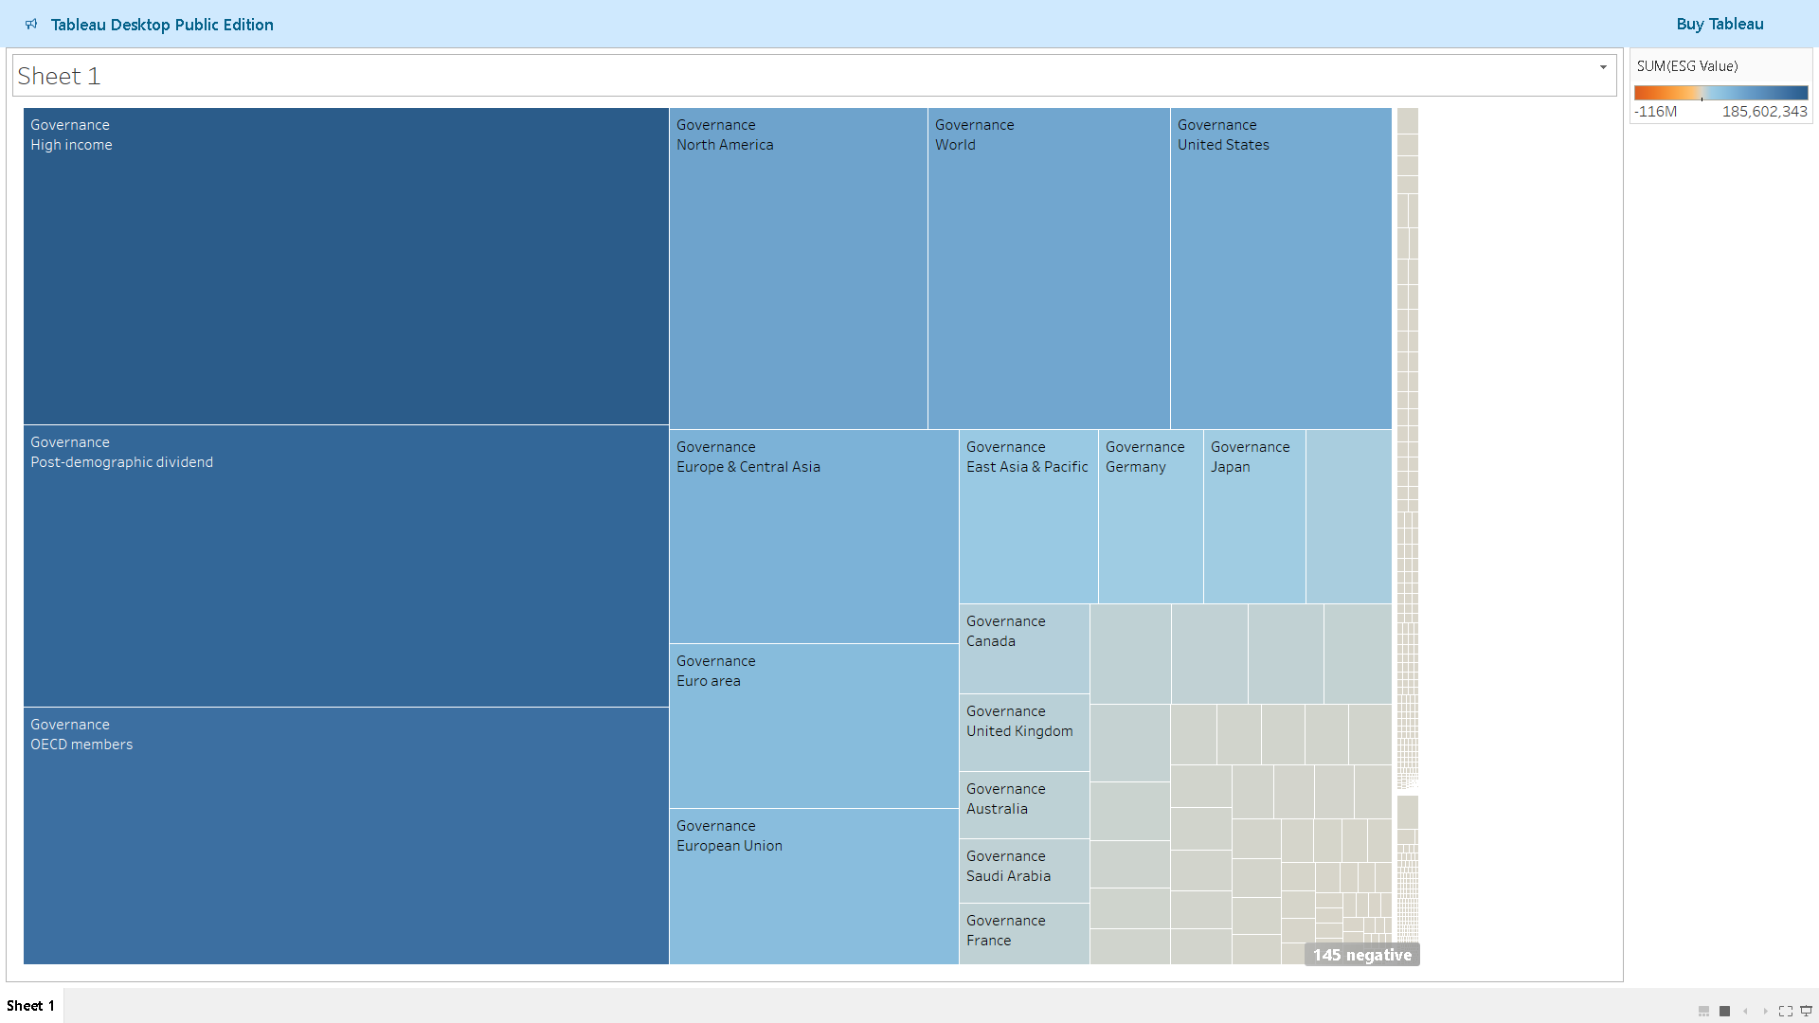

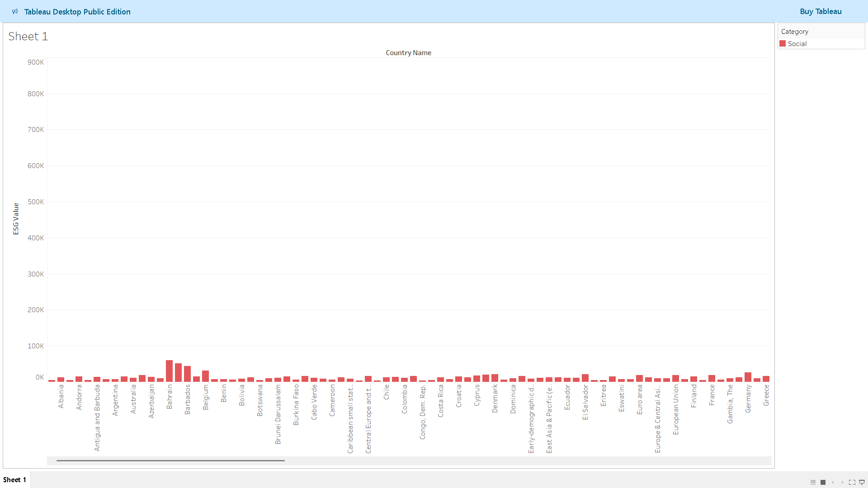

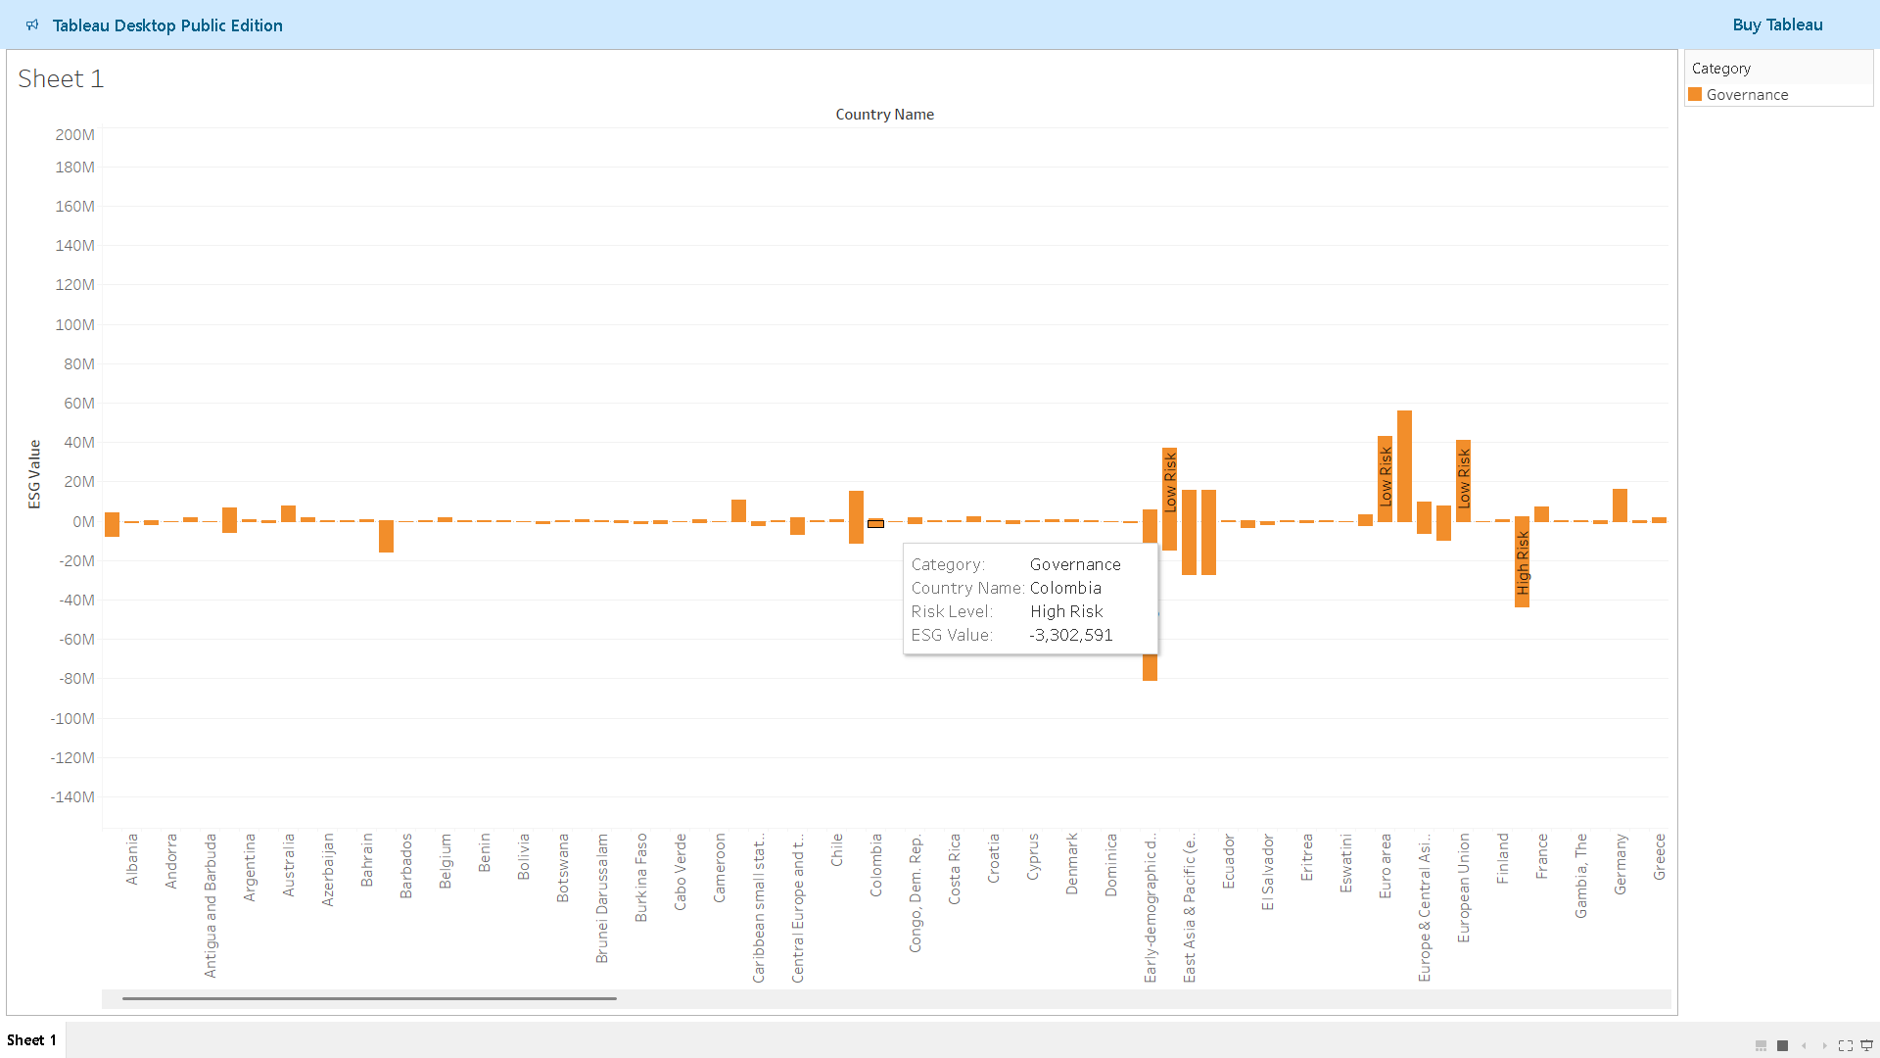

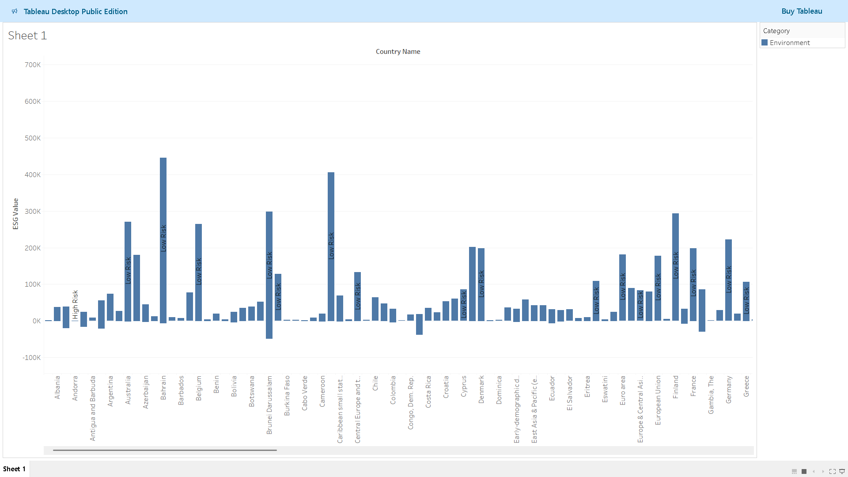

## 6. Key Insights & Observations

- Environmental Challenges – Countries with significant ecological pressures exhibit consistently lower ESG scores.  
- Stability in Governance – Governance-related indicators show greater temporal consistency.  
- Policy Impact – Notable improvements in ESG values over decades correlate with progressive policy changes.  
- High-Risk Hotspots – The risk classification framework helps spotlight regions requiring urgent sustainability interventions.

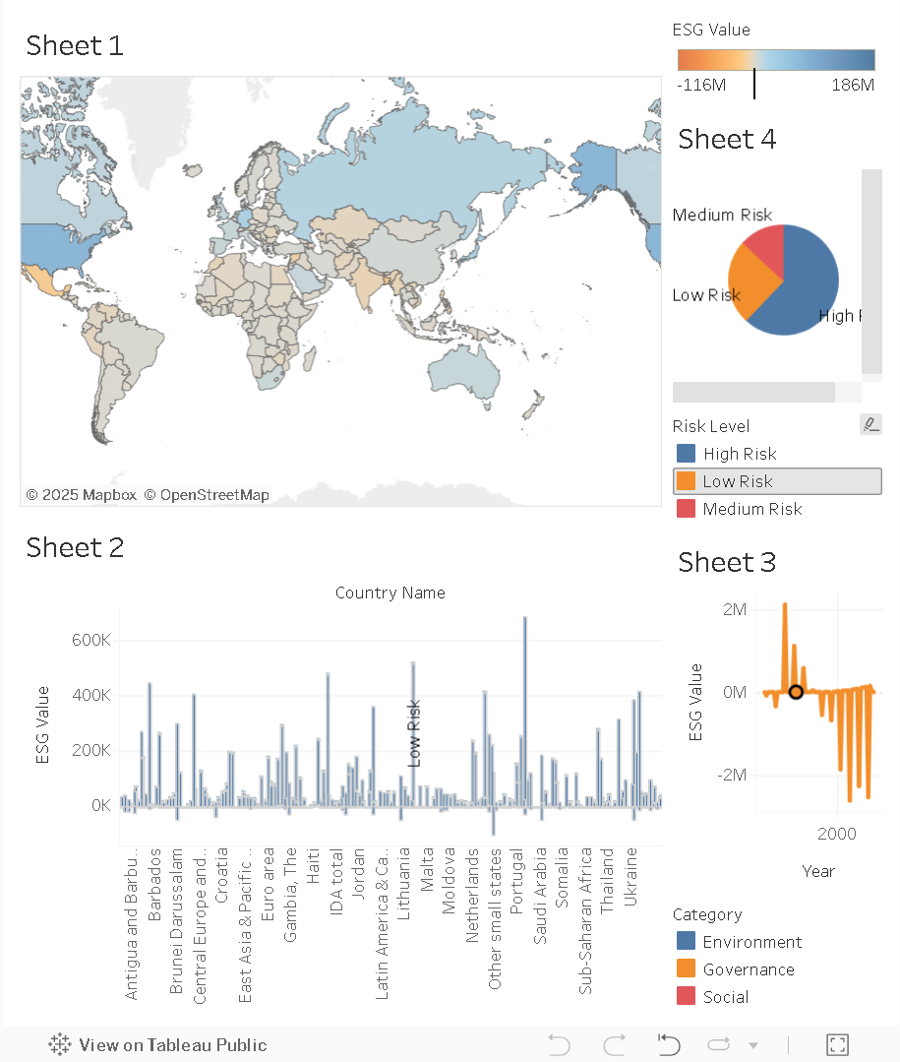

## 7. Conclusion & Future Scope

The ESG Dashboard consolidates decades of ESG data into a structured and interactive platform. It enhances transparency and aids in the strategic assessment of global ESG risks and sustainability efforts.

Future Enhancements:  
- Integration with real-time ESG feeds and SDG indicators.  
- Development of a web-based dashboard using Plotly Dash or Power BI for broader access.  
- Inclusion of machine learning models to forecast ESG risk trajectories.  
- Collaboration with stakeholders to refine the risk models and category mappings.

The modular design ensures scalability, making this dashboard a strong foundation for long-term ESG analytics.