**MALLIK ENGINEERING INDIA PRIVATE LIMITED**

**Mallik Engineering** (India) Pvt. Ltd., established in 1997 as a Small Scale Engineering Industry and registered under Directorate of Industries, Bangalre.

Mallik Engineering (India) Pvt Ltd is a part of Mallik Engineering Group Companies and the other Companies are **MALLIK MULTITECHNOLOGIES PRIVATE LIMITED, SULAX TECHNOLOGIES PRIVATE LIMITED, SUMUKHA ENGINEERING INDIA PVT. LTD. REHANI TRADERS**

**MEPL** An ISO 9001-2000 Certified Company,

**MEPL** Has set up two manufacturing units:

Unit 1 situated at Jigani Industrial Area, Anekal Taluq, Bangalore

Having 18,000 sq ft shop area in a company owned land of 35,000 sq ft

Unit 2 situated at Rajajinagar Industrial Estate

**Our Vision…**

**To be a trusted partner in OUR CUSTOMER’s Continual Progress…**

**Our Mission…**

* Provide Healthy & Safe working Environment.
* Work closely with Customers on all New Product development initiatives.
* Build Fair Business relationship with Suppliers.
* Focus on Continual Improvements & Business Growth.
* Constantly upgrade the Systems (QMS) and Manufacturing Technologies to meet customers On Time requirements

**Our Goal:**

To deliver the products of high quality to the entire satisfaction of the customer at competitive prices and within the stipulated time frame.

**Our Quality Policy…**

* Supply HIGH QUALITY Products
* Delivery at AGREED TIME
* Focus on CONTINUAL IMPROVEMENT
* Comply with STATUTORY & REGULATORY requirements

**Our EHS Policy…**

* We Commit ourselves to protect the Environment with effective utilization of natural resources by reducing wastages.
* Ensure best Safety practices in our organization to eliminate the injuries and ill health.
* Comply with all applicable Legal & Statutory requirements to improve the Environment Health & Safety performances.
* Review the systems periodically with continual improvements of the EHS performance in our organization and achieve satisfaction of interested parties.

**Our Key Customers…**

* **OTIS ELEVATORS (INDIA) PRIVATE LIMITED.**
* **INDIAN SPACE REASEARCH ORGANISATION (ISRO)**
* **FAIVELY TRANSPORT RAIL TECHNOLOGIES INDIA LIMITED**
* **BHARATH HEAVY ELECTRICALS LIMITED-EDN.**
* **FLOWSERVE CONTROLS (INDIA) LIMITED**
* **ABB LIMITED.**
* **KONE ELEVATORS LIMITED**
* **PEPPERL + FUCHS LIMITED**
* **KIRLOSKAR TOYODA TEXTILE MACHINERY LIMITED.**
* **MITSUBISHI ELEVATORS.**
* **VOLVO BUSES LIMITED**
* **CLIMAVENETA**
* **SCHNEIDER ELECTIC**
* **ORB SOLAR LIMITED.**

**Our Expertise:**

**We specialize in the following Engineering Works**

* Sheet Metal Pressed Components
* Light Sheet Metal Fabrication to high accuracies
* Precision Machined Components
* Assembly of General Mechanisims
* Sheet Metal Consoles for Electronic Equipment
* Customer Specific Sheet Metal Products
* Sheet Metal enclosures for various applications.

**Our Parts are used on…**

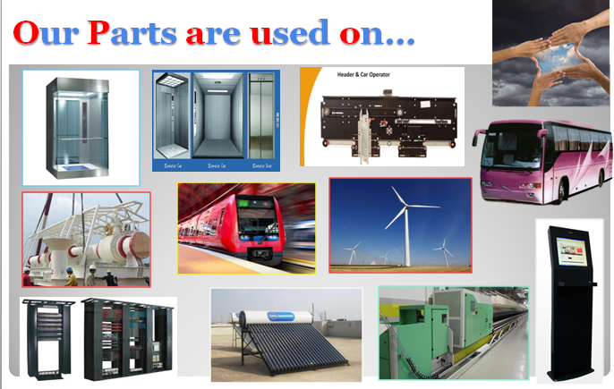

**Our Technical Capabilities:**

* Product design and execution of customer defined products in sheet metal and machined components
* Assembly and testing of various mechanisims as required by the customer
* Design, Manufacture and Assembly of consoles for Electronic packages
* Manufacture of intricate Sheet Metal Components requiring punching, piercing, stamping, bending, forming etc.,
* Design & Manufacture of Jigs, fixtures, forming dies required for production.

**Our Expertise in Manufacturing…**

* **ELEVATOR SUB ASSEMBLIES …**
  + HOISTWAY & CAR DOORS
  + DOOR OPERATING ASSEMBLY
  + CAR PANELS & CEILINGS
  + PLATFORMS ASSEMBLIES
  + STRUT , SILL , HITCH & MACHINE BED PLATES.
  + COUNTER WEIGHTS,BUFFERS & RAIL BRACKETORIES.
* **SS TRAIN DOORS ,FORCED VENTILATION & BRAKE ACCESSORIES.**
* **ELECTRICAL CABINATES,TRACTION PANELS & JUNCTION BOXES.**

**Our People Domain…**

* TOP MANAGEMENT : 05
* NEW PRODUCT DEVELOPMENT : 20
* QUALITY ASSURANCE : 30
* SUPPLY CHAIN : 20
* OPERATIONS (Management) : 25
* SUPPORT STAFF (Administration) : 20
* SEMI SKILLED MANPOWER : 75

SKILLED MANPOWER (Technical) : 125

**Our Assembly Facilities…**

**Separate Assembly line**

**Sophisticated Assembly Tools**

**Our Growth…**

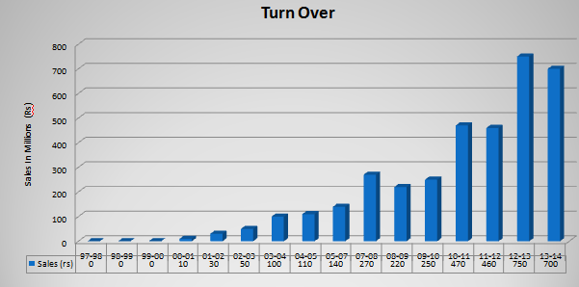

**Our Business Spread…**

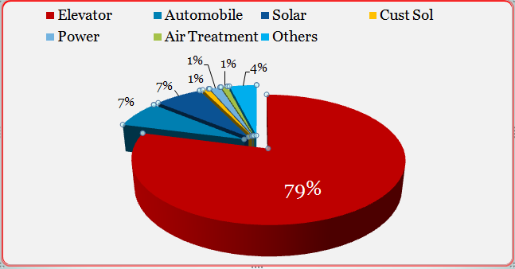

**Our In-house Facilities…**

* CNC Turret Punching Machine
* CNC Bending Machine
* NC Shearing Machine
* MIG & TIG Welding Machines
* Projection Welding
* Mechanical & Hydro Pneumatic Press
* Solid works
* Catia
* AutoCAD
* Soft vent ERP
* Tally
* Microsoft OS
* E Mail
* DRO Milling Machine
* Surface Grinding Machine
* Tube Cutting Machines
* Spray Painting Booths
* Assembly Lines
* More than 1,00,000 sq. shop floor Area

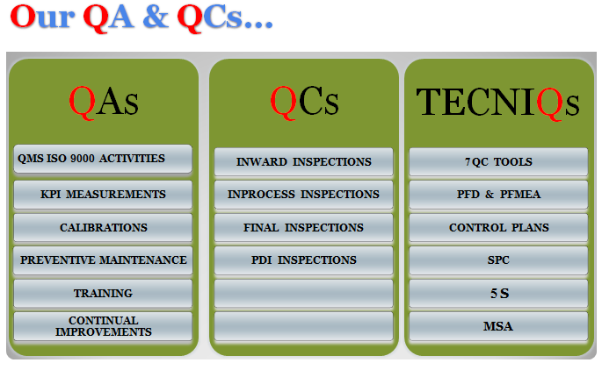

**Our Certifications…**

* ISO 9001: 2008 Certification.
* ISO 14000:2008 Certification
* UTC Level 3 certification
* Volvo SEM Certification.
* EN 287-1 Welding Certification.
* DUNS Certification (SV2A , 85-874-4708 )
* OHSAS 18001:2008 Under Certification

**Our Organization Structure..**

Directors

General Managers

Unit Heads & Functional Heads

Engineers / Cell Leaders / Team Leaders

Operators / Assistants / Semi Skilled Personnel

**Our People Domain…**

* Human Resource Development
* Business Development
* Finance
* Accounts
* Facilities
* Planning
* Production
* Quality Assurance
* Purchase & Stores
* Maintenance
* Sheet Metal Design
* Press Tool Design
* Jigs & Fixture Design

**Our Strength…**

* Sheet Metal Product Design Capabilities using 3D Software
* Exposure to Engineering Multinationals
* Strong Customer Focus
* Ability to meet International Standards
* Infrastructure that suits to manufacture wide variety of Sheet Metal Components & Sub Assemblies.

**Our Opportunities…**

* Increasing Requirements of our Parts in Elevator Industry , Automobile Industry, Textile Machine Manufacturing & Solar Industries
* Demand for custom made Information & Transaction Kiosks
* Existing Customer’s have Export Requirements
* Overseas companies want to Set Up Business JVs at India.

**Our Future Focus Areas…**

* Addition of 42000 Sq. ft. Work Space area.
* Addition of in-house Laser Cutting facility.
* Addition of Higher Tonnage Bending Facility.

**Our CSR activities…**

* Study Books & Uniforms distribution to School Children.

Financial Aids to Old Age Homes

How Mallik Engineering can be helpful to you:

By understanding manufacturing of sub-assemblies, which involves variety of items manufactured by different companies at different locations, hence you can optimize your vendor base and save time in follow-ups.

By undertaking kitting of different parts including hardware, thereby supporting you in executing your projects with minimum effort

Our capabilities in terms of the range experience, financial strength, the depth of Product Development expertise and the extent of specialization in sheet metal compenets equips us to handle high volumes of business and ensure on-time delivery as per your requirements.

Contact Us:

Mallik Engineering

Unit 1: Plot no 126, Road No 3, Jigani Industrial Area, Jigani, Bangalore 562 106

Tel: +91-811-7825436, Telefax: +91-811-7825437

Unit 2: No F51, KSSIDC Industrial Estate, Rajajinagar, Bangalore-560 044

Tel: +91-80-23357601/23508148, Telefax: +91-80-23305956

Mobile: +91 98441 84103/+91 99800 84103 – Mr.Laxminarayan

Email: [mallikengg@vsnl.net/](mailto:mallikengg@vsnl.net/) [laxminarayan@mallikengineering.com](mailto:laxminarayan@mallikengineering.com)

Website: [www.malliengineering.com](http://www.malliengineering.com)

Representative:

No.311, Forest Drive, Avenel, New Jersy, USA,

Tel: 732-857-0165

Email: usa@mallikengineering.com