***Brain Tumor detection and segmentation Brain Tumor detection and segmentation***

*A project report submitted to ICT Academy of Kerala*

*in partial fulfillment of the requirements*

*for the certification of*

**CERTIFIED SPECIALIST**

**IN**

**Machine Learning and Artificial Intelligence**

submitted by

**Team 2**

**Members**

**ANANA K.P**

**ANAGHA MOHAN**

**GOWRI MOHAN**

**MOHAMMED SHIBIN ROSHAN K T**

**INDU GEORGE**



**ICT ACADEMY OF KERALA**

**THIRUVANANTHAPURAM, KERALA, INDIA**

**August 2023**

**Table of Contents**

Abstract ……………………………………. 3

1. Problem Definition …………………………………….. 4
2. Introduction …………………………………….. 5
3. System Design …………………………………….. 6
4. Data Preprocessing …………………………………….. 6
5. Modeling …………………………………….. 7
6. Results …………………………………….. 11
7. Conclusion …………………………………….. 16
8. References …………………………………….. 17

**Abstract**

The early detection and precise diagnosis of many disorders, including brain tumors, are greatly aided by medical imaging. In order to improve the detection and segmentation of brain tumors in medical images, this project will make use of cutting-edge computer vision algorithms. The 77 brain scans in the dataset used in this study represent a wide variety of tumor sizes and types.

The dataset contains a total of 77 brain images for training, testing and validating the model. The proposed approach uses the YOLO algorithm, which is well renowned for its quick and accurate object detection, to find tumors in medical images. The annotated dataset will be used to train the algorithm, which will enable it to learn various tumor characteristics and locations.

The project uses the SAM algorithm, an advanced segmentation approach, to precisely define tumor boundaries after tumor's have been found. The Segment Anything Model offers a powerful and versatile solution for object segmentation in images, enabling you to enhance your datasets with segmentation masks.

In order to improve patient outcomes and enable wise clinical decision-making, the proposed project aims to address the significant difficulties in early tumor identification and accurate segmentation.

**1. Problem Definition**

**1.1 Overview**

We aim to detect Brain Tumors and segmentation of detected brain tumors using medical images.

**1.2 Problem Statement**

Our goal is to train a deep learning model which focuses on using the YOLO (You Only Look Once) algorithm for tumor diagnosis and the SAM (Segment Anything Model) algorithm for segmentation of the detected tumor.

**2. Introduction**

Computer vision in medical imaging is a rapidly advancing field that involves the application of artificial intelligence (AI) and image processing techniques to analyze and interpret medical images. It aims to assist healthcare professionals in diagnosing diseases, planning treatments, and monitoring patients more effectively and accurately. Medical imaging refers to various non-invasive techniques used to create visual representations of the internal structures of the human body.

Our Goal is to create a custom image segmentation application where we only want to put mask on our desired classes.\

First we would build an object detection model which would detect brain tumors. We are planning to do this by training YOLOv8 using a custom dataset taken from Roboflow. Then using that custom trained YOLOv8 model we will obtain the bounding boxes of our desirable classes. We would send our bounding box area to SAM as a prompt which could then segment it or put a mask on it.

**3. System Design**

**Detection and Segmentation**

Brain Tumor detection using YOLOv8 and segmentation using SAM algorithm.

Preprocessing

Mask Generation

Download dataset

Perform Inference

Prediction

Training the dataset

Generate Segmentation

**4. Data Preprocessing**

**4.1 Preprocessing Steps**

* The dataset contains a total of 77 brain images for training, testing, and validating the model. Out of this 60 are for training the model
* No missing values are identified
* The images were of size 240*240 which is changed into 256*256
* Label informations are given as 'labels’
* Pixel values are normalized to [0, 1]

**5. Modeling**

**1. YOLOv8**

YOLOv8 is a real time object detection model developed by Ultralytics. It is the 8th version of YOLO and is an improvement over the previous versions in terms of speed, accuracy and efficiency. YOLO proposes using an end-to-end neural network that makes predictions of bounding boxes and class probabilities all at once. It differs from the approach taken by previous object detection algorithms, which repurposed classifiers to perform detection.

There are five different models available in each category for detection, classification and segmentation. YOLOv8 Nano is the smallest and the fastest while the YOLOv8x is the most accurate and slowest among the other YOLOv8 models.

**2. Segment Anything Model**

Segment Anything Model (SAM) is a new AI model from Meta AI that can "cut out" any object, in any image, with a single click. SAM is a promptable segmentation system with zero-shot generalization to unfamiliar objects and images, without the need for additional training. SAM can generate masks for any object in any image or video, even for objects and image types it has not encountered during training.

We have trained YOLOv8 on a brain tumor dataset with an image resolution of 640 for detection. After training the YOLOv8 model on our custom dataset predictions are done by setting mode to predict indicating that it is for inference. The model points to the best-trained weights of the YOLO model. The source specifies the input image to be analyzed. After detecting brain tumors, the results are saved in a specified directory. It is then plotted as an image that contains the predicted bounding boxes drawn around brain tumors along with confidence scores.

After detection using the YOLOv8 model we define a function for mask generation. The SamPredictor class provides an easy interface to the model for prompting the model. It allows the user to first set an image using the set_image method, which calculates the necessary image embeddings. Then, prompts can be provided via the predict method to efficiently predict masks from those prompts. The model can take as input both point and box prompts, as well as masks from the previous iteration of prediction. In this project we are using the bounding boxes that we got from performing object detection using YOLOv8 as the prompt for SAM for segmentation.

# 

# Segmenting and Masking by SAM

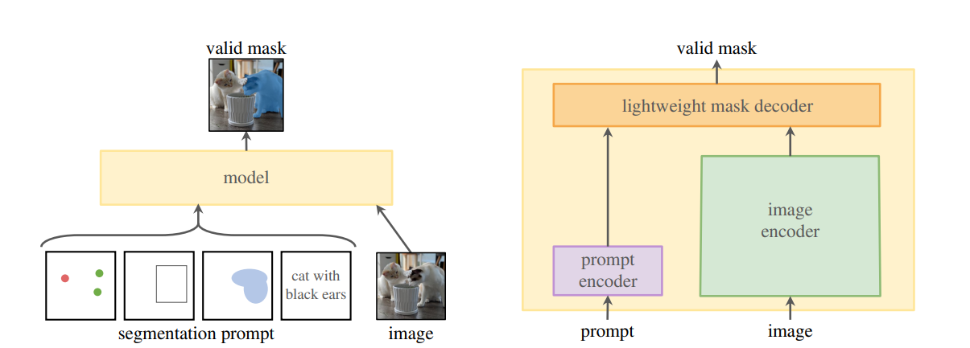

SAM considers two sets of prompts: sparse (points, boxes, text) and dense (masks). With one output, the model will average multiple valid masks if given an ambiguous prompt. To address this, the Sam model is modified to predict multiple output masks for a single prompt . It has been found 3 mask outputs is sufficient to address most common cases (nested masks are often at most three deep: whole, part, and subpart). During training, we backprop only the minimum loss over masks. To rank masks, the model predicts a confidence score (i.e., estimated IoU) for each mask.

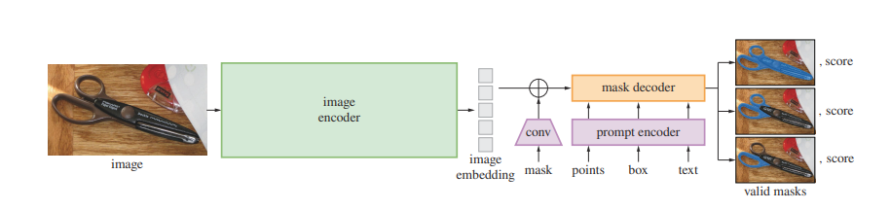

As described, a single input prompt may be ambiguous in the sense that it corresponds to multiple valid masks, and the model will learn to average over these masks. SAM eliminates this problem with a simple modification: instead of predicting a single mask, it uses a small number of output tokens and predicts multiple masks simultaneously. By default, we predict three masks, since we observe that three layers (whole, part, and subpart) are often enough to describe nested masks. During training, we compute the loss between the ground truth and each of the predicted masks, but only backpropagate from the lowest loss.

With the ambiguity-aware model, if a point lies on a part or subpart, our model will return the subpart, part, and whole object. The IoU prediction module of the model is used to select confident masks; moreover, we identified and selected only stable masks (we consider a mask stable if thresholding the probability map at 0.5 − δ and 0.5 + δ results in similar masks). Finally, after selecting the confident and stable masks, we applied non-maximal suppression (NMS) to filter duplicates.

Following recent approaches SAM has an interactive segmentation setup during training(Training algorithm). First, with equal probability either a foreground point or bounding box is selected randomly for the target mask. Points are sampled uniformly from the ground truth mask. Boxes are taken as the ground truth mask’s bounding box, with random noise added in each coordinate with standard deviation equal to 10% of the box side length, to a maximum of 20 pixels. This noise profile is a reasonable compromise between applications like instance segmentation, which produce a tight box around the target object, and interactive segmentation, where a user may draw a loose box.

After making a prediction from this first prompt, subsequent points are selected uniformly from the error region between the previous mask prediction and the ground truth mask. Each new point is foreground or background if the error region is a false negative or false positive, respectively. SAM also supply the mask prediction from the previous iteration as an additional prompt to our model. To provide the next iteration with maximal information, SAM supply the unthresholded mask logits instead of the binarized mask. When multiple masks are returned, the mask passed to the next iteration and used to sample the next point is the one with the highest predicted IoU.

We used the mean intersection-over-union(mIoU) after a given number of prompts to evaluate the segmentation quality of a mask when prompted with points. We used average precision(AP) to evaluate instance segmentation for a given box and edge detection. The per-dataset mIoU is the per-mask IoU averaged across all objects in the dataset.

**6. Result**

**1. YOLO Results:**

* **Tumor detection using YOLO**:

After training the YOLOv8 model on our custom dataset, we used our custom trained model for prediction. We plotted the bounding box of the detected object along with its confidence score labeled above the bounding box. The plotted result is shown below:

|  |  |
| --- | --- |
| **Original Image** | **Tumor Detected Image** |

* **Tumor detection using YOLO for test folder images** :

The plotted result of object detection using YOLO on test folder images is shown below:

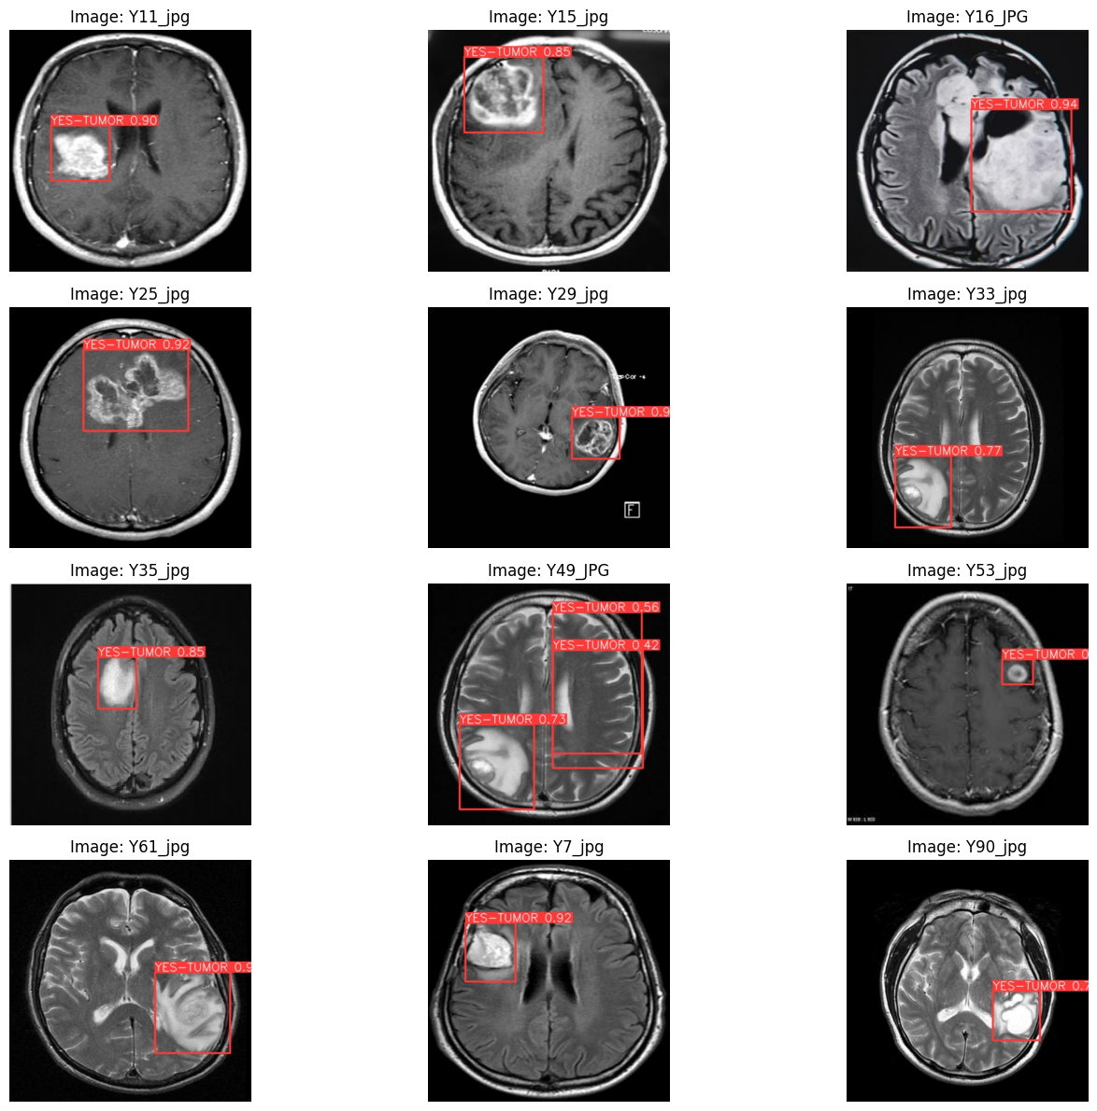

**2. SAM Results:**

* **Tumor segmentation using SAM**:

After object detection, specifically in our project tumor detection, using the YOLOv8 model we passed the extracted bounding box of the detected object as a prompt to the Segment Anything Model for mask generation. Out of the bounding boxes generated by YOLO we set a threshold value of 0.7. Only those bounding boxes which are greater than our set up threshold value would be passed as prompts to SAM. The images are plotted along with predicted masks and its corresponding scores.

When we Predict with SamPredictor.predict the model returns masks, quality predictions for those masks, and low-resolution mask logits that can be passed to the next iteration of prediction. With multimask_output=True (the default setting), SAM outputs 3 masks, where scores give the model's own estimation of the quality of these masks. This setting is intended for ambiguous input prompts, and helps the model disambiguate different objects consistent with the prompt. When False, it will return a single mask.

Prediction with multimask_output=True, three masks are generated for a single input image. They are as follows:

**Segmented masks for an input image**

|  |  |  |
| --- | --- | --- |
|  |  |  |

When multimask_output=False, only the first predicted mask is considered.

Here you can see that from the input image a tumor is detected then the detected tumor is being masked.

|  |  |
| --- | --- |
| **Original Image** | **Tumor Detected Image** |

**Segmented masks on the input image**

|  |  |  |
| --- | --- | --- |
|  |  |  |

* **Tumor segmentation using SAM for test folder images** :

The plotted result of tumor segmentation using SAM on test folder images is shown below:

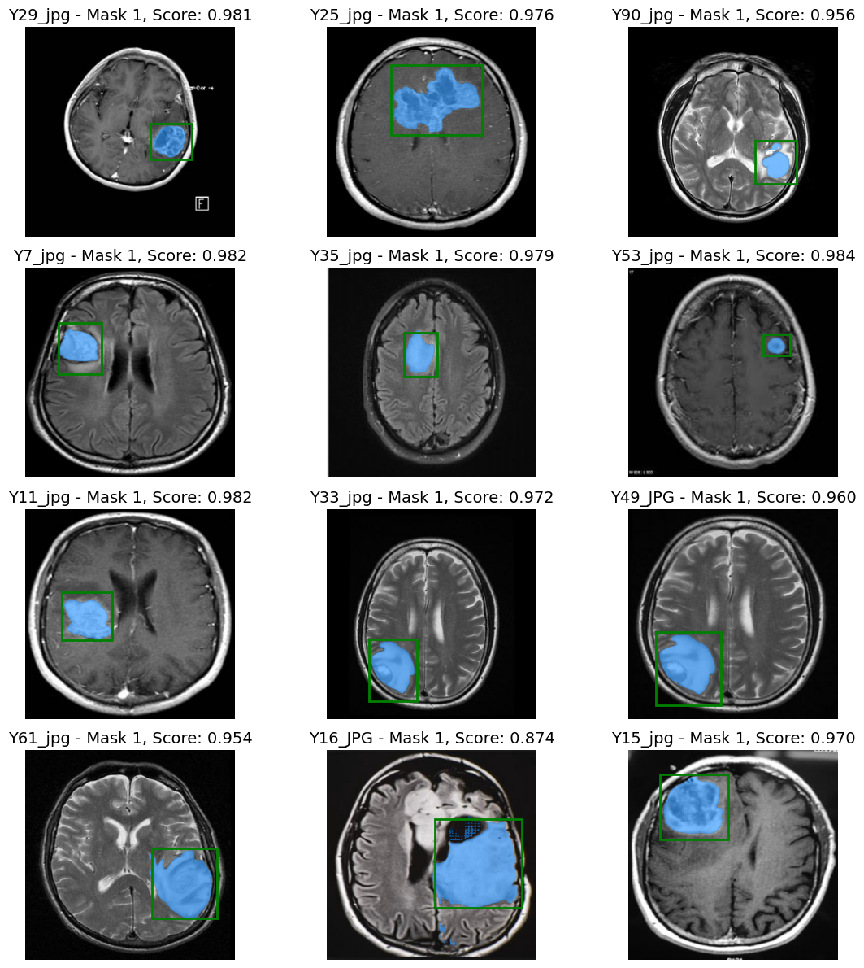

**7. Conclusion**

The project report presents a comprehensive exploration into the detection of brain tumors using YOLOv8 and the segmentation using the "Segment Anything Model" methodology. The fusion of these two advanced techniques showcases promising results in terms of accuracy, efficiency, and potential clinical applications.

Through the utilization of YOLOv8, the project successfully achieves robust and real-time detection of brain tumors in medical images. The model's ability to accurately identify tumor regions is a crucial step towards early diagnosis and treatment planning. The detection process, being efficient and capable of handling various image formats, enhances the workflow of medical professionals and minimizes human error.The application of the "Segment Anything" approach for tumor segmentation provides a detailed understanding of tumor boundaries, aiding in precise localization and size estimation.

The integration of detection and segmentation techniques offers a holistic solution for improved brain tumor analysis. The success of the project relies heavily on the availability of high-quality labeled data and efficient computing resources. Additionally, the model's performance might vary across different types of brain tumors and imaging modalities, necessitating ongoing fine-tuning and validation.

By leveraging the power of deep learning and innovative segmentation techniques, this project contributes to the ongoing efforts to enhance the accuracy, speed, and efficacy of brain tumor diagnosis, ultimately improving patient outcomes and healthcare practices. Future work could involve refining the model further, exploring interpretability techniques, and collaborating with medical professionals for clinical validation and deployment.

**8. References**

1. **Ultralytics YOLOv8 -** <https://docs.ultralytics.com/>
2. **Segment Anything** - Alexander Kirillov, Eric Mintun, Nikhila Ravi, Hanzi Mao, Chloe Rolland, Laura Gustafson, Tete Xiao, Spencer Whitehead, Alexander C. Berg, Wan-Yen Lo, Piotr Dollár, Ross Girshick :- <https://arxiv.org/pdf/2304.02643>
3. Jun Ma and Bo Wang: Segment Anything in Medical Images
4. Chaoning Zhang, Fachrina Dewi Puspitasari, Sheng Zheng, Chenghao Li,Yu Qiao, Taegoo Kang,Xinru Shan, Chenshuang Zhang, Caiyan Qin, Francois Rameau, Lik-Hang Lee,Sung-Ho Bae, Choong Seon Hong :A Survey on Segment Anything Model(SAM): Vision Foundation Model Meets Prompt Engineering.