- Read an integer and determine whether its absolute value is less than 10, between 10 and 99, or at least 100.
Problem Statement
Read an integer and determine whether its absolute value is:
- Less than 10
- Between 10 and 99
- At least 100
Aim:
To read an integer and classify it based on the magnitude of its absolute value.
Flowgorithm Logic
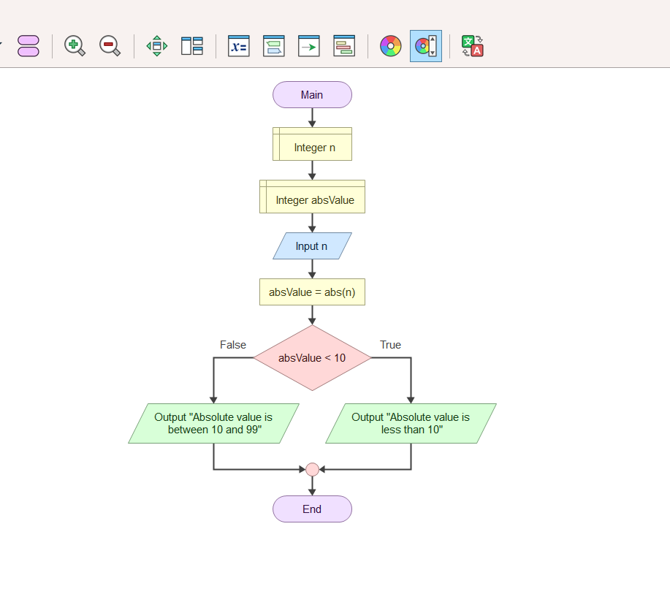

Pseudo code
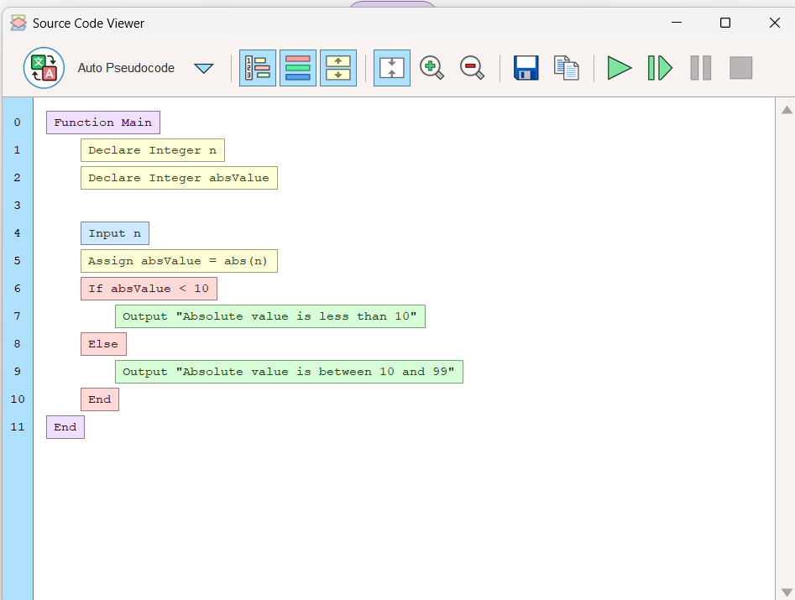
Output
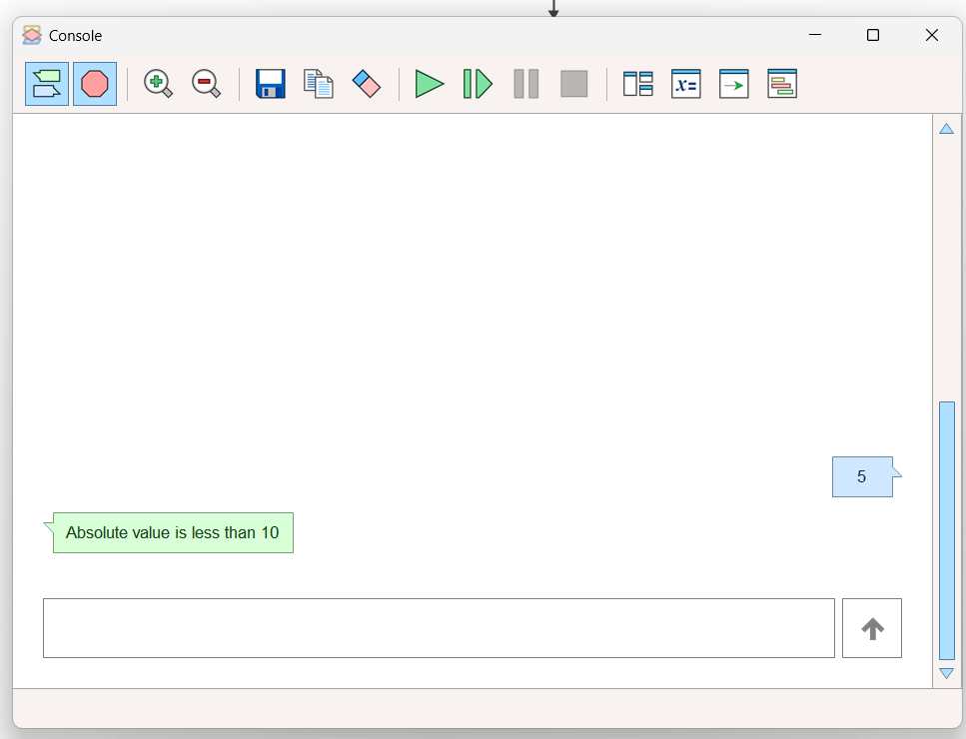

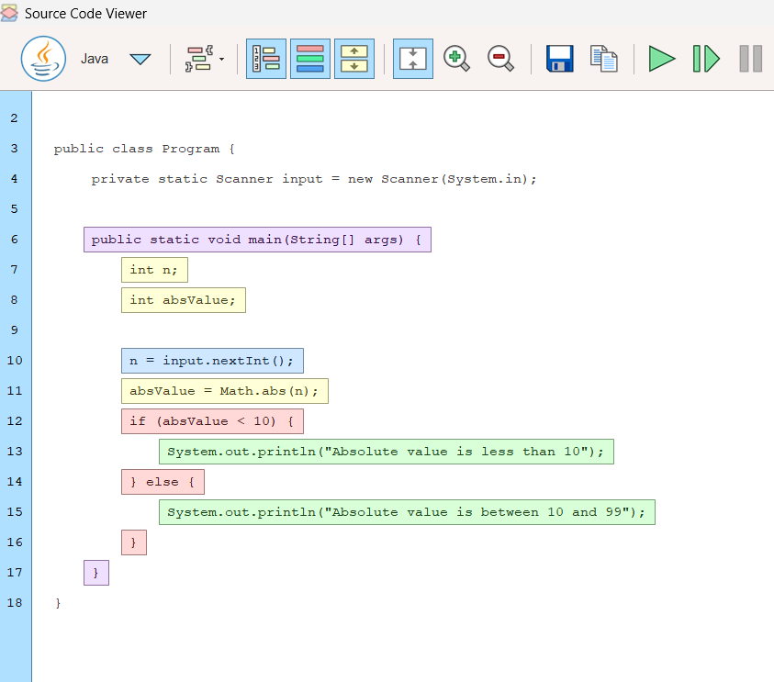
Java Code

Result:
The program successfully determines and displays the correct category of the entered integer based on its absolute value.

2.Read an integer and display its digits from left to right without converting it to a string.
Display Digits from Left to Right
Problem Statement
Read an integer and display its digits from left to right without converting it to a string.
Aim:
To read an integer and display each of its digits from left to right without using string conversion.
Flowgorithm Logic
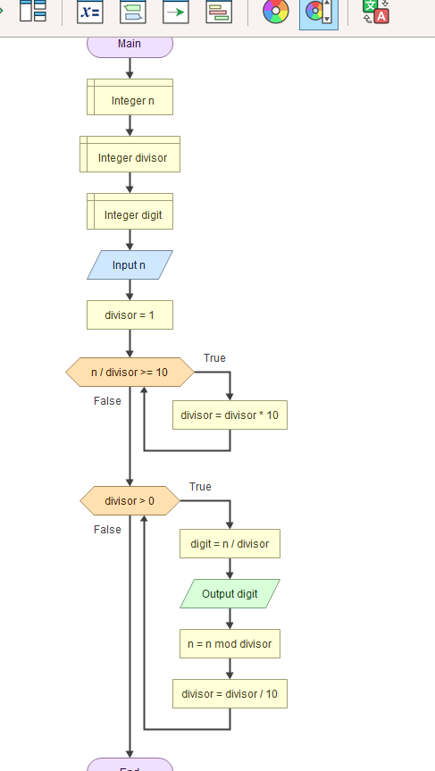

Pseudo code
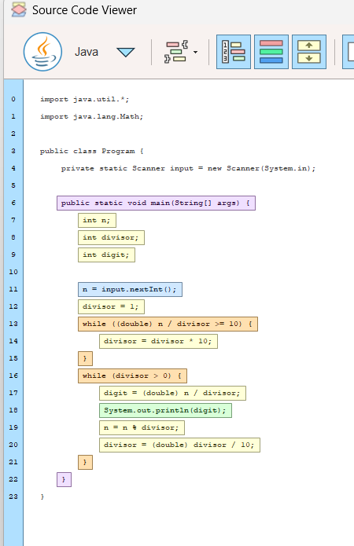
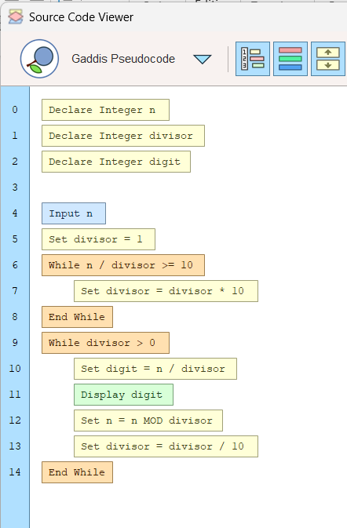
Java Code

output
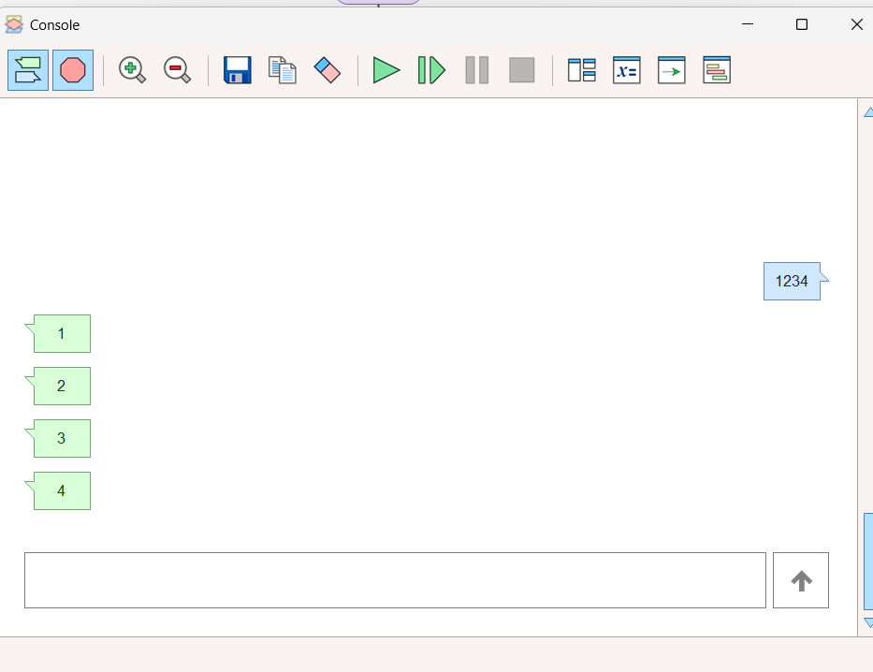

Result:
The program successfully displays all digits of the given integer from left to right without converting the number into a string.

3. Design a restaurant-billing flowchart with DineIn, TakeAway, and Delivery order types. Apply different service or delivery charges and relate the logic to overriding.
Restaurant Billing System (DineIn, TakeAway, Delivery)
Aim:
To design a restaurant billing system that calculates the final bill based on DineIn, TakeAway, or Delivery order types with different service and delivery charges.
Flowgorithm Logic
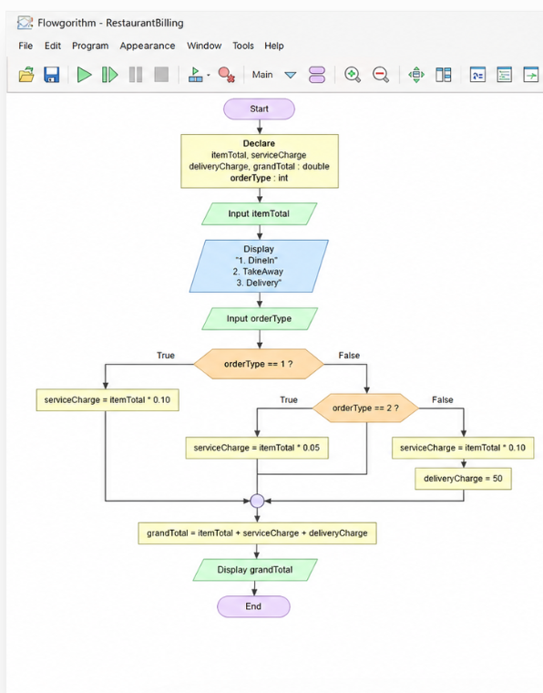

Java Code
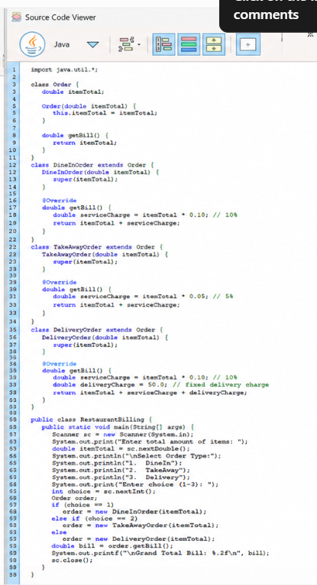
Pseudo code
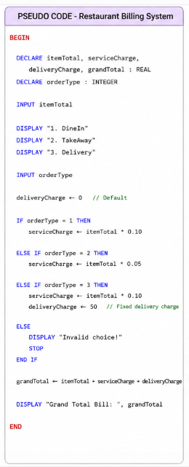

Output
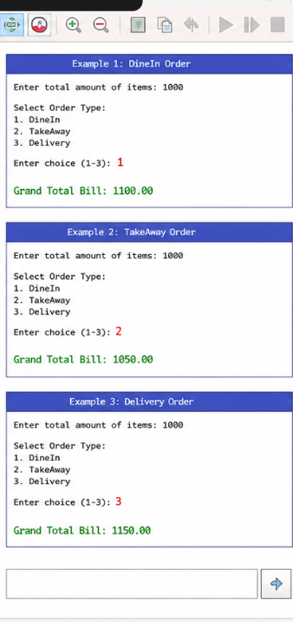
Result:
The program correctly calculates and displays the final restaurant bill according to the selected order type and applicable charges.

