DELIVERABLE 3
Challenges faced during running and testing the program:
The main challenges were handling the edge cases and fixing errors revealed by the automated system in VScode. Initially several pytest test cases failed due to the mismatches in the expected output strings and the actual return value from classify_triangle().
Eg:
The right triangle test was failed because the function returned a combined string instead of expected right triangle format.
Also failures were there due to the invalid input cases such as zeros, negative value and so on.
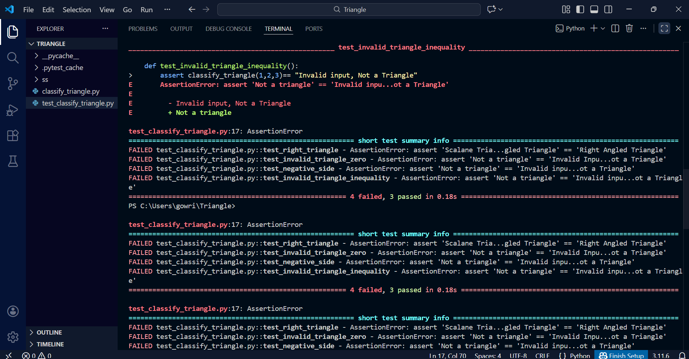
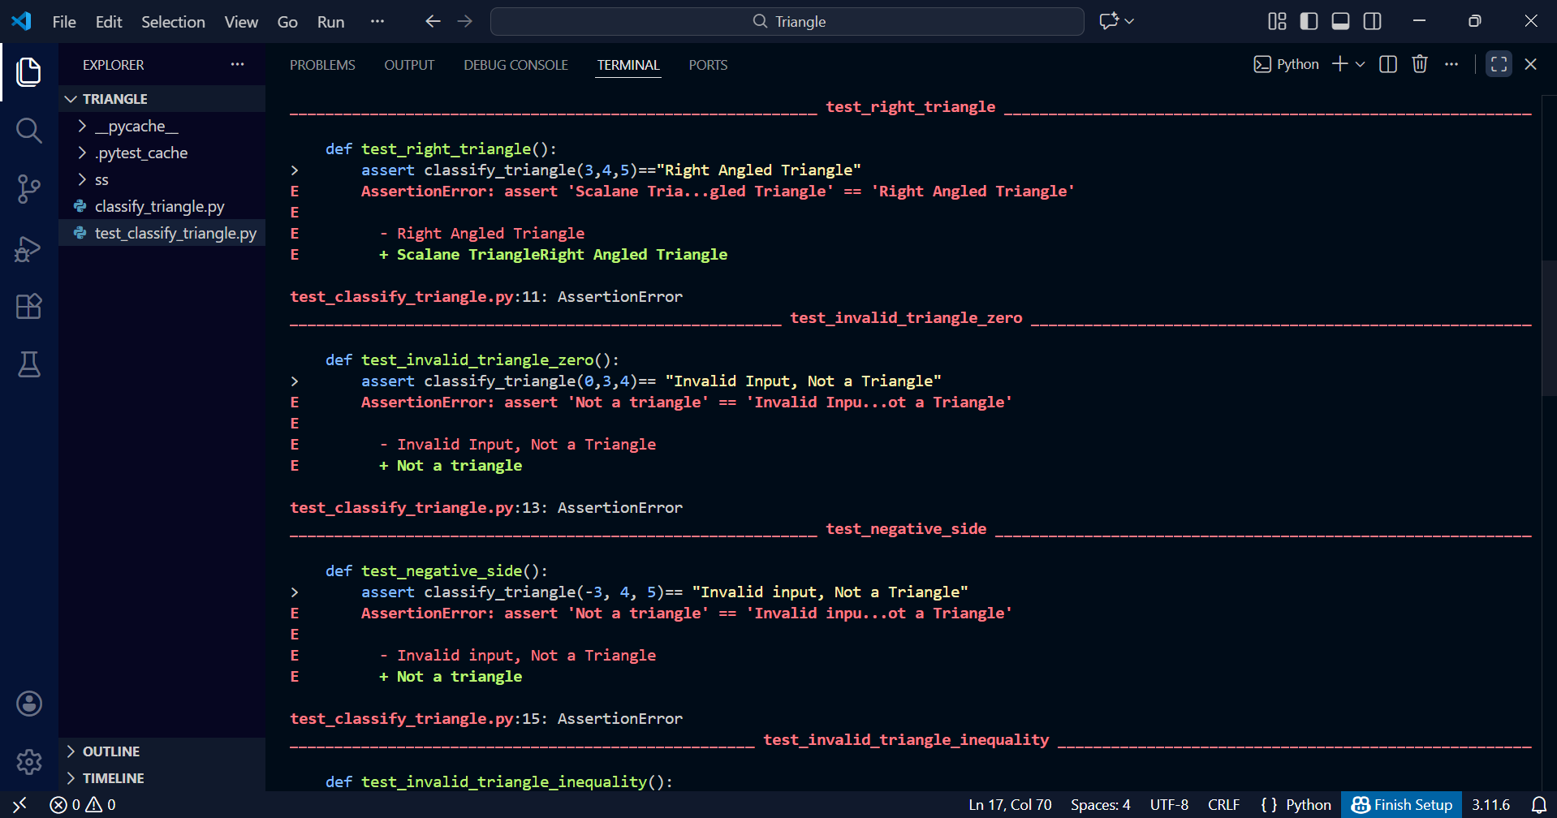
These errors helped to highlight the inconsistency in the error messages and find the importance of aligning implementation of output exactly with the test expectations. Debugging these failures took time but it was the most important learning experience.

Requirement specifications for the assignment:
The requirement specifications were clear and well defined. It has been stated in the requirement about the expected classification that are isosceles, scalene, equilateral and right triangle and it also mentioned handling the invalid triangles too. This made it easier to design the implementation and automated test cases.

Challenges encountered with the tools:
Initially the command pytest was not recognised when I ran pytest -v, which required me to dig deeper into learning how to correctly run tests. Then I uses python -m pytest -v. understanding pytest’s discovery rules, assertation failures and error messages took some time but once learned to decode, pytest became the most powerful and efficient way to validate program.

Criteria used to determine if the test cases were sufficient:
The test cases were considered sufficient once all the major triangle types that is equilateral. Scalen, isosceles and right triangles; have been passed successfully along with invalid inputs.
Ran python -m pytest -v to see all the tests pass and confirmed the function behaved correctly across the tests.

DELIVERABLE 4
https://github.com/Gowridaslovely/Triangle

