ShellSripting

1. Creation of files using touch commands in the terminal

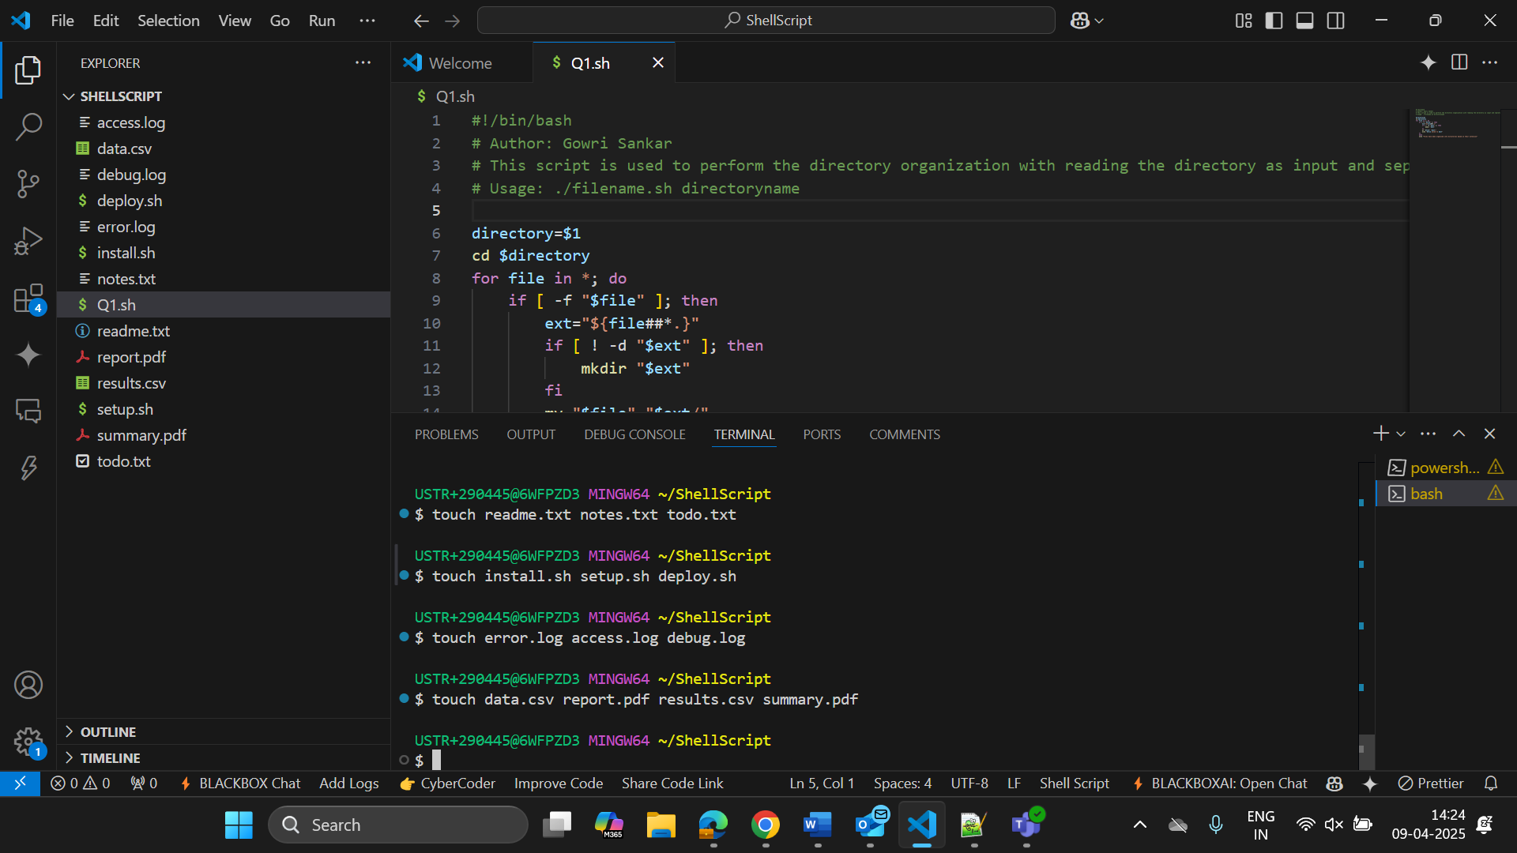

1. Shell Script

#!/bin/bash

# Author: Gowri Sankar

# This script is used to perform the directory organization with reading the directory as input and seprating files in to respective directories

# Usage: ./filename.sh directoryname

directory=$1

cd $directory

for file in *; do

    if [ -f "$file" ]; then

        ext="${file##*.}"

        if [ ! -d "$ext" ]; then

            mkdir "$ext"

        fi

        mv "$file" "$ext/"

        echo "$file moved to $ext"

    fi

    done

    echo "Files have been organized into directories based on their extension"

After Organization Summary.pdf

