Q3 – Docker and Container Internals

1. Cloning the repository

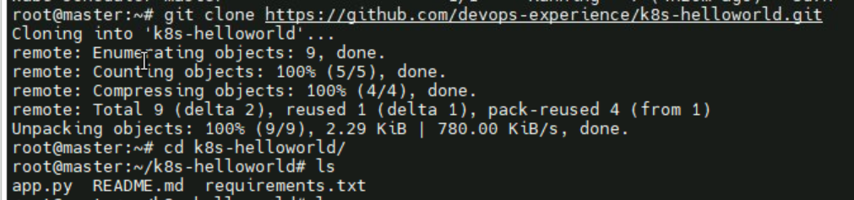

1. Writing Docker file

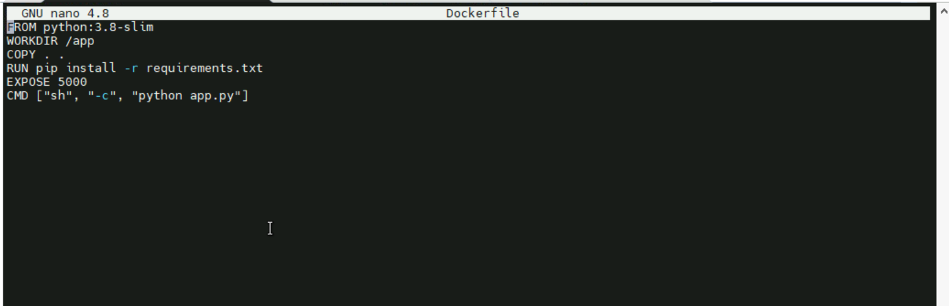

1. Docker Image Building

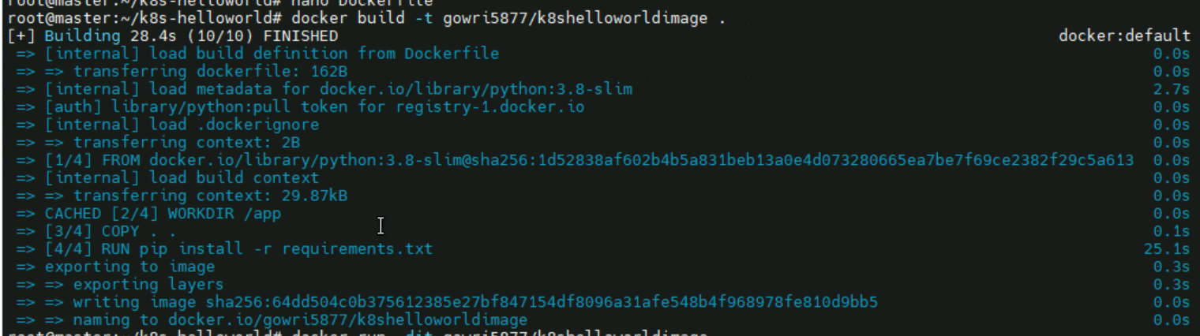

1. Running the docker container



1. Read write layer on host is present in /var/lib/docker/containers

And in that dfa3c… folder

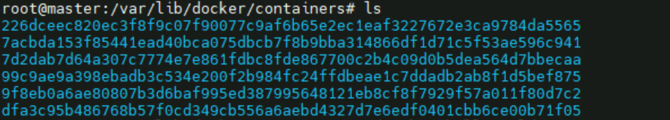

1. Working directory of the container



1. **Writable layer directory**

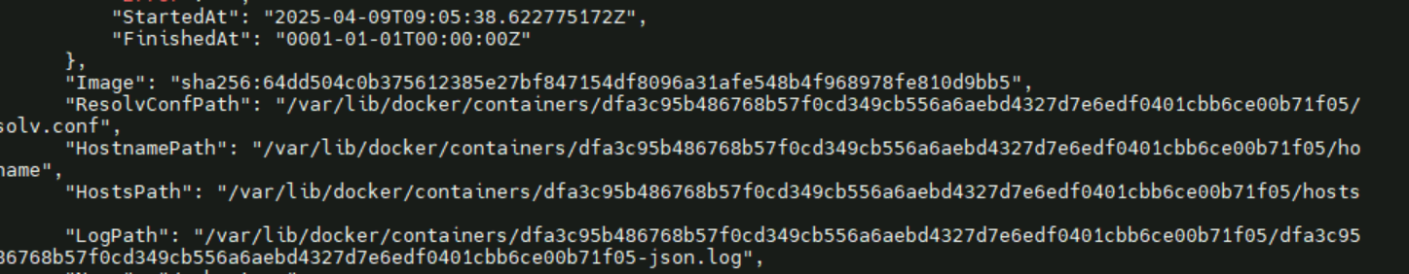

**Commands used**

Git clone <https://github.com/Gowrisankar5877/k8s-helloworld.git>

 cd k8s-helloworld/

 ls

 nano Dockerfile

 docker build -t gowri5877/k8shelloworldimage .

 docker run -dit gowri5877/k8shelloworldimage

 docker ps

 cd /var/lib/docker/containers/

docker exec -it dfa pwd

docker container inspect dfa