Git branching:

1. **Main Branch**: This is the primary branch that contains the stable version of the project. It is the branch from which releases are made, and the version on main should always be production-ready. We can directly merge stable features into main after thorough testing and validation.
2. **Developer Branch** This branch can be considered a working branch for developers. It serves as an integration branch where developers integrate each other's work after coding, but before it's merged into main.
3. **Feature Branches** These are temporary branches created for specific features. They are focused on individual features or fixes. After the feature development is complete and verified through testing, the feature branch is merged back into the developer branch.

Github repository with a feature, developer and main branches

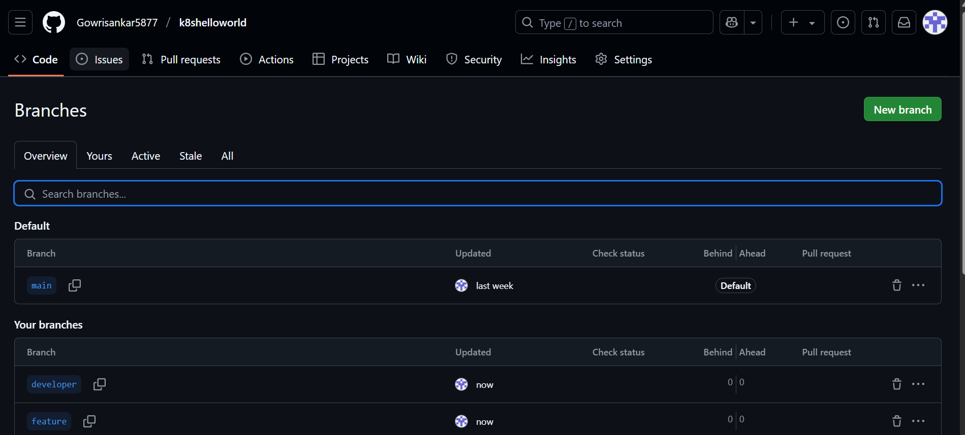

Sample_file.txt is committed in the developer branch

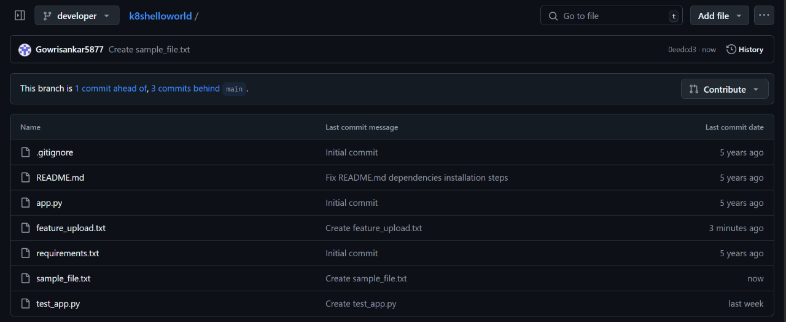

In the pull requests tab we can see the developer branch had recent pushes. Clicking on compare & pull request we can create a pull request

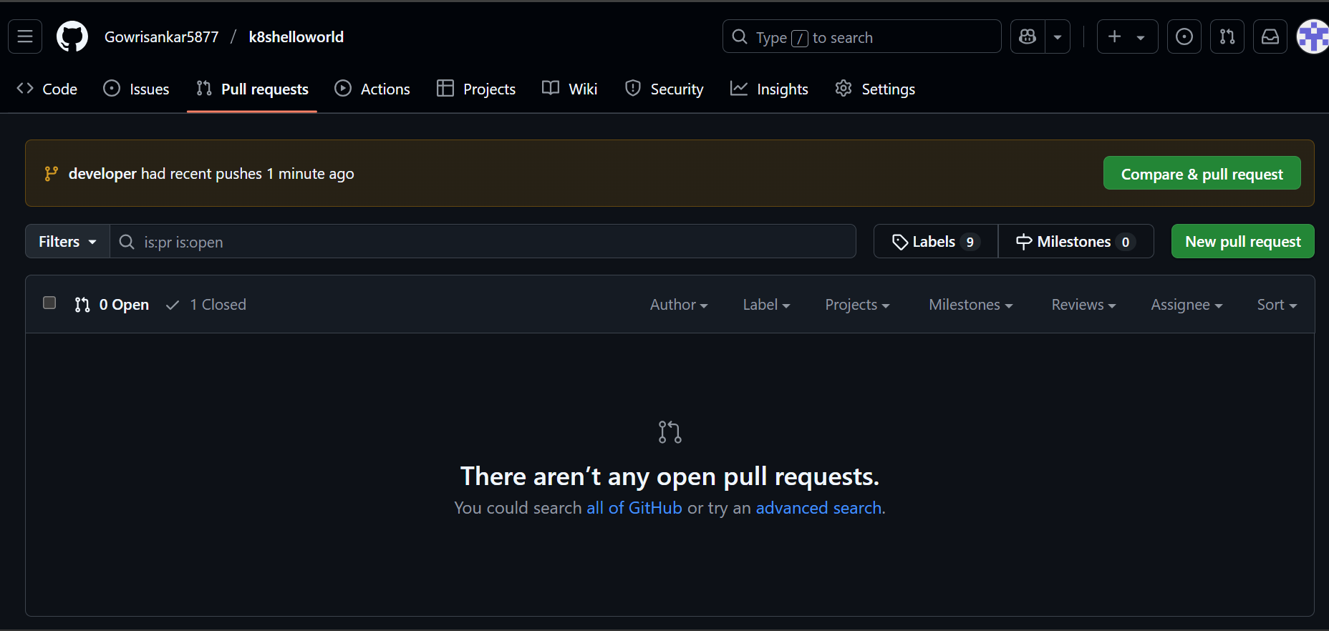

We are creating a pull request from developer branch to feature branch

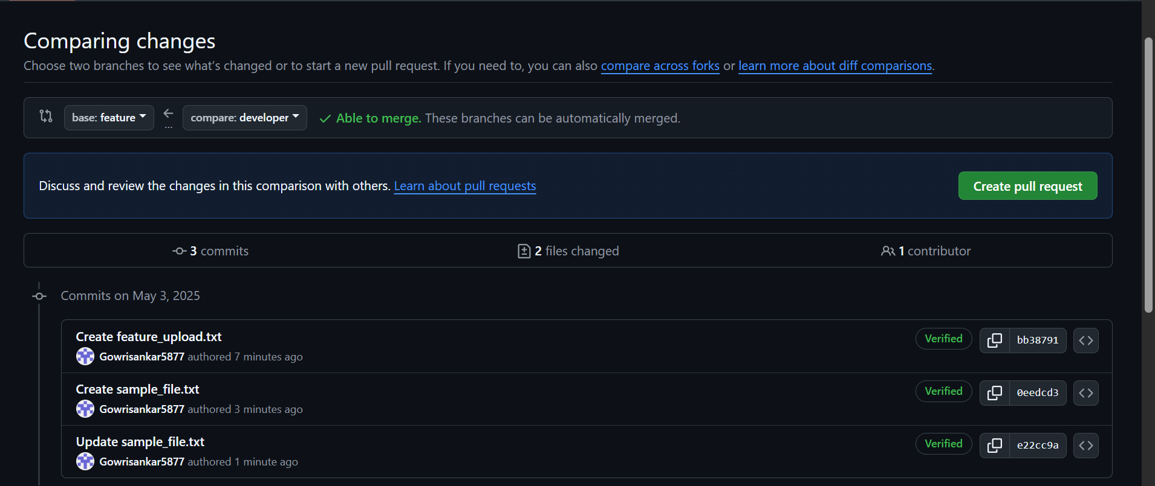

Pull request is created

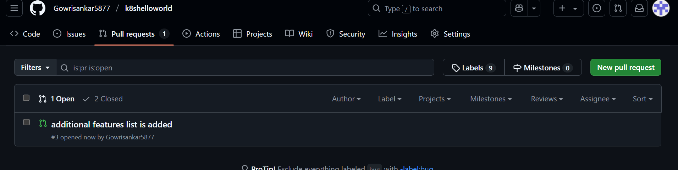

Merging pull request

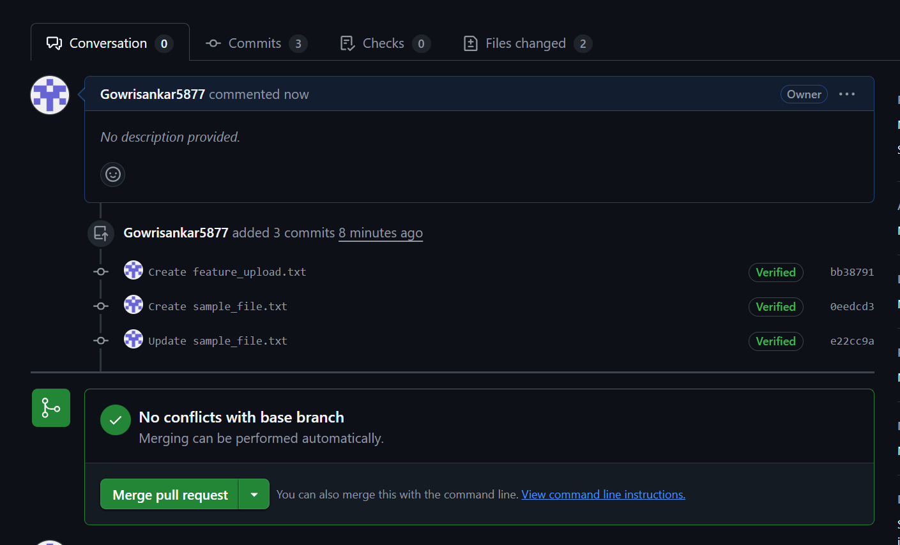

Pull requests are merged

