Kubernetes Retail App Deployment

1. Created Namespace
Created namespace 'namespace-ns' using kubectl command.
Verified namespace creation using 'kubectl get ns'.
Namespace isolates all retail application resources.
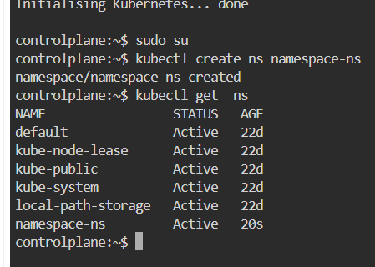

2. Created Retail App Deployment YAML
Defined Deployment with 2 replicas.
Container image: saiteja2502/userprofileretail:latest.
Container port: 3130.
Configured environment variables for MongoDB and email credentials.
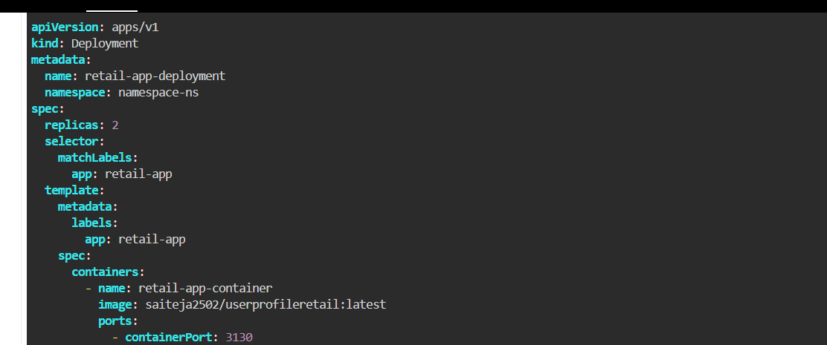

3. Created MongoDB Deployment YAML
MongoDB deployed with 1 replica.
Container image: mongo:latest.
Database initialized with 'myDatabase'.
Port 27017 exposed internally.
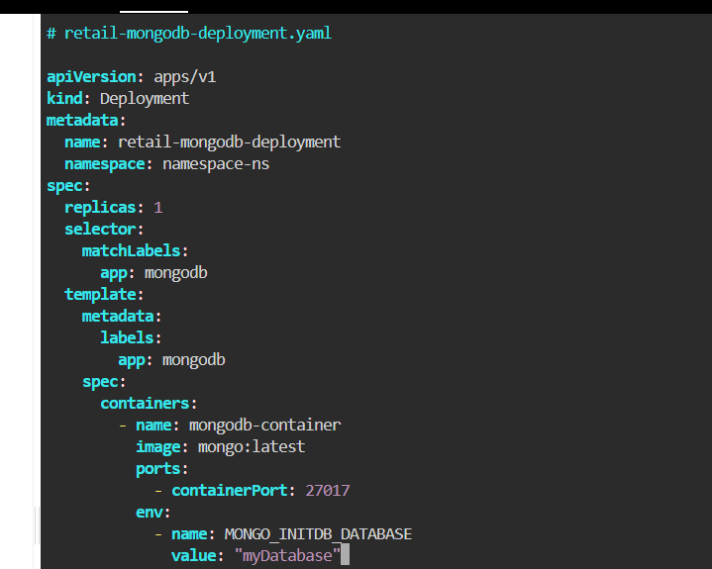

4. Created ConfigMap
Stored non-sensitive configuration values.
Keys stored: APP_NAME and APP_VERSION.
Applied using 'kubectl apply -f configmap.yaml'.
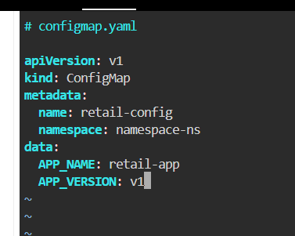

5. Applied All YAML Files
Applied ConfigMap, MongoDB Deployment, MongoDB Service,
Retail App Deployment, and Retail App Service.
Verified resources created successfully.
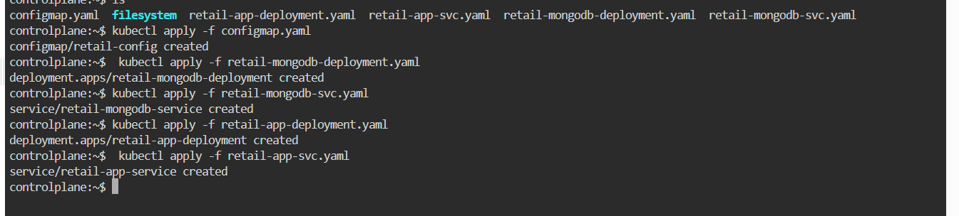

6. Verified Cluster Resources
Used 'kubectl get all -n namespace-ns'.
Confirmed Pods, Services, Deployments, and ReplicaSets are running.
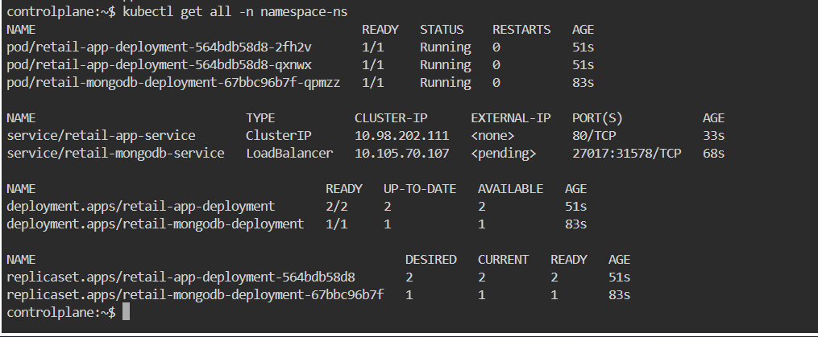

7. Encoded Secret Values
Encoded SESSION_SECRET, EMAIL_USER, and EMAIL_PASS using base64.
Prepared values for Secret YAML configuration.
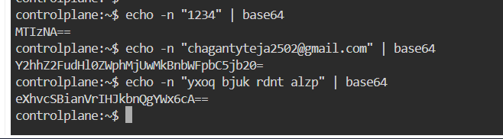

8. Created Secret YAML
Created retail-secret with encoded credentials.
Secret type: Opaque.
Stored 3 sensitive values securely.
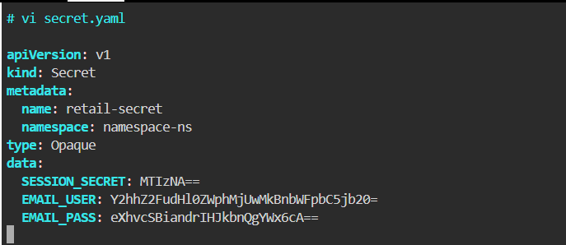

9. Applied Secret
Applied secret using 'kubectl apply -f secret.yaml'.
Verified using 'kubectl get secret -n namespace-ns'.
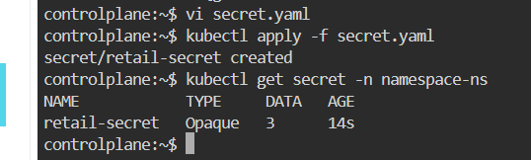

10. Updated Deployment to Use ConfigMap and Secret
Modified Deployment to use configMapKeyRef and secretKeyRef.
Injected MongoDB URI, SESSION_SECRET, EMAIL_USER, and EMAIL_PASS securely.
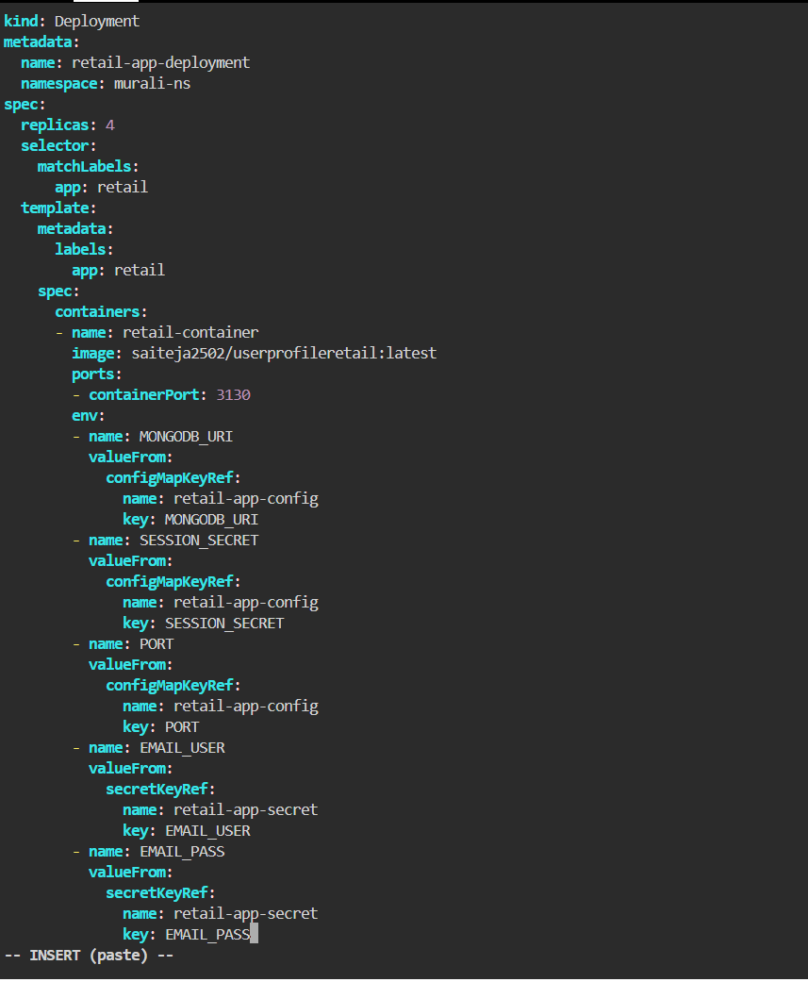

11. Verified Final Deployment Status
Checked pods using 'kubectl get pods'.
Observed running state and identified CreateContainerConfigError.
Ensured configuration and secret injection working correctly.
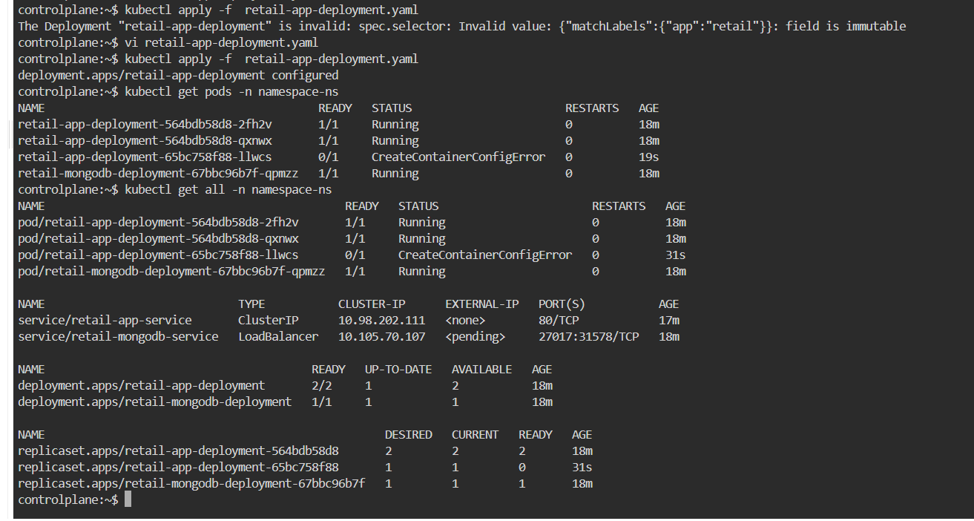

Final Result
Namespace created successfully.
MongoDB deployed internally.
Retail application deployed with replicas.
ConfigMap and Secret injected successfully.
Application resources verified inside Kubernetes cluster.

