Maven Pipeline using Jenkins
Step 1: Open Jenkins dashboard and verify Jenkins is running successfully.
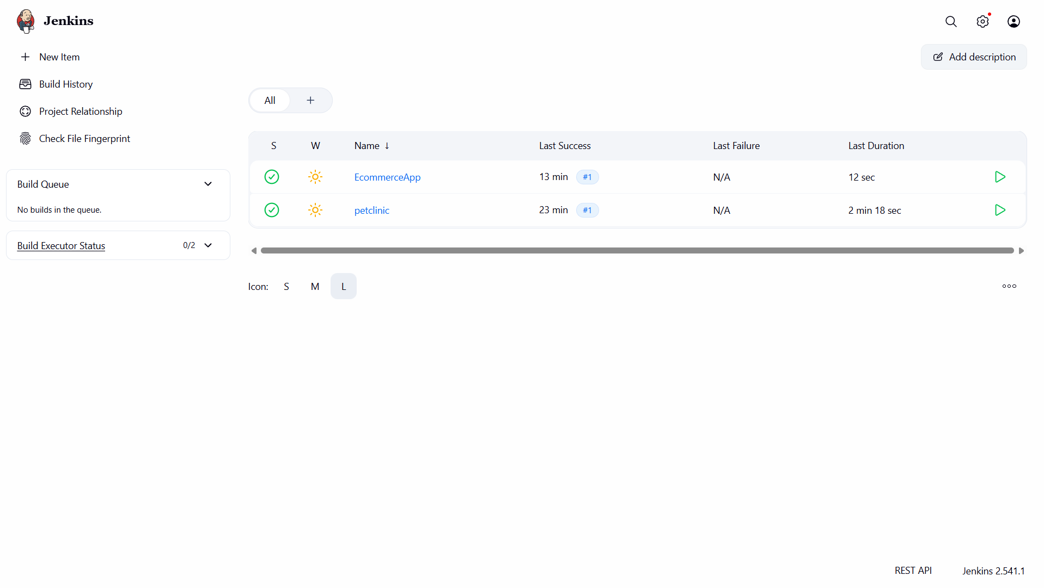
Step 2: Click on New Item and enter the pipeline name as 'maven-pipeline' and select Pipeline project and Click OK.
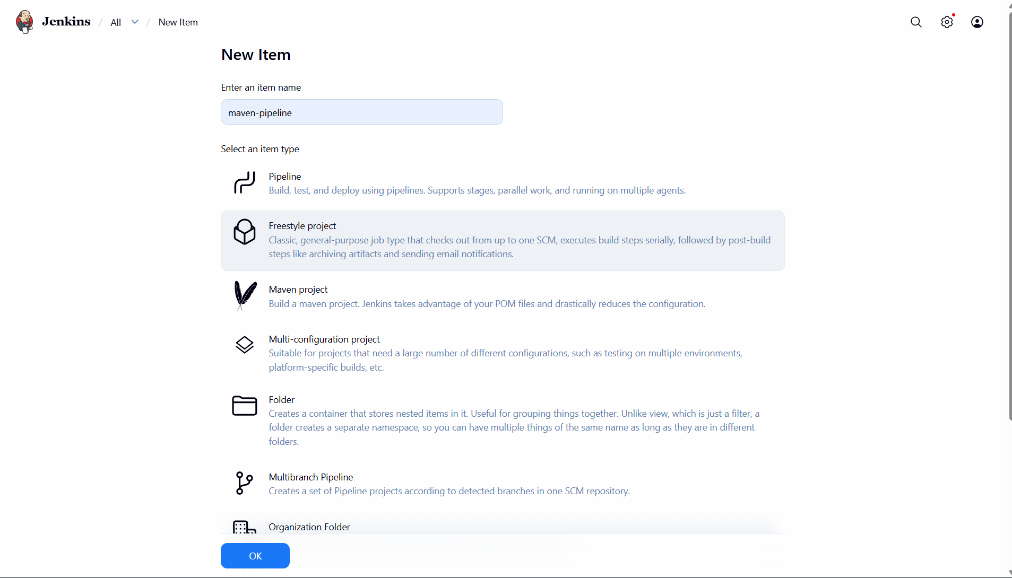

Step 3: Add description and configure project settings.Go to the source code management and select git.
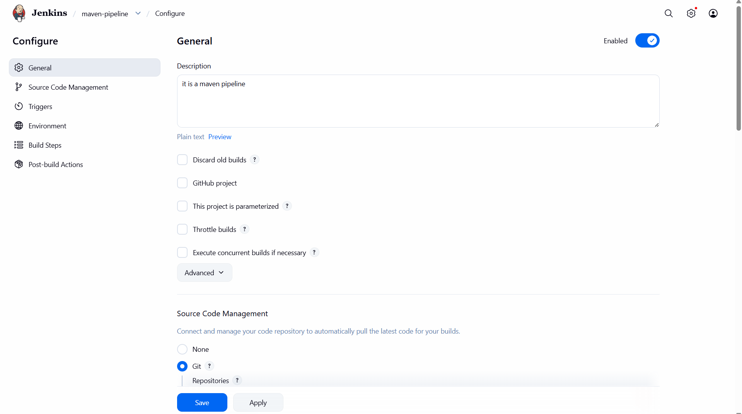
Step 4: Configure Source Code Management and provide GitHub repository URL and branch. If the repo is public no need to give the credentials.
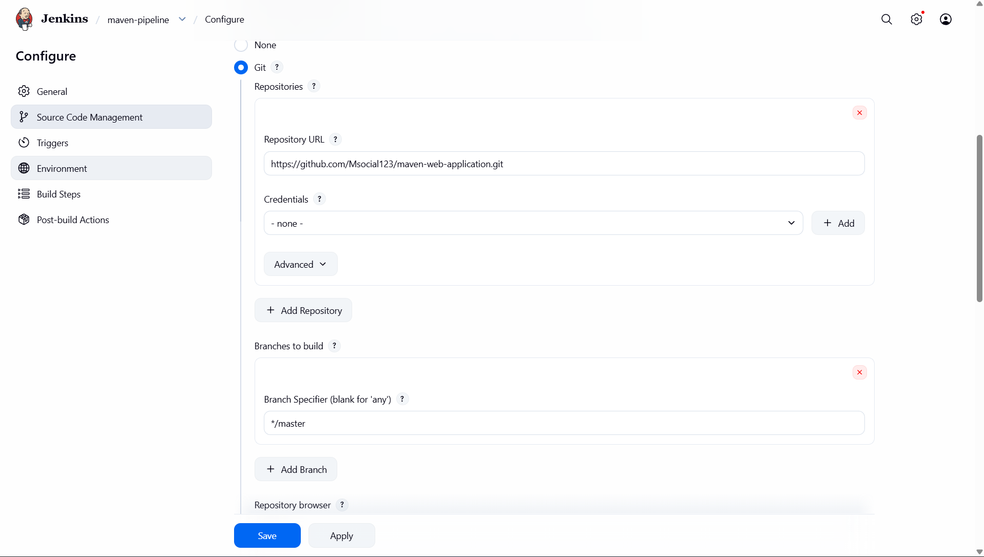

Step 5: Here we have go to build steps and click Add build step and select the invoke top level maven project.
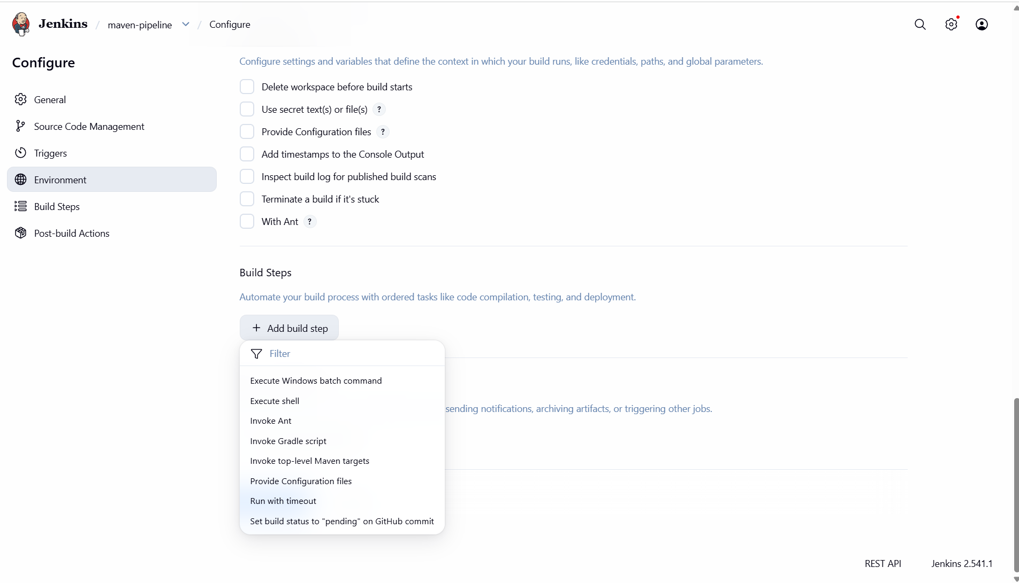
Step 6: Add Build Step and choose 'Invoke top-level Maven targets' and in maven version change default to our maven, with goal 'clean package'.
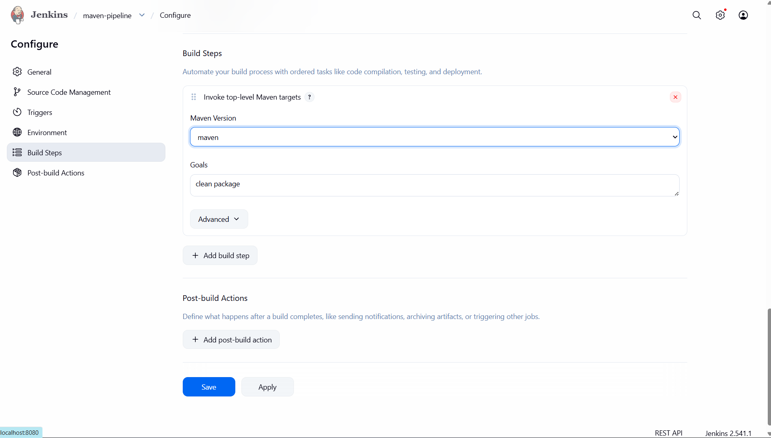

Step 7: Next we have to add post build action and in that we have to select Deploy war/ear to a container
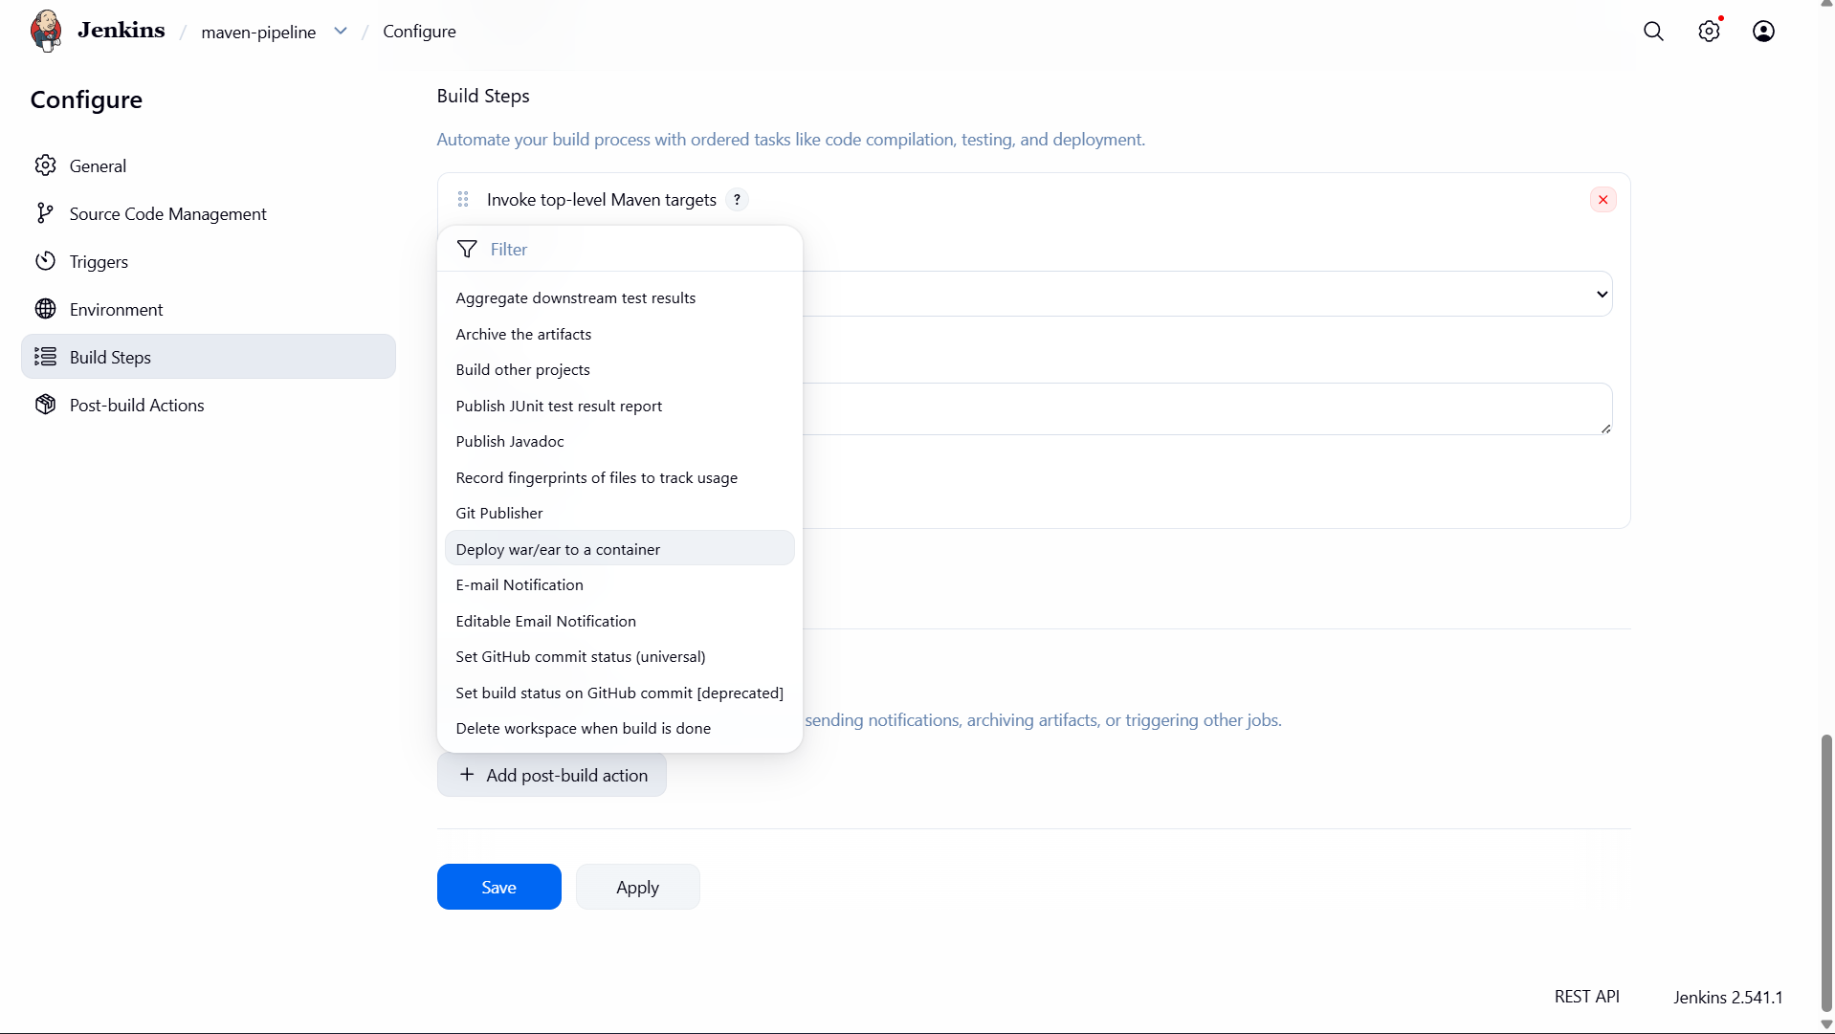
Step 8: Here we have to give the war/ear files and next we have to click add container.
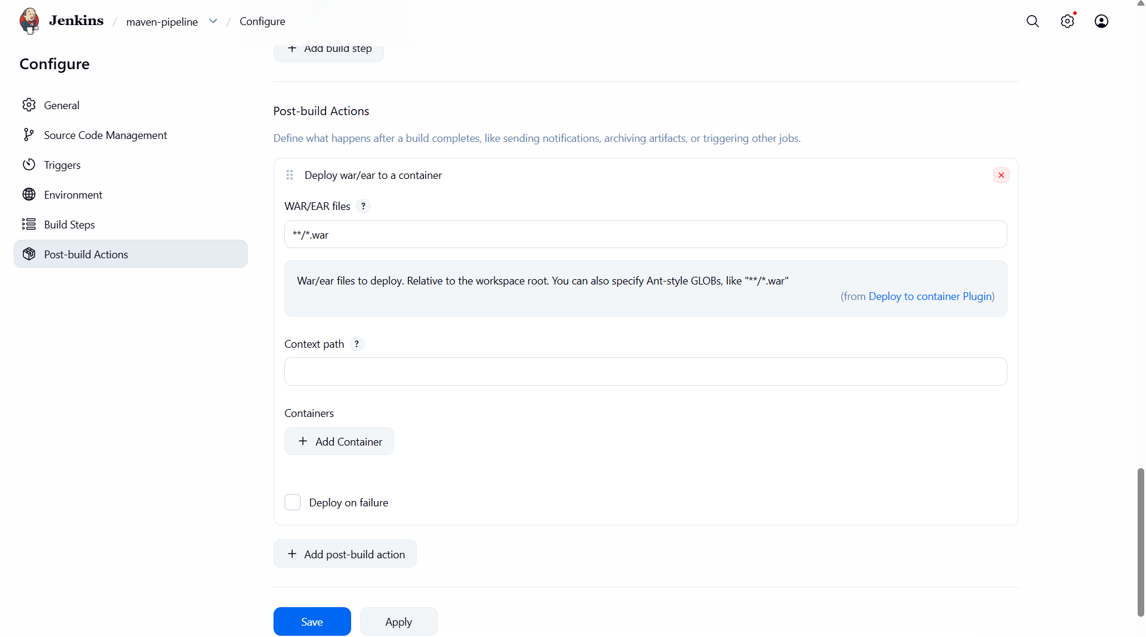

Step 9: Here we have to give the credentials and tomcat URL. Next u have to save and click Apply.
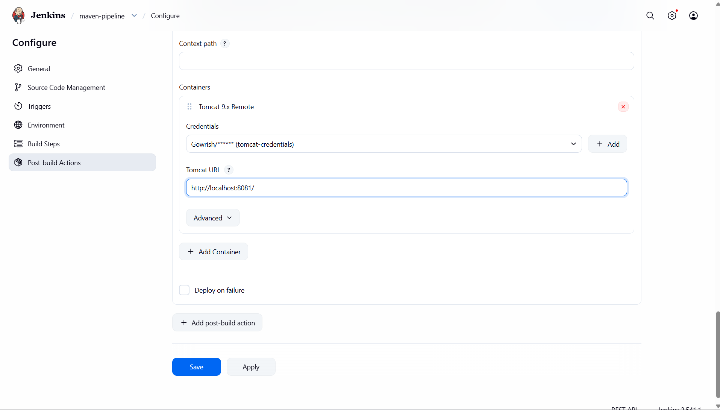
Step 10: After saving the pipeline it shows like this here we have to click the build now to create a pipeline.
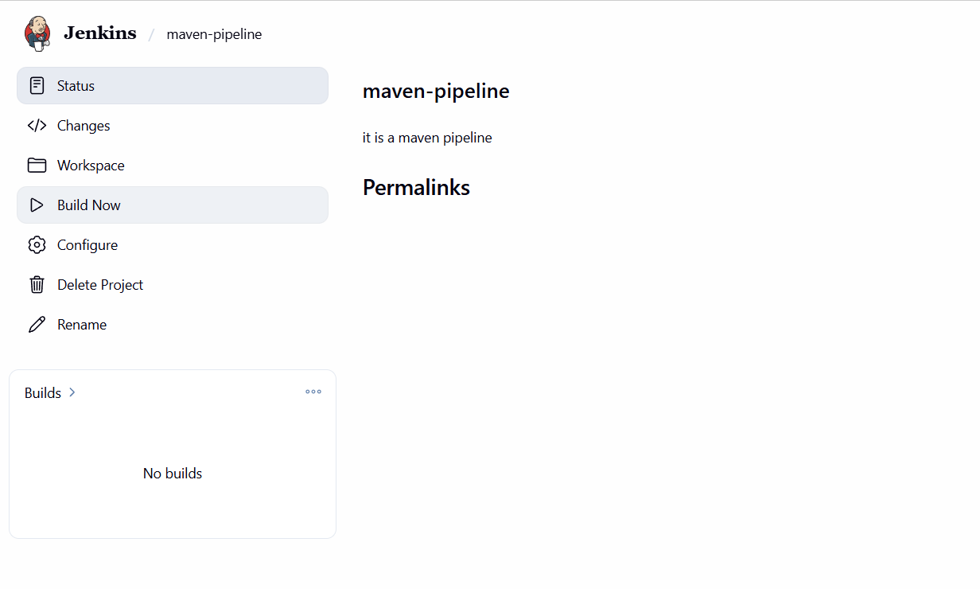

Step 11: After build now the console output is displayed like this
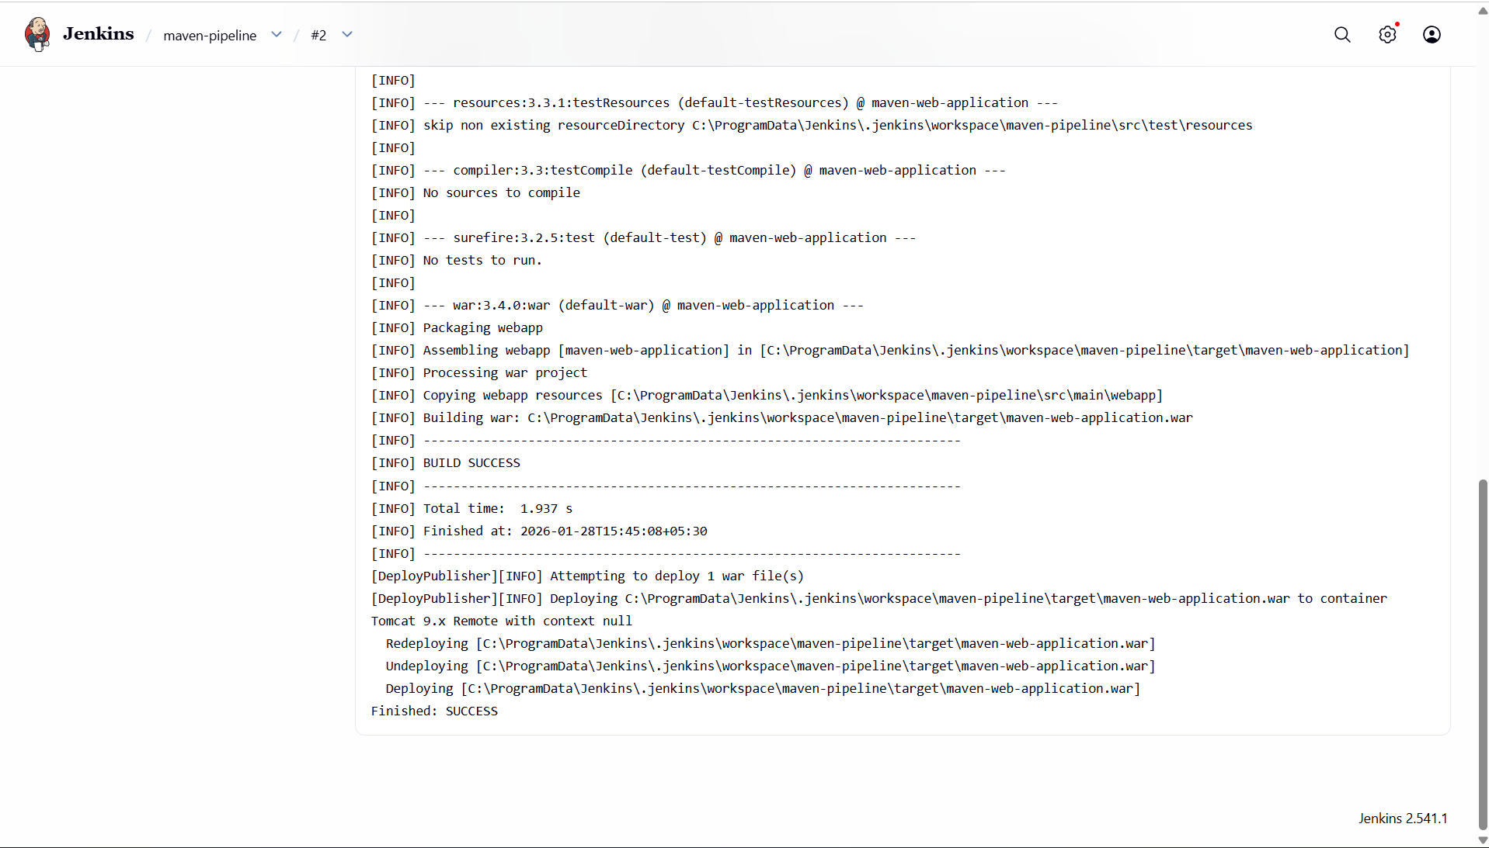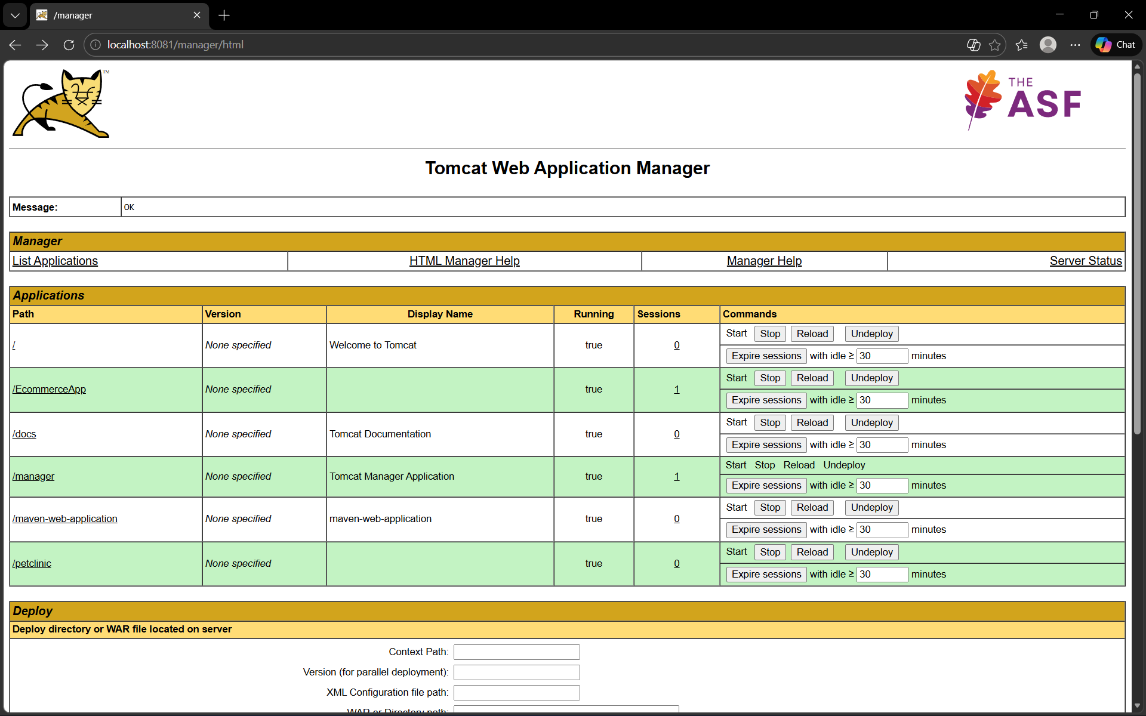
Step 12: We can check the pipeline is build or not in the tomcat server here there will be available. Here the file name maven-web-application is our pipeline

Step 13: On clicking the maven-web-Application we can see the web_application as output.



