Kubernetes Deployment Management
Name: Gowrish
This document explains the creation and management of Kubernetes Deployments using namespaces, ReplicaSets, and Pods.

1. Writing deployment.yaml
• Defined a Deployment named fitness-deployment
• Deployment runs inside namespace: namespace-ns
• Configured 5 replicas (pods)
• Each pod runs image: gowrish006/fitness-app:v1.0.0 on port 3101
• Label app: fitness connects Deployment → ReplicaSet → Pods
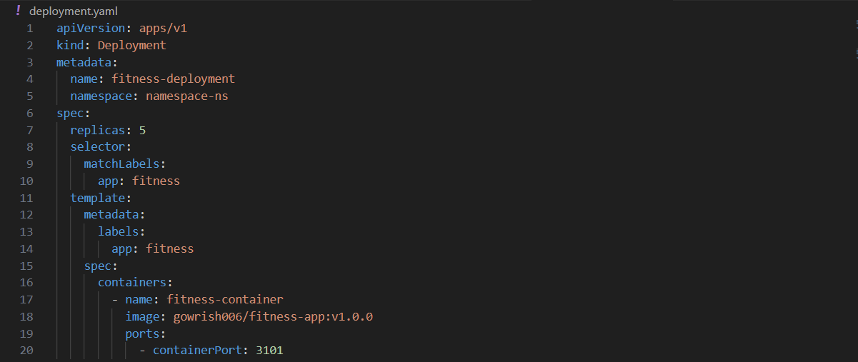

2. Creating Namespace
• Kubernetes does not auto-create namespaces
• Created namespace using: kubectl create ns namespace-ns
• Verified namespace using: kubectl get ns
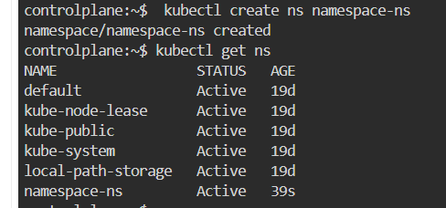

3. Applying Deployment
• Applied deployment using: kubectl apply -f deployment.yaml
• Deployment and ReplicaSet were created successfully
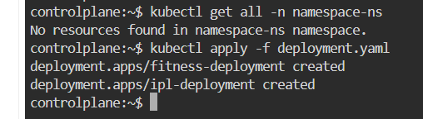

4. Checking Resources
• Used: kubectl get all -n namespace-ns
• Initially pods were in ContainerCreating state
• After image pull, pods moved to Running state
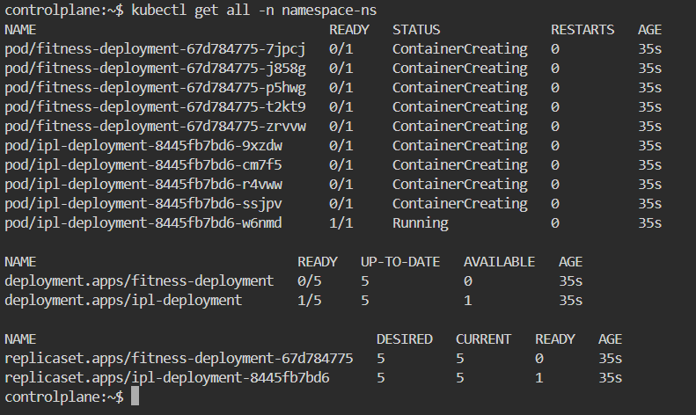

5. Verifying Deployment
• Used: kubectl get deployments -n namespace-ns
• Replicas: 5 desired | 5 updated | 5 available
• Strategy: RollingUpdate
• Deployment is stable and healthy
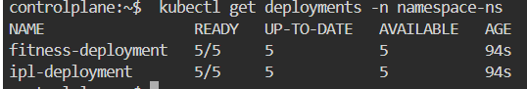

6. Describing Deployment
• Used: kubectl describe deployment fitness-deployment
• Confirms image, replica count, and status
• Shows events like scaling from 0 to 5
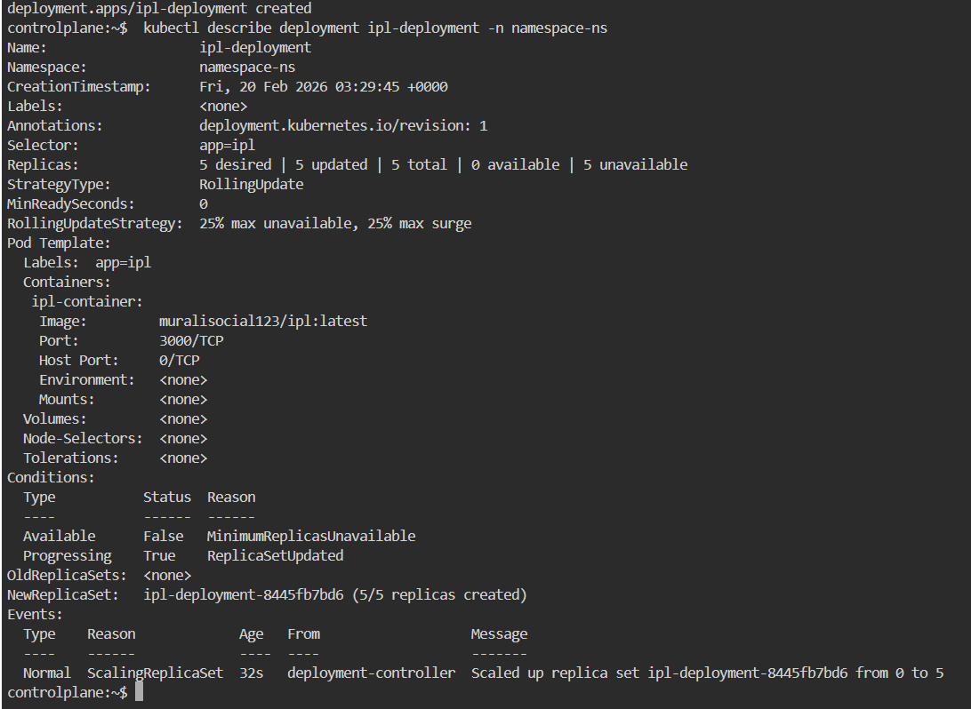

7. Describing Pod
• Used: kubectl describe pod <pod-name>
• Pod is controlled by ReplicaSet
• ReplicaSet is controlled by Deployment
• Confirms container image and port configuration
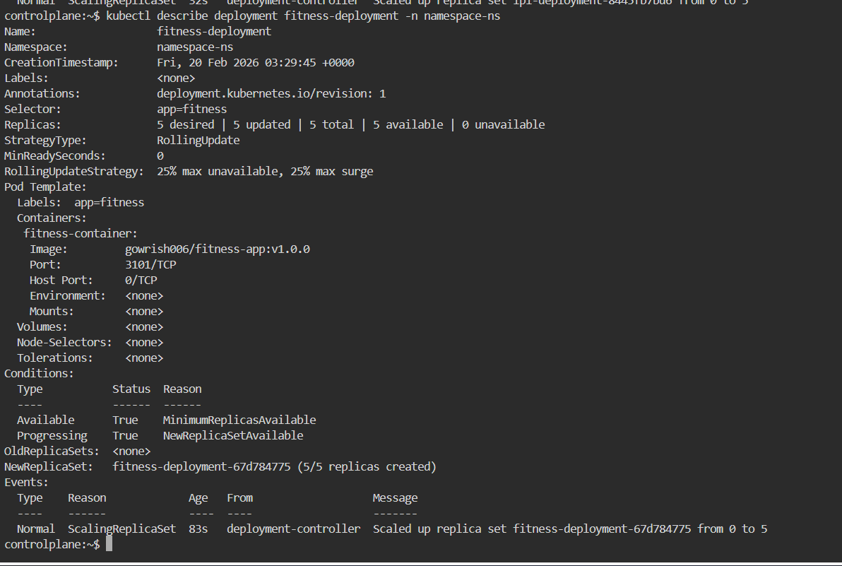

8. Rollout History
• Used: kubectl rollout history deployment ipl-deployment
• Currently only Revision 1 exists
• After updating image and reapplying, new revisions will appear
