Linux Commands Practical Steps

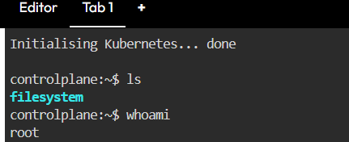
whoami command shows logged in user
ls: Lists all files and folders in the current directory.

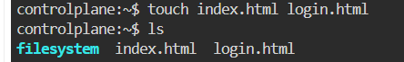
touch – Creates a new empty file or updates the timestamp of an existing file.

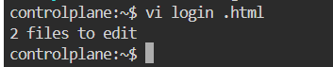
vi – Opens a file in the Vi text editor to view or edit its contents.
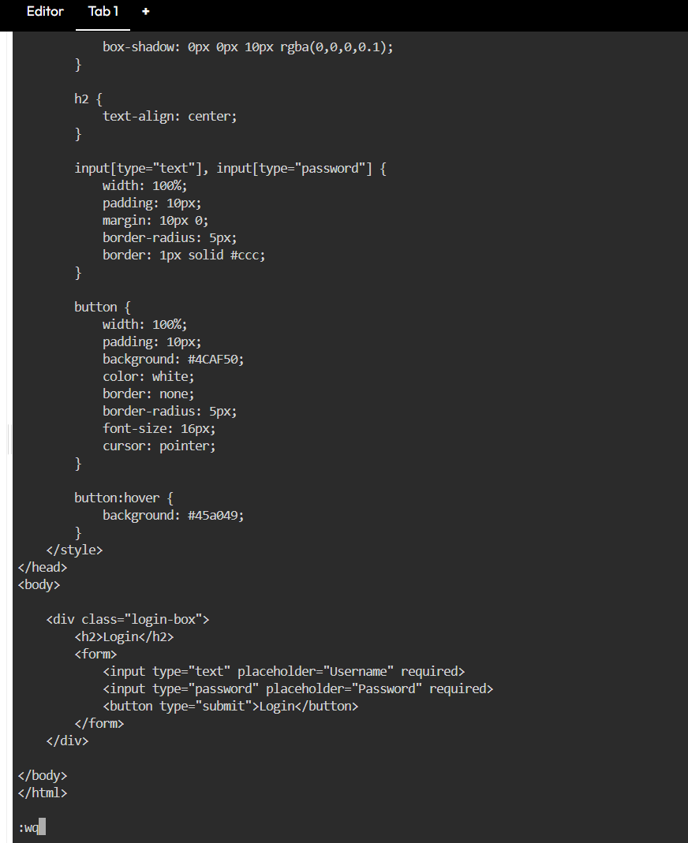
vi command opens login.html file for editing and :wq to exit.
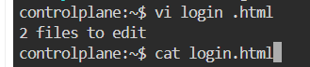
cat command displays the content of login.html.
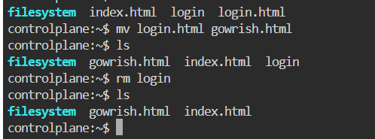
mv command-renames login.html to gowrish.html and rm deletes login file.
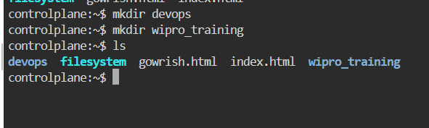
mkdir – Creates a new directory (folder) in the current location.
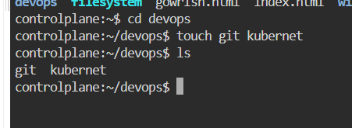
cd – Changes the current working directory to the specified folder.
EXP: cd devops and touch creates git and kubernet files.
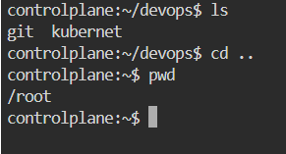
pwd command shows the current working directory.
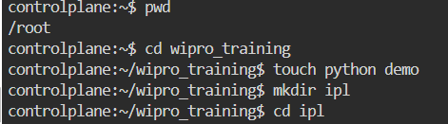
touch and mkdir commands create files and folders inside wipro_training.
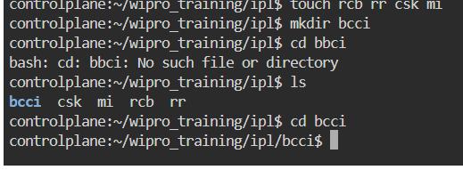
touch creates multiple files (rcb, rr, csk, mi) and mkdir creates bcci folder. cd bcci moves into that folder.
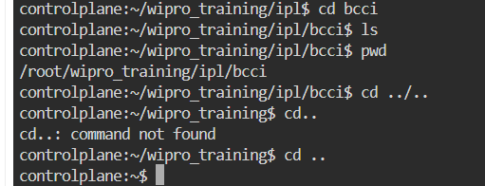
ls and pwd show files and path. cd .. is used to move back to parent directory.

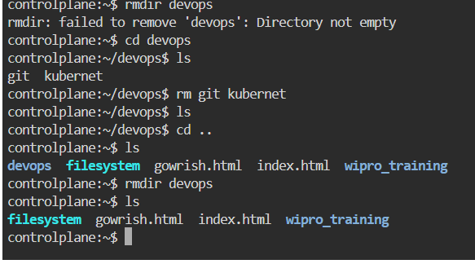
rmdir cannot delete the directory if it contains files. So we have to delete the files in the dir to delete the directory.
rm -rf command is used to delete the directories directly
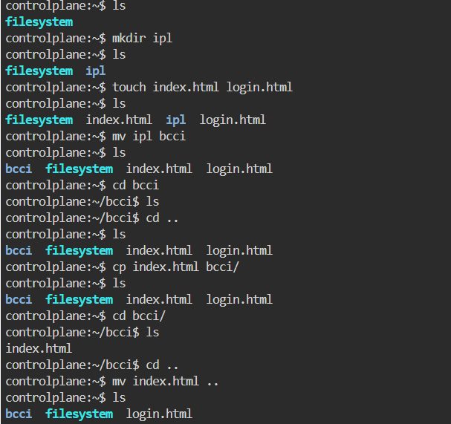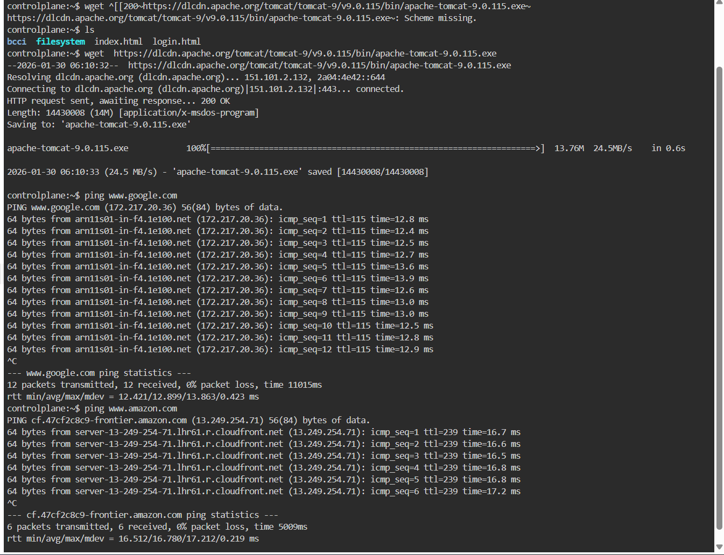
Cp -Here we use cp command to add the files into the directories

wget https://dlcdn.apache.org/tomcat/...exe
Downloads the Apache Tomcat installer file from the internet.
The file will be saved in the current directory.
ping www.google.com
Checks whether Google server is reachable from your system.
Used to test internet connectivity and network response.
ping www.amazon.com
Checks network connection between your system and Amazon server.
Shows packet response time and connectivity status.

ADD USER:
COMMAND: sudo adduser username
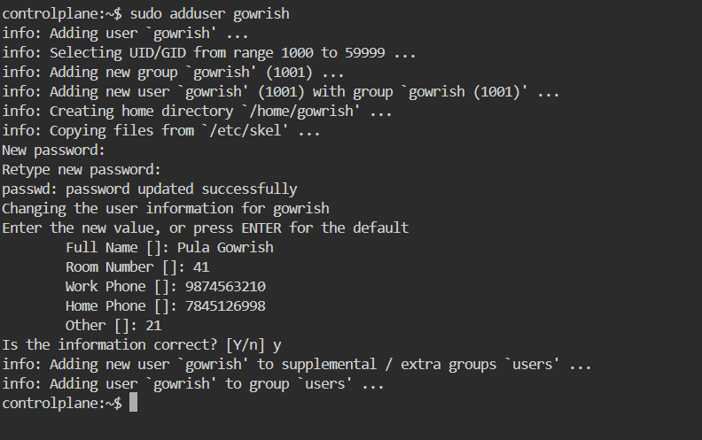
• sudo adduser gowrish creates a new user account named gowrish in the Linux system.
• It also sets up the user’s home directory and prompts to assign a password and user details.

SYSTEM COMMANDS:
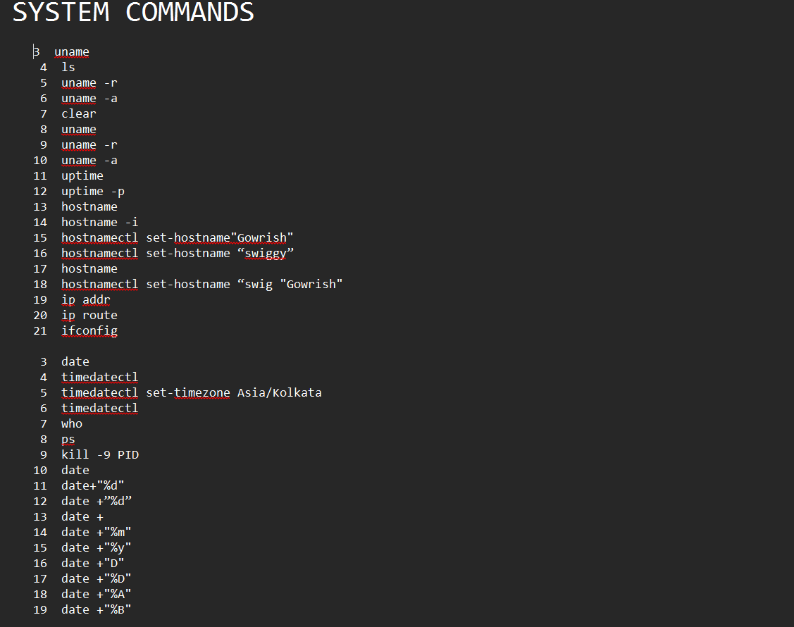
- uname : used to get type of OS
- uname -r : used to get kernel version of our OS
- uname -a : used to get full info about OS
- clear: this command is used to clear the clear (or) you can use ctrl + l as a short cut
- uptime : used to get since how long our system is in running state
- uptime -p : this will give only time
- hostname: used to get private dns name of our system
- hostname -i : used to get private ip of our system
- hostnamectl set-hostname “swiggy” : used to change hostname
- ip addr : used to get private IP
- ip route : used to get private IP
- ifconfig : used to get private IP
- date : to get todays date
- timedatectl : used to get timezones
- timedatectl set-timezone Asia/Kolkata : used to change Timezone to IST
- who : used to see how many users have been loggin into your system
- whoami : used to see the current user.
- ps : used to see the running processors in system
- kill -9 PID : used to kill a processor
- date : Shows system date and timestamp
- date +”%d” : Prints day of the month (01-31)
- date +”%m” : Prints the month of the year 01-12
- date +”%y” : Prints only the last two digits of Year
- date +”%H” : Prints the hour 00-23
- date +”%M” : Prints the Minute of the hour 00-59
- date +”%S” : Prints the current seconds count in the minute (00-60)
- date +"%D" : Prints Date in MM/DD/YY
- date +”%F” : Prints only the Full date as YYYY-MM-DD
- date +”%A” : Prints the Day of the Week Saturday-Sunday
- date +”%B” : Prints the month between January-December

HARDWARE COMMANDS:

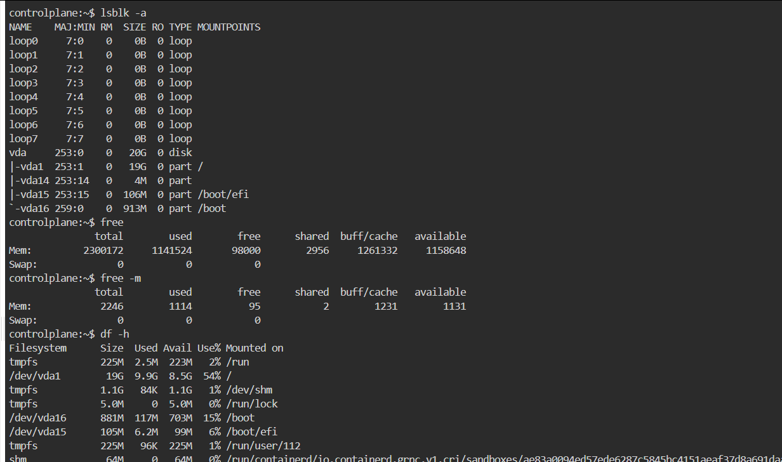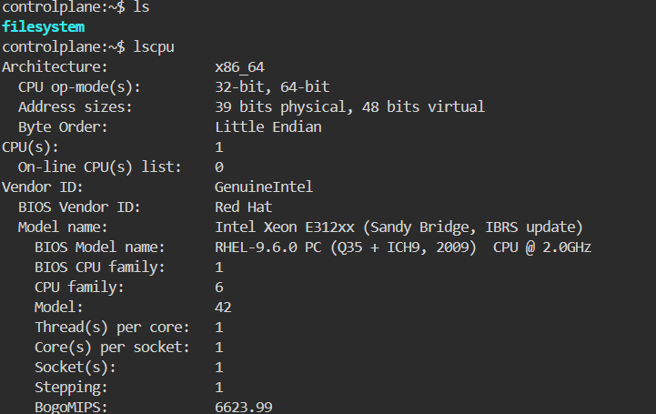

- lscpu (or) cat /proc/cpuinfo : Displays information about the CPU architecture
- lsblk -a : Lists the information about all the block devices attached to the system
- free (or) cat /proc/meminfo: Displays system memory(RAM) details in KB
- free -m : Displays system memory(RAM) details in MB
- df -h : Report file system disk space usage in human readable languages

GREP (Global Regular Expression Print):
GREP (Global Regular Expression Print):

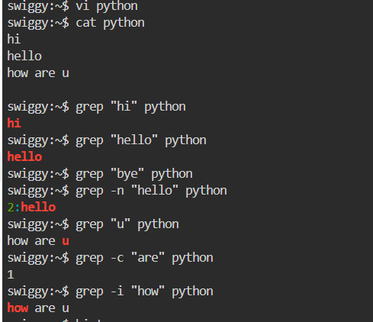

It is used to search for a word in a file
SYNTAX: grep “word” filename
- grep “word” filename : used to search for a word in a file
- grep -n “word” filename : it prints the data along with line numbers
- grep -c “word” filename : it prints no of occurances of a word
- grep -i “word” filename : used to search for a case-sensitive

CHMOD ( CHANGE MODE):

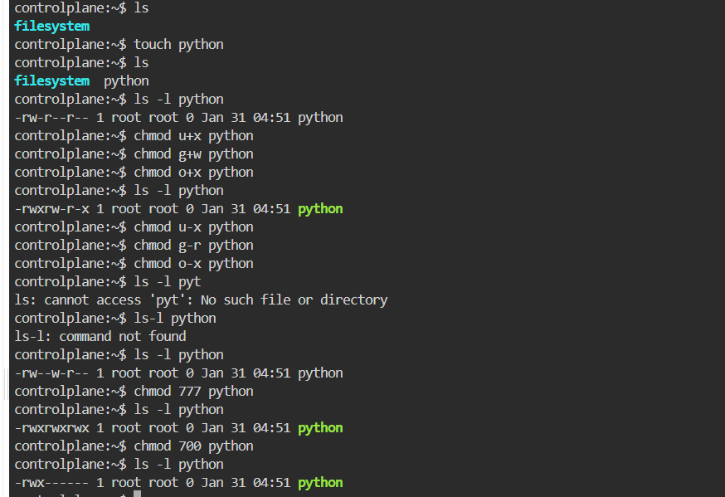 Chmod command changes the permissions of a file or dire (read,write and executes) access for users,group and others.

