1)INSERT

create database db1

use db1

create table employee(

id int primary key,

name1 varchar(50),

gender varchar(50),

deptid int

);

insert into employee values(1,'siva','male',3);

insert into employee values(2,'hari','male',2);

insert into employee values(3,'gowsalya','female',1);

insert into employee values(4,'john','male',4);

insert into employee values(5,'anitha','female',1);

select * from employee

create table dept2(

d_id int ,

deptname varchar(50)

);

delete from dept2;

insert into dept2 values(1,'IT');

insert into dept2 values(2,'CS');

insert into dept2 values(3,'EEE');

insert into dept2 values(4,'DB');

select * from dept2;

select * from employee;

create view vm

as

select id,name1,gender,deptname from employee join dept2 on employee.deptid = dept2.d_id;

select * from vm;

insert into vm values(6,'mike','male','IT');

create trigger trig on vm Instead of insert as begin

select * from inserted

select * from deleted end

alter trigger trig on vm Instead of insert

as

begin

declare @a int

select @a=d_id from dept2 join inserted on inserted.deptname=dept2.deptname

if(@a is null)

begin

return

end

insert into employee(id,name1,gender,deptid)

select id,name1,gender,@a from inserted

end

OUTPUT: 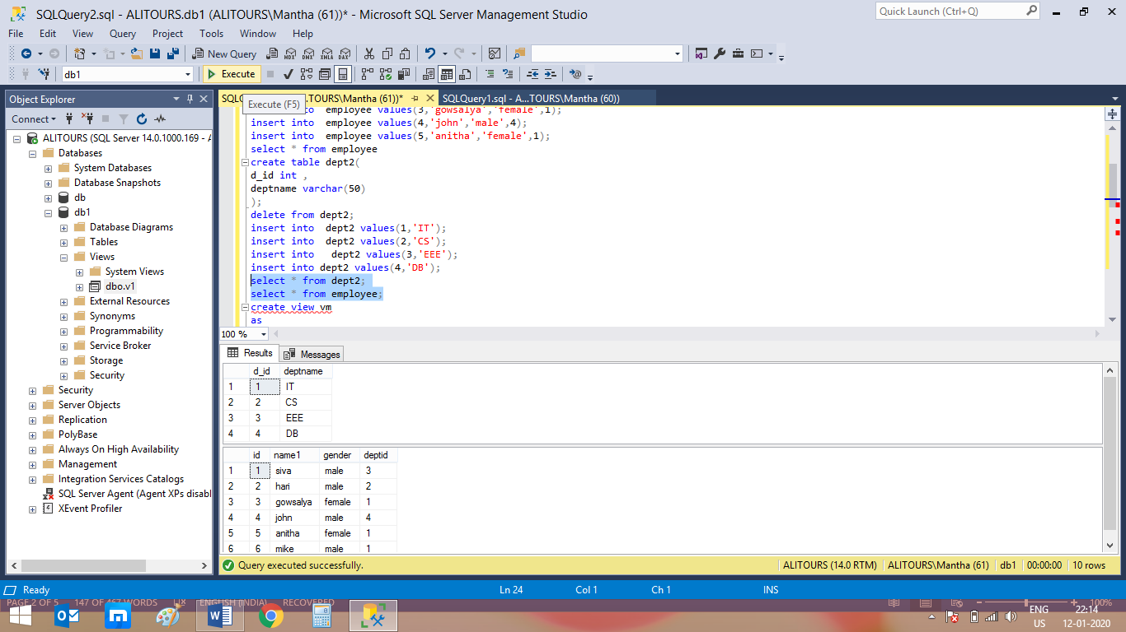

2)Delete

create database db1

use db1

create table employee(

id int primary key,

name1 varchar(50),

gender varchar(50),

deptid int

);

insert into employee values(1,'siva','male',3);

insert into employee values(2,'hari','male',2);

insert into employee values(3,'gowsalya','female',1);

insert into employee values(4,'john','male',4);

insert into employee values(5,'anitha','female',1);

select * from employee

create table dept2(

d_id int ,

deptname varchar(50)

);

delete from dept2;

insert into dept2 values(1,'IT');

insert into dept2 values(2,'CS');

insert into dept2 values(3,'EEE');

insert into dept2 values(4,'DB');

select * from dept2;

select * from employee;

create view view2

as

select id,name1,gender,deptname from employee join dept2 on employee.deptid = dept2.d_id;

select * from view2;

delete from view2 where id=1;

create trigger trig1 on view2 Instead of delete as begin

delete from employee where id in (select id from deleted)

end;

OUTPUT: 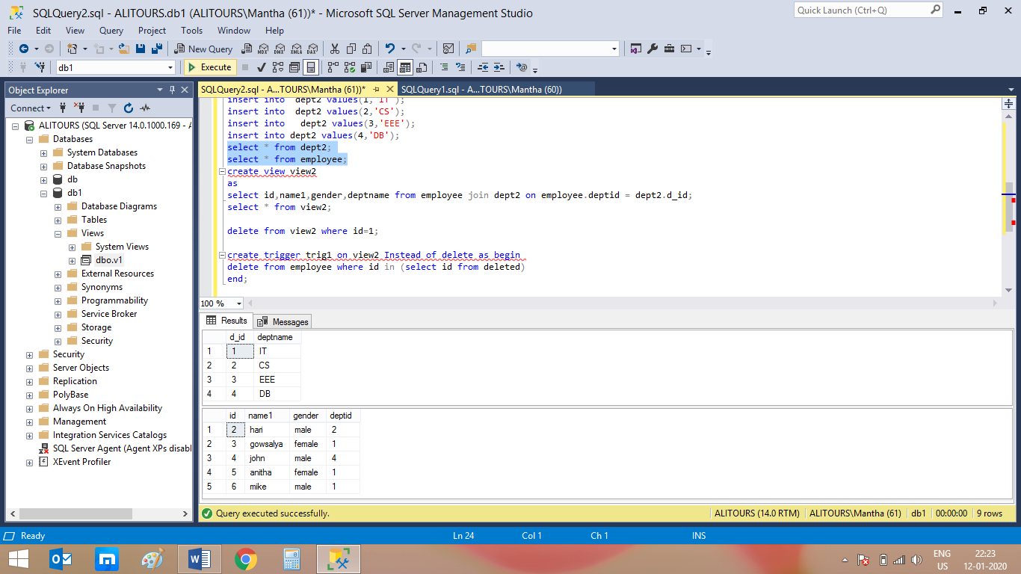

Update

create database db1

use db1

create table employee2(

id int primary key,

name1 varchar(50),

gender varchar(50),

deptid int

);

insert into employee2 values(1,'siva','male',3);

insert into employee2 values(2,'hari','male',2);

insert into employee2 values(3,'gowsalya','female',1);

insert into employee2 values(4,'john','male',4);

insert into employee2 values(5,'anitha','female',1);

select * from employee2

create table audittb1(

id int ,

auditdata varchar(50)

);

select * from audittb1;

select * from employee2;

create trigger trig1 on employee2 Instead of update as begin

select * from inserted

select * from deleted

end;

update employee2 set name1='john',gender='male' where id=5;

alter trigger trig1 on employee2 instead of update as begin

declare @id int;

declare @oldname varchar(20),@newname varchar(20), @oldgender varchar(20),@newgender varchar(20), @audit varchar(20),@oldid int,@newid int

select * into #temptable from inserted

while(exists(select id from #temptable))

begin

set @audit='';

select top 1 @id=id,@newname=name1,@newgender=gender,@newid=deptid from #temptable;

select @oldid=deptid,@oldname=name1,@oldgender=gender,@oldid=deptid from deleted where id=@id;

set @audit='employee with id='+cast(@id as varchar(4))+'changed'

if(@oldname <> @newname)

set @audit= @audit+'name from'+@oldname+'to'+@newname

if(@oldgender <> @newgender)

set @audit= @audit+'gender from'+@oldgender+'to'+@newgender

insert into audittb1 values(@audit)

delete from #temptable where id=@id;

end

end

OUTPUT:UPDATE IN AUDIT TABLE

4)

create table pagination(

id int primary key,

rowname varchar(50)

);

insert into pagination values(1,"john");

insert into pagination values(2,"siva");

insert into pagination values(3,"hari");

insert into pagination values(4,"ani");

insert into pagination values(5,"kiru");

insert into pagination values(6,"asmi");

insert into pagination values(7,"nandhini");

insert into pagination values(8,"asmi");

insert into pagination values(9,"arun");

insert into pagination values(10,"aravind");

insert into pagination values(11,"swathiga");

select * from pagination;

call ne1(2,2);

//STORED PROCEDURE:

CREATE DEFINER=`root`@`localhost` PROCEDURE `ne1`(in pagenum int,in num int)

BEGIN

declare a,b int;

set a=(pagenum-1)*num;

select id,rowname from pagination limit num offset a;

END

//OUTPUT: 