Scenario :1 Using Restful web service:

Get Method- <http://localhost:8080/payment>

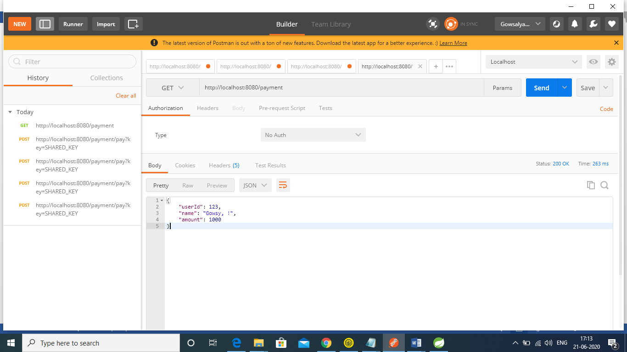

Post Method-http://localhost:8080/payment/pay? Key=SHARED_KEY

Scenario :1 Using sandbox and pg-checksum jar

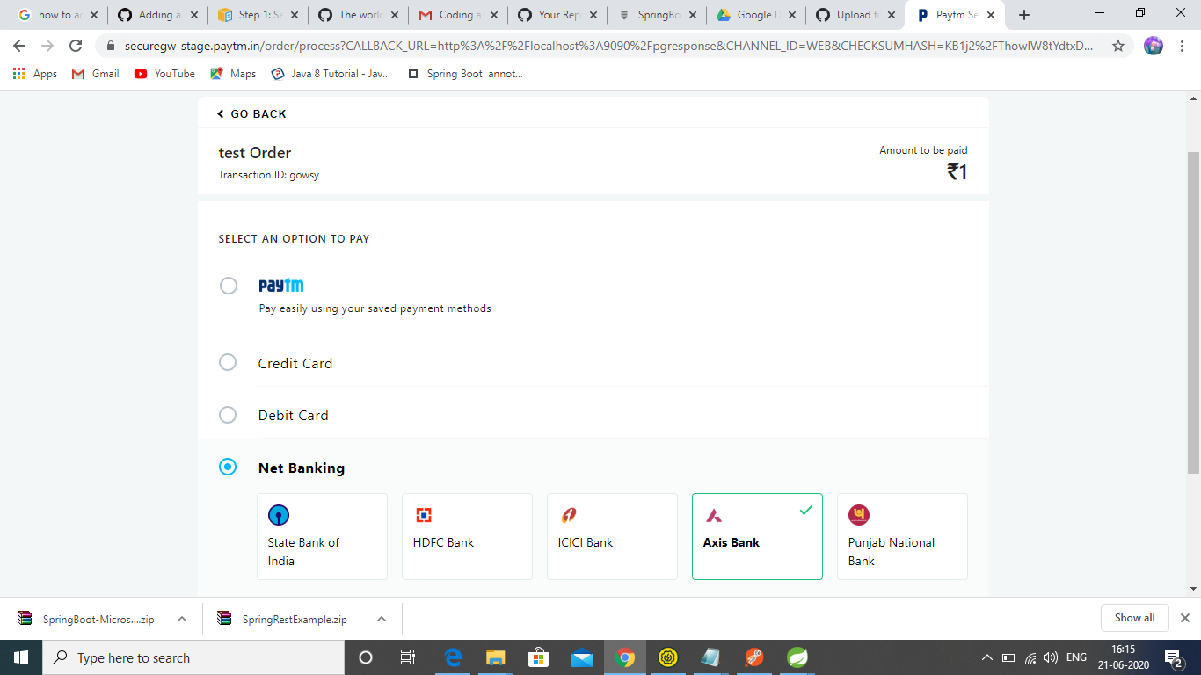

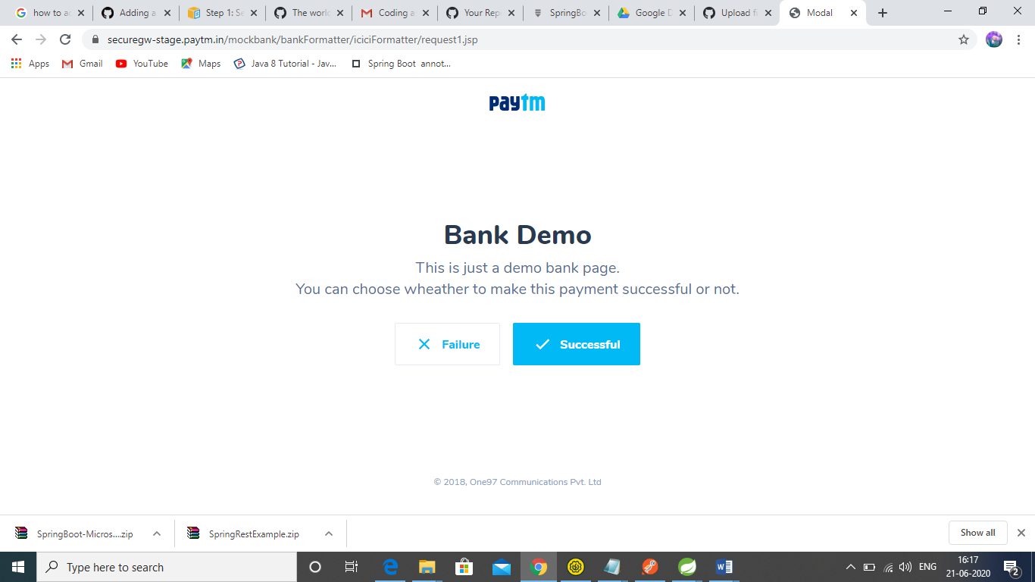

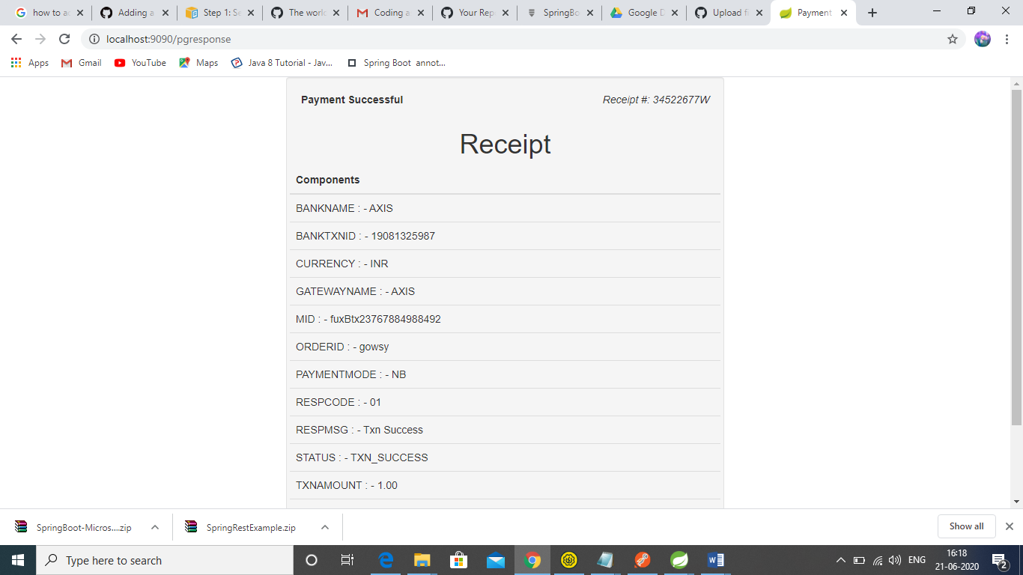

Scenario:2-

