SCOF - Supply Chain Cognitive Orchestration Framework
  - Complete End-to-End Walkthrough, System Topology, and Feature-by-Feature Verification Manual

1. System Architecture & Topology Overview
The Supply Chain Cognitive Orchestration Framework (SCOF) is an enterprise multi-agent autonomous control system designed to arbitrate cross-tier supply disruptions, simulate counterfactual interventions, and provide human-in-the-loop (HITL) auditability for high-tech manufacturing networks.

Microservices Fleet Architecture
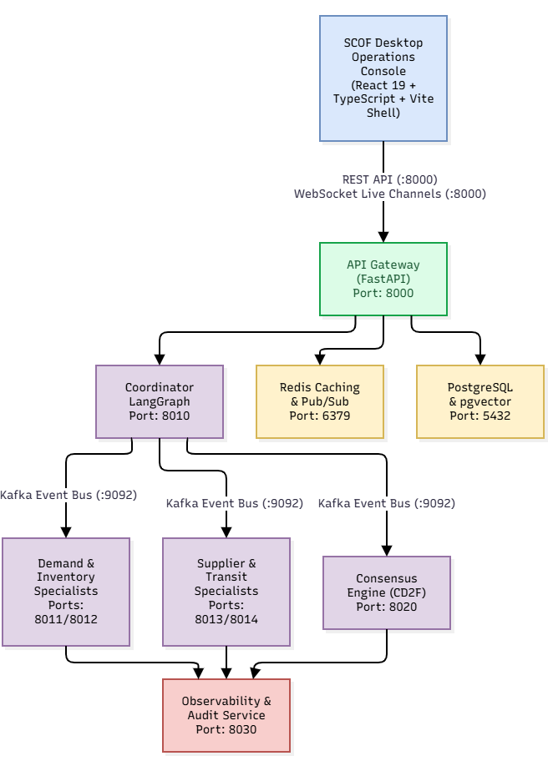

1.2 Enterprise Domain Scope: Peninsular India Electronics Network
The primary demonstration environment operates on the mvp-electronics domain profile, modeling 25 realistic supply disruption scenarios across the South Indian semiconductor corridor:
- Tier-1 Semiconductor & Component Suppliers:
  - sup-01: SPEL Semiconductor (Maraimalai Nagar, Chennai, Tamil Nadu)
  - sup-02: Continental Device India - CDIL (Electronic City, Bengaluru, Karnataka)
  - sup-03: Kaynes Technology India (Koorgalli Industrial Area, Mysuru, Karnataka)
  - sup-04: Syrma SGS Technology (Bargur Industrial Estate, Tamil Nadu)
  - sup-05: Centum Electronics (Yelahanka, Bengaluru, Karnataka)
  - sup-06: Vinyas Innovative Technologies (Hebbal Industrial Area, Mysuru, Karnataka)
  - sup-07: SFO Technologies NeST (Kakkanad, Kochi, Kerala)
  - sup-08: Sahasra Electronic Solutions (Hyderabad, Telangana)
- Central Assembly Hub:
  - mfg-01: Sriperumbudur High-Tech Assembly Plant (Sriperumbudur, Tamil Nadu)
- Strategic Buffer Warehouses:
  - wh-01: Hosur Logistics Buffer Warehouse (Hosur, Tamil Nadu)
  - wh-02: Whitefield Inland Container Depot (Bengaluru, Karnataka)
  - wh-03: Oragadam JIT Supplier Warehouse (Oragadam, Tamil Nadu)
  - wh-04: Sri City FTWZ Logistics Center (Sri City, Andhra Pradesh)
- Multi-Modal Gateways & Transit Corridors:
  - dc-01: Chennai Port Container Terminal
  - dc-02: Cochin Port Vallarpadam ICTT
  - dc-03: Hyderabad Aerotropolis Air Cargo Gateway
  - Arterial freight lanes along NH44, NH48, and NH544

2. Phase 0: System Initialization & Pre-Flight Verification

Step 0.1: Container Infrastructure Startup
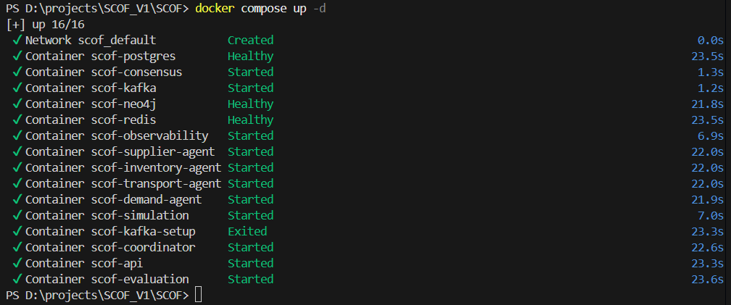
- Spawns the underlying message bus (zookeeper, kafka), operational database (postgres with pgvector), cache layer (redis), and knowledge graph (neo4j).
- Bootstraps the backend microservices fleet (scof-api, scof-coordinator, scof-demand-agent, scof-inventory-agent, scof-supplier-agent, scof-transport-agent, scof-consensus, scof-observability, scof-simulation).
- Executes database migrations, populates the scof schema, and seeds baseline supply chain topology tables.
Verification:
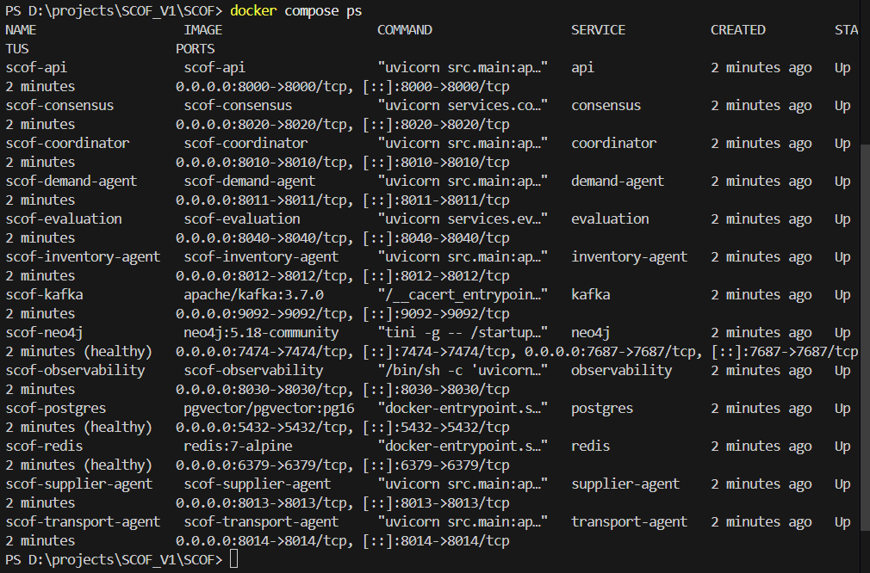

Step 0.2: Desktop Console Launch
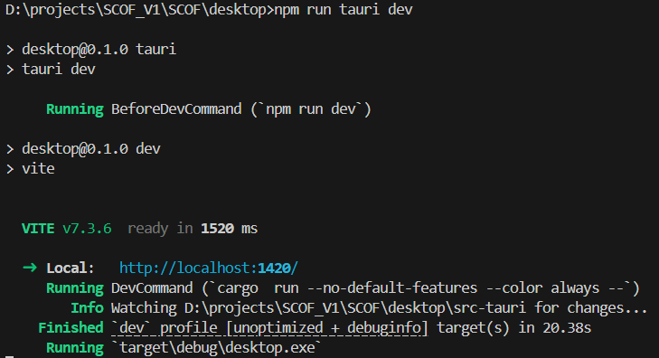
- Starts the Vite bundler compiling the React 19 application.
- Serves the application locally (typically at http://localhost:5173).
- Initializes the global connection state manager (desktop/src/state/connection.tsx), establishing REST polling and WebSocket connections to ws://localhost:8000/ws/dashboard/state, ws://localhost:8000/ws/decisions/live, and ws://localhost:8000/ws/agents/activity.

Step 0.3: Global Header Bar & Connectivity Check
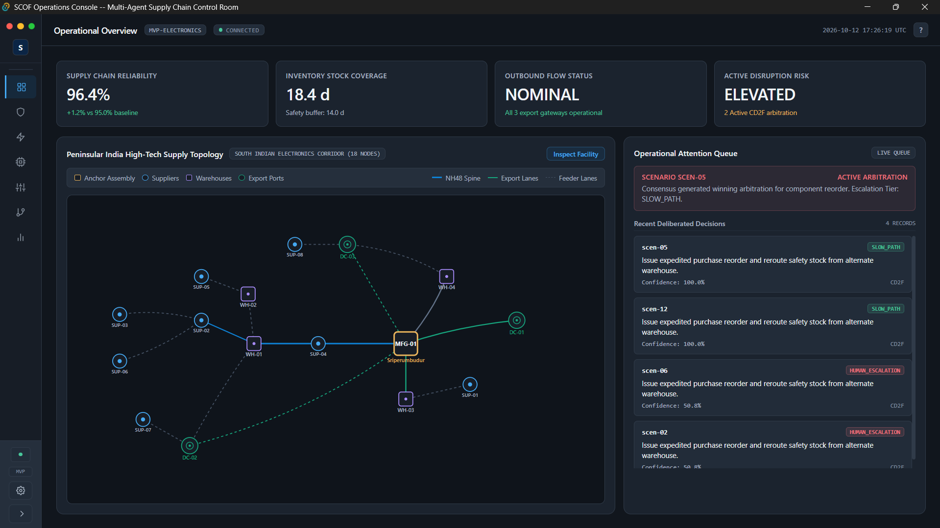

3. Phase 1: Global Navigation & Common Utilities

Step 1.1: Navigation Rail Expansion & Workspaces listing
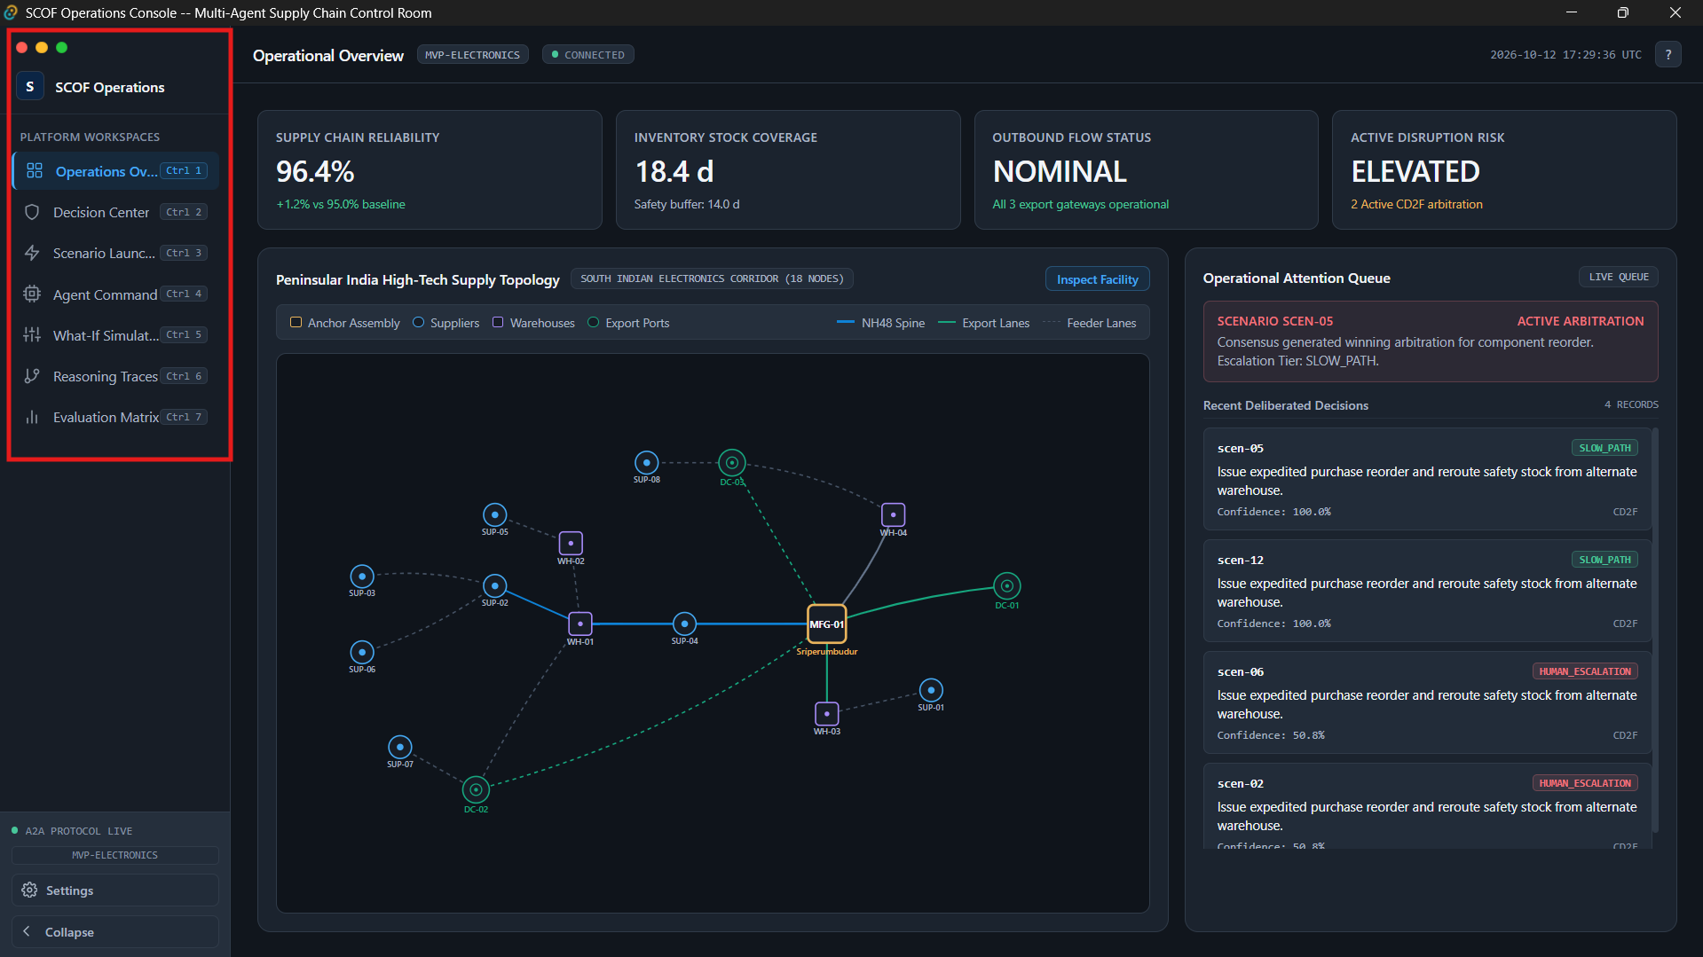
Note: Highlighted in RED

4. Phase 2: Operations Overview
Shortcut key: Ctrl + 1

Step 2.1: Key Performance Indicator (KPI) Metric Cards
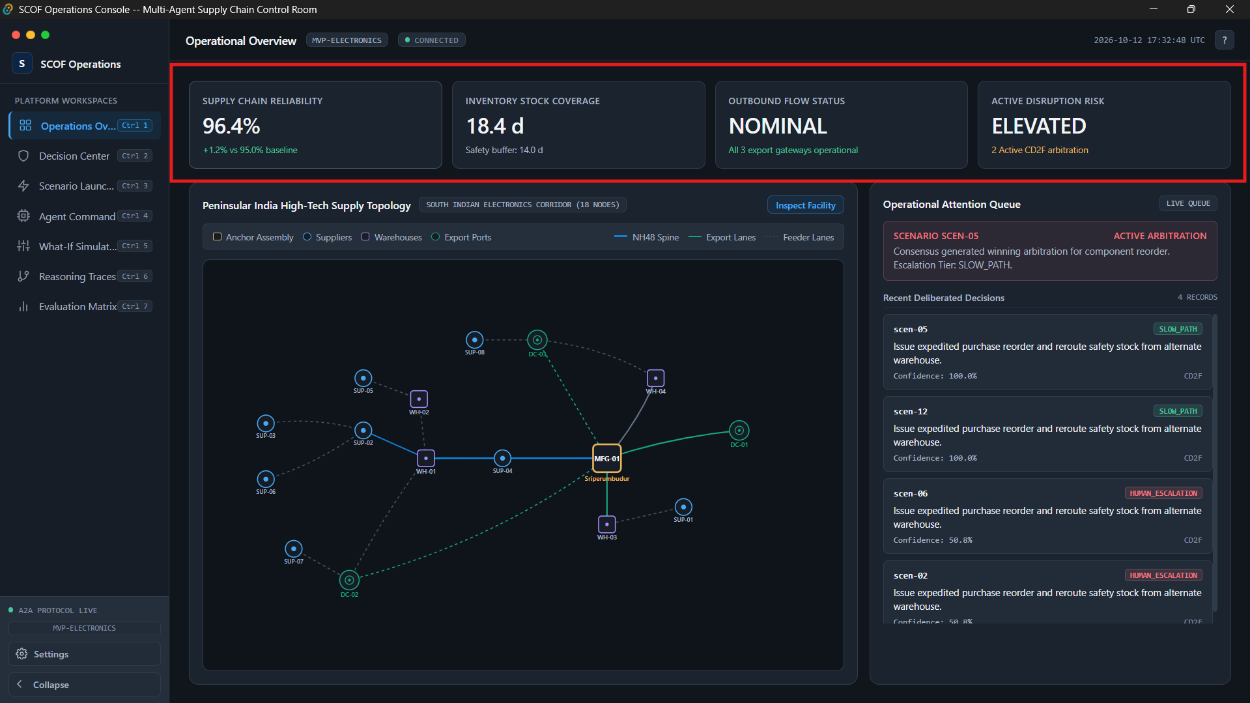
Note: Highlighted in RED

- Supply Chain Reliability: Displays network reliability index (nominal benchmark: 96.4%, with target variance indicator +1.2%).
- Inventory Stock Coverage: Shows aggregate buffer inventory across all warehouses (e.g., 18.4 days vs safety threshold of 14.0 days).
- Active Disruption Risk: Displays NOMINAL badge during steady state, switching to ELEVATED or CRITICAL when disruptions are in flight.
- Specialist Agents Online: Fleet status displaying 4 / 4 with active multi-agent discovery confirmation.

Step 2.2: Interactive Supply Network Topology Map
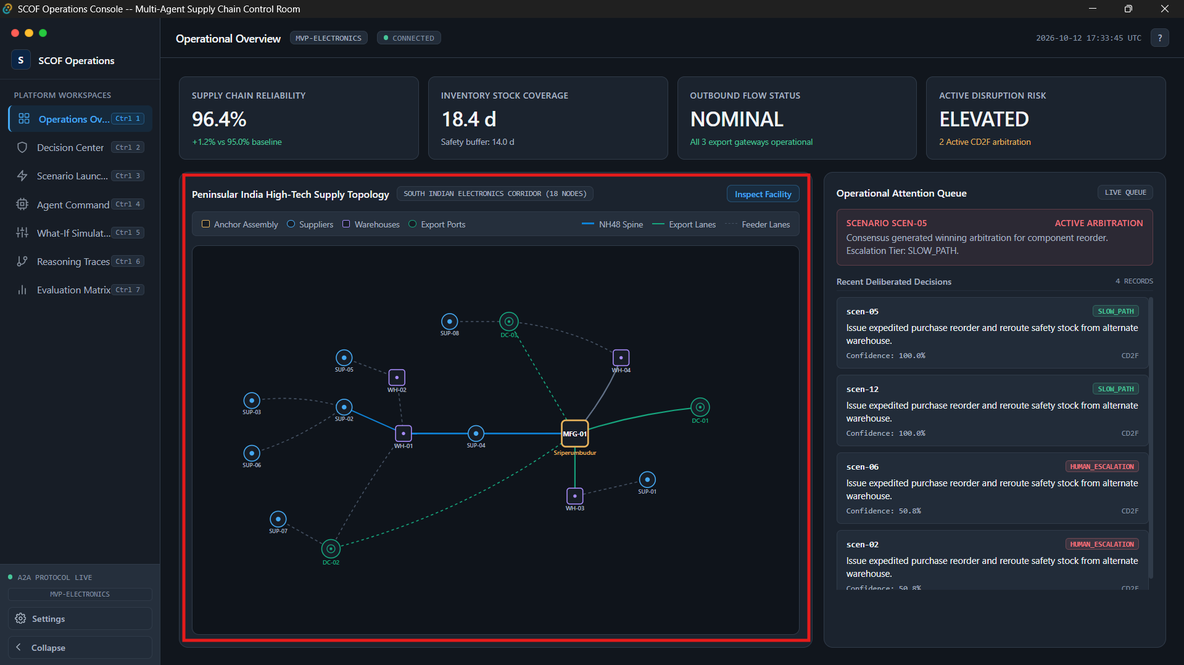
Note: Highlighted in RED

- Supplier Cluster: Displays tier-1 suppliers across Chennai (sup-01), Bengaluru (sup-02, sup-05), Mysuru (sup-03, sup-06), Bargur (sup-04), Kochi (sup-07), and Hyderabad (sup-08).
- Assembly Hub: Central node mfg-01 representing the Sriperumbudur manufacturing campus.
- Logistics Nodes: Buffer warehouses (wh-01 to wh-04) and multimodal container ports (dc-01, dc-02, dc-03).
- Corridor Vectors: Freight lanes connecting nodes with directional arrows and state glow.

Step 2.3: Operational Alerts Banner & Recent Consensus Stream
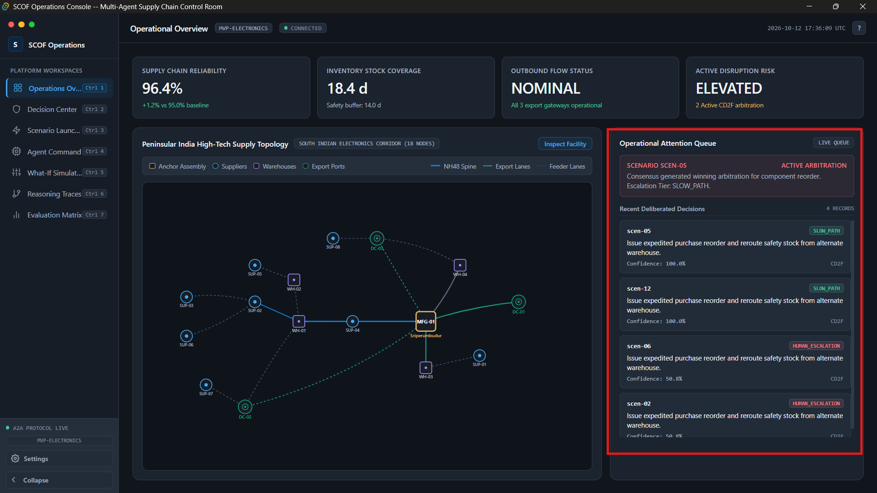
- Active Disruption Alerts: In nominal state, displays ALL SYSTEMS NOMINAL - NO ACTIVE DISRUPTIONS.
- Recent Decisions Stream: Displays cards summarizing the latest consensus arbitrations from PostgreSQL (scof.decisions), showing Scenario ID, Escalation Tier (FAST_PATH or HUMAN_ESCALATION), final recommendation snippet, and consensus confidence percentage.

5. Phase 3: Scenario Launcher
Shortcut key: (Ctrl + 3)
Primary Role: Catalog browsing, custom parameter formulation, and two-stage idempotent dispatch of disruption shocks into the live Kafka message bus.

Step 3.1: Scenario Catalog Browsing & Filtering
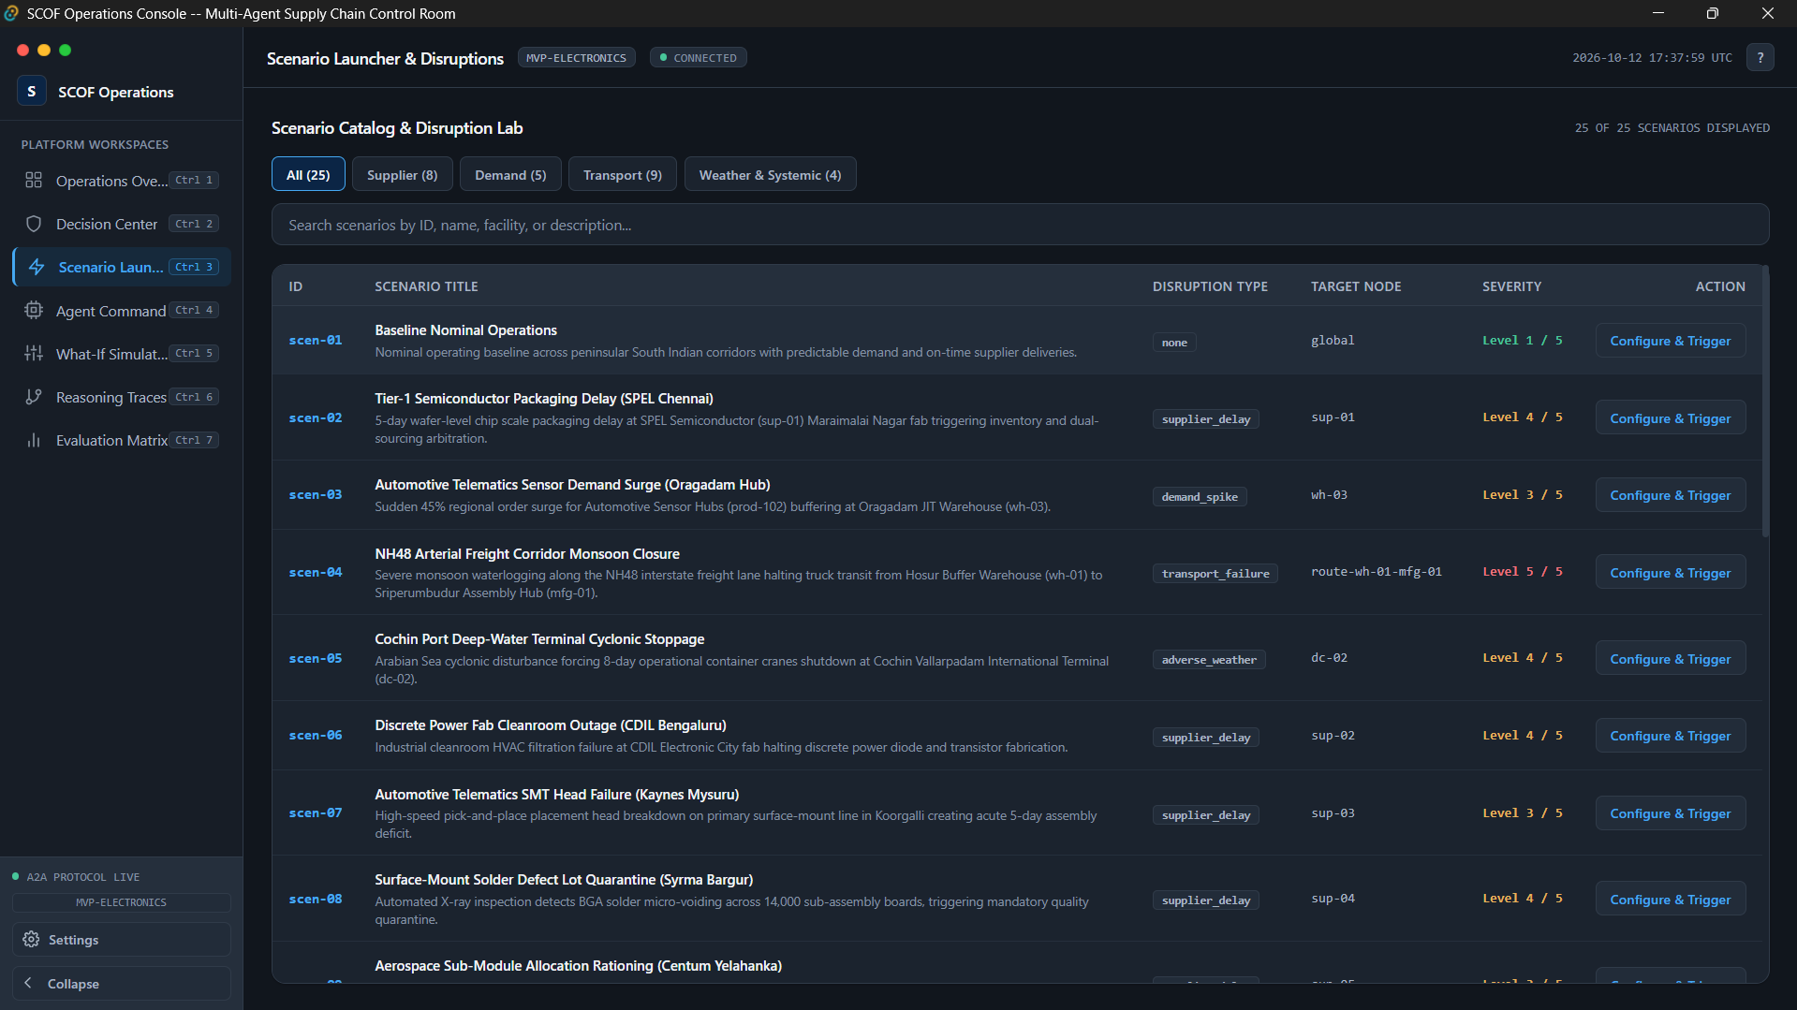

Step 3.2: Configuration Drawer & In-Session Draft Form
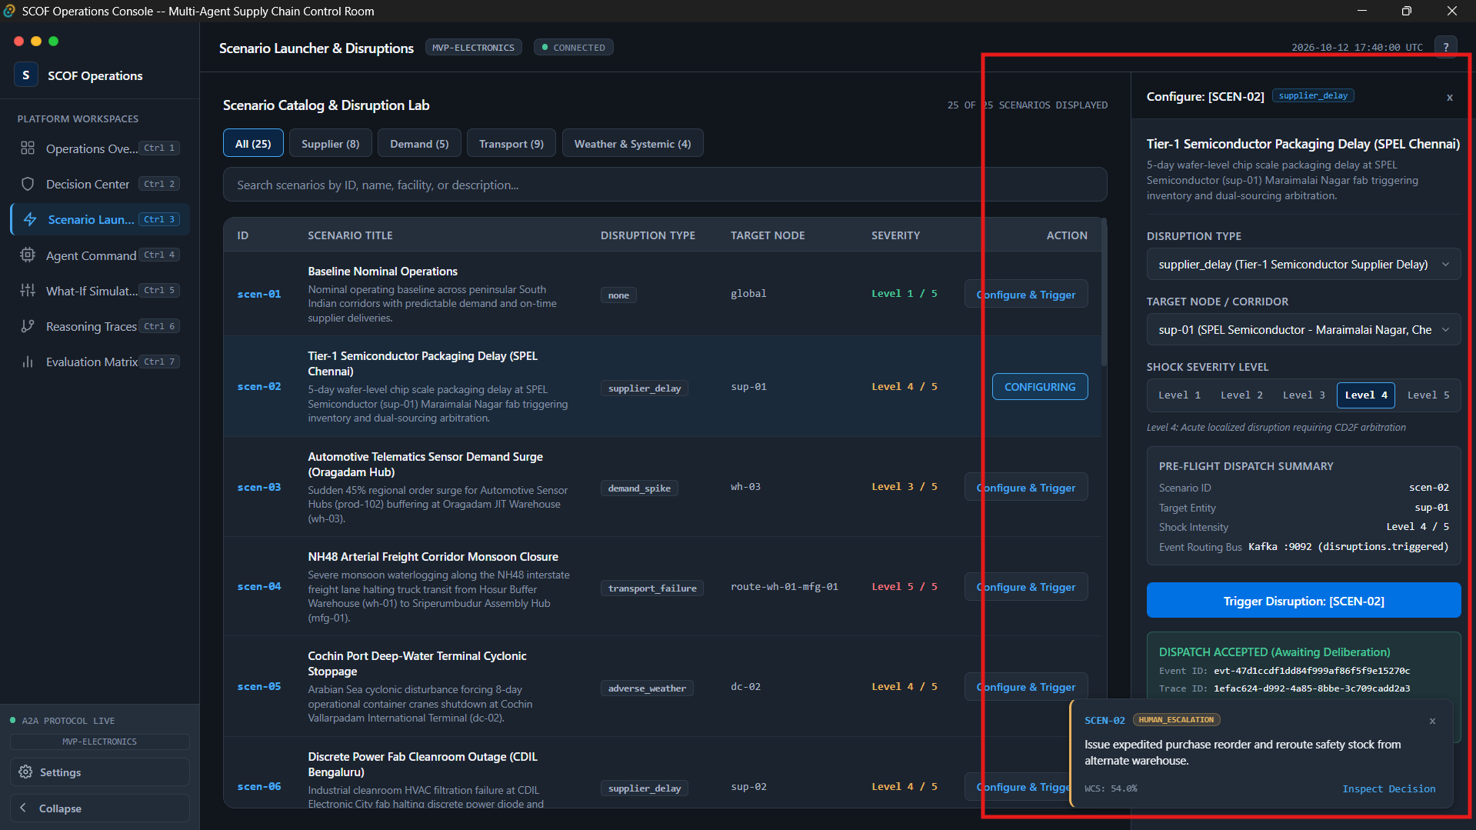
The drawer displays an immediate Accepted Outcome Banner:
- Status: ACCEPTED (Green border)
- Event ID: evt-...
- Trace ID: trace-...
- Notification: Disruption accepted by API Gateway. Awaiting multi-agent deliberation on Kafka bus

6. Phase 4: Agent Command Center
Shortcut key: Ctrl + 4
Primary Role: Live monitoring of autonomous specialist fleet activity, task execution states, and emitted claims.

Step 4.1: Specialist Fleet Telemetry Table
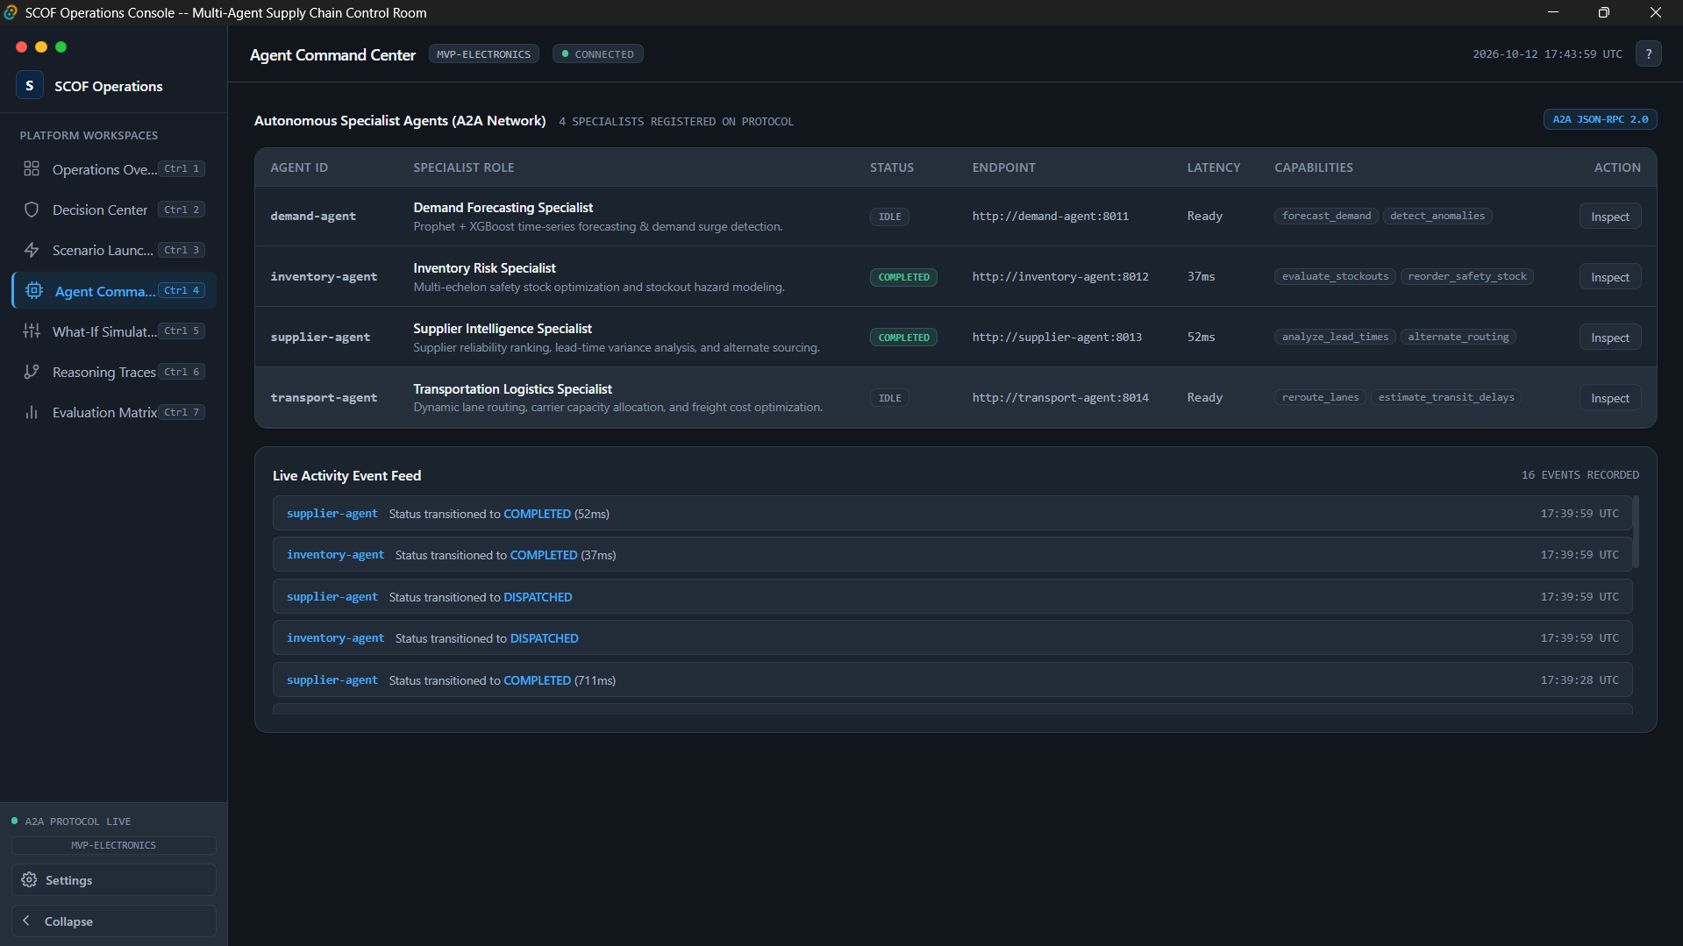
- Specialist Agent Fleet Cards:
  - Demand Forecasting Specialist (scof-demand-agent, port 8011)
  - Inventory Risk Specialist (scof-inventory-agent, port 8012)
  - Supplier Intelligence Specialist (scof-supplier-agent, port 8013)
  - Logistics & Transit Specialist (scof-transport-agent, port 8014)
- Status Indicators: Each specialist displays operational state (IDLE, ANALYZING, CLAIM_EMITTED, or COMPLETED).
- Telemetry Metrics: Heartbeat timestamp, latency (ms), and active correlation trace ID.

Step 4.2: Real-time Claims & Activity Inspection
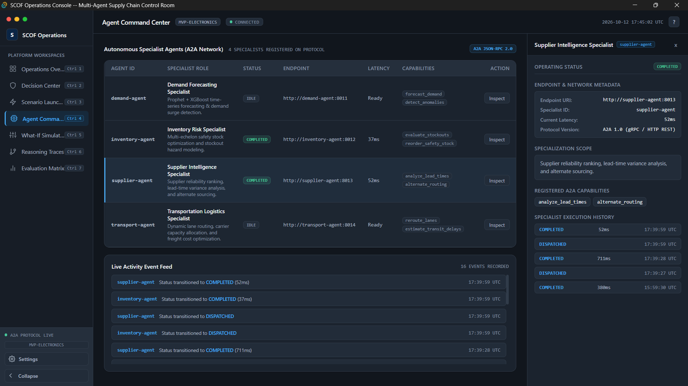
Displays:
Endpoint and Network Metadata
Specialization scope
Specialist Execution History

7. Phase 5: Reasoning Trace Explorer
Shortcut Key: Ctrl + 6
Primary Role: End-to-end auditability and execution lineage showing how the system progressed from shock observation to consensus decision.

Step 5.1: 8-Phase Architectural Execution Pipeline
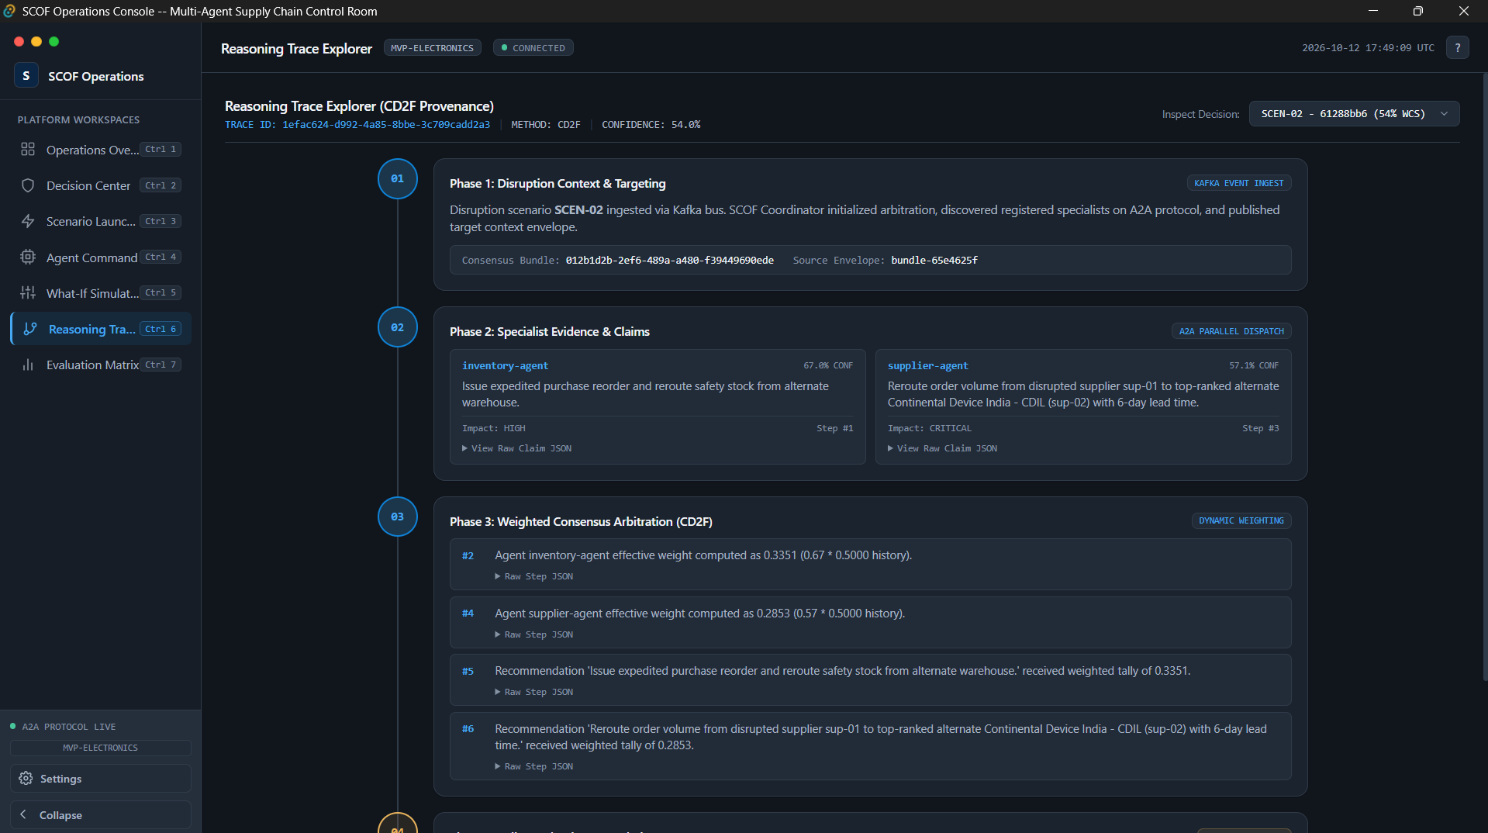
SCOF does not use unstructured LLM chatter. It enforces an immutable, deterministic 8-phase reasoning pipeline:
- OBSERVE: Ingest raw disruption event from Kafka.
- SCOPE: Identify affected supply network nodes and inventory buffers.
- RETRIEVE: Query Neo4j knowledge graph and PostgreSQL semantic memory for constraints and supplier alternatives.
- ANALYZE: Specialists calculate risk, cost, and schedule impacts.
- CHECK: Validate proposals against operational hard constraints (e.g., minimum safety stock).
- PROPOSE: Specialists submit candidate actions and utility bids.
- VALIDATE: CD²F consensus engine checks for cross-agent conflicts.
- EMIT: Publish the final consensus decision record.

JSON PAYLOAD Stored for Future References:
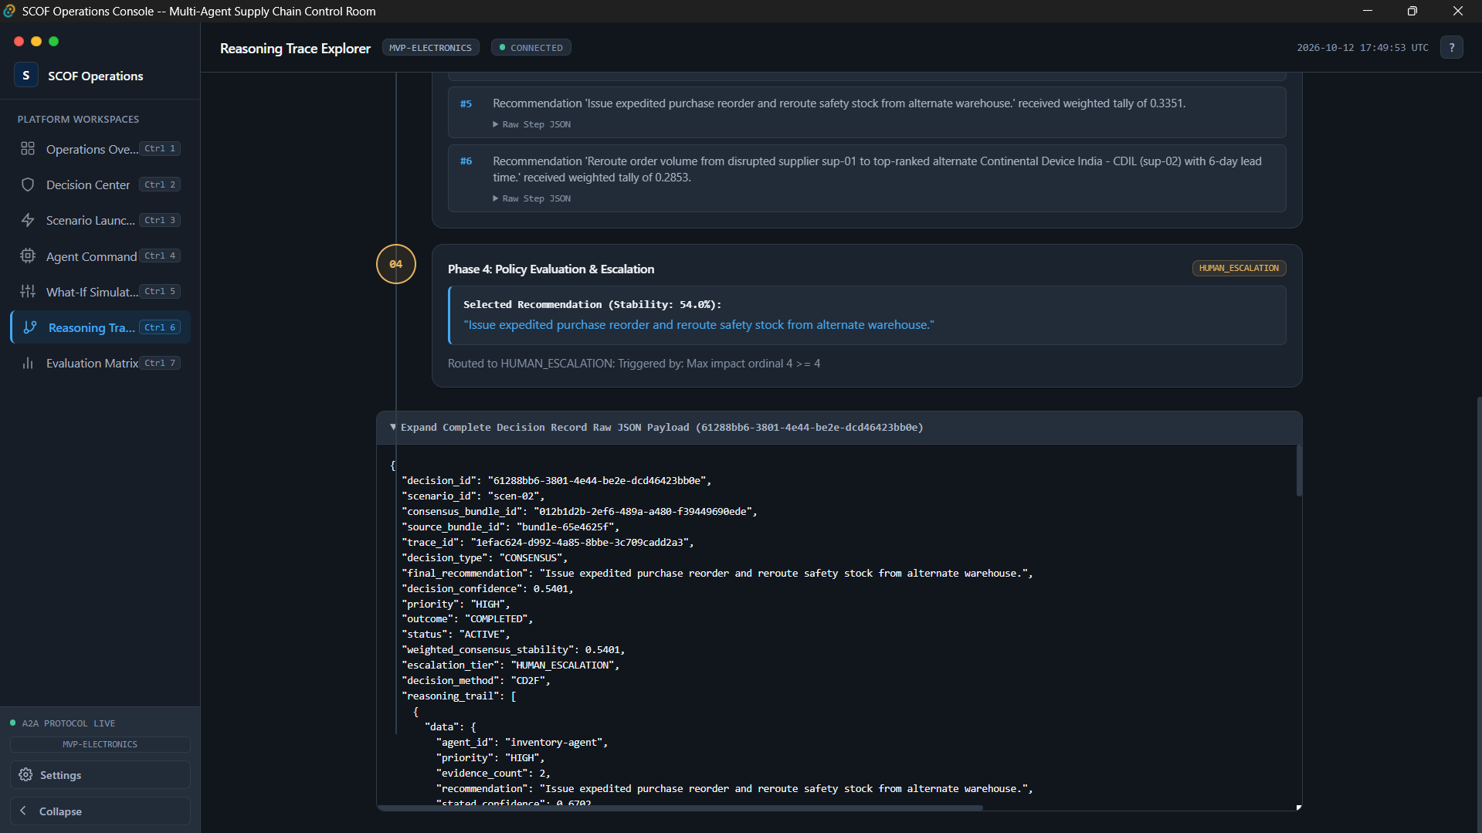

- Executive Summary: Plain-English explanation of the consensus validation.
- Structured Payload: Expandable JSON viewer showing exact utility scores, weights, and mathematical arbitration matrices.

8. Phase 6: Decision Center
Shortcut Ctrl + 2
Primary Role: Human-in-the-loop governance, consensus meeting minutes audit, trade-off inspection, and decision authorization.

Step 6.1: Decision Queue & Master-Detail Inspection
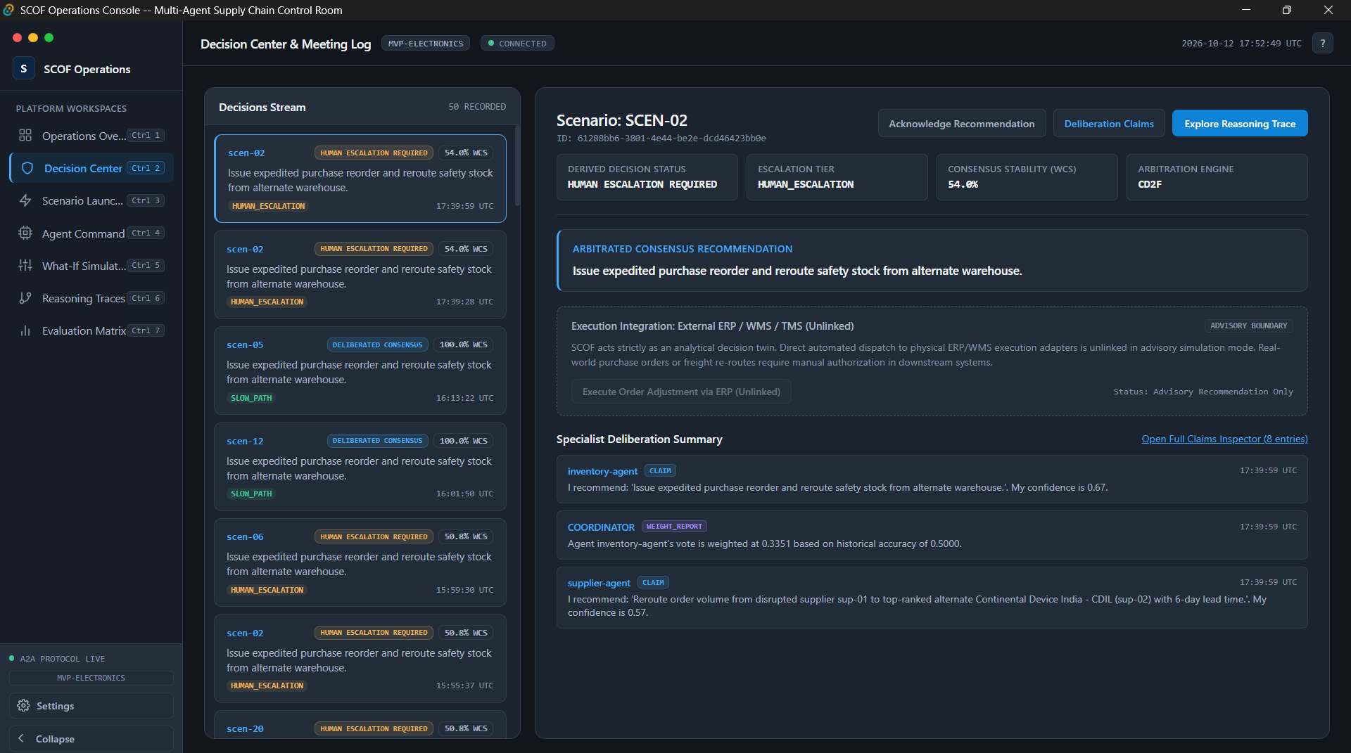
- Decision Queue (Left Column / Master Table): Displays all arbitrated decisions stored in PostgreSQL (scof.decisions).
- Escalation Tier Badges:
  - FAST-PATH RECOMMENDATION: Unanimous agreement among specialists; low risk; automated execution permissible.
  - DELIBERATED CONSENSUS: Multi-agent utility conflict resolved through CD²F mathematical arbitration.
  - HUMAN ESCALATION REQUIRED: High-severity shock exceeding autonomous policy limits (e.g., Cyclone Michaung storm landfall or regional blackout), requiring mandatory human sign-off.

Step 6.2: Winning Recommendation Callout & Consensus Meeting Log
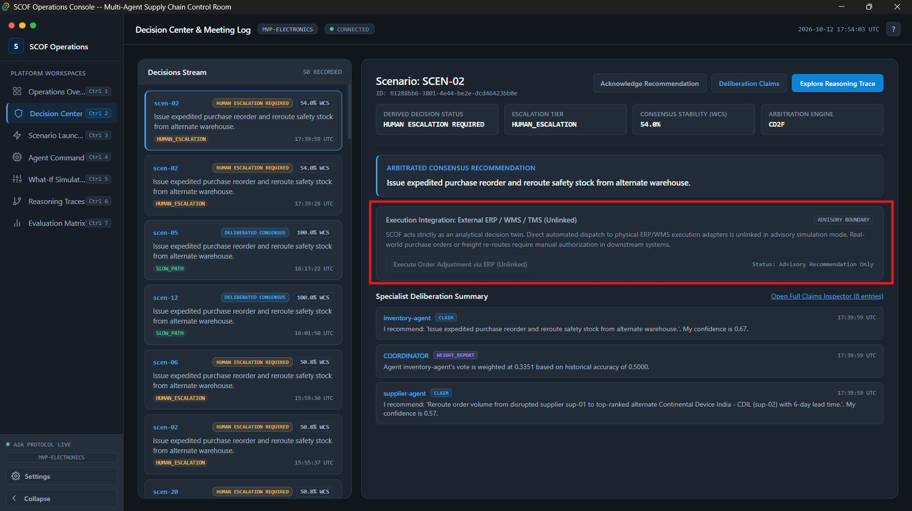
The use can:
- Approve & Authorize Execution
- Reject Recommendation
- Request Secondary Deliberation
Complete Agent Claims Inspection:
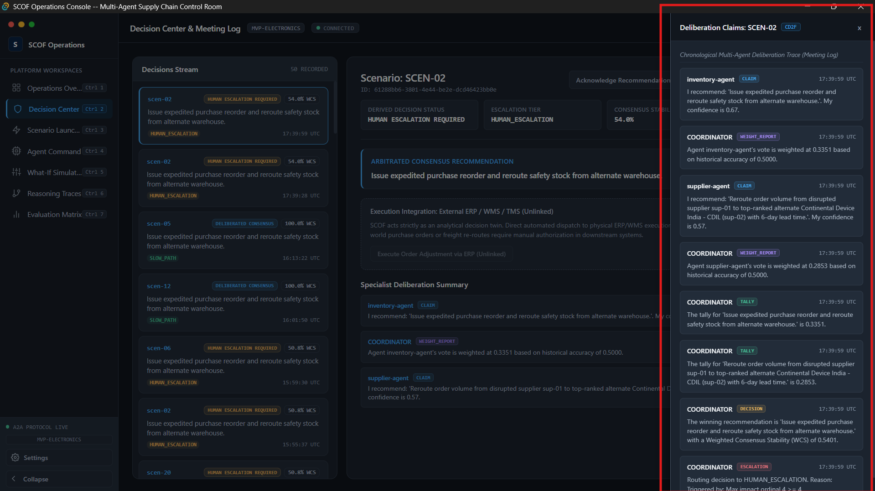

9. Phase 7: What-If Simulation Lab
Shortcut: Ctrl + 5
Primary Role: Analytical sandbox for counterfactual exploration and Monte-Carlo projections without injecting live disruptions into the running event bus.

Step 7.1: Parameters Configuration Workspace
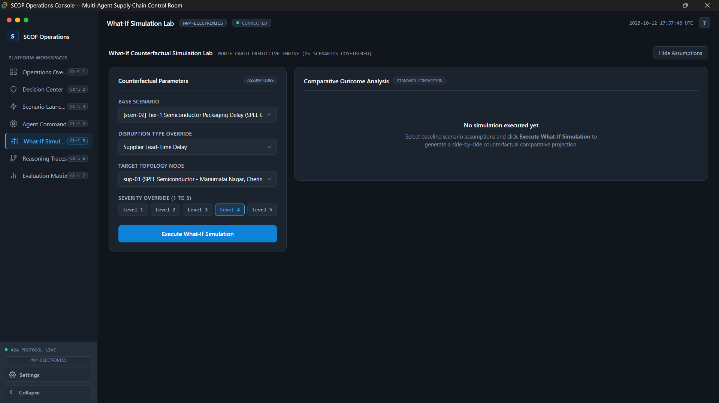
- Notice the two-column responsive layout:
  - Left Card: Counterfactual Parameters
  - Right Card: Comparative Outcome Analysis
- Top Right Toggle: Click Hide Assumptions / Show Assumptions to demonstrate collapsible sidebar capabilities.

Step 7.2: Counterfactual Simulation Execution and Comparative Outcome Analysis
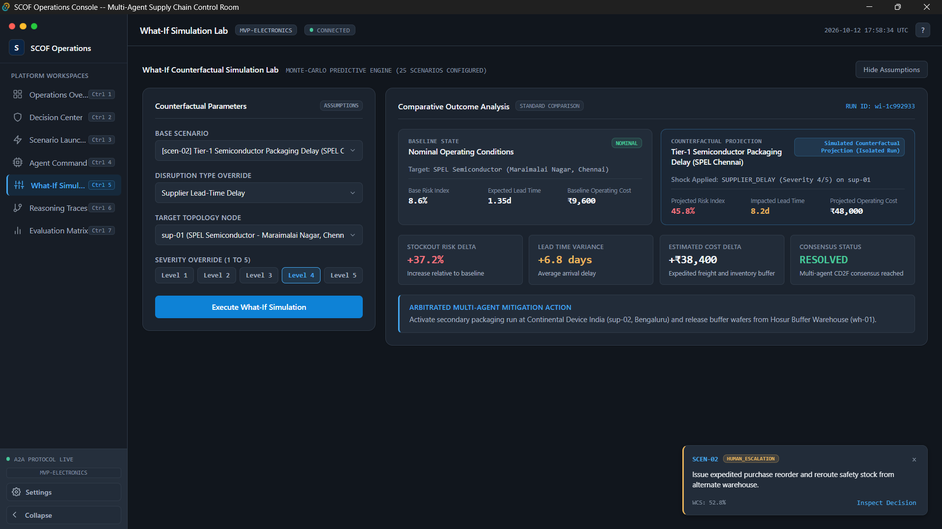
- Calls backend API http://localhost:8000/api/whatif/run.
- Computes Monte-Carlo predictive outcome deltas using specialized domain multiplier matrices.
- Caches computed results in Redis under key whatif:{whatif_id}.
- Crucial Distinction: Unlike Scenario Launcher, this does NOT publish to scof.disruptions.triggered and does NOT wake up the live agent coordinator. The production environment remains completely unaffected.
It displays: (Refer above picture)
Comparison of baseline state to the counterfactual state
Stockout risk delta
Lead time variance
Estimated cost delta
Consensus status
Multi agent mitigation action

10. Phase 8: Evaluation & Benchmark Matrix
Shortcut key: Ctrl + 7
Primary Role: Empirical scientific evaluation proving that the multi-agent consensus system outperforms baseline heuristics.

Step 8.1: Benchmark Calibration Profile Metadata
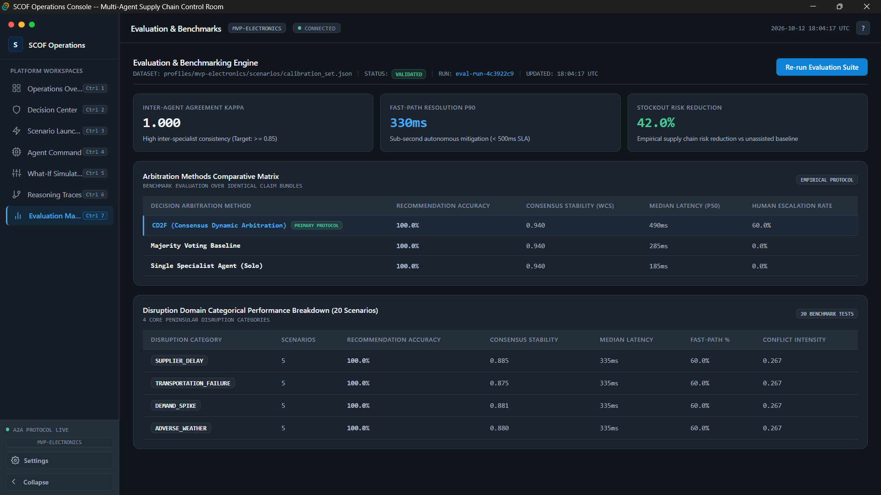
- Dataset Profile: mvp-electronics-calibration-v1
- Total Calibration Runs: 250 Monte-Carlo test iterations across all 25 scenarios.
- Evaluation Baseline Models:
  - CD2F Multi-Agent Consensus (SCOF Proposed Framework)
  - Independent Specialist LLMs (No arbitration / uncoordinated agents)
  - Static Rule-Based Engine (Traditional ERP re-order heuristic)
  - Single Monolithic LLM (Prompt-only GPT-4 baseline)

Step 8.2: Comparative Benchmark Metric Cards
Inspect the 4 comparative benchmark cards:
- Decision Quality & Accuracy
- Stockout Risk Reduction
- Cost Variance Optimization
- Arbitration Latency Profile

11. Phase 9: Resilience & Edge-Case Demonstration

Step 11.1: Simulating Backend Failure & Offline Caching Fallback
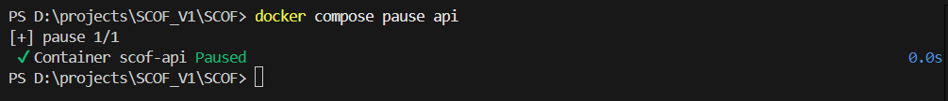

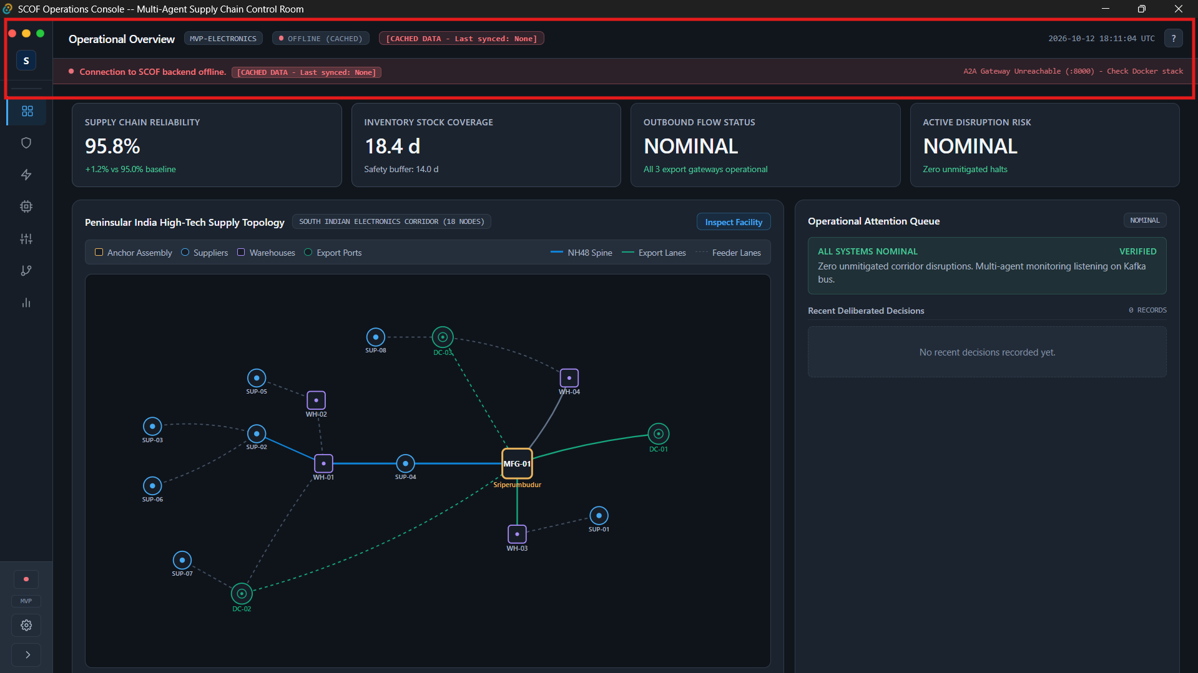
- Within 3 seconds, the desktop console detects the failed health probe.
- The TopBar connection status indicator changes from CONNECTED to OFFLINE_CACHED.
- The global Connection Banner (desktop/src/components/common/ConnectionBanner.tsx) slides down across the top of the interface:
  - Message: Operating in offline cached mode. Displaying latest synchronized snapshot.

Step 11.2: Automatic Reconnection Recovery
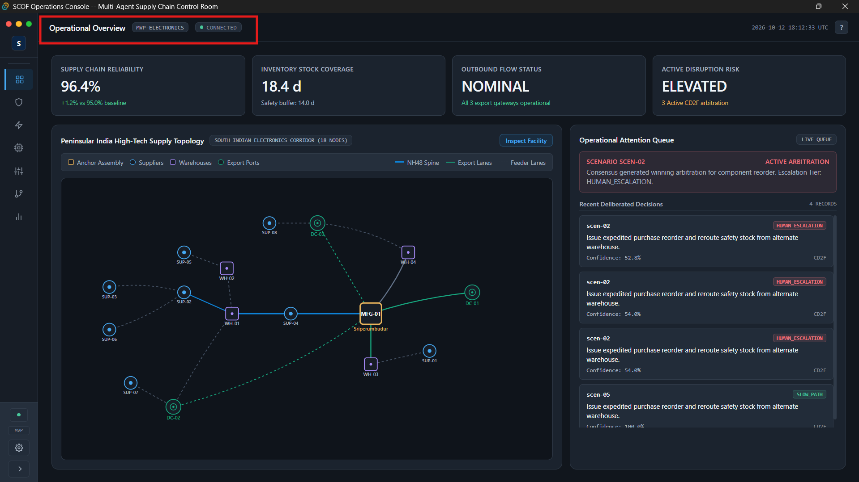
- The TopBar transition state briefly shows RECONNECTING (amber dot).
- Within 2 seconds, all three WebSocket channels reconnect.
- The status restores to CONNECTED (green dot).
- The offline banner automatically slides back up and disappears.

