**Coding contest 2 AUTOMATION-TESTING**

**727721EUIT042-Gowtham**

**PART A**

**CODE**

**package com.selenium.project1.selenium1;**

**import org.testng.annotations.Test;**

**import io.github.bonigarcia.wdm.WebDriverManager;**

**import org.testng.*;**

**//import org.testng.annotations.BeforeMethod;**

**import org.openqa.selenium.By;**

**import org.openqa.selenium.WebDriver;**

**import org.openqa.selenium.WebElement;**

**import org.openqa.selenium.chrome.ChromeDriver;**

**import org.openqa.selenium.chrome.ChromeOptions;**

**//import org.testng.annotations.AfterMethod;**

**public class CC {**

**WebDriver driver;**

**@Test**

**public void f() throws InterruptedException{**

**WebDriverManager.*chromedriver*().setup();**

**WebDriver driver;**

**ChromeOptions co = new ChromeOptions();**

**co.addArguments("--remote-allow-origins=*");**

**driver=new ChromeDriver(co);**

**driver.manage().window().maximize();**

**driver.get("https://www.yatra.com/hotels");**

**WebElement flight=driver.findElement(By.*xpath*("//*[@id=\"booking_engine_flights\"]"));**

**flight.click();**

**WebElement trip=driver.findElement(By.*xpath*("//*[@id=\"BE_flight_form_wrapper\"]/div[1]/div[1]/ul[1]/li[2]/a"));**

**trip.click();**

**}**

**}**

**OUTPUT:**

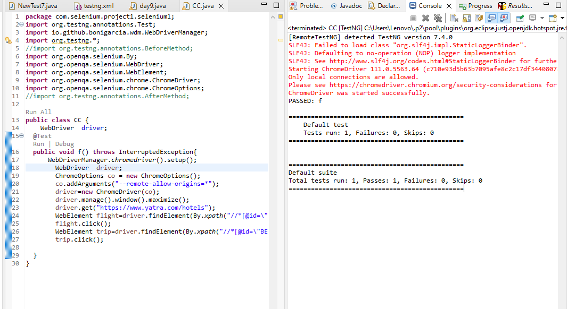

**PART B**

**CODE:**

**package com.selenium.project1.selenium1;**

**import org.openqa.selenium.By;**

**import org.openqa.selenium.WebDriver;**

**import org.openqa.selenium.chrome.ChromeDriver;**

**import org.openqa.selenium.chrome.ChromeOptions;**

**import org.testng.annotations.Test;**

**import io.github.bonigarcia.wdm.WebDriverManager;**

**public class CC {**

**WebDriver d;**

**@Test**

**public void f() throws InterruptedException {**

**ChromeOptions co=new ChromeOptions();**

**co.addArguments("--remote-allow-origins=*");**

**WebDriverManager.chromedriver().setup();**

**d=new ChromeDriver(co);**

**d.get("https://www.yatra.com/flights");**

**d.manage().window().maximize();**

**Thread.sleep(4000);**

**d.findElement(By.xpath("//*[@id=\"booking_engine_flights\"]")).click();**

**Thread.sleep(2000);**

**d.findElement(By.xpath("//*[@id=\"BE_flight_form_wrapper\"]/div[1]/div[1]/ul[1]/li[2]/a")).click();**

**Thread.sleep(2000);**

**d.findElement(By.xpath("//*[@id=\"BE_flight_origin_city\"]")).click();**

**Thread.sleep(2000);**

**d.findElement(By.xpath("//*[@id=\"BE_flight_form_wrapper\"]/div[1]/div[2]/ul/li[1]/ul/li[1]/div/div/ul/div/div/div/li[3]")).click();**

**Thread.sleep(2000);**

**d.findElement(By.xpath("//*[@id=\"BE_flight_form_wrapper\"]/div[1]/div[2]/ul/li[1]/ul/li[3]/div/div/ul/div/div/div/li[4]")).click();**

**Thread.sleep(2000);**

**d.findElement(By.xpath("//*[@id=\"BE_flight_origin_date\"]")).click();**

**Thread.sleep(2000);**

**d.findElement(By.xpath("//*[@id=\"20/04/2023\"]")).click();**

**Thread.sleep(2000);**

**d.findElement(By.xpath("//*[@id=\"BE_flight_arrival_date\"]")).click();**

**Thread.sleep(2000);**

**d.findElement(By.xpath("//*[@id=\"24/04/2023\"]")).click();**

**Thread.sleep(2000);**

**d.findElement(By.xpath("//*[@id=\"BE_flight_paxInfoBox\"]/i")).click();**

**Thread.sleep(2000);**

**d.findElement(By.xpath("//*[@id=\"BE_flight_passengerBox\"]/div[1]/div[1]/div/div/span[2]")).click();**

**Thread.sleep(2000);**

**d.findElement(By.xpath("//*[@id=\"flight_class_select_child\"]/ul/li[3]")).click();**

**Thread.sleep(2000);**

**d.findElement(By.xpath("//*[@id=\"BE_flight_form_wrapper\"]/div[3]/div[1]/div[1]/a/i")).click();**

**Thread.sleep(2000);**

**d.findElement(By.xpath("//*[@id=\"BE_flight_flsearch_btn\"]")).click();**

**}**

**}**

**OUTPUT:**

