Game Tester Assignment
Level – 1
Test Environment: Android Device (256GB ROM / 8GB RAM)
The objective of this report is to document the issues and gameplay observations encountered while testing Hitwicket Superstars.
While exploring the game, I focused not only on functional bugs but also on areas such as UI behaviour, navigation flow, usability, and overall gameplay experience. Since this is a live game experience, I also paid attention to how the game feels in real use including transitions, responsiveness, visual clarity, and player-facing friction points.
This report is written from the perspective of both a player and a tester. So along with the issues identified, I have also included a few observations and appreciations wherever the design or gameplay intent stood out in a good way.
The issue descriptions below include the related screenshots and video references wherever applicable:
- Delay During Startup Player Intro / Loading Sequence:
Screen / Area: App Launch / Startup
Type: Performance / UX Observation
Severity: Medium
Frequency: Low to Medium
When launching the game, the startup sequence includes a player intro animation along with a bat-hit sound effect. The sound design is a nice touch and adds to the feel of the game. However, the loading transition during this sequence takes slightly longer than expected, and at times it comes across as a lag before reaching the main screen.
Expected:
The startup animation and transition should feel smooth and quick, without noticeable delay before entering the game.
Actual:
There is a slight delay during the player intro/loading phase, which can make the transition feel slow or slightly laggy before reaching the home screen.
Occurrence:
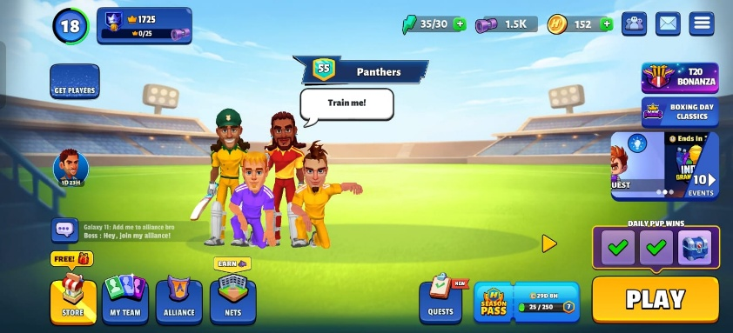

Link: Delay During Startup Player Intro / Loading Sequence
Observations:
- The bat-hit sound effect during launch is a well-thought detail and adds a good initial feel to the game.
- The player intro concept is engaging, but optimizing the transition speed could improve first impressions.

- Failed to Initialize TrophyRoad:
Screen / Area: PvP Hub
Type: Functional / UX Issue
Severity: Medium
Frequency: Low to Medium
While playing PvP matches, after completing a game (observed more consistently after winning), an error popup appears stating “Failed to Initialize TrophyRoad.”
Along with this, the UI elements related to progression (trophies/rewards) do not behave properly and at times appear to be misaligned or floating in inconsistent positions on the screen.
Initially, I suspected this might be a device-specific issue since I am part of an OPPO device trial and observed it earlier. However, the issue continued to occur across sessions, which indicates that it is likely an application-side issue rather than device-specific behavior.
Expected:
After completing a PvP match, the TrophyRoad/progression should load correctly, and UI elements should appear properly aligned without errors.
Actual:
An error popup appears stating “Failed to Initialize TrophyRoad.” Additionally, progression-related UI elements may not load correctly or appear visually inconsistent on the screen.
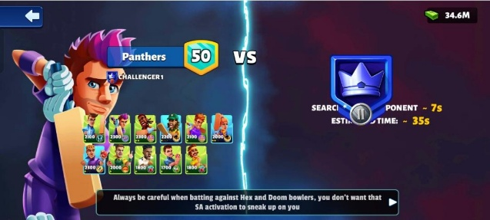
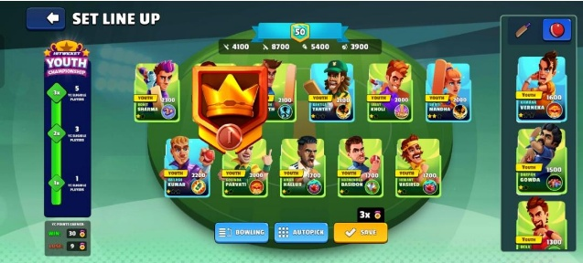
Previous Occurrences:

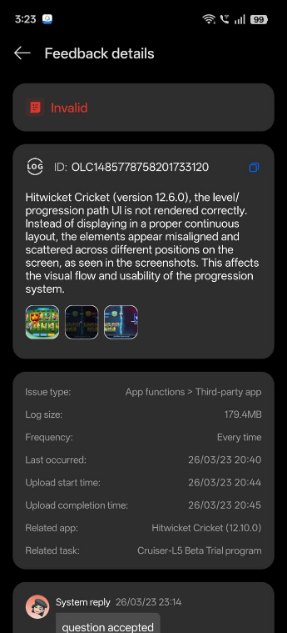
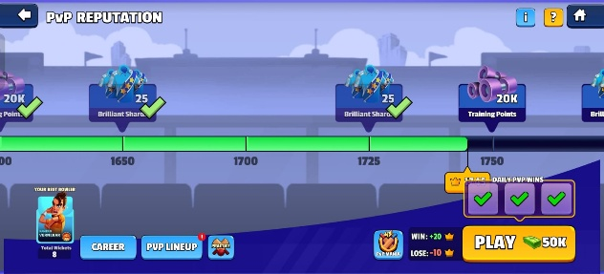
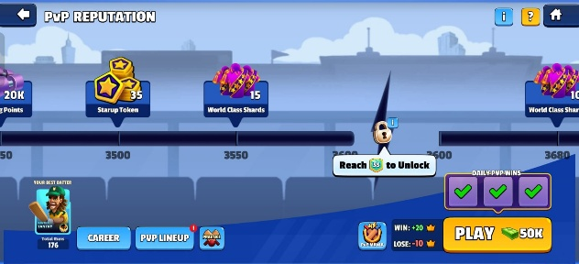
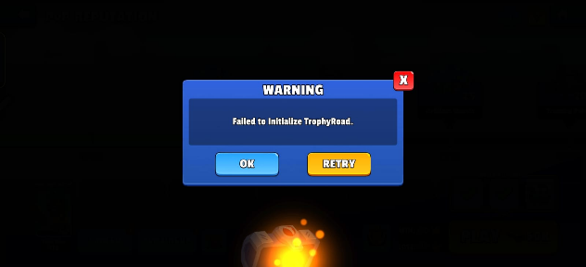
Recent Occurrences:

Link: Failed to Initialize TrophyRoad
Observations:
- The TrophyRoad progression system is engaging and gives a clear sense of progression, with rewards placed well enough to keep the player motivated to continue playing.
- The idea of placing Brilliant Player jerseys in the roadmap is one of the key aspects that made me come back and play more, build a stronger team, and try to progress quicker.
- Device Heating During Extended Gameplay Sessions:
Screen / Area: Gameplay (General – Across Sessions)
Type: Performance / Device Behaviour
Severity: Medium to High
Frequency: Medium
While playing the game over extended sessions, the device starts heating up noticeably. Initially, the game feels stable, but over time (especially after longer play durations), the temperature increases to a point where the device feels genuinely hot rather than just warm.
This is particularly noticeable around the camera region, making it slightly uncomfortable to hold and continue playing. In some cases, the heating starts earlier, but it is more consistently observed after continuous gameplay of around an hour.
This observation was made under indoor conditions, so external environmental factors are minimal, No significant background apps were running during testing.
As of my knowledge about normal mobile gaming conditions, temperatures around 35°C are generally considered acceptable. Sustained temperatures above ~40°C can start affecting user comfort and device handling.
Expected:
During normal gameplay, the device temperature should remain within a comfortable range and not impact usability, even during longer sessions.
Actual:
The device temperature increases over time, reaching around 39°C–42°C, making the device feel hot to touch, especially near the camera area, and slightly affecting comfort during gameplay.
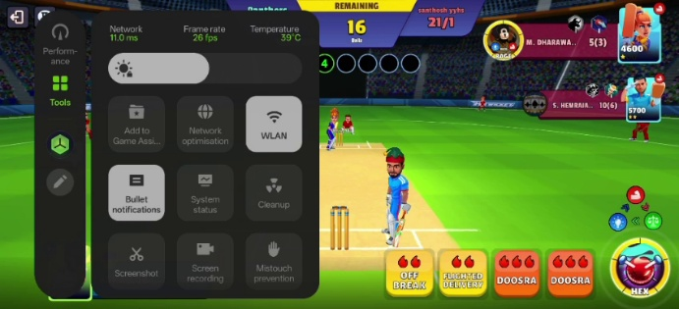
Occurrence:
Link: Device Heating During Extended Gameplay Sessions
Observations:
- The gameplay experience itself remains smooth initially, which shows the game is handling performance well in shorter sessions.
- Even though the device heats up over time, I did not notice a major drop in the game’s performance. Apart from the phone becoming harder to hold for longer due to the heat, the gameplay continues to perform well overall.

- 60 FPS Setting Not Fully Reflected During Gameplay / Lag Spike When Opponent Quits:
Screen / Area: Home Screen / PvP Match Gameplay / In-Game Settings
Type: Performance / Gameplay Experience
Severity: Medium
Frequency: Medium
The game includes a 60 FPS option in the settings, and it was enabled during testing. While checking the frame output through device game tools, I observed that the non-gameplay home screen was running around ~50 FPS, which feels relatively smoother.
However, during actual PvP gameplay, the frame rate appears to stay closer to ~30 FPS on average instead of consistently reflecting the selected 60 FPS mode.
This does not immediately break gameplay during normal play, but the issue becomes more noticeable when the opponent quits/disconnects, where a visible lag or pause occurs at that moment. That interruption makes the PvP flow feel less smooth than it should.
Expected:
With 60 FPS enabled, both lighter screens and gameplay should maintain smoother and more consistent frame output, especially during active match scenarios, even when the opponent quits the game.
Actual:
The home screen appears to run relatively smoother at around ~50 FPS, but actual gameplay runs closer to ~30 FPS on average. A more noticeable lag/pause is also observed when the opponent quits, which affects the smoothness of the PvP experience.
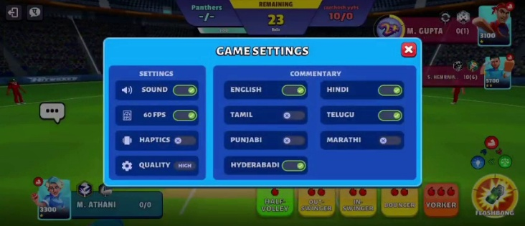
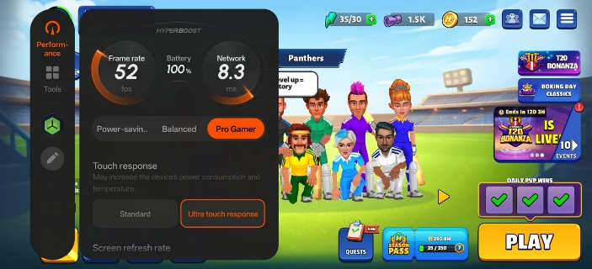
Occurrences:

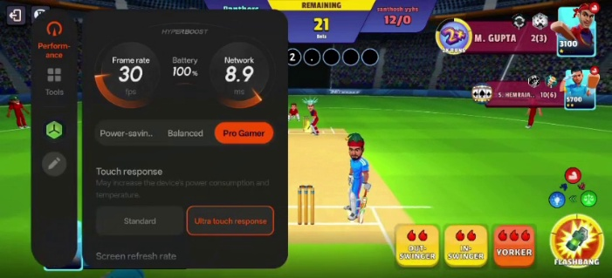
Link: 60 FPS Setting Not Fully Reflected During Gameplay / Lag Spike When Opponent Quits
Observations:
- The presence of a 60 FPS option, quality controls, and touch response settings is a strong customization feature and gives players better control over how they want the game to feel.
- The home screen already shows that the game can feel smoother in lighter scenarios, so if that same consistency carries better into gameplay and quit/disconnect moments, the PvP experience would feel much cleaner overall.

- Notification Indicator Appears Without Clear Actionable Context:
Screen / Area: Home Screen / Events / Daily Co-op Quest
Type: UX / UI Observation
Severity: Low to Medium
Frequency: High
On the home screen, a red notification/alert indicator appears near the Daily Co-op Quest / Events area, which naturally gives the impression that there is something pending, new, or requiring attention.
However, even after opening and checking the related section, there does not appear to be any clear update, reward, task, or specific actionable item directly tied to that alert. Because of that, the notification starts to feel a bit pointless and can confuse the player into checking for something that is not clearly there and beyond a point it starts to feel annoying.
Expected:
If a notification/alert symbol is shown, it should clearly point toward a new, pending, or actionable item that actually needs the player’s attention.
Actual:
A notification indicator is visible, but after checking the related section, there is no clear or immediate reason for the alert, which makes it feel unnecessary or unclear.

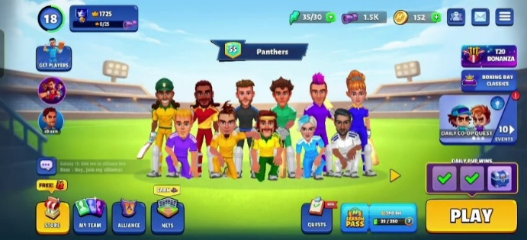
Occurrences:

Link: Notification Indicator Appears Without Clear Actionable Context
Observations:
- The use of notification cues is good in general, as it helps draw attention toward active areas and can improve engagement when used meaningfully.
- If the alert is tied more clearly to a visible task, reward, or update, it would make the interaction feel more intentional and less confusing.

- Alliance Chat / Reconnect Not Functioning Properly:
Screen / Area: Alliance Hub / Chat Section
Type: Functional / Network / UX Issue
Severity: Medium
Frequency: Low
While navigating to the Alliance section, the chat area does not load properly and remains blank. Instead of showing messages or chat activity, a “Retrying…” state is displayed continuously along with a Reconnect button.
Even after attempting to reconnect, the chat does not always recover immediately, and no messages or interaction appear in the chat area. This makes the chat feature unusable during that session and gives the impression that the feature is not functioning properly.
Expected:
The alliance chat should load properly and display messages without requiring repeated reconnect attempts. If a network issue occurs, reconnect should restore the chat quickly and reliably.
Actual:
The chat section remains blank and shows a “Retrying…” state. Even after attempting to reconnect, the chat does not consistently load, making the feature unusable.

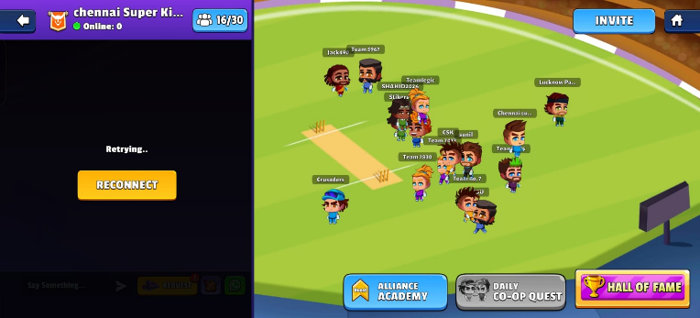
Occurrence:

Link: Alliance Chat Reconnect Not Functioning Properly
Observations:
• The Alliance feature itself feels interactive and well-designed with multiple entry points like chat, co-op quest, and academy.
• If the chat flow becomes stable and loads reliably, it would make the alliance experience feel much more active and engaging.

Conclusion:
Overall, Hitwicket Superstars gives a genuinely engaging gameplay experience, and while testing it, it was clear that many of the systems are built in a way that keeps the player involved and wanting to progress further. That player pull is one of the stronger parts of the game.
The issues documented in this report were observed across different areas including startup flow, PvP progression, gameplay performance, frame consistency, UI attention cues, and alliance interaction. While most of them do not completely break the experience, they do affect the smoothness and clarity of certain gameplay moments.
A total of 6 issues/observations were identified during testing under the current environment. Along with this report, I have also created a structured Level 1 Issue Tracker Sheet to make the findings easier to review in a more concise format.
Tracker Sheet
