
Basic Linux Commands Assignments

Assignment-1
Connect and disconnect with login Access
- What happens when you login a non-existent users or username?
  - Provide Screenshot and What you understand, explain in short brief?
- Account created with Gowtham. Successful login with valid credential.
- Tried with not listed user “Test”, throws an error while logging in.

- 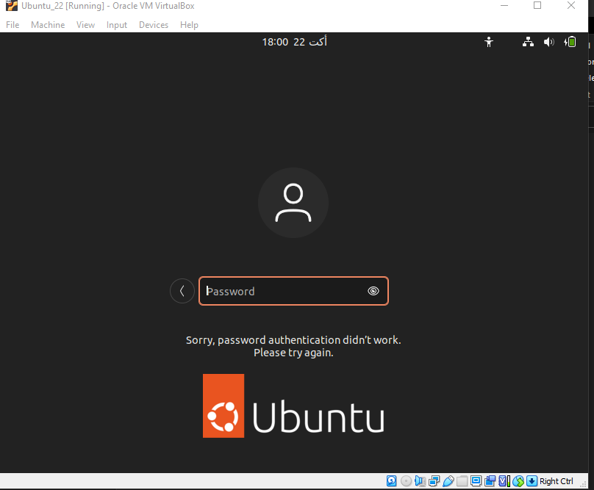

Assignment-2
Password changing
- Login into your account and then change password?
  - Change your password into IneuR0n#42 and hit the Enter key
    - Explain what happen and give screenshot?

-I have changed to “IneuROn#42” it is working fine

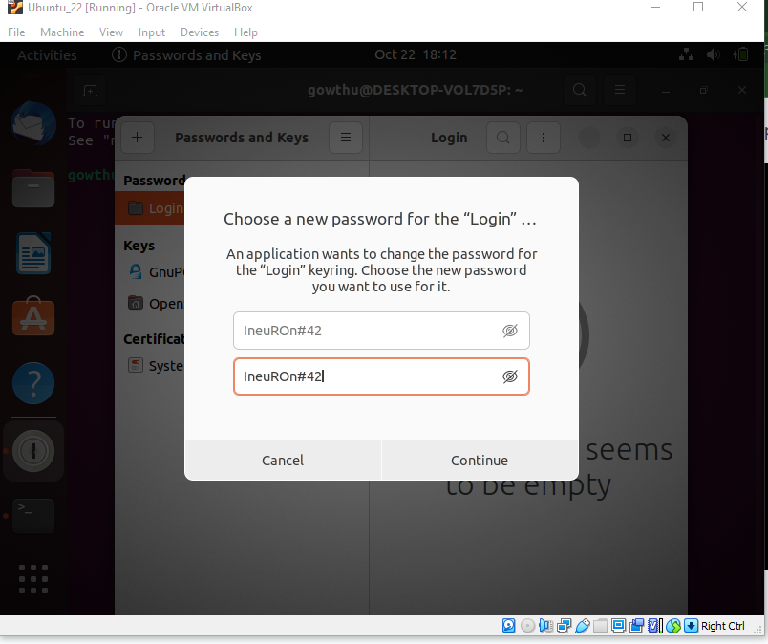

  - Try again to change password but use like password 1234 or abcd
    - Explain what happen and give screenshot?

-
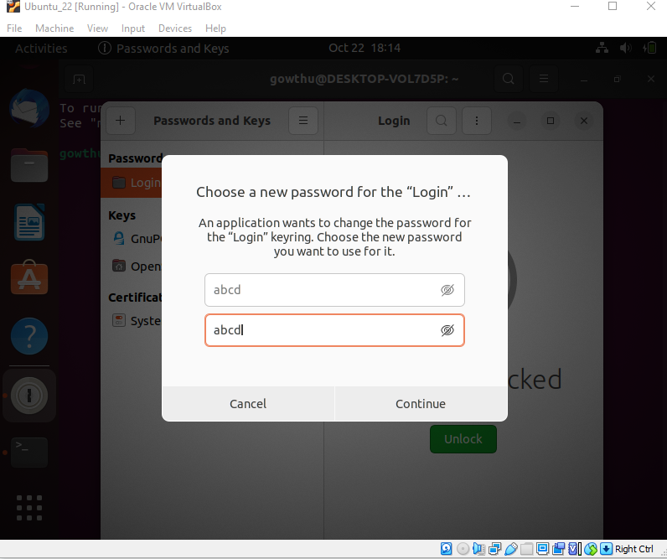

  - Try again to change password but now don’t use any password just hit Enter key
    - Explain what happen and give screenshot?

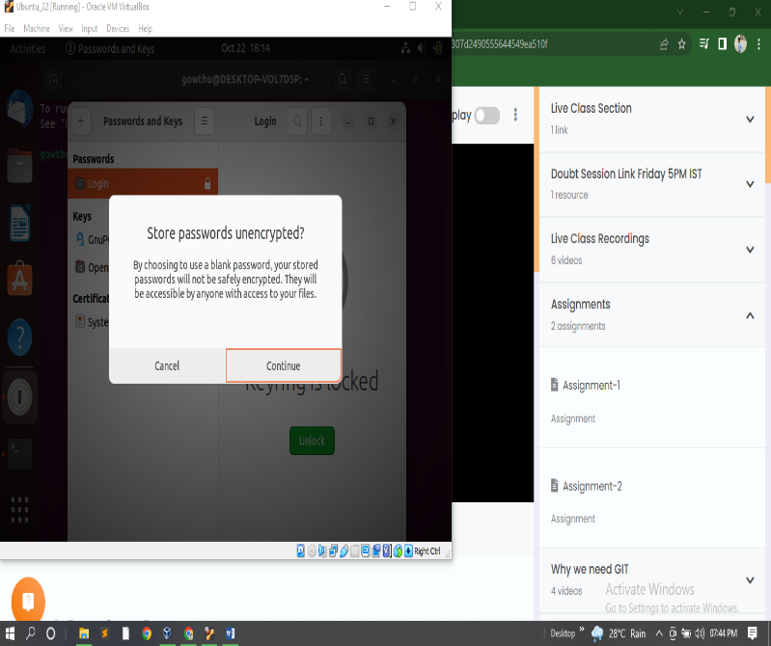

Assignment-3
Working with Directories
- Enter the command cd / and then ls and then hit Enter key
  - Take screenshot and explain what output we got?

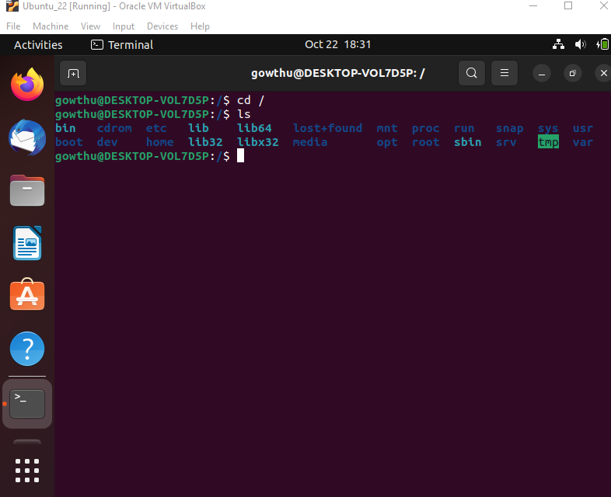

- Enter the command now cd /home and then hit Enter key
  - Do ls, provide screenshot and explain what is /home directory used for?
The Linux home directory is a directory for a particular user of the system and consists of individual files. It also referred to as the login directory. This is the first place that occurs after logging into a Linux system. It is automatically created as "/home" for each user in the directory'.
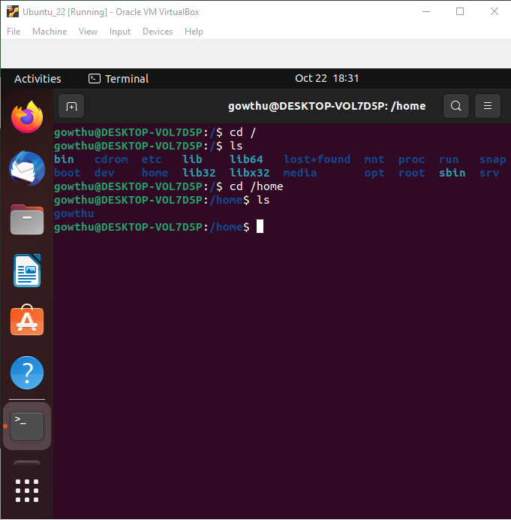

- Enter cd .. and hit Enter key [ Note: here we have space after cd then use double dot]
  - Check what happen and give screenshot?

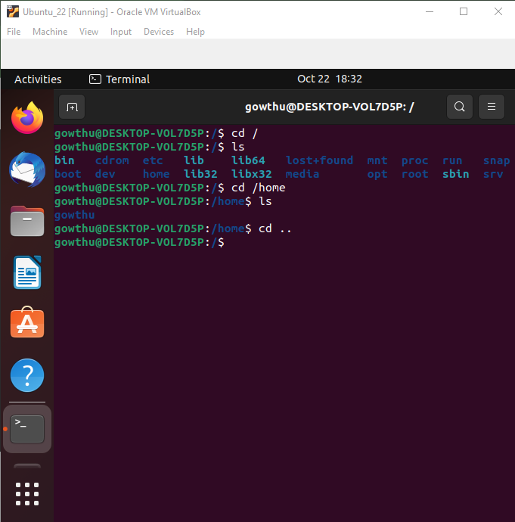

- Now enter cd /var/www/html and then type cd and hit Enter key
  - Explain what happen and give screenshot?
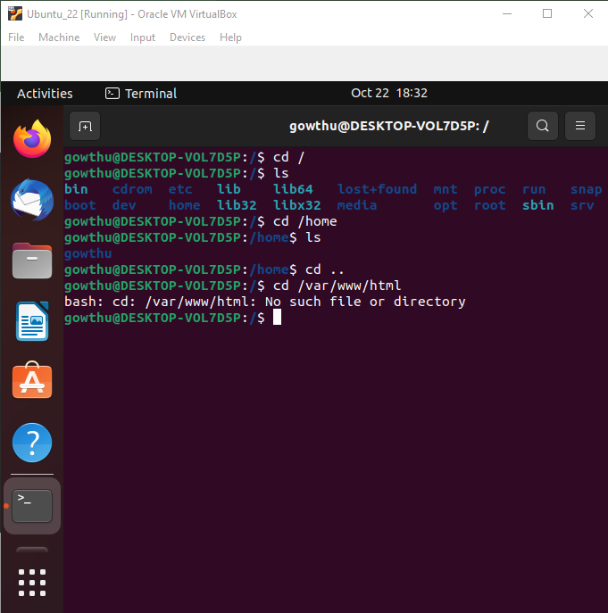

- Now type cd /root and then hit Enter key
  - Do ls, check any output we have on screen if yes then take screenshot?
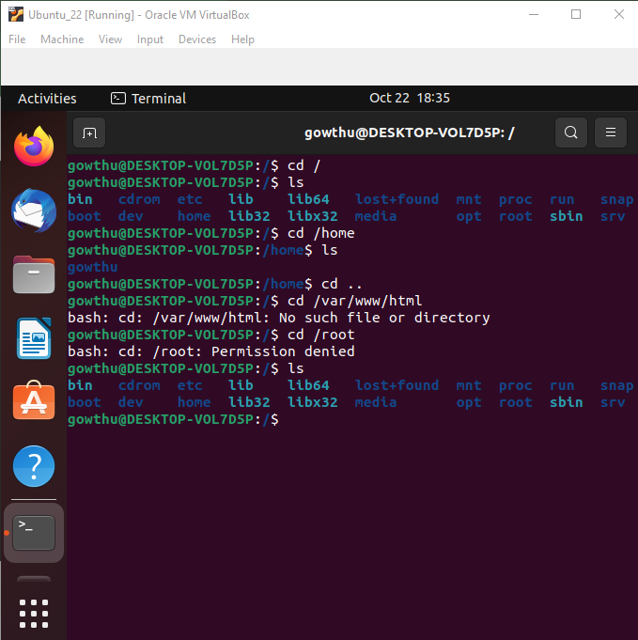

Assignment-4
Working with File Listing
- Go to cd /etc and type ls
  - Take screenshot and explain what files you have seeing?
  - Take screenshot and explain what different output you found compare to previous command you used?
All kind of file under etc. Etc is the folder inside “/” root.
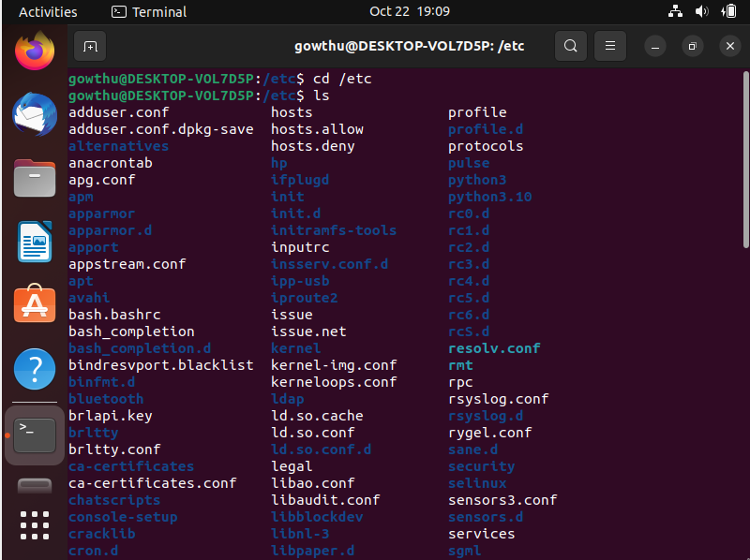
- Then type ls -al and hit Enter key
  - Take screenshot and explain what new file or directory you found?
With ls –l it was 1132 and with ls –al it is 1152. 20 more files are displayed.
- Then use ls -i and hit Enter key
  - Now see what different output its shows and take screenshot?
- File with Id’s

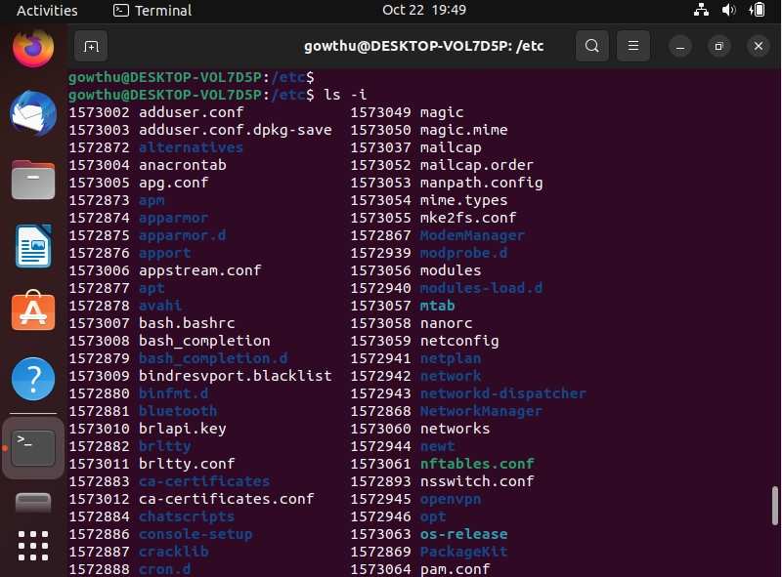
- Then use ls –help and see other options about ls command
  - Explore it and try with other attribute we can use with ls command

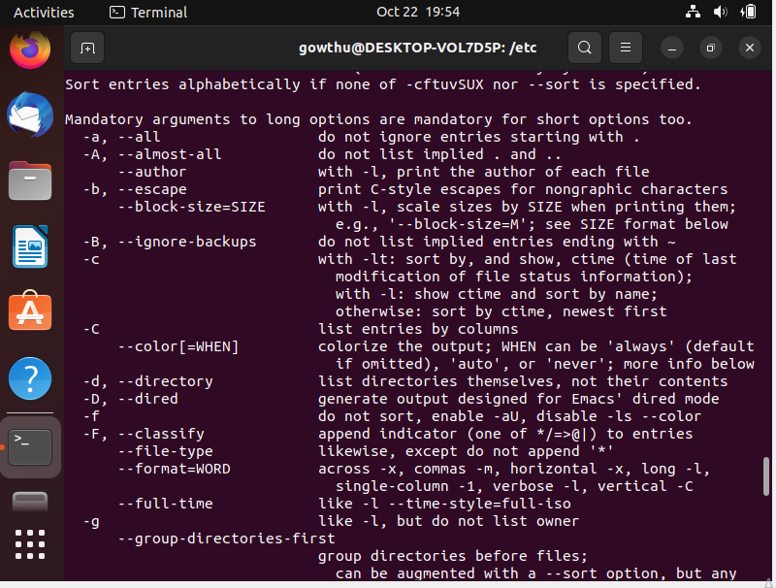
Assignment-5
Know where you are and where you working
Here we use pwd, cd and ls as combine task to understand where you working on terminal and how you can switch from one directory to another one.
- Open terminal after restart the linux
  - Check which location you working, type pwd and take screenshot

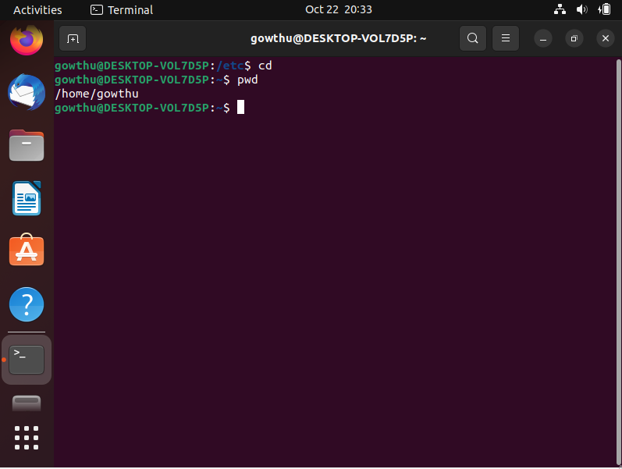
- Now use cd /var and hit Enter key
  - Do ls, and see what output comes, give screenshot?

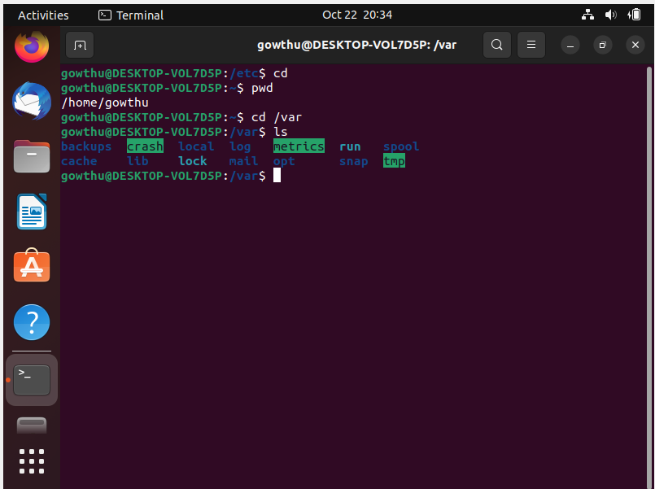
- Do explore other help options of each command to learn more other things we can do with these commands

