Introduction
What is HTML?
- HTML (HyperText Markup Language) was created by Tim Berners-Lee in 1991.
- t's a markup language used to structure content on the web, defining elements like headings, paragraphs, links, and images

HTML is the language of the web, used to create websites.
- HTML defines the barebone structure or layout of web pages that we see on the Internet.
- HTML consists of a set of tags contained within an HTML document, and the associated files typically have either a .html or .htm extension.
- There are several versions of HTML, with HTML5 being the most recent version.

Page Structure
!DOCTYPE html>
<html>
<head>
<title>Document</title>
</head>
<body>
<!-- content -->
</body>
</html>

A typical HTML page looks like this
<html>
<head>
<title>Page title</title>
</head>
<body>
<h1>This is a heading</h1>
<p>This is a paragraph.</p>
<p>This is another paragraph.</p>
</body>
</html>
Note: These are the essential elements for a basic HTML document: <!DOCTYPE html>, <html>, <head>, <title>, </head>, <body>, </body>, </html>.

DOCTYPE Declaration
<!DOCTYPE html>
<!DOCTYPE html> is a like a comment in a HTML

HTML Root Element
<html> </html> root element that encapsulates all the content on the page.

Title Tag
<title>Document</title>
sets the title of the web page, which is displayed in the browser's title bar or tab.

Body Tag
<body> </body> contains the visible content of the web page. This is where text, images
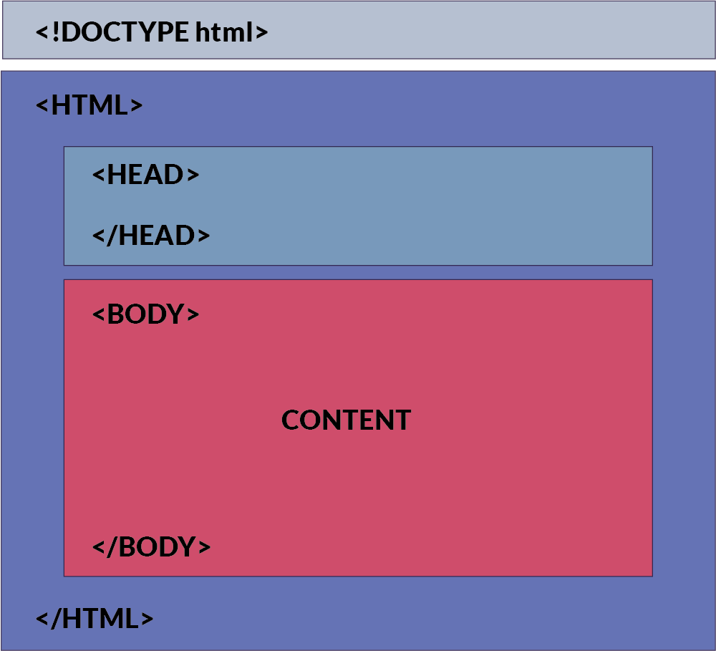
<!DOCTYPE html>
<html>
<head>
<title>Document</title>
</head>
<body>
<h1> This is a heading</h1>
<p>This is a paragraph</p>
</body>
</html>
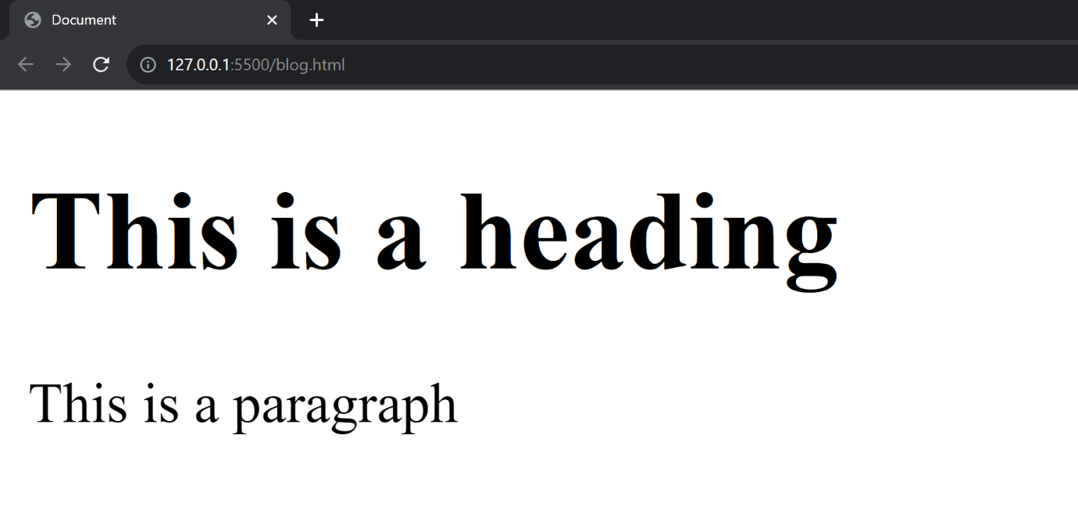

Tags
An HTML tag acts as a container for content or other HTML tags. Tags are words enclosed within < and > angle brackets.

Commonly used tags in HTML
Here are some commonly used tags in HTML. These are the only tags used 70% of the time.
Document Structure Tags
- <DOCTYPE html>: Specifies the document type.
- <html>: Encloses the entire HTML document.
- <head>: Contains meta-information and links to scripts and stylesheets.
- <body>: Contains the content of the web page.
Metadata Tags
- <title>: Sets the title of the web page.
- <meta>: Provides metadata such as character set, author, and viewport settings.
- <link>: Links external resources like stylesheets.
Text Formatting Tags
- <p>: Paragraph.
- <h1>, <h2>, <h3>, <h4>, <h5>, <h6>: Headings.
- <strong>: Strong emphasis (typically bold).
- <em>: Emphasis (typically italic).
- <br>: Line break.
- <hr>: Horizontal rule.
List Tags
- <ul>: Unordered list.
- <ol>: Ordered list.
- <li>: List item.
Hyperlink and Media Tags
- <a>: Anchor (used for links).
- <img>: Image.
- <audio>: Audio content.
- <video>: Video content.
Form Tags
- <form>: Form.
- <input>: Input field.
- <textarea>: Text area.
- <button>: Button.
- <select>: Dropdown list.
- <option>: Options within a <select> or <datalist>.
Table Tags
- <table>: Table.
- <tr>: Table row.
- <td>: Table data cell.
- <th>: Table header cell.
- <thead>: Table header group.
- <tbody>: Table body group.
- <tfoot>: Table footer group.
Semantic Tags
- <header>: Header section.
- <footer>: Footer section.
- <article>: Article.
- <section>: Section.
- <nav>: Navigation.
- <aside>: Sidebar content.
Paired and Unpaired HTML Tags
1. Paired Tags (Container Tags)
- Opening Tag: The opening tag starts with < and ends with >. For example, <p>.
- Closing Tag: The closing tag also starts with < but includes a forward slash / before the tag name, and ends with >. For example, </p>.
Examples:
- Paragraphs: <p>This is a paragraph.</p>
- Headings: <h1>This is a heading.</h1>
2. Unpaired Tags (Self-Closing Tags or Stand-Alone Tags)
- Self-Closing Tag: A self-closing tag starts with < and ends with /> (though the / is optional in HTML5). For example, <img /> or <br>.
Note: Later if you happen to use React or a framework like Next.js, you will have to close the tag like this <br/> <hr/>. So it is better to cultivate the habit!
Examples of self-closing tags:
- Line Break: <br/>
- Horizontal Rule: <hr/>
- Image: <img src="image.jpg" alt="An example image"/>

