Reverse the given string

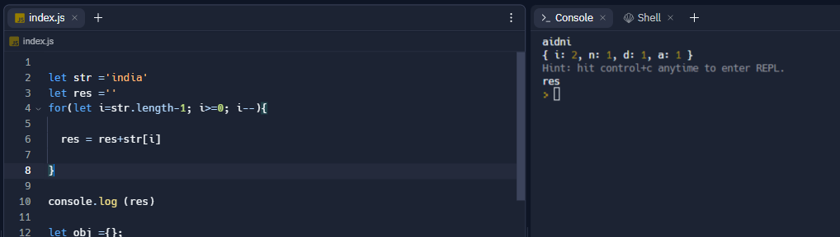

Count the characters in given string

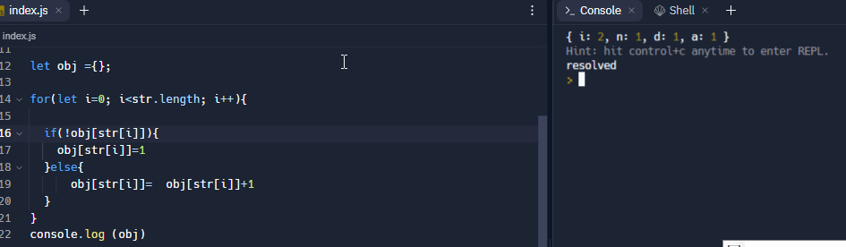

Make a simple promise function

