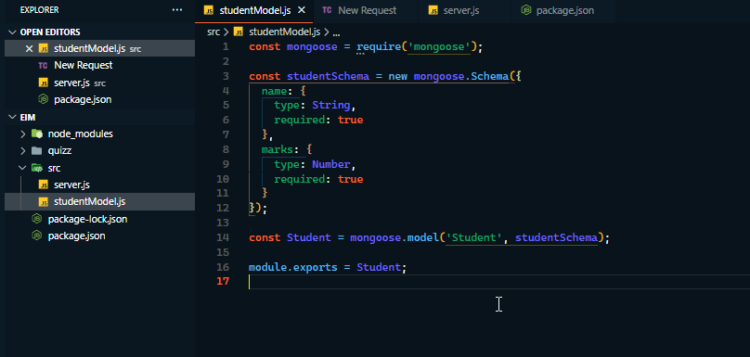

Created Model for Student and Express server with routes to do sum of all marks and name of 2nd max mark

