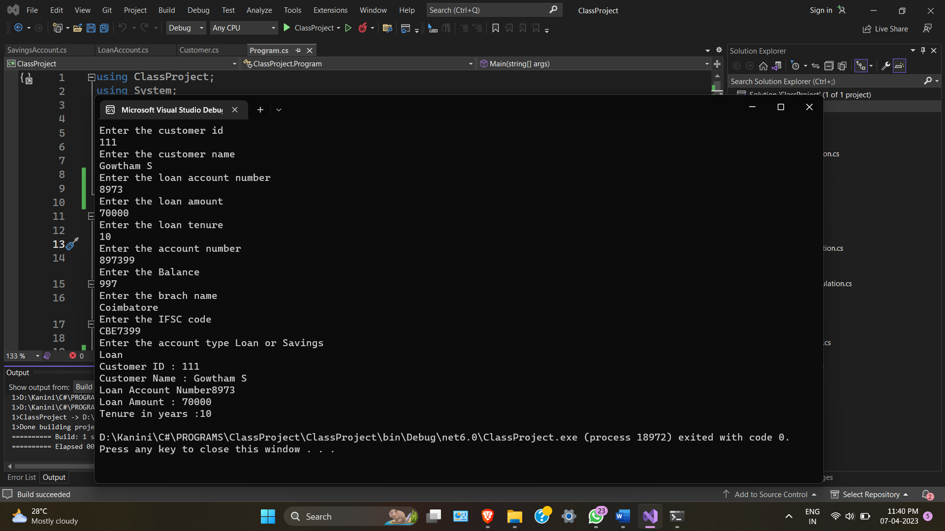

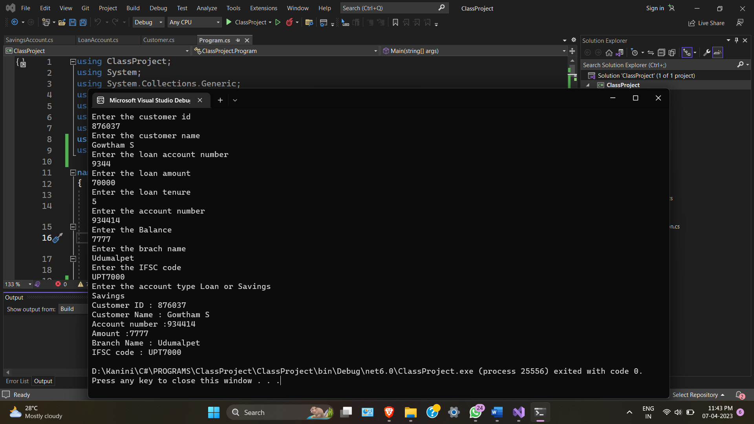

**Implementation of Hierrarchial Inheritance, Method Overriding and base class constructor**

using Basic_Program;

using System.Net.Http.Headers;

class Demo1

{

public static void Main(string[] args)

{

Console.WriteLine("Enter the customer id");

int custid = Convert.ToInt32(Console.ReadLine());

Console.WriteLine("Enter the customer name");

string custname = Console.ReadLine();

Console.WriteLine("Enter the loan account number");

int loanAccNo = Convert.ToInt32(Console.ReadLine());

Console.WriteLine("Enter the loan amount");

int loanAmount = Convert.ToInt32(Console.ReadLine());

Console.WriteLine("Enter the loan tenure");

int loanTenureinyrs = Convert.ToInt32(Console.ReadLine());

Console.WriteLine("Enter the account number");

int accno = Convert.ToInt32(Console.ReadLine());

Console.WriteLine("Enter the Balance");

double amount = Convert.ToDouble(Console.ReadLine());

Console.WriteLine("Enter the brach name");

string branchname = Console.ReadLine();

Console.WriteLine("Enter the IFSC code");

string ifsc = Console.ReadLine();

Customer customer = new Customer(custid, custname);

LoanAccount loanAccount = new LoanAccount(loanAccNo, loanAmount, loanTenureinyrs, custid, custname);

SavingsAccount savingsAccount = new SavingsAccount(accno, amount, branchname, ifsc, custid, custname);

Console.WriteLine("Enter the account type Loan or Savings" );

string ch = Console.ReadLine();

switch (ch)

{

case "Loan" or "loan":

loanAccount.CustDetails();

break;

case "Savings" or "savings":

savingsAccount.CustDetails();

break;

default:

Console.WriteLine("Enter Laon or savings");

break;

}

}

}

using System;

using System.Collections.Generic;

using System.Linq;

using System.Text;

using System.Threading.Tasks;

namespace Basic_Program

{

internal class Customer

{

private int custid;

private string custname;

public Customer(int custid, string custname)

{

this.Custid = custid;

this.Custname = custname;

}

public int Custid { get => custid; set => custid = value; }

public string Custname { get => custname; set => custname = value; }

public void CustDetails()

{

Console.WriteLine(this.Custid);

Console.WriteLine(this.Custname);

}

}

}

using System;

using System.Collections.Generic;

using System.Linq;

using System.Text;

using System.Threading.Tasks;

namespace Basic_Program

{

internal class LoanAccount:Customer

{

private int loanAccNo;

private int loanAmount;

private int loanTenureinyrs;

public LoanAccount(int loanAccNo, int loanAmount, int loanTenureinyrs, int custid, string custname):base(custid, custname)

{

this.LoanAccNo = loanAccNo;

this.LoanAmount = loanAmount;

this.LoanTenureinyrs = loanTenureinyrs;

}

public int LoanAccNo { get => loanAccNo; set => loanAccNo = value; }

public int LoanAmount { get => loanAmount; set => loanAmount = value; }

public int LoanTenureinyrs { get => loanTenureinyrs; set => loanTenureinyrs = value; }

public void CustDetails()

{

Console.WriteLine("Customer ID : " + this.Custid);

Console.WriteLine("Customer Name : "+ this.Custname);

Console.WriteLine("Loan Account Number"+ this.LoanAccNo);

Console.WriteLine("Loan Amount : " + this.LoanAmount);

Console.WriteLine("Tenure in years" + this.LoanTenureinyrs);

}

}

}

using System;

using System.Collections.Generic;

using System.Linq;

using System.Text;

using System.Threading.Tasks;

namespace Basic_Program

{

internal class SavingsAccount:Customer

{

private int accno;

private double amount;

private string branchname;

private string ifsc;

public SavingsAccount(int accno, double amount, string branchname, string ifsc, int custid, string custname) :base(custid, custname)

{

this.Accno = accno;

this.Amount = amount;

this.Branchname = branchname;

this.Ifsc = ifsc;

}

public int Accno { get => accno; set => accno = value; }

public double Amount { get => amount; set => amount = value; }

public string Branchname { get => branchname; set => branchname = value; }

public string Ifsc { get => ifsc; set => ifsc = value; }

public void CustDetails()

{

Console.WriteLine("Customer ID : " + this.Custid);

Console.WriteLine("Customer Name : " + this.Custname);

Console.WriteLine("Account number :" + this.Accno);

Console.WriteLine("Amount :" + this.Amount);

Console.WriteLine("Branch Name : " + this.Branchname);

Console.WriteLine("IFSC code : " + this.Ifsc);

}

}

}

**Abstract Class and Interface**

using Basic_Program;

using System.Net.Http.Headers;

class Demo1

{

public static void Main(string[] args)

{

DerivedAbstractClass derivedAbstractClass = new DerivedAbstractClass();

derivedAbstractClass.display();

}

}

using System;

using System.Collections.Generic;

using System.Linq;

using System.Text;

using System.Threading.Tasks;

namespace Basic_Program

{

internal abstract class AbstractClass

{

public abstract void display();

}

}

using System;

using System.Collections.Generic;

using System.Linq;

using System.Text;

using System.Threading.Tasks;

namespace Basic_Program

{

internal class DerivedAbstractClass:AbstractClass

{

public override void display()

{

Console.WriteLine("Welcome Boss");

}

}

}



**Work with concept of interface**

using Basic_Program;

using System.Net.Http.Headers;

class Demo1

{

public static void Main(string[] args)

{

UI ui = new UI();

DBdesign dBdesign = new DBdesign();

Console.WriteLine("Enter the status");

string status = Console.ReadLine();

switch(status)

{

case "UI":

Console.WriteLine(ui.Progress());

break;

case "DBdesign":

Console.WriteLine(dBdesign.Progress());

break;

default:

Console.WriteLine("Enter UI or DBdesign");

break;

}

}

}

using System;

using System.Collections.Generic;

using System.Linq;

using System.Text;

using System.Threading.Tasks;

namespace Basic_Program

{

internal class UI:IProject

{

public string Progress()

{

return "Completed UI";

}

}

}

using System;

using System.Collections.Generic;

using System.Linq;

using System.Text;

using System.Threading.Tasks;

namespace Basic_Program

{

internal class DBdesign:IProject

{

public string Progress()

{

return "Completed DB Design";

}

}

}

using System;

using System.Collections.Generic;

using System.Linq;

using System.Text;

using System.Threading.Tasks;

namespace Basic_Program

{

internal interface IProject

{

string Progress();

}

}



**Implement multiple inheritance with abstract class and interface.**

namespace basicprgm1

{

internal class multipleclass

{

public void display()

{

Console.WriteLine("Base Class 1");

}

}

}

namespace basicprgm1

{

internal interface multipleinterface

{

public void display1();

}

}

namespace basicprgm1

{

internal class derivedclass : multipleclass, multipleinterface

{

public derivedclass() : base()

{ }

public void derived()

{

Console.WriteLine("Derived Class");

}

public void display1()

{

Console.WriteLine("Base class 2");

}

}

}

derivedclass d = new derivedclass();

d.display();

1.

namespace Assign3

{

internal class Program

{

public static void Main(string[] args)

{

Console.Write("Enter limit: ");

int limit = Convert.ToInt32(Console.ReadLine());

int[] array1 = new int[limit];

for (int i = 0; i < limit; i++)

{

array1[i] = Convert.ToInt32(Console.ReadLine());

}

for (int i = 0; i < limit; i++)

{

for (int j = i + 1; j < limit; j++)

{

if (array1[i] > array1[j])

{

int temp = array1[i];

array1[i] = array1[j];

array1[j] = temp;

}

}

}

Console.WriteLine("--------------------------------");

Console.WriteLine("Ascending Order Sort is displayed Below");

Console.Write(String.Join(",", array1));

}

}

}

**Just implement class and use getter and setter in it**

namespace Assign3

{

internal class Array

{

private int id;

private string name;

private int age;

private string addr;

public Array(int id, string name, int age, string addr)

{

this.id = id;

this.name = name;

this.age = age;

this.addr = addr;

}

public int Id { get => id; set => id = value; }

public string Name { get => name; set => name = value; }

public int Age { get => age; set => age = value; }

public string Addr { get => addr; set => addr = value; }

public void display()

{

Console.WriteLine(this.id);

Console.WriteLine(this.name);

Console.WriteLine(this.age);

Console.WriteLine(this.addr);

}

}

internal class Program

{

public static void Main(string[] args)

{

Console.Write("Enter id: ");

int id = Convert.ToInt32(Console.ReadLine());

Console.Write("Enter Name: ");

string name = Console.ReadLine();

Console.Write("Enter Age: ");

int age = Convert.ToInt32(Console.ReadLine());

Console.Write("Enter addr: ");

string addr = Console.ReadLine();

Console.WriteLine("------------------------------------------------");

Array array = new Array(id, name, age, addr);

array.display();

}

}

}

3.

public void jagged()

{

int i, j;

int[][] jaggedArray = new int[4][];

jaggedArray[0] = new int[] { 1, 2, 3, 4, 5 };

jaggedArray[1] = new int[] { 40, 50, 11, 4 };

jaggedArray[2] = new int[] { 55, 17 };

jaggedArray[3] = new int[4];

Console.WriteLine(jaggedArray[0][2]);

for (i = 0; i < jaggedArray[3].Length; i++)

{

jaggedArray[3][i] = Convert.ToInt32(Console.ReadLine());

}

int[][,] jaggy = new int[3][,];

jaggy[0] = new int[5, 4];

jaggy[1] = new int[6, 5];

jaggy[2] = new int[7, 6];

for (i = 0; i < 5; i++)

{

for (j = 0; j < 4; j++)

{

jaggy[0][i, j] = Convert.ToInt32(Console.ReadLine());

}

}

for (i = 0; i < 5; i++)

{

for (j = 0; j < 4; j++)

{

Console.Write(jaggy[0][i, j]);

}

Console.WriteLine();

}

}