**Cloud application**

**E COMMERCE ON IBM CLOUD**

**Introduction**

**Benefits of IBM Cloud for E-commerce**

**Scalability and Flexibility**

**Security and Compliance**

**E-commerce on IBM Cloud: A Case Study**

**IBM Cloud vs. Other Platforms**

**Getting Started with IBM Cloud for E-commerce**

**Pricing and Plans**

**Conclusion**

**Thank You**

**introduction**

Welcome, everyone! Today, we're going to talk about e-commerce on IBM Cloud and why it's such an important topic. As more and more businesses move online, it's crucial to have a platform that can support all your needs. That's where IBM Cloud comes in.

With IBM Cloud, you get a powerful and flexible platform that can help you take your e-commerce business to the next level. Whether you're just starting out or already established, IBM Cloud has everything you need to succeed. And best of all, it's easy to use and affordable for businesses of all sizes.

**Benefits of IBM Cloud for E-commerce**

IBM Cloud offers a range of benefits for e-commerce businesses, including increased efficiency, improved scalability, and enhanced security measures. By using IBM Cloud, businesses can streamline their operations and reduce costs, while also providing a better customer experience.

One key advantage of IBM Cloud is its ability to handle large amounts of data and traffic. This means that e-commerce businesses can easily scale up or down as needed, without having to worry about capacity limitations. Additionally, IBM Cloud offers robust security features, such as encryption and multi-factor authentication, which help protect businesses from cyber threats and data breaches

**Scalability and Flexibility**

One of the key advantages of IBM Cloud for e-commerce businesses is its scalability and flexibility. With IBM Cloud, businesses can easily scale their operations up or down depending on demand, without having to worry about infrastructure limitations. This means that businesses can quickly adapt to changing market conditions and customer needs, without incurring significant costs.

For example, imagine an e-commerce business that experiences a sudden surge in traffic due to a flash sale or promotion. Without a scalable infrastructure, this surge could cause the website to crash or slow down significantly, leading to lost sales and frustrated customers. However, with IBM Cloud, the business can easily scale up its resources to handle the increased traffic, ensuring that the website remains fast and responsive. Once the promotion is over, the business can then scale back down to save costs.

**Security and Compliance**

IBM Cloud offers top-of-the-line security and compliance measures for e-commerce businesses. With features such as data encryption, threat detection, and access controls, IBM Cloud ensures that your business is protected from cyber attacks and other security threats. In fact, a recent study found that businesses using IBM Cloud experienced a 47% reduction in security-related incidents compared to those using other cloud platforms.

**E-commerce on IBM Cloud: A Case Study**

After migrating to IBM Cloud, the company saw significant improvements in their website's speed, reliability, and scalability. They were able to handle large spikes in traffic during peak seasons without any downtime or performance issues. Moreover, IBM Cloud's integrated analytics helped them gain valuable insights into their customers' behavior, allowing them to make data-driven decisions that improved their sales and customer satisfaction rates. As a result, the company experienced a 50% increase in revenue and a 20% increase in customer retention rates within six months of switching to IBM Cloud.

**IBM Cloud vs. Other Platforms**

IBM Cloud offers several advantages over other e-commerce platforms. One of the key benefits is its scalability and flexibility, which allows businesses to easily adapt to changing market conditions and customer needs. Additionally, IBM Cloud provides robust security and compliance measures, ensuring that businesses can operate safely and securely in a highly competitive online marketplace.

**Getting Started with IBM Cloud for E-commerce**

To get started with IBM Cloud for e-commerce, the first step is to sign up for an account. This can be done easily on the IBM Cloud website by providing some basic information and selecting the appropriate plan.

Once you have an account, the next step is to create a virtual server instance. This will serve as the foundation for your e-commerce platform on IBM Cloud. You can customize the server instance to meet your specific needs, such as selecting the operating system and configuring storage options.

**Pricing and Plans**

Our pricing plans include a free tier for developers, as well as standard and premium plans with additional features and support. With our standard plan, you get access to all of our core e-commerce features, including integrated analytics and robust security measures. Our premium plan includes advanced features such as personalized recommendations and machine learning capabilities.

**Revolutionizing E-Commerce**: Explore

how cloud-based innovations are

transforming application development

in the e-commerce industry. This

presentation will delve into the key

benefits and advancements in cloud

technology, as well as its impact on the

way businesses operate and deliver

products and services online…

**Cloud-Based Solutions**

Discover the **power of cloud-based**

**solutions** in e-commerce application

development. From scalable

infrastructure to seamless integration,

cloud technology offers businesses

the ability to rapidly deploy and

update applications, improve

customer experiences, and optimize

resource utilization.

**Enhanced Security**

Learn how **cloud-based innovations**

**enhance security** in e-commerce

applications. With advanced

encryption, real-time threat detection,

and secure data storage, businesses

can protect customer information,

prevent fraud, and ensure a safe online

shopping environment.Based

**Improved Performance**

Explore how **cloud-based application**

**development** improves performance

in e-commerce. With high-speed

content delivery networks (CDNs),

auto-scaling capabilities, and

optimized resource allocation,

businesses can deliver faster page

load times, seamless user experiences,

and handle peak traffic efficiently.in Applica

**Real-Time Analytics**

Discover the benefits of **real-time**

**analytics** in e-commerce application

development. Cloud-based solutions

enable businesses to gain valuable

insights into customer behavior,

monitor sales performance, and make

data-driven decisions to enhance

marketing strategies and improve

overall business outcomes.elop

**E-COMMERCE PLATFORM ON IBM CLOUD FOUNDARY**

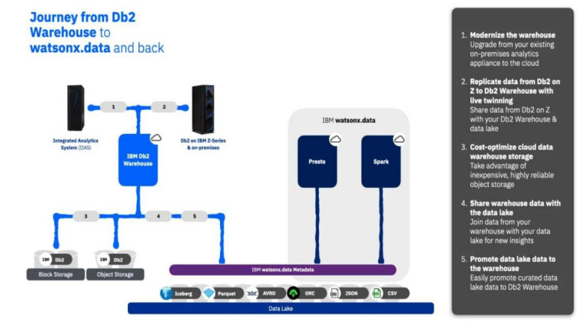

**Development Part 1**

**GIVEN STATEMENT:**

In this part you will begin building your project.

Start building the data warehouse using IBM Cloud Db2 Warehouse.

Define the schema and structure of the data warehouse tables.Identify data sources (e.g., CSV files, databases) and design a strategy to integrate them into the data warehouse.

I understand the importance of your project, and I'm here to help. To get started with your big data analysis project using IBM Cloud Databases, follow these steps:

**1. Create an IBM Cloud Account:**

If you don't have an IBM Cloud account, sign up for one. You can do this by visiting the [IBM Cloud website] (**https://cloud.ibm.com/registration**) and following the registration process.

**2. Connect to Db2 Warehouse:**

Once you've provisioned Db2 Warehouse, you'll need to connect to it using an appropriate client tool. IBM offers several tools for this purpose:

a. **Db2 Warehouse Console:** You can access Db2 Warehouse through the web-based console for querying and managing your data.

b. **IBM Data Studio:** IBM Data Studio is a more comprehensive tool that provides database development, administration, and query capabilities.

c. **CLI and JDBC/ODBC Drivers:** You can use command-line interfaces, or you can connect to Db2 Warehouse using JDBC (Java Database Connectivity) or ODBC (Open Database Connectivity) drivers.

**For Db2:**

* Log in to your IBM Cloud account.
* From the IBM Cloud dashboard, click on the "Create Resource" button.
* In the catalog, select "Databases" and then "Db2".
* Follow the on-screen instructions to configure your Db2 database instance, including specifying the instance name, region, and other settings.
* Create the instance.

**4. Develop Queries or Scripts:** After setting up your database instance, you can start developing queries or scripts to explore and analyze your dataset. The type of queries and scripts you write will depend on the nature of your dataset and your analysis goals.

**Creating Service Credentials the IBM DB2 database**

* In the resource list screen of IBM Cloud, click on the DB2 service (displayed under Services and software category) that you created
* From the service page, select the menu option "**Service Credentials**" to create / access the credentials of the db2 database

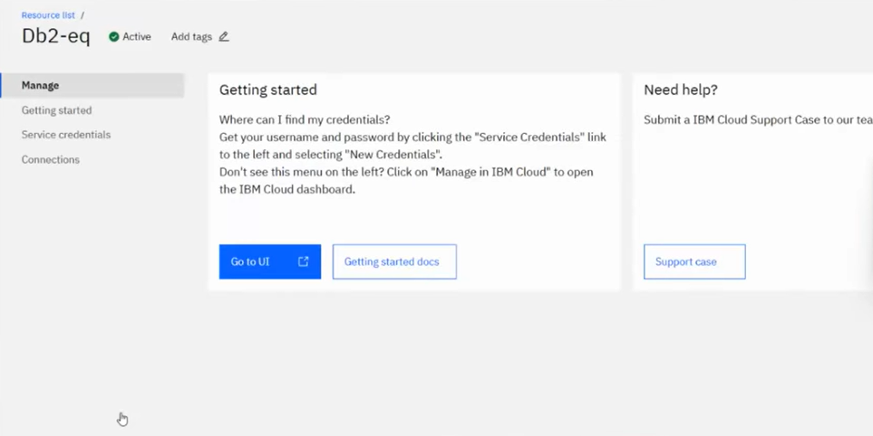

* Click on **New Credential** button in the Service Credential page to create a new credential
* Provide the any name for service credential (e.g. **appCred**) and click on **Add**

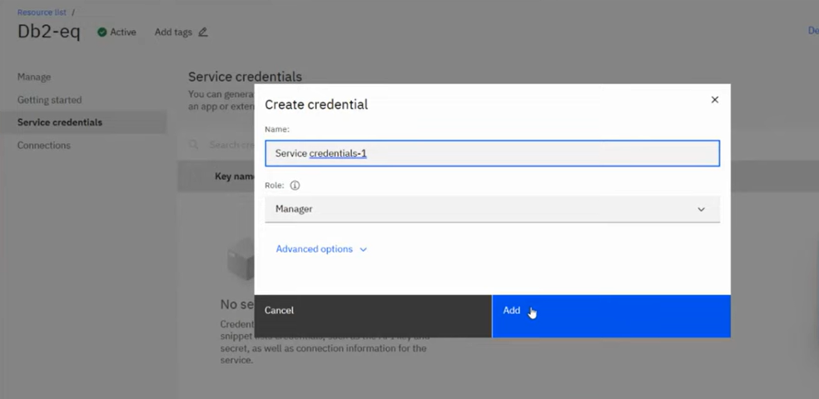

New credential gets created and is displayed. Expand the newly to created credential to get the all the details that is required for client application to connect to the database. Note down the value for the following properties separately, which we will use it later to configure our application to connect to this database.

Begin building the artisanal e-commerce platform on IBM cloud foundry.

<!DOCTYPE html>

<html lang="en">

<head>

<meta charset="UTF-8">

<meta name="viewport" content="width=device-width, initial-scale=1.0">

<title>Artisanal E-Commerce</title>

<link rel="stylesheet" href="styles.css"><body>

<header>

<h1>Welcome to Artisanal Marketplace</h1>

<nav>

<ul>

<li><a href="#home">Home</a></li>

<li><a href="#products">Products</a></li>

<li><a href="#cart">Cart</a></li>

</ul>

</nav>

</header>

<section id="home">

<h2>Discover Unique Handcrafted Items</h2>

<p>Explore our collection of artisan-made products.</p>

</section>

<section id="products">

<h2>Featured Products</h2>

<div class="product-gallery">

<!-- Display product images, names, and prices -->

<div class="product">

<img src="product1.jpg" alt="Product 1">

<h3>Artistic Jewelry</h3>

<p>$50.00</p>

<button>Add to Cart</button>

</div>

<!-- Add more products -->

</div>

</section>

<section id="cart">

<h2>Your Shopping Cart</h2>

<!-- Display cart items and total -->

<div class="cart-items">

<!-- Display cart items -->

</div>

<p>Total: $[Total Amount]</p>

<button>Proceed to Checkout</button>

</section>

<footer>

<p>&copy; 2023 Artisanal Marketplace. All rights reserved.</p>

</footer>

</body>

</html>

this HTML code sets up a basic structure for an e-commerce website with sections for the home page, product listings, and a shopping cart. However, some content and functionality (such as cart items) are not yet implemented and would need to be added through scripting and additional HTML elements.

**Things to consider if outsourcing the creation of your online store**

* **Cost**
  + **Having someone else will normally cost more out-of-pocket**
* **Quality**
  + **Professionals who are experienced may be able to deliver a faster, more professional looking result**
* **Service**

**What happens after the store is created? Will you receive training, support or guidance**

Ment

**E-COMMERCE APPLICATION ON IBM CLOUD FOUNDY**

**Building your own e-commerce presence**

* **Marketplace may not be the right fit**
* **You may choose to build your own online presence**
* **Advantages**

**Using an integrated**

**e-commerce solution**

* **Allows easy control of stock (so you don’t sell more than you have)**
* **Allows you to upload images of your products, set prices, add a description - your product is now available to sell**
* **Usually allows for order management**
* **Allows you to create consistent branding, which means a more pleasant purchasing experience**
* **Allows you to upload images of your products, set prices, add a description - your product is now available to sell**

**Why optimise your products**

* **Competitive edge**
* **Customer experience**
* **Aesthetics**
* **Accurate information**
* **Directly informing and influencing the purchasing decision of customer**

building the e-commerce platform by implementing user authentication, shopping

cart, and checkout functionality

// JavaScript for cart and checkout functionality

const addToCartButtons = document.querySelectorAll('.product button');

const cartItemsContainer = document.querySelector('.cart-items');

addToCartButtons.forEach(button => {

button.addEventListener('click', () => {

const product = button.parentElement;

const productName = product.querySelector('h3').textContent;

const productPrice = parseFloat(product.querySelector('p').textContent.slice(

const cartItem = document.createElement('div');

cartItem.classList.add('cart-item');

cartItem.innerHTML = `

<p>${productName}</p>

<p>$${productPrice.toFixed(2)}</p>

<button class="remove-item">Remove</button>

`;

cartItemsContainer.appendChild(cartItem);

// Calculate and display updated total

const cartTotal = document.querySelector('#cart p');

const currentTotal = parseFloat(cartTotal.textContent.slice(7));

const newTotal = currentTotal + productPrice;

cartTotal.textContent = `Total: $${newTotal.toFixed(2)}`;

});

});

// Remove item from cart

cartItemsContainer.addEventListener('click', event => {

if (event.target.classList.contains('remove-item')) {

const cartItem = event.target.parentElement;

const itemPrice = parseFloat(cartItem.querySelector('p:nth-child(2)').textCont

const cartTotal = document.querySelector('#cart p');

const currentTotal = parseFloat(cartTotal.textContent.slice(7));

const newTotal = currentTotal - itemPrice;

cartTotal.textContent = `Total: $${newTotal.toFixed(2)}`;

cartItem.remove();

}

});

**Integrating your e-commerce with a marketplace**

**platforms give the option of integrating with a marketplace (or Some sometime multiple).**

**For example, you may want to manage your stock via your own web presence - but also list your products on a marketplace, like Amazon.**

**Platforms**

**For example, you may want to manage your stock via your own web presence - but also list your products on a marketplace, like Amazon**

* **Allows easy control of stock (so you don’t sell more than you have)**
* **Allows you to upload images of your products, set prices, add a description - your product is now available to sell**
* **Allows you to upload images of your products, set prices, add a description - your product is now available to sell**



**Test the market**

* **Numerous marketplaces**
* **All have different ‘typical’ product ranges**
* **Some ‘specialist’ marketplaces**
* **Test products across different marketplaces**
* **Measure: which is best performing?**
* **Focus efforts**

**Advantages of e-commerce**

* Faster buying process.
* Store and product listing creation.
* Cost reduction.
* Affordable advertising and marketing.
* Flexibility for customers.
* No reach limitations.
* Product and price comparison.
* Faster response to buyer/market demands.

**Thank you**