**E-COMMERCE PLATFORM ON IBM CLOUD FOUNDARY**

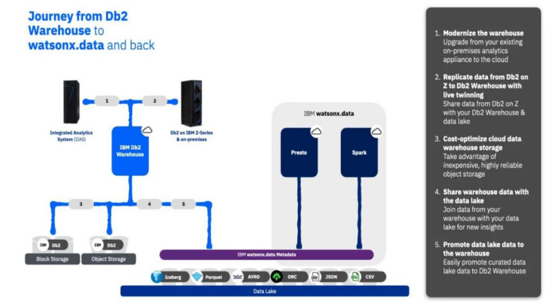

**PHASE 3: Development Part 1**

**GIVEN STATEMENT:**

In this part you will begin building your project.

Start building the data warehouse using IBM Cloud Db2 Warehouse.

Define the schema and structure of the data warehouse tables.Identify data sources (e.g., CSV files, databases) and design a strategy to integrate them into the data warehouse.

I understand the importance of your project, and I'm here to help. To get started with your big data analysis project using IBM Cloud Databases, follow these steps:

**1. Create an IBM Cloud Account:**

If you don't have an IBM Cloud account, sign up for one. You can do this by visiting the [IBM Cloud website] (**https://cloud.ibm.com/registration**) and following the registration process.

**2. Connect to Db2 Warehouse:**

Once you've provisioned Db2 Warehouse, you'll need to connect to it using an appropriate client tool. IBM offers several tools for this purpose:

a. **Db2 Warehouse Console:** You can access Db2 Warehouse through the web-based console for querying and managing your data.

b. **IBM Data Studio:** IBM Data Studio is a more comprehensive tool that provides database development, administration, and query capabilities.

c. **CLI and JDBC/ODBC Drivers:** You can use command-line interfaces, or you can connect to Db2 Warehouse using JDBC (Java Database Connectivity) or ODBC (Open Database Connectivity) drivers.

**For Db2:**

* Log in to your IBM Cloud account.
* From the IBM Cloud dashboard, click on the "Create Resource" button.
* In the catalog, select "Databases" and then "Db2".
* Follow the on-screen instructions to configure your Db2 database instance, including specifying the instance name, region, and other settings.
* Create the instance.

**4. Develop Queries or Scripts:** After setting up your database instance, you can start developing queries or scripts to explore and analyze your dataset. The type of queries and scripts you write will depend on the nature of your dataset and your analysis goals.

**Creating Service Credentials the IBM DB2 database**

* In the resource list screen of IBM Cloud, click on the DB2 service (displayed under Services and software category) that you created
* From the service page, select the menu option "**Service Credentials**" to create / access the credentials of the db2 database

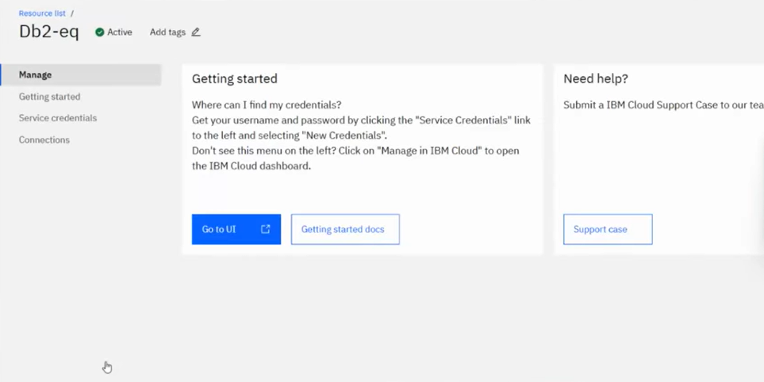

* Click on **New Credential** button in the Service Credential page to create a new credential
* Provide the any name for service credential (e.g. **appCred**) and click on **Add**

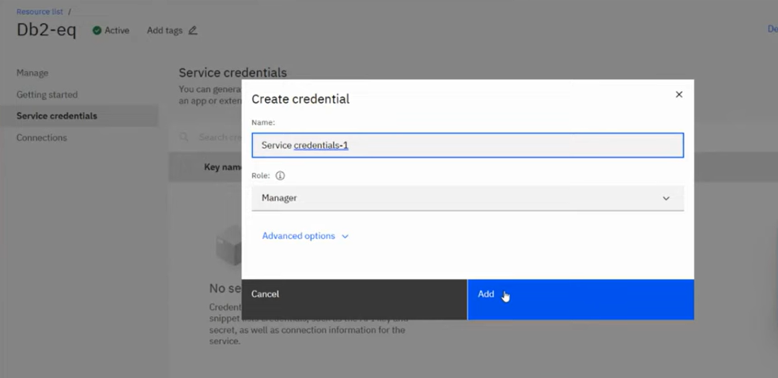

New credential gets created and is displayed. Expand the newly to created credential to get the all the details that is required for client application to connect to the database. Note down the value for the following properties separately, which we will use it later to configure our application to connect to this database.

Begin building the artisanal e-commerce platform on IBM cloud foundry.

<!DOCTYPE html>

<html lang="en">

<head>

<meta charset="UTF-8">

<meta name="viewport" content="width=device-width, initial-scale=1.0">

<title>Artisanal E-Commerce</title>

<link rel="stylesheet" href="styles.css"><body>

<header>

<h1>Welcome to Artisanal Marketplace</h1>

<nav>

<ul>

<li><a href="#home">Home</a></li>

<li><a href="#products">Products</a></li>

<li><a href="#cart">Cart</a></li>

</ul>

</nav>

</header>

<section id="home">

<h2>Discover Unique Handcrafted Items</h2>

<p>Explore our collection of artisan-made products.</p>

</section>

<section id="products">

<h2>Featured Products</h2>

<div class="product-gallery">

<!-- Display product images, names, and prices -->

<div class="product">

<img src="product1.jpg" alt="Product 1">

<h3>Artistic Jewelry</h3>

<p>$50.00</p>

<button>Add to Cart</button>

</div>

<!-- Add more products -->

</div>

</section>

<section id="cart">

<h2>Your Shopping Cart</h2>

<!-- Display cart items and total -->

<div class="cart-items">

<!-- Display cart items -->

</div>

<p>Total: $[Total Amount]</p>

<button>Proceed to Checkout</button>

</section>

<footer>

<p>&copy; 2023 Artisanal Marketplace. All rights reserved.</p>

</footer>

</body>

</html>

this HTML code sets up a basic structure for an e-commerce website with sections for the home page, product listings, and a shopping cart. However, some content and functionality (such as cart items) are not yet implemented and would need to be added through scripting and additional HTML elements.

**Things to consider if outsourcing the creation of your online store**

* **Cost**
  + **Having someone else will normally cost more out-of-pocket**
* **Quality**
  + **Professionals who are experienced may be able to deliver a faster, more professional looking result**
* **Service**

**What happens after the store is created? Will you receive training, support or guidance**

**Conclusion**

**In conclusion, building an artisanal e-commerce platform on IBM Cloud Foundry is a strategic choice, combining reliability, security, scalability, and cost-effectiveness to help your business thrive. It's essential to engage skilled developers and adhere to best practices to realize the full potential of this project.**

**Thank you**