**E-COMMERCE APPLICATION ON IBM CLOUD FOUNDY**

**Building your own e-commerce presence**

* **Marketplace may not be the right fit**
* **You may choose to build your own online presence**
* **Advantages**

**Using an integrated**

**e-commerce solution**

* **Allows easy control of stock (so you don’t sell more than you have)**
* **Allows you to upload images of your products, set prices, add a description - your product is now available to sell**
* **Usually allows for order management**
* **Allows you to create consistent branding, which means a more pleasant purchasing experience**

**Why optimise your products**

* **Competitive edge**
* **Customer experience**
* **Aesthetics**
* **Accurate information**
* **Directly informing and influencing the purchasing decision of customer**

building the e-commerce platform by implementing user authentication, shopping

cart, and checkout functionality

// JavaScript for cart and checkout functionality

const addToCartButtons = document.querySelectorAll('.product button');

const cartItemsContainer = document.querySelector('.cart-items');

addToCartButtons.forEach(button => {

button.addEventListener('click', () => {

const product = button.parentElement;

const productName = product.querySelector('h3').textContent;

const productPrice = parseFloat(product.querySelector('p').textContent.slice(

const cartItem = document.createElement('div');

cartItem.classList.add('cart-item');

cartItem.innerHTML = `

<p>${productName}</p>

<p>$${productPrice.toFixed(2)}</p>

<button class="remove-item">Remove</button>

`;

cartItemsContainer.appendChild(cartItem);

// Calculate and display updated total

const cartTotal = document.querySelector('#cart p');

const currentTotal = parseFloat(cartTotal.textContent.slice(7));

const newTotal = currentTotal + productPrice;

cartTotal.textContent = `Total: $${newTotal.toFixed(2)}`;

});

});

// Remove item from cart

cartItemsContainer.addEventListener('click', event => {

if (event.target.classList.contains('remove-item')) {

const cartItem = event.target.parentElement;

const itemPrice = parseFloat(cartItem.querySelector('p:nth-child(2)').textCont

const cartTotal = document.querySelector('#cart p');

const currentTotal = parseFloat(cartTotal.textContent.slice(7));

const newTotal = currentTotal - itemPrice;

cartTotal.textContent = `Total: $${newTotal.toFixed(2)}`;

cartItem.remove();

}

});

**Integrating your e-commerce with a marketplace**

**platforms give the option of integrating with a marketplace (or Some sometime multiple).**

**For example, you may want to manage your stock via your own web presence - but also list your products on a marketplace, like Amazon.**

**Platforms**

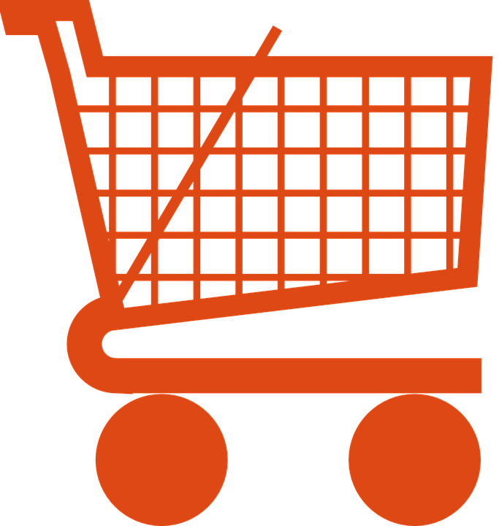

**Test the market**

* **Numerous marketplaces**
* **All have different ‘typical’ product ranges**
* **Some ‘specialist’ marketplaces**
* **Test products across different marketplaces**
* **Measure: which is best performing?**
* **Focus efforts**

**Advantages of e-commerce**

* Faster buying process.
* Store and product listing creation.
* Cost reduction.
* Affordable advertising and marketing.
* Flexibility for customers.
* No reach limitations.
* Product and price comparison.
* Faster response to buyer/market demands.

**Thank you**