27 MARKETS
Trade Beyond Limits

Client Relationship Management (CRM)
Back-Office Platform — What It Includes & Why We Are Building It

Prepared for: Client | Date: 2026-06-22 | Version 1.0

This document explains the internal back-office system (CRM) that powers the 27 Markets platform behind the scenes — the tools your team uses to manage leads, clients, identity verification, deposits and withdrawals, support, and partners — and the business reasons for building it.

Contents
1. What Is the CRM? 3
2. Why We Are Building It 3
3. What the CRM Includes 4
4. Lead & Sales Pipeline 4
5. The Client 360° View 5
6. KYC & Compliance Review 5
7. Finance & Withdrawal Approvals 5
8. Staff Roles & Access Control 6
9. Status Reference 6
10. How We Will Build It 6
11. Important Note — Costs & Go-Live 7
12. Summary 7

1. What Is the CRM?
The 27 Markets platform has two sides. Clients see the public website and the secure client portal. Your team needs the other side: a private, secure back-office to run the business. That back-office is the CRM (Client Relationship Management) system.
In one place, the CRM lets your staff see every lead and client, review identity documents, approve deposits and withdrawals, answer support requests, manage partners, and read live performance reports — with strict access controls and a full record of who did what.
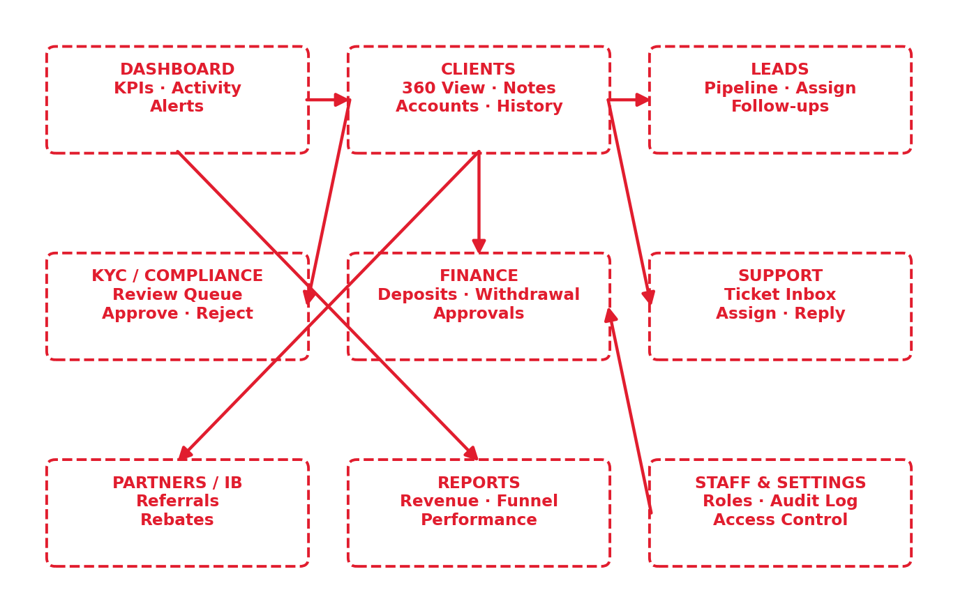
Figure 1 — The CRM back-office modules and how they connect around the client.

2. Why We Are Building It
Without a CRM, client information lives in scattered spreadsheets, inboxes, and chat messages. That is slow, error-prone, hard to audit, and impossible to scale. The CRM solves this directly:
- One source of truth — Every lead, client, document, payment, and conversation in one place — no more scattered spreadsheets or lost information.
- More conversions, more revenue — Leads are captured, assigned, and followed up systematically, so more visitors become funded, active clients.
- Regulatory compliance — A KYC review queue, sanction checks, and a complete audit trail keep the business compliant and inspection-ready.
- Financial control & safety — No money moves without staff review. Withdrawals are held and approved by finance, protecting against fraud and error.
- Operational visibility — Live dashboards show deposits, withdrawals, pending work, and team performance at a glance.
- Better client service — Staff see a client’s full history instantly, so they resolve requests faster and more personally.
- Accountability & security — Role-based access (Admin / Agent) plus an audit log mean each person sees only what they should, and every action is recorded.
- Built to scale — As the client base grows from hundreds to thousands, the same system keeps working — manual methods would break.

3. What the CRM Includes
The CRM is delivered as a single back-office application with the following modules:
Module | What your team can do
Dashboard | See key numbers and pending work — new clients, KYC to review, withdrawals to approve, open tickets, deposits today.
Clients (360 View) | Search any client and see their full profile, accounts, balances, KYC status, transactions, notes, and activity history.
Leads | A visual sales pipeline: capture leads from the website and demo requests, assign them to agents, and track follow-ups to conversion.
KYC / Compliance | Review submitted identity documents in a queue and approve or reject them, which unlocks the client’s withdrawals.
Finance | See all deposits and approve or reject withdrawal requests; make controlled manual adjustments (Admin only).
Accounts | View all trading accounts and suspend, activate, or change leverage when needed.
Support | A shared ticket inbox — assign tickets to staff, reply to clients, and keep internal notes.
Partners / IB | See partners and the clients they referred, with referral and rebate tracking.
Reports | Charts for deposits, withdrawals, net flow, lead conversion, and agent performance.
Staff & Settings | Manage staff accounts, assign Admin or Agent access, and review the full audit log (Admin only).

4. Lead & Sales Pipeline
Every visitor is a potential client. The CRM captures leads automatically from the website and demo requests, assigns them to a sales agent, and tracks each one through clear stages until they fund and start trading — so no opportunity is missed.
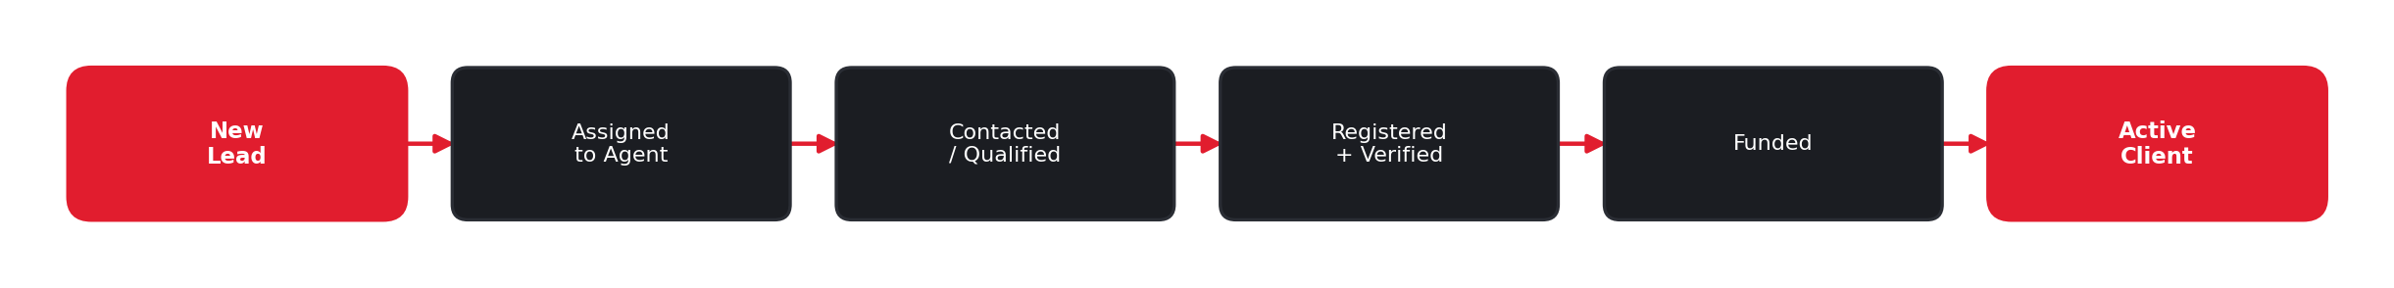
Figure 2 — How a lead moves to a funded, active client.

5. The Client 360° View
When a staff member opens a client, they see everything about that person on one screen — no switching between tools:
- Personal profile and contact details.
- All trading accounts with live balances.
- KYC verification status and uploaded documents.
- Full deposit, withdrawal, and transfer history.
- Internal staff notes and the complete activity timeline.

6. KYC & Compliance Review
To keep the platform secure and compliant, clients verify their identity. Submissions land in a review queue where a compliance officer approves or rejects them. Withdrawals stay locked until verification is approved.
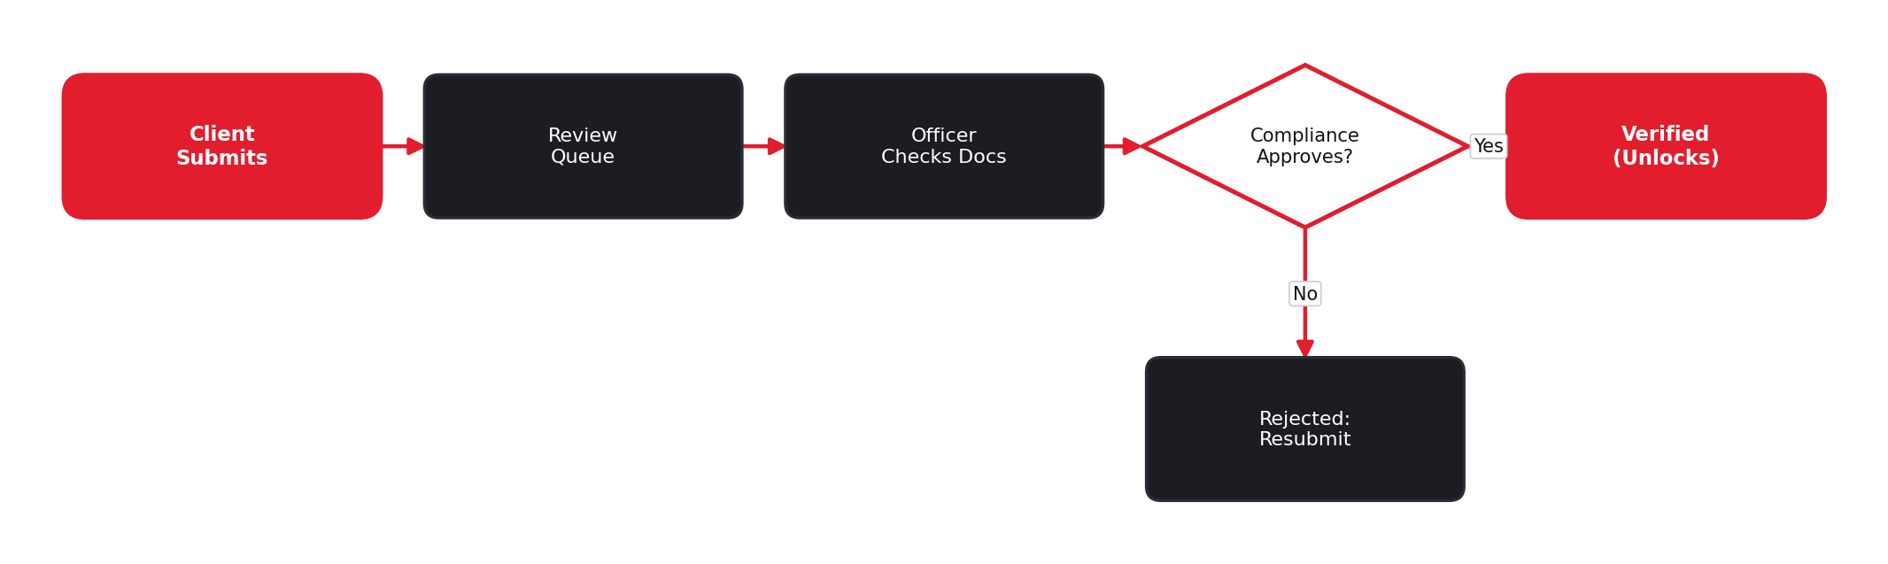 | ▸ The client uploads identity, address, and selfie documents.  ▸ Submissions appear in the compliance review queue.  ▸ An officer checks the documents against the rules.  ▸ Approved clients are Verified and withdrawals unlock.  ▸ Rejected submissions are returned with a reason to resubmit.

Figure 3 — KYC review handled inside the CRM.

7. Finance & Withdrawal Approvals
Money safety is central. Every withdrawal is checked and held, then approved by the finance team before any payout — so no funds leave without a human review and a recorded decision.
▸ A client requests a withdrawal in the portal.  ▸ The system checks KYC status and available balance.  ▸ Valid requests are held and placed in the approval queue.  ▸ Finance reviews and approves the payout, or rejects it.  ▸ Rejections release the hold and restore the balance. | 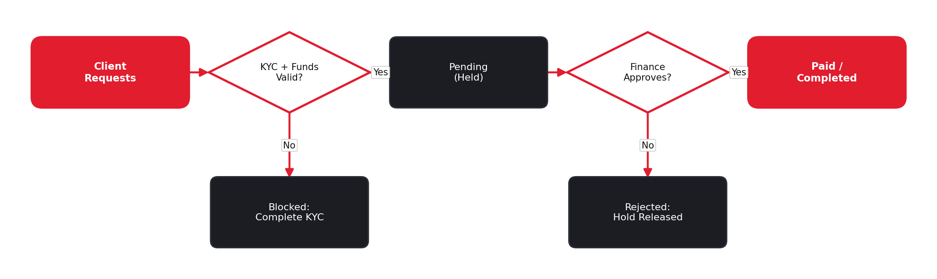

Figure 4 — Withdrawal approval workflow in the finance module.

8. Staff Roles & Access Control
Access is two-tier, so each person only sees and does what their job requires — and every action is logged for accountability.
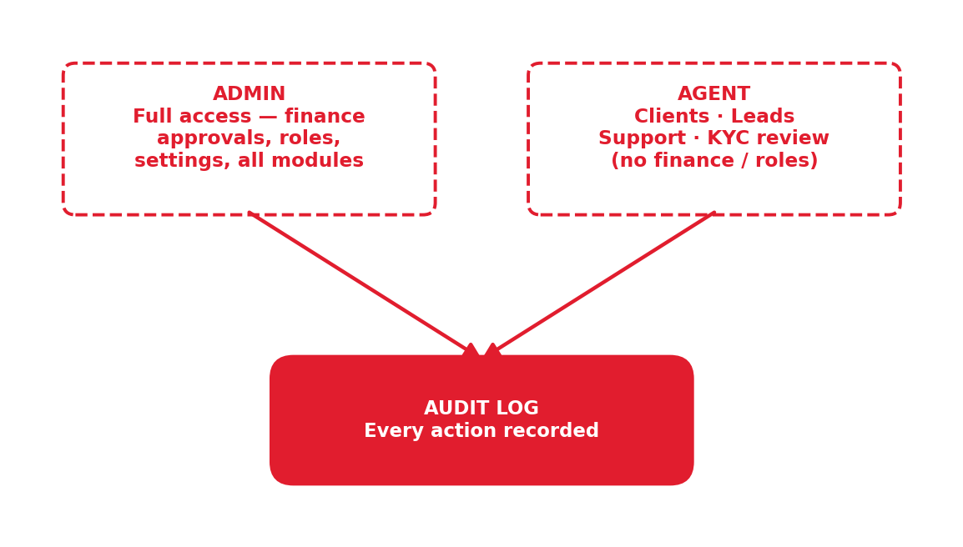 | ▸ Admin: full access — finance approvals, staff and role management, settings, and all modules.  ▸ Agent: day-to-day work — clients, leads, support, and KYC review — but no finance approvals or role changes.  ▸ Audit log: every state-changing action is recorded with who, what, and when.

Figure 5 — Two-tier access (Admin / Agent) with a full audit trail.

9. Status Reference
Every item the team manages has a clear status, so work is never ambiguous.
Area | Possible statuses
Lead | New, Contacted, Qualified, Converted, Lost
Client account | Active, Suspended, Closed
KYC step | Not Submitted, Pending, Approved, Rejected
Trading account | Active, Pending, Suspended, Archived
Deposit | Pending, Completed, Failed
Withdrawal | Pending, Approved, Paid, Rejected
Support ticket | Open, In Progress, Resolved

10. How We Will Build It
The CRM is delivered in independent phases, so you can see and use working pieces early rather than waiting for everything at once:
Phase | Delivered
1 | Foundations — staff roles (Admin/Agent), secure access, and the admin shell.
2 | Dashboard with live numbers and recent activity.
3 | Clients (360 view + notes) and the KYC review queue.
4 | Finance (withdrawal approvals) and account administration.
5 | Leads pipeline and the support desk.
6 | Partners, reports, staff/settings, audit log, and final polish.

11. Important Note — Costs & Go-Live
Please note the following:
- Current stage: This build runs on simulated data for demonstration. Live money movement is not active yet.
- Going live: The CRM goes fully live once the trading platform, payment gateways, identity-verification provider, and brokerage licensing are connected and approved.
- Third-party costs: Some capabilities (identity-verification checks, email/SMS notifications, payment reconciliation) rely on paid third-party services billed by each provider; they are not free or included in this build.
- Future phases: Advanced features — automated marketing campaigns, a full IB commission engine, and granular per-permission roles — are planned for later phases and quoted separately.

12. Summary
The CRM is the control center of 27 Markets. It turns scattered, manual work into one secure system where leads convert faster, clients are served better, money is moved only with proper approval, and the business stays compliant and fully auditable. It gives your team complete operational visibility today, and a foundation that scales as 27 Markets grows.

