
27 MARKETS
Trade Beyond Limits
Complete Platform Workflow Specification
Version 1.0 | 2026-06-22 | CFD/Forex Brokerage — Marketing Site + Client Portal

End-to-end operational workflow covering actors, modules, user journeys, money movement, compliance, statuses, data model, permissions, and integrations.

Prepared by Core Care Consultancy

Table of Contents
1. Application Actors / User Roles 4
2. Full System Modules 4
3. End-to-End User Journey 5
4. Lead-to-Client Conversion Workflow 6
5. Registration & Onboarding Workflow 6
6. KYC Verification Workflow 6
7. Trading Account Creation Workflow 7
8. Client Dashboard Workflow 7
9. Deposit Workflow 8
10. Withdrawal Workflow 8
11. Internal Transfer Workflow 9
12. Support / Helpdesk Workflow 9
13. Partner / IB Workflow 9
14. Admin Workflow 10
15. Notification Workflow 10
16. Compliance & Risk Workflow 10
17. Edge Cases / Exception Handling 10
18. Recommended Statuses per Module 11
19. Database Entities / Data Structure Overview 11
20. API / Module Logic Overview 12
21. Page-to-Page Navigation Logic 12
22. Suggested Permissions by Role 12
23. Recommended Future Integrations 13
24. Costs, Licensing & Go-Live 13
25. Final Master Workflow Summary 14
Appendix A — Reusable Component System 15
A.1 UI primitives (components/ui) 15
A.2 Layout components 15
A.3 Marketing / composite components 15
A.4 Portal components 15
Appendix B — Recommended Folder Structure 15
Appendix C — 3D & Animation Plan 16
Appendix D — Design System 16
D.1 Color palette 16
D.2 Typography 16
D.3 Spacing & utilities 17
Appendix E — Implementation Phases 17

1. Application Actors / User Roles
Actor | Scope | Description
Visitor (Lead) | Public | Anonymous prospect browsing the marketing site; can submit lead/demo/contact forms.
Registered Client | Portal | Verified or pending account holder; trades, funds, manages account.
IB / Partner | Partner portal | Introducing Broker / affiliate earning rebates on referred client volume.
Support Agent | Admin | Handles tickets, live chat, basic client assistance.
KYC / Compliance Officer | Admin | Reviews and approves/rejects KYC, AML checks, risk flags.
Finance Officer | Admin | Approves deposits/withdrawals/transfers, reconciles funds.
Administrator | Admin | Full configuration: accounts, leverage, content, roles, partners.
System / Scheduler | Automated | Notifications, status transitions, rebate calc, scheduled jobs.

2. Full System Modules
- Public Website: Home, About, Trading Accounts, Markets, Partnership/IB, Contact, Login, Register.
- Onboarding: Multi-step registration, demo request, lead capture, email verification.
- KYC / Compliance: Identity, Proof of Address, Selfie — upload, review, status.
- Account Management: Dashboard, Accounts, account creation (Standard/Raw/VIP), leverage selection.
- Funds / Cashier: Deposit, Withdraw, Internal Transfer, Transaction History.
- Downloads: Platform installers + document download center.
- Support / Helpdesk: Tickets, live chat, FAQ.
- Partner / IB: IB registration, referral links, rebate reports, marketing assets.
- Profile: Profile, security, preferences, notification settings.
- Admin Back-office: User mgmt, KYC queue, finance approvals, content/CMS, partner mgmt, audit log.
- Notifications: In-app, email, toast queue across all events.
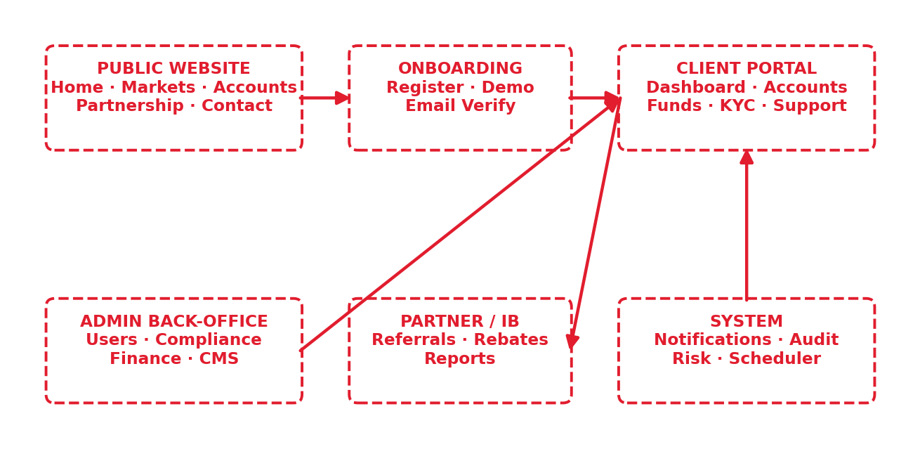
Figure 1 — System modules and how they connect.

3. End-to-End User Journey
Visitor → Marketing site → Lead form / Register → Email verify → Login → KYC → Open trading account → Deposit → Trade → Withdraw → Ongoing support / partner growth
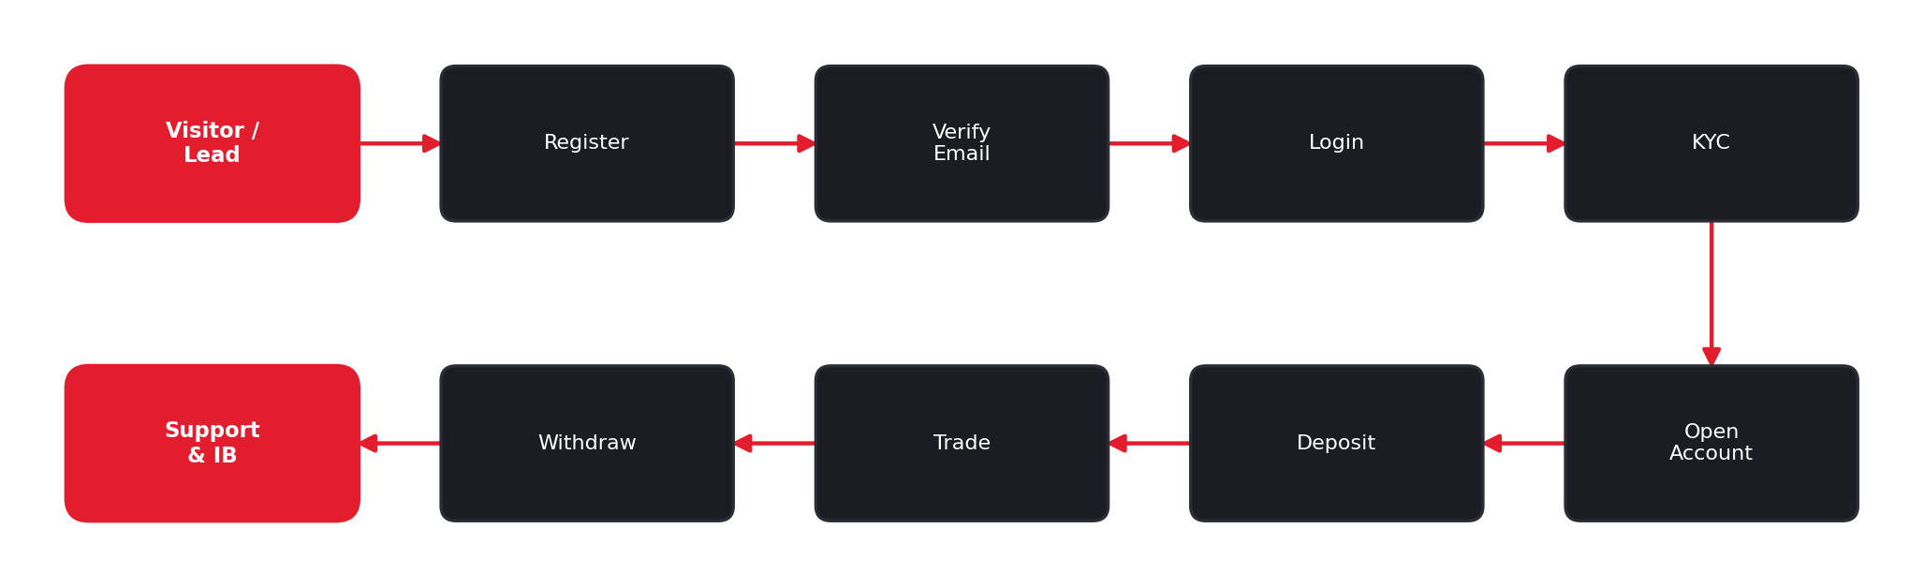
Figure 2 — End-to-end client journey (top row left-to-right, bottom row right-to-left).
- Visitor discovers the brand via marketing site or partner referral link.
- Submits a lead (demo / contact) or registers a live account.
- Verifies email, logs into the client portal.
- Completes KYC (identity, address, selfie).
- Opens a trading account (Standard / Raw Spread / VIP) with chosen leverage.
- Deposits funds via preferred method.
- Downloads platform, trades, monitors KPIs on dashboard.
- Withdraws profits; raises support tickets as needed.
- Optionally becomes an IB to refer and earn rebates.

4. Lead-to-Client Conversion Workflow
Lead captured → Nurtured → Registered → Verified → KYC → Funded → Active Client
- Lead captured (contact form, demo request, partner referral, newsletter).
- Lead stored with source + UTM + referring IB; status = New.
- Automated welcome + nurture notifications; assigned to sales/support if configured.
- Lead registers a live account → becomes Pending Client.
- Email verified + KYC approved → status = Verified.
- First deposit cleared → status = Funded / Active Client (conversion complete).
Conversion KPIs: lead→register, register→KYC, KYC→funded. Each transition emits an event for analytics and (if referred) credits the originating IB.
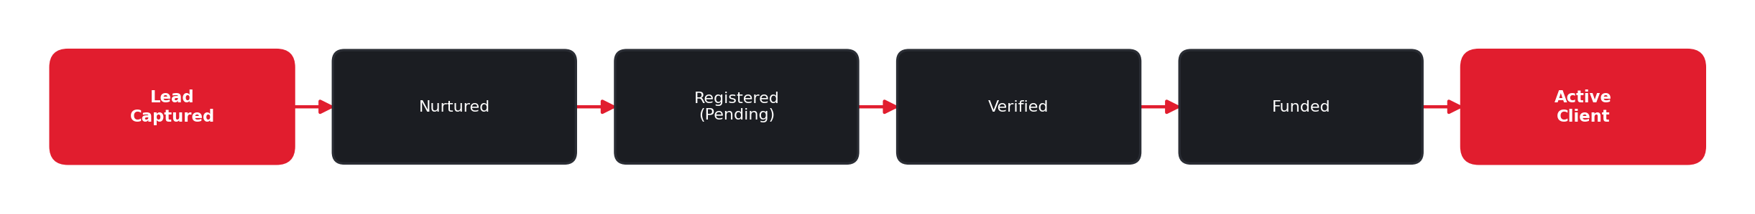
Figure 3 — Lead-to-client conversion with status at each stage.

5. Registration & Onboarding Workflow
Form (multi-step) → Validation → Create user → Email verify → Login → Onboarding checklist
- Step 1 — Personal details (name, email, phone, country).
- Step 2 — Account preferences (account type, base currency, leverage).
- Step 3 — Credentials + agreements (password, T&C, risk disclosure).
- Client-side zod validation on each step; cannot advance until valid.
- On submit: create user (status = Pending), send verification email.
- Email verified → first login → onboarding checklist (verify KYC, open account, deposit).
Demo flow: shorter form → instant demo account with virtual balance, no KYC required.
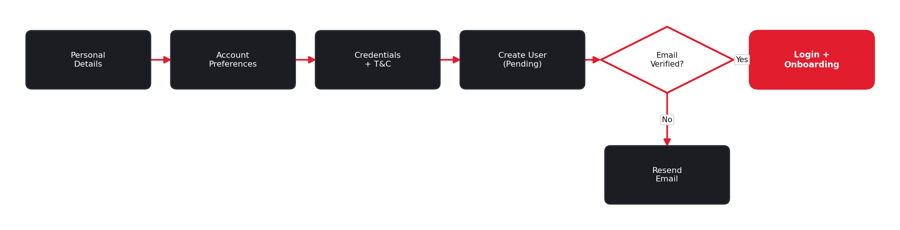
Figure 4 — Registration and onboarding flow.

6. KYC Verification Workflow
Not Submitted → Submitted/Pending → Under Review → Approved | Rejected (→ Resubmit)
- Client opens KYC; sees 3 steps with current statuses.
- Identity Verification — upload ID/passport (front/back).
- Proof of Address — upload utility bill / bank statement.
- Selfie Verification — upload selfie holding ID.
- Each upload sets that step to Pending → Compliance Officer reviews.
- Officer approves (Approved) or rejects with reason (Rejected → client resubmits).
- All three Approved → overall KYC = Verified → unlocks withdrawals & full funding limits.
Gating: deposits may be allowed pre-KYC up to a limit; withdrawals require full KYC. Progress bar reflects completed steps; compliance message shown throughout.
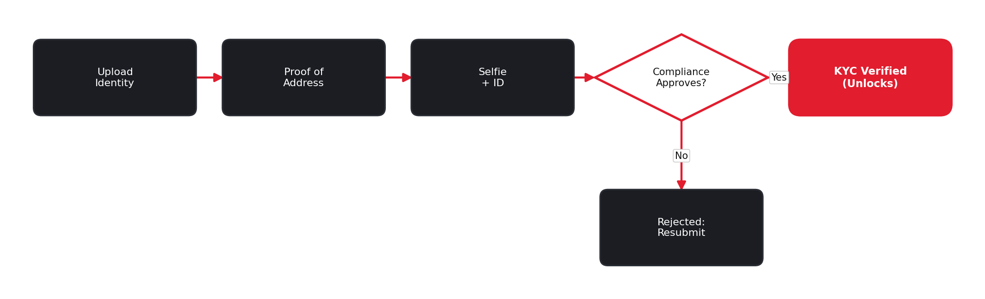
Figure 5 — KYC verification with compliance review.

7. Trading Account Creation Workflow
Choose type → Configure → Confirm → Provision account number → Active
- Client clicks Open New Account (dashboard) or Choose Account (pricing page).
- Selects type: Standard / Raw Spread / VIP.
- Configures base currency + leverage (within type limits).
- Confirms; system provisions a unique account number with zero balance.
- Account appears in dashboard table with status = Active.
Type | Spreads from | Commission | Leverage | Audience
Standard | 0.8 pips | Commission-free | 1:500 | All traders
Raw Spread | 0.0 pips | $7 / lot | 1:500 | Experienced (Popular)
VIP | 0.0 pips | Custom | 1:500 | High-volume

8. Client Dashboard Workflow
- On login, land on Dashboard with "Welcome back, {name}".
- Animated KPI widgets: Total Balance, Equity, Free Margin, Margin Level.
- Accounts table: Account #, Type, Balance, Equity, Status.
- Quick actions: Open New Account, Deposit, Withdraw, complete KYC if pending.
- Sidebar navigation to all portal modules; notifications bell + profile menu.
Margin Level = (Equity / Used Margin) x 100. Color-coded thresholds warn on low margin.

9. Deposit Workflow
Select method → Enter amount → Confirm → Pending → Processing → Completed | Failed
- Funds → Deposit tab; choose method (Bank Transfer, Card, E-Wallet, Crypto).
- Enter amount + account to credit; see fees, ETA, min/max.
- Confirm → transaction created (status = Pending).
- Instant methods (Card/E-Wallet/Crypto) → Processing → Completed quickly; Bank Transfer 1–3 days.
- On Completed → account balance credited, toast + notification, history updated.
- On Failed/Rejected → reason shown, balance unchanged, client may retry.
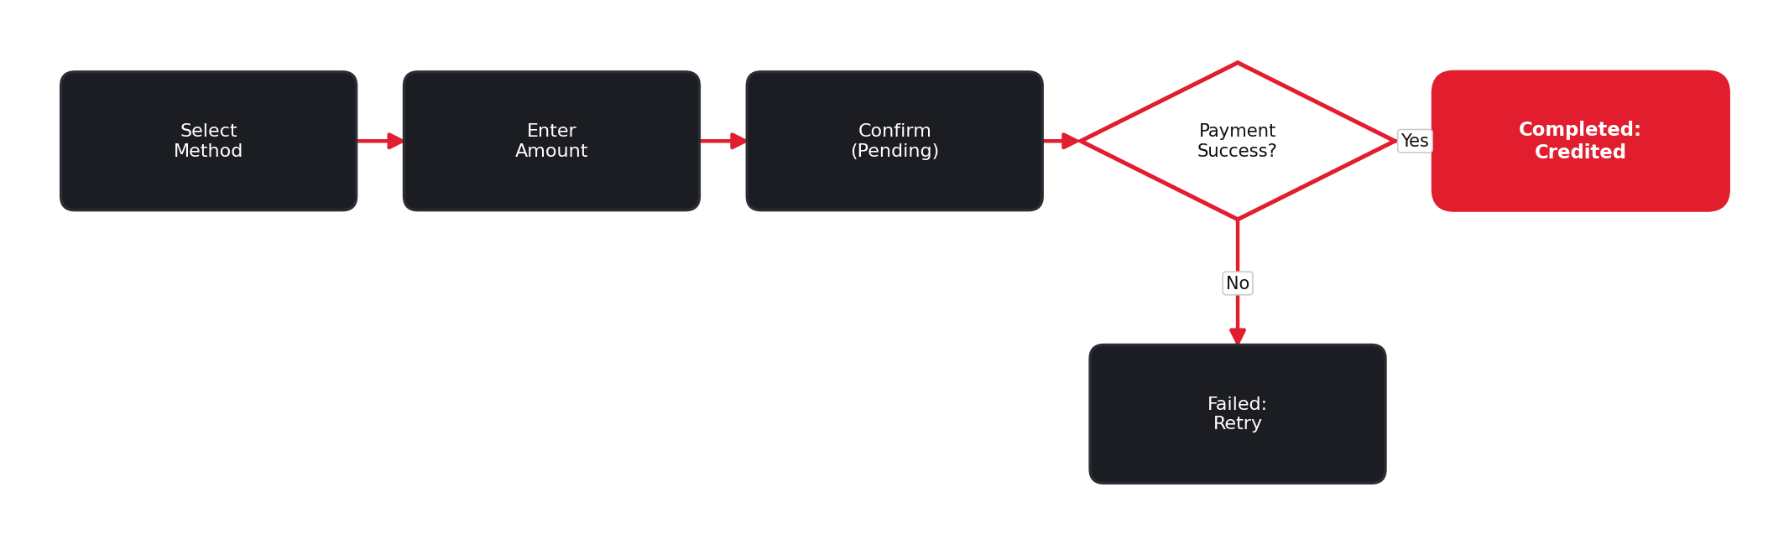
Figure 6 — Deposit flow from method selection to credited balance.

10. Withdrawal Workflow
Request → Validate (KYC + balance) → Pending → Finance review → Approved → Paid | Rejected
- Funds → Withdraw; select account + method + amount.
- System checks: KYC Verified, sufficient free margin, withdrawal limits, AML rules.
- Request created (status = Pending) → balance reserved/held.
- Finance Officer reviews; Approved → funds sent → status = Paid/Completed.
- Rejected → reason shown, hold released, balance restored.
Anti-fraud: withdrawals typically returned to the original deposit source first (source-of-funds rule).
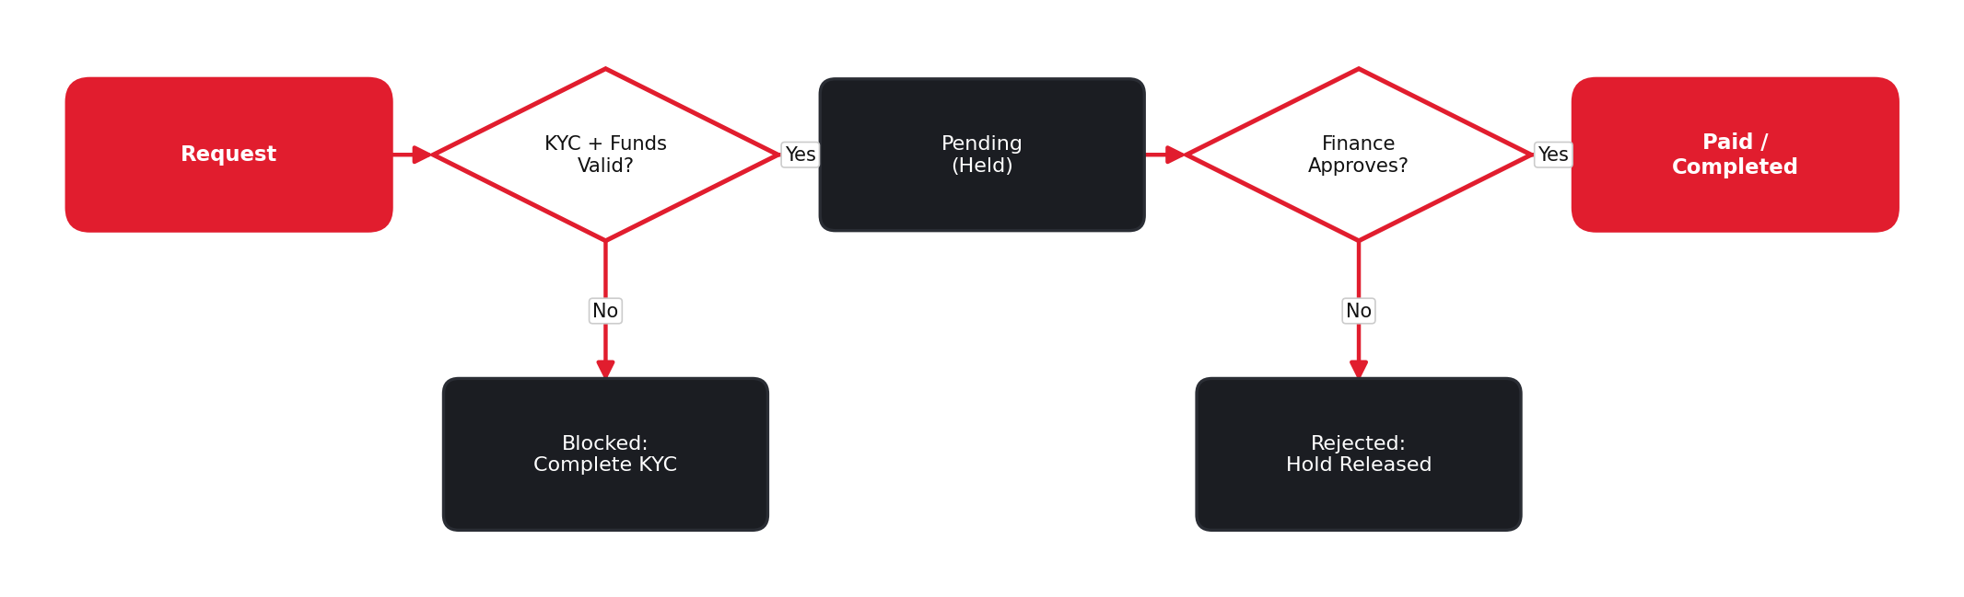
Figure 7 — Withdrawal flow with verification and finance approval.

11. Internal Transfer Workflow
Select from/to accounts → Amount → Validate → Execute → Both balances updated
- Funds → Internal Transfer; choose source + destination account (same client).
- Enter amount; validate sufficient free margin in source.
- Confirm → debit source, credit destination (instant, same-currency) or FX-converted.
- Two linked transactions recorded; both balances + history updated; toast confirms.

12. Support / Helpdesk Workflow
Open ticket → Open → In Progress → Awaiting Reply → Resolved → Closed
- Client creates ticket (category, subject, message, optional attachment) or starts live chat.
- Ticket queued (status = Open) + reference ID; client + agent notified.
- Agent responds → In Progress; threaded replies; status toggles Awaiting Reply.
- Issue solved → Resolved; client confirms or auto-closes after inactivity → Closed.
- Client can reopen a closed ticket within a window.

13. Partner / IB Workflow
Apply → Approved → Get referral link → Refer clients → Track volume → Earn rebates → Payout
- Visitor applies via Partnership page (Become an IB Partner).
- Admin reviews application → Approved → IB account created.
- IB receives unique referral link(s) + marketing assets.
- Referred leads tagged to IB through registration → conversion.
- System tracks referred clients’ trading volume in real time.
- Rebates calculated per lot/spread; shown in IB reports dashboard.
- IB requests rebate payout → Finance approves → paid; reflected in history.

14. Admin Workflow
- User mgmt: Create/suspend/edit clients, reset access, adjust leverage.
- Compliance: Review queue, approve/reject KYC with reasons, AML flags.
- Finance: Approve deposits/withdrawals, reconcile, manual adjustments with audit trail.
- Products: Configure account types, spreads, leverage caps, fees.
- Partners: Approve IBs, set rebate tiers, review partner reports, payouts.
- CMS: Edit marketing content, markets list, downloads, announcements.
- Support ops: Assign tickets, manage agents, SLA monitoring.
- Audit: Immutable audit log of all privileged actions.

15. Notification Workflow
Trigger | Channel | Recipient
Registration / email verify | Email + in-app | Client
KYC submitted / approved / rejected | Email + toast | Client + Compliance
Deposit / withdrawal status change | Email + toast | Client + Finance
Account opened | Toast + in-app | Client
Support reply | Email + in-app | Client / Agent
IB: new referral / rebate | In-app + email | Partner
Security (login, password change) | Email | Client

Global ToastContext queues transient UI toasts; persistent items live in a notifications center with read/unread state.

16. Compliance & Risk Workflow
- KYC/AML gate before withdrawals and high-value funding.
- Sanctions / PEP screening on registration (integration-ready).
- Source-of-funds rule on withdrawals (return to origin).
- Transaction monitoring for unusual patterns → risk flag → manual review.
- Leverage caps and negative-balance protection per account type/jurisdiction.
- Risk disclosure + T&C acceptance recorded at registration.
- Full audit trail; data retention + privacy compliance.

17. Edge Cases / Exception Handling
- Unverified email: Allow re-send verification; block login until verified.
- KYC incomplete: Block withdrawal, prompt to complete KYC.
- KYC rejected: Rejected with reason; client resubmits specific step.
- Withdrawal > balance: Reject with insufficient-funds message; suggest deposit.
- Payment failure: Show Failed state, keep balance unchanged, offer retry.
- Double submit: Idempotent submit; disable button + spinner; dedupe by request key.
- Expired session: Session expiry → redirect to login, preserve intended route.
- Loading/empty/error: Skeletons on load; ErrorState with retry on fetch failure; EmptyState when no data.
- Reduced motion: prefers-reduced-motion disables 3D/parallax; static fallbacks.
- Negative balance: Block negative balances; margin-call/stop-out warnings.

18. Recommended Statuses per Module
Module | Statuses
Lead | New, Contacted, Qualified, Converted, Lost
Client/User | Pending, Verified, Active, Suspended, Closed
KYC step | Not Submitted, Pending, Under Review, Approved, Rejected
Trading Account | Active, Inactive, Suspended, Archived
Deposit | Pending, Processing, Completed, Failed, Cancelled
Withdrawal | Pending, Approved, Paid, Rejected, Cancelled
Transfer | Pending, Completed, Failed
Support Ticket | Open, In Progress, Awaiting Reply, Resolved, Closed
IB Application | Pending, Approved, Rejected, Suspended
Rebate Payout | Accrued, Requested, Approved, Paid

19. Database Entities / Data Structure Overview
Entity | Key fields
User | id, name, email, phone, country, role, status, createdAt
Lead | id, source, utm, referrerIB, status, contactInfo
KycRecord | userId, idStatus, addressStatus, selfieStatus, docs[], reviewedBy
TradingAccount | id, userId, accountNumber, type, currency, leverage, balance, equity, status
Transaction | id, accountId, type(deposit/withdraw/transfer), method, amount, status, ref, ts
SupportTicket | id, userId, category, subject, messages[], status, agentId
Partner/IB | id, userId, status, referralCode, tier, referredClients[], rebateBalance
Notification | id, userId, type, message, read, ts
AuditLog | id, actorId, action, target, metadata, ts

In the current build these are mock entities in React Context persisted to localStorage; the schema is backend-ready for a real API.

20. API / Module Logic Overview
Domain | Representative operations
Auth | register, verifyEmail, login, logout, refreshSession, forgotPassword
KYC | submitStep, getStatus, review (admin)
Accounts | createAccount, listAccounts, getAccount, updateLeverage
Funds | deposit, withdraw, transfer, listTransactions
Support | createTicket, replyTicket, listTickets, closeTicket
Partner | applyIB, getReferralLink, getRebateReport, requestPayout
Admin | manageUsers, reviewKyc, approveFunds, manageContent, viewAudit
Notifications | push, list, markRead

Current implementation: context reducers + hooks (useAuth, usePortalData, useToast) standing in for API calls; same signatures map 1:1 to future REST/GraphQL endpoints.

21. Page-to-Page Navigation Logic
- Public: Home → CTAs → Register / Demo / Accounts; nav → About/Markets/Partnership/Contact.
- Onboarding: Register → email verify → Login → Dashboard.
- Portal: Dashboard → KYC (if pending) → Accounts → Funds → trade; sidebar persists across portal.
- Guards: Guarded routes: unauthenticated portal access → Login (then redirect back).
- Gating: KYC-gated actions (withdraw) → redirect to KYC if incomplete.
- Deep links: Contextual deep links: notification → relevant page; ticket reply → ticket thread.

22. Suggested Permissions by Role
Capability | Visitor | Client | IB | Support | Compliance | Finance | Admin
Browse public site | Yes | Yes | Yes | Yes | Yes | Yes | Yes
Portal / trade | No | Yes | Yes | - | - | - | Yes
Submit KYC | No | Yes | Yes | - | - | - | -
Review KYC | No | No | No | No | Yes | No | Yes
Approve funds | No | No | No | No | No | Yes | Yes
Manage tickets | No | Own | Own | Yes | - | - | Yes
Partner reports | No | No | Yes | - | - | - | Yes
Manage users/content | No | No | No | No | No | No | Yes

23. Recommended Future Integrations
- Trading platform: MT4/MT5 or cTrader bridge for real trading + live balances.
- Payments: Stripe / bank rails / e-wallets / crypto gateway for real money movement.
- KYC/AML: Sumsub / Onfido / Jumio for automated identity verification.
- Market data: Real-time quotes feed + TradingView charts.
- CRM/marketing: CRM (HubSpot/Salesforce) + email automation for lead nurture.
- Notifications: SendGrid (email), Twilio (SMS/OTP), web push.
- Analytics: GA4 / Mixpanel + server-side conversion + affiliate tracking.
- Security: Authenticator / SMS 2FA, device management.

24. Costs, Licensing & Go-Live
Current status:
This deliverable is a front-end application using simulated (mock) data persisted locally. Live trading is NOT active in the current build — no real orders, balances, payments, or identity checks are processed.
When live trading starts:
Live trading begins only after the following are completed and approved. Each is a separate workstream beyond the current front-end build:
- Backend: Backend / API layer connecting the app to real services.
- Trading engine: Trading platform / liquidity integration (e.g. MT4 / MT5 / cTrader bridge) for real orders and balances.
- Payments: Payment gateway onboarding and approval (cards, bank, e-wallet, crypto).
- KYC/AML: Automated identity-verification provider connected and live.
- Market data: Real-time price/market-data feed subscribed and connected.
- Licensing: Brokerage regulatory licensing and compliance sign-off in the operating jurisdiction.
Third-party costs (paid services — not free):
The integrations in Section 23 are commercial third-party services. Their API keys are paid credentials with setup and/or ongoing usage charges, billed by each provider and NOT included in this build:
Service | Typical cost model
Trading platform / bridge | License + monthly/setup fees
Payment gateways | Per-transaction % + fixed fee, plus setup
KYC / AML provider | Per-verification (per-check) fee
Market-data / price feed | Monthly subscription
Email / SMS / OTP | Usage-based (per message)
Cloud hosting, domain, SSL, monitoring | Recurring subscription

Exact pricing depends on the chosen provider, transaction volume, and region, and will be confirmed in a separate commercial quotation. API keys/credentials for these services are not free of cost.

25. Final Master Workflow Summary
VISITOR → (marketing / IB referral) → REGISTER → VERIFY EMAIL → LOGIN → KYC → OPEN ACCOUNT → DEPOSIT → TRADE → WITHDRAW → SUPPORT / GROW (IB)
A visitor is captured as a lead and nurtured into a registered user. After email verification and KYC approval, the client opens a trading account, funds it, and trades — monitored from a KPI dashboard. Money movement (deposit, withdrawal, transfer) flows through validated, status-driven workflows with finance and compliance gates. Support, notifications, and an optional IB partner track run throughout, while admins govern users, compliance, finance, content, and partners behind the scenes. Every module is status-driven, auditable, permission-scoped, and integration-ready — built today as a mock-data SPA that maps cleanly onto a real backend.

Appendices — Design & Architecture

Appendix A — Reusable Component System

A.1 UI primitives (components/ui)
Button, Card, Badge/StatusChip, Tabs, Modal, Dropdown, Toast, Accordion, Input, Select, FileUpload, Skeleton, EmptyState, ErrorState, StatCard, ProgressBar, DataTable.

A.2 Layout components
Navbar (responsive + mobile drawer), Footer, PortalSidebar, PortalTopbar, PublicLayout, PortalLayout, Container, Section.

A.3 Marketing / composite components
HeroBlock, StatsStrip, FeatureCard, MarketCategoryCard, AccountComparisonCard, PartnerBenefit, InfinityRibbon, ContactForm, AnimatedCounter, ScrollReveal.

A.4 Portal components
KpiWidget, AccountsTable, DepositMethodCard, WithdrawForm, TransferForm, TransactionHistory, KycStepCard, SupportTicketForm, DownloadCard, RegisterStepper, LoginForm.

Appendix B — Recommended Folder Structure
src/
main.tsx
App.tsx
routes.tsx
assets/ # logos, textures, fonts
styles/ # globals.css, tailwind layers
lib/ # cn(), formatters, constants
data/ # mock accounts, markets, transactions
context/ # AuthContext, PortalDataContext, ToastContext
hooks/ # useAuth, usePortalData, useToast, useReducedMotion
animations/ # framer variants, gsap timelines
components/
ui/ # Button, Card, Tabs, Modal, ...
layout/ # Navbar, Footer, Sidebar, layouts
three/ # HeroScene, Globe, InfinityRibbon, Particles
marketing/ # HeroBlock, StatsStrip, FeatureCard, ...
portal/ # KpiWidget, AccountsTable, DepositMethodCard, ...
pages/
public/ # Home, About, Accounts, Markets, Partnership, Contact
auth/ # Login, Register, Demo
portal/ # Dashboard, Accounts, Funds, Kyc, Downloads, Profile, Support

Appendix C — 3D & Animation Plan
Element | Tech | Behavior
Hero laptop + mobile + waveform | R3F / Three.js | Floating mockups over glowing red market wave + particles
Rotating globe + arcs | R3F / Three.js | Slow auto-rotate, glowing connection arcs (partner section)
Infinity ribbon | R3F / shader | Glowing red looping light ribbon (partnership page)
Section backgrounds | GSAP / canvas | Subtle red particle field + animated waveform
Scroll reveals / parallax | Framer Motion | Layered fade/slide on enter, parallax depth
KPI counters | Framer Motion | Count-up on in-view
Cards / buttons | Framer + CSS | Lift + red edge-glow on hover
Nav / tabs | Framer Motion | Animated active indicator, layout transitions
KYC / funds progress | Framer Motion | Animated progress + status transitions

Accessibility: all 3D is lazy-loaded behind Suspense + skeleton; prefers-reduced-motion renders static fallbacks. Easing is fast and elegant — premium, never excessive.

Appendix D — Design System

D.1 Color palette
Token | Value | Use
bg-base | #050505 | App background (near-black)
bg-elevated | #0a0a0a | Elevated background
panel | #111111 -> #181818 | Cards / glass panels
primary (red) | #e11d2e | Accent, CTAs, glows, active states
text | #ffffff | Primary text
text-muted | #9aa0a6 | Secondary text
border | #222222 | Thin dark borders (red on active)
success | #16a34a | Status: Active / Approved
warning | #f59e0b | Status: Pending
danger | #dc2626 | Status: Rejected

D.2 Typography
- Primary: Inter (400-800) - body, UI, data.
- Display: Space Grotesk (500-700) - display headlines, brand.
- Scale: Scale: 12 / 14 / 16 / 20 / 24 / 32 / 48 / 64px with tight display leading.

D.3 Spacing & utilities
- Spacing: 4px base scale (4/8/12/16/24/32/48/64/96).
- Utilities: .glass-panel, .red-glow, .card-lift; consistent radii; reduced-motion fallbacks everywhere.

Appendix E — Implementation Phases
Phase | Scope | Deliverables
1 - Foundation | Scaffold + design system | Tailwind tokens, UI primitives, contexts, mock data, toasts, layouts
2 - Marketing | Public website | Navbar/Footer, Home + all public pages, 3D hero + globe, scroll reveals
3 - Auth & Shell | Login + portal shell | Auth flow, route guards, sidebar shell, dashboard + KPIs + accounts table
4 - Portal modules | Feature depth | Funds, KYC, downloads, profile, support, multi-step onboarding
5 - Polish & QA | Production readiness | Skeleton/empty/error states, responsive, a11y, reduced-motion, build QA

