27 MARKETS
Trade Beyond Limits

How the Platform Works
End-to-End Workflow — Client Overview

Prepared for: Client | Date: 2026-06-22 | Version 1.0

This document explains, in plain language and visual diagrams, how the 27 Markets trading platform works from a visitor’s first click through to active, funded trading — including onboarding, identity verification, funding, withdrawals, and ongoing support.

Contents
1. Platform at a Glance 3
2. End-to-End Client Journey 3
3. Becoming a Client (Lead → Active) 4
4. Registration & Onboarding 5
5. Identity Verification (KYC) 5
6. Depositing Funds 6
7. Withdrawing Funds 7
8. Status Reference 8
9. Important Note — Costs & Go-Live 8
10. Summary 9

1. Platform at a Glance
27 Markets is a premium online brokerage made of two connected parts that work as one product:
- Public Website — A public marketing website that introduces the brand, markets, account types, and partnership program, and converts visitors into registered clients.
- Client Portal — A secure client portal where verified clients open accounts, deposit and withdraw funds, complete identity checks, download platforms, and get support.
Behind the scenes, an admin back-office and automated system handle compliance reviews, finance approvals, notifications, and partner rebates.
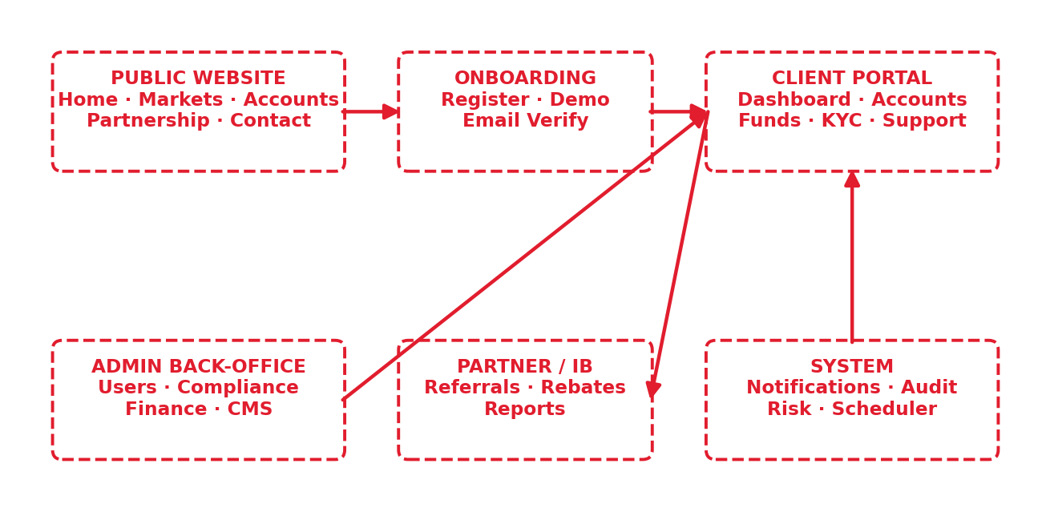
Figure 1 — The platform modules and how they connect.

2. End-to-End Client Journey
The diagram below shows the complete path a person takes — from first discovering 27 Markets to actively trading and growing with us. Read it left-to-right across the top row, then right-to-left along the bottom row.
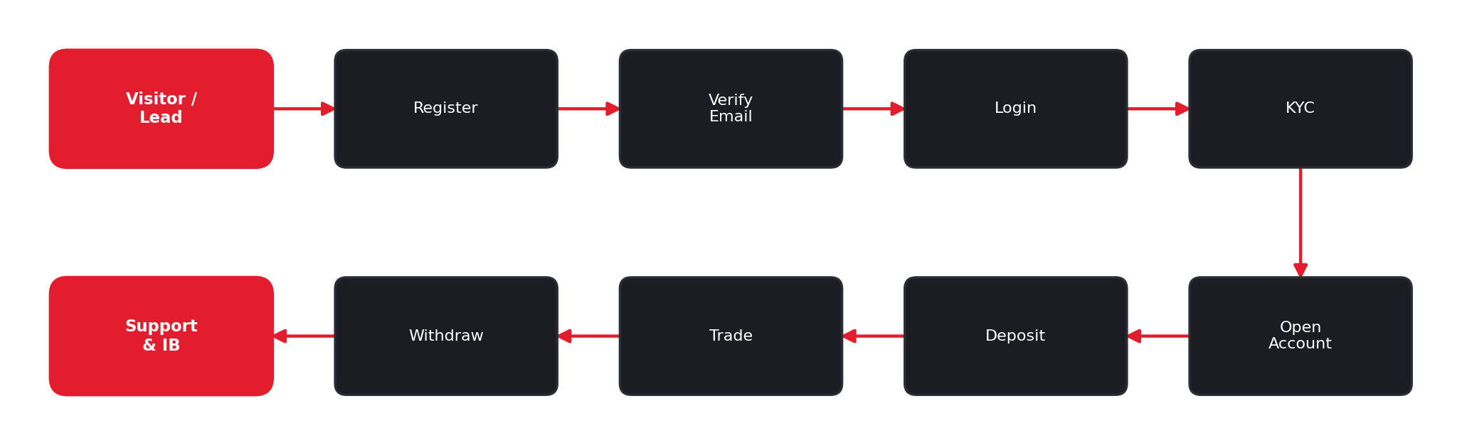
Figure 2 — The end-to-end journey, stage by stage.

3. Becoming a Client (Lead → Active)
Every visitor is a potential client. The platform tracks each person’s progress through clear stages, so the team always knows where someone is in their journey.
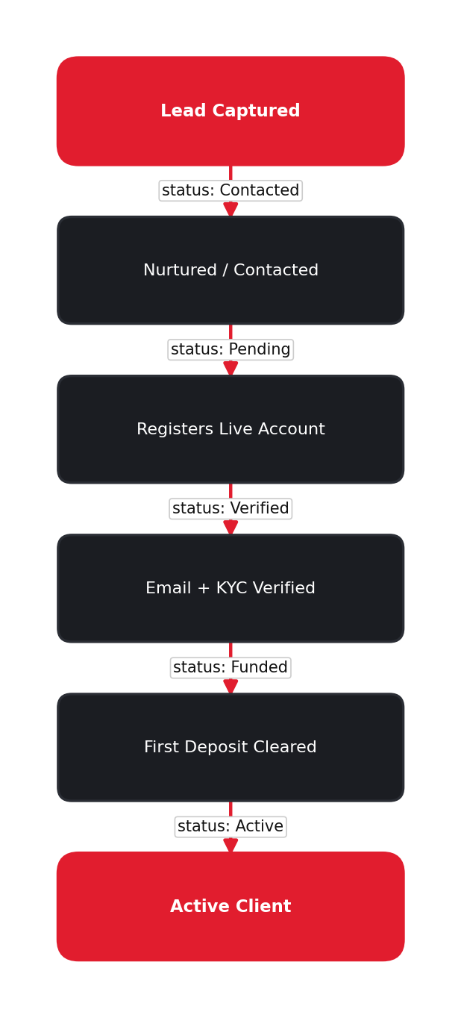 | ▸ A lead is captured from the website, a demo request, or a partner referral.  ▸ Nurtured with welcome and follow-up communication.  ▸ On registration the person becomes a Pending client.  ▸ Email + KYC verification moves them to Verified.  ▸ The first cleared deposit makes them a Funded, Active client.

Figure 3 — Lead-to-client conversion with status at each stage.

4. Registration & Onboarding
Signing up is a guided, multi-step form. Each step is validated before the user can continue, and the account is activated only after the email is verified.
▸ Step 1 collects personal details (name, email, country).  ▸ Step 2 captures account preferences (type, currency, leverage).  ▸ Step 3 sets credentials and accepts the terms.  ▸ The account is created in a Pending state.  ▸ A verification email must be confirmed before first login.  ▸ Once verified, the client lands in guided onboarding. | 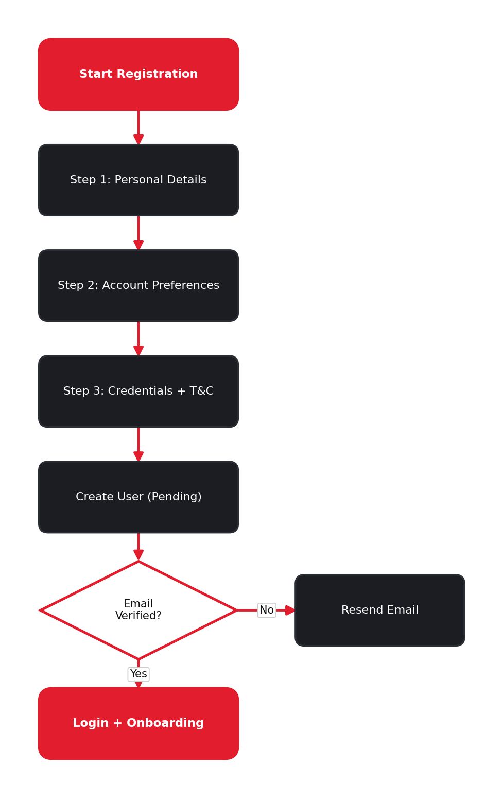

Figure 4 — Registration and onboarding flow.

5. Identity Verification (KYC)
To keep the platform secure and compliant, clients verify their identity in three steps. A compliance officer reviews each submission. Withdrawals are unlocked once verification is approved.
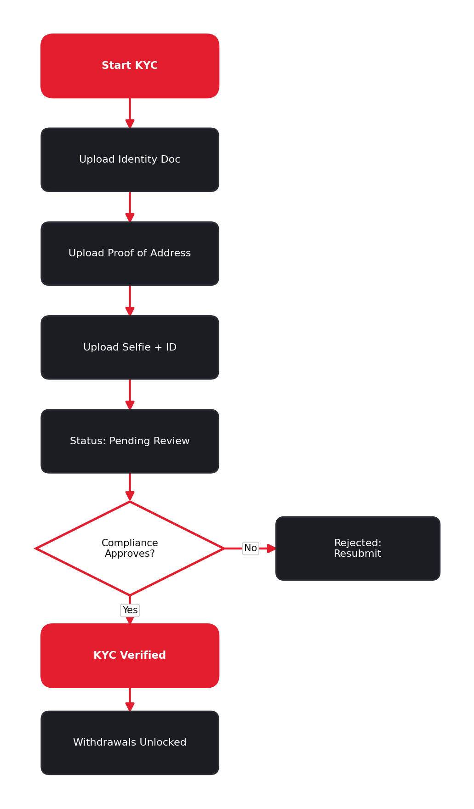 | ▸ Upload an identity document (ID or passport).  ▸ Upload proof of address (utility bill or statement).  ▸ Upload a selfie holding the ID.  ▸ Submissions move to Pending Review.  ▸ Compliance approves, or rejects with a reason to resubmit.  ▸ Once approved, KYC is Verified and withdrawals unlock.

Figure 5 — KYC verification with compliance review.

6. Depositing Funds
Clients can fund their account using several methods — bank transfer, card, e-wallet, or crypto. Most methods are instant; bank transfers take 1–3 business days.
▸ Choose a deposit method.  ▸ Enter the amount and the account to credit.  ▸ Confirm — the transaction is created as Pending.  ▸ If the payment succeeds it moves to Processing.  ▸ On completion the account balance is credited instantly.  ▸ A failed payment keeps the balance unchanged and can be retried. | 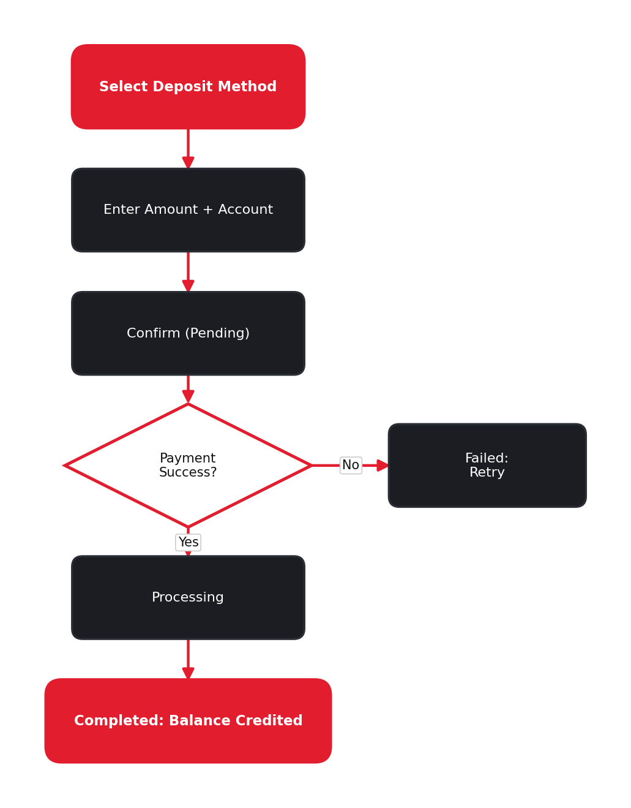

Figure 6 — Deposit flow from method selection to credited balance.

7. Withdrawing Funds
Withdrawals are protected by identity and balance checks, then approved by the finance team. Funds are returned to the original payment source for security.
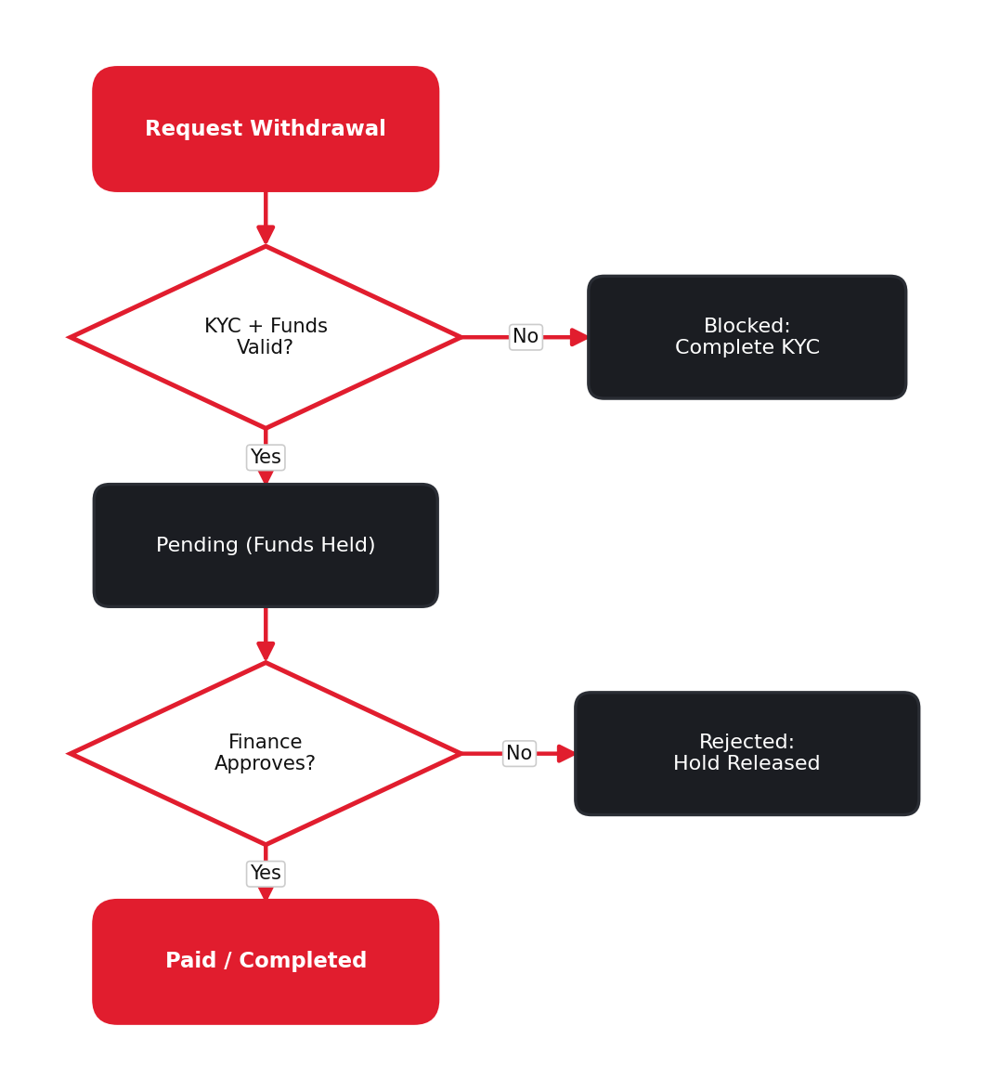 | ▸ The client requests a withdrawal.  ▸ The system checks KYC status and available balance.  ▸ If valid, funds are held and the request goes Pending.  ▸ The finance team reviews and approves the payout.  ▸ Approved funds are Paid to the original source.  ▸ A rejection releases the hold and restores the balance.

Figure 7 — Withdrawal flow with verification and finance approval.

8. Status Reference
Every important item in the platform has a clear status, so clients and staff always know what is happening.
Area | Possible statuses
Client account | Pending, Verified, Active, Suspended, Closed
KYC step | Not Submitted, Pending, Approved, Rejected
Trading account | Active, Inactive, Suspended
Deposit | Pending, Processing, Completed, Failed
Withdrawal | Pending, Approved, Paid, Rejected
Support ticket | Open, In Progress, Resolved, Closed

9. Important Note — Costs & Go-Live
Please note the following before launch:
- Current stage: This version uses simulated data for demonstration. Live trading is not active yet.
- Going live: Real trading starts only after the trading platform, payment gateways, identity verification, market-data feed, and brokerage licensing are connected and approved.
- Third-party costs: These are paid third-party services. Their API keys carry setup and ongoing usage charges (billed by each provider) and are not free of cost or included in this build.
- Pricing: Final pricing depends on the chosen providers, volume, and region, and will be shared in a separate quotation.

10. Summary
27 Markets delivers a complete, secure brokerage experience: a polished public website that earns trust and converts visitors, and a full client portal for verification, funding, trading, and support — all governed by clear statuses, compliance checks, and finance controls. The result is a smooth journey for clients and full operational visibility for the business.

