***DL  
Module-1***BATCH-12

Aiml-E

***P. Man mohan***

Department of ACSE(AI&ML) *231FA18167*  
 VFSTR(Deemed to be)University [231fa18167@gmail.com](mailto:231fa18167@gmail.com)

**K. Sai Kumar**

Department of ACSE(AI&ML)  
 *231FA18429* VFSTR(Deemed to be)University  
 [231fa18429@gmail.com](mailto:231fa18429@gmail.com)

R. Yamini   
Department of ACSE(AI&ML)  
*231fa18139*VFSTR(Deemed to be)University  
[231fa18139@gmail.com](mailto:231fa18139@gmail.com)

**P.Gajendra Monish**

Department of ACSE(AI&ML)  
 231FA18442 VFSTR(Deemed to be)University  
 [231fa18442@gmail.com](mailto:231fa18442@gmail.com)

Title:  
Deep Learning Neural Network Architecture

Abstract:

Deep learning has become a powerful technique in artificial intelligence (AI), enabling systems to learn complex features from large datasets. This paper presents an overview of the architecture of deep learning neural networks, focusing on their essential components such as input layers, hidden layers, and output layers. The concept of forward pass computation is explained step by step, highlighting how raw input features are transformed into predictions. The process of training neural networks using backpropagation and optimization techniques is also discussed. This work aims to provide a simplified understanding of deep learning fundamentals and their practical significance in AI applications.

### Keywords

Deep Learning, Neural Networks, Forward Pass, Backpropagation, Optimizer, Artificial Intelligence.

. Introduction

In recent years, deep learning has emerged as a leading approach in machine learning due to its ability to learn hierarchical patterns from data. Unlike traditional machine learning models, which rely heavily on handcrafted features, deep neural networks (DNNs) automatically extract relevant representations through multiple layers of processing.

A typical deep learning neural network consists of three main components: input layer, hidden layers, and output layer. The “deep” aspect refers to the use of many hidden layers that progressively learn more abstract and complex features. These architectures have achieved remarkable success in diverse domains such as image recognition, natural language processing, speech recognition, and medical diagnosis.

This paper discusses the structural design of deep neural networks, the flow of data during the forward pass, and the iterative process of training through backpropagation and optimization.

### II. Neural Network Architecture

### A. Input Layer

The input layer is the entry point of raw data into the neural network. Each neuron represents one feature of the dataset, such as pixel values in an image or attributes in a dataset. Its primary function is to pass the input data to subsequent hidden layers for further transformation.

### B. Hidden Layers

Hidden layers form the computational backbone of the network. Each layer applies mathematical operations using weights, biases, and activation functions. These layers learn increasingly complex patterns, enabling the model to understand intricate relationships within the data.

### C. Output Layer

The output layer produces the final predictions. Depending on the task, the output may be a single value (regression) or multiple class probabilities (classification). Common activation functions used in this layer include Softmax and Sigmoid.

### III. Forward Pass

The forward pass is the process where data moves sequentially through the layers:

1. Input layer receives features.
2. Hidden layers perform transformations using ReLU activation.
3. Output layer applies Softmax for classification.

### Example:

* Input → Flattened vector (784 features)
* Hidden Layer 1 → ReLU(W₁x + b₁)
* Hidden Layer 2 → ReLU(W₂h₁ + b₂)
* Output Layer → Softmax(W₃h₂ + b₃)

### Compact Equation:

1. y^=Softmax(W3 ReLU(W2 ReLU(W1x+b1)+b2)+b3)\hat{y} = \text{Softmax}\big(W_3 \, \text{ReLU}(W_2 \, \text{ReLU}(W_1x+b_1)+b_2)+b_3\big)y^​=Softmax(W3​ReLU(W2​ReLU(W1​x+b1​)+b2​)+b3​)

### IV. Training the Network

*Training involves teaching the neural network to minimize prediction error. The process includes:*

1. ***Forward Pass*** *– Computing predictions.*
2. ***Loss Function*** *– Measuring error between predicted and actual values.*
3. ***Backpropagation*** *– Calculating gradients of the error with respect to weights.*
4. ***Optimization*** *– Updating weights using algorithms like Gradient Descent or Adam.*
5. ***Epochs*** *– Repeating the process until performance improves.*

*Through multiple iterations, the model progressively improves its accuracy.*

### DIAGRAM:

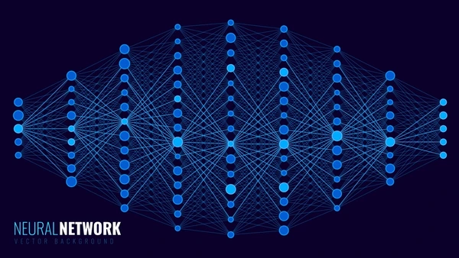

### V. Conclusion:

*Deep learning neural networks are capable of learning complex features and achieving high accuracy in various tasks. Their architecture—comprising input, hidden, and output layers—enables efficient representation learning. The forward pass allows prediction generation, while training through backpropagation and optimization ensures continuous improvement. As AI continues to evolve, deep learning architectures will remain central to solving real-world problems.*

### References:

1. *I. Goodfellow, Y. Bengio, and A. Courville, Deep Learning, MIT Press, 2016.*
2. *Y. LeCun, Y. Bengio, and G. Hinton, “Deep learning,” Nature, vol. 521, pp. 436–444, 2015.*
3. *S. Haykin, Neural Networks and Learning Machines, 3rd ed., Pearson, 2009.*