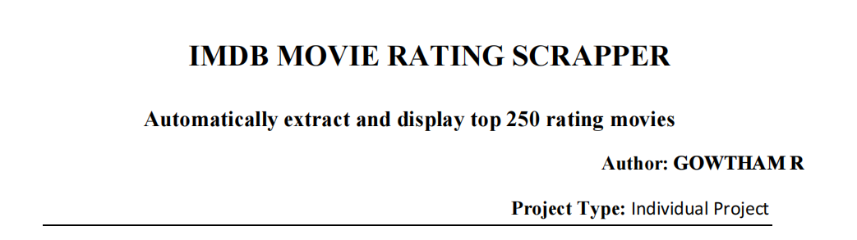

INTRODUCTION :

- In today’s digital era, data plays a vital role in analyzing trends and making informed decisions across various domains, including the entertainment industry. IMDb (Internet Movie Database) is one of the most reliable and comprehensive sources for movie-related information.
- This project, an advanced evolution of a basic movie scraper, automates the collection of this data through a robust, menu-driven Python application. The application is designed not just to scrape data, but to process, store, and analyze it, providing a complete pipeline from data acquisition to actionable insights.
- The This tool utilizes Selenium to handle complex, dynamically-loaded JavaScript content, ensuring that all data is accurate. It then provides interactive tools, such as a "Terminal Dashboard" and a "Movie Recommender," allowing the user to immediately interact with the data they have collected.

PROJECT OVERVIEW:
The IMDb Movie Rating Scraper is a Python-based automation project designed to extract movie details from IMDb’s Top 250 Movies list using Selenium and Chrome WebDriver. It dynamically collects key information such as movie titles, release years, IMDb ratings, and rankings, even from JavaScript-rendered pages.
The scraped data is organized and exported into a CSV file for further analysis or integration into other applications. This project provides an efficient and automated way to gather up-to-date movie data, which can be used for trend analysis, recommendation systems, or personal databases.
TOOLS AND TECHNOLOGIES :
Programming Language:
- Python: The core language used for developing the scraper due to its simplicity, rich library support, and strong community base.
Libraries and Frameworks:
- Selenium: Used for automating web browser interactions and handling dynamic, JavaScript-loaded web content.
- webdriver_manager: Automatically manages and installs the appropriate Chrome WebDriver version.
- pandas: Utilized for organizing, manipulating, and exporting the scraped data into structured formats like CSV.
- time: Provides delay control to ensure proper page loading during scraping.
Browser and Driver:
- Google Chrome: The browser used for rendering IMDb web pages.
- Chrome WebDriver: Acts as a bridge between the Python script and Chrome browser for automation.
Output Format:
- CSV (Comma-Separated Values): Used to store and export the collected movie data in a structured and easily accessible format.
Optional Features:
- Headless Mode: Allows the scraper to run without opening a visible browser window, ideal for automated or background execution.
FEATURES :
- Dual-Mode Top 250 Scraper:
- Fast Mode: Scrapes only Rank, Title, Year, and Rating.
- Deep Mode: Scrapes all "Fast" data, then visits all 250 individual movie pages to also retrieve Genre, Director, and Cast.

- Targeted Genre Scraper: A separate scraper that prompts the user for genres (e.g., "Action, Drama") and scrapes the Top 50 movies from those IMDb search pages.
- Movie Recommendation Engine: A menu option that loads the imdb_top_250_deep.csv file. The user can enter a movie title, and the script will recommend other films from the list that share the same Director or Genre.
- Terminal Summary Dashboard: A menu option that reads both .csv files and prints a clean, tabular summary (total movies, average rating, top 5 items) directly to the console.
- 24-Hour Auto-Update Scheduler: An option to run the entire deep scrape and genre scrape process automatically once every 24 hours.
- Scalable Design: Easily extendable to collect additional movie information like genre, cast, and director details from individual pages.

CO DE IMPLEMENTATION
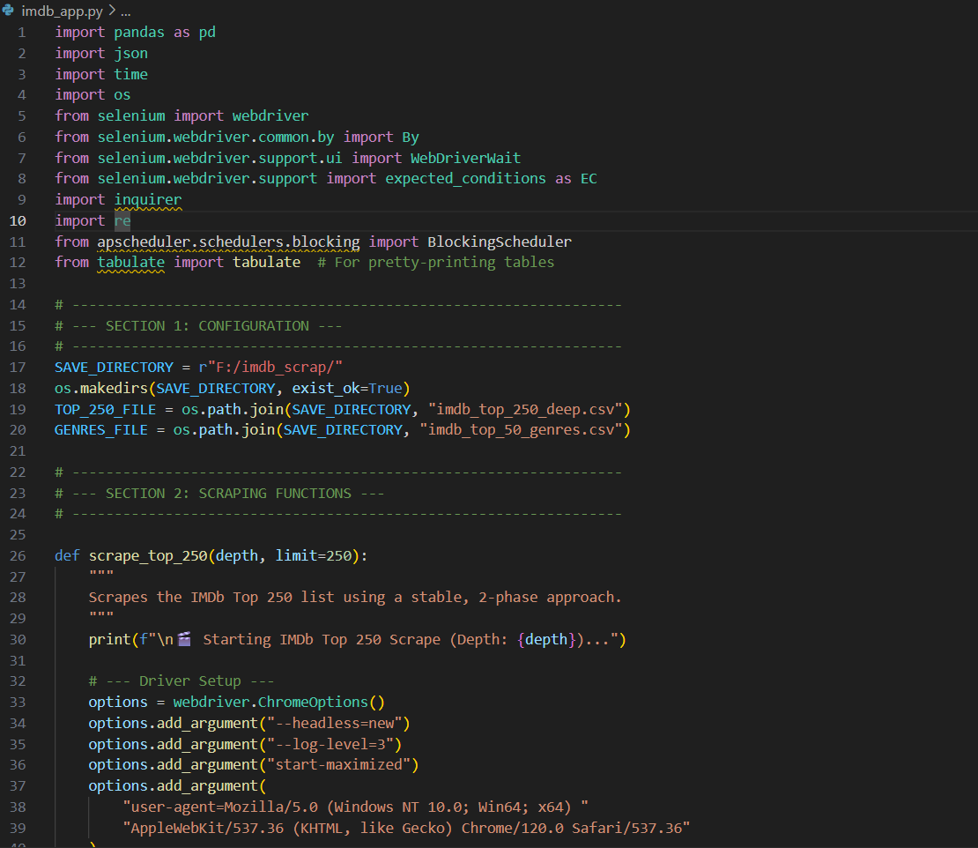

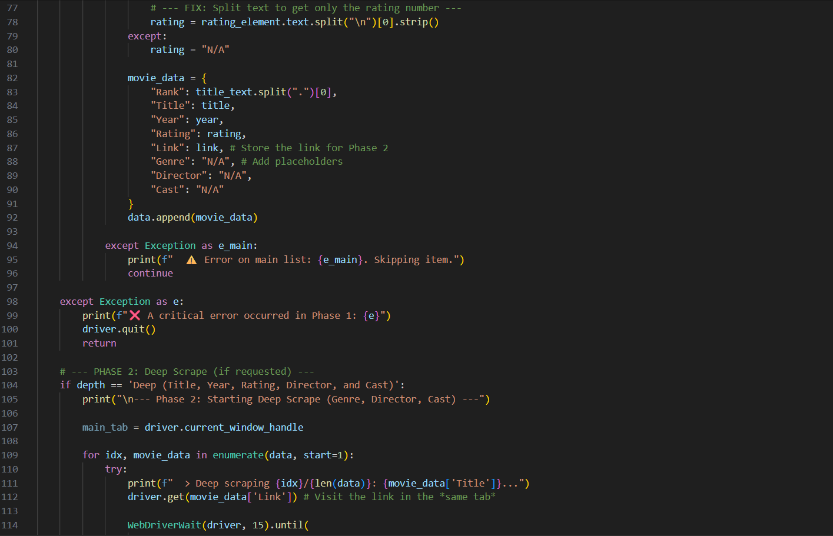
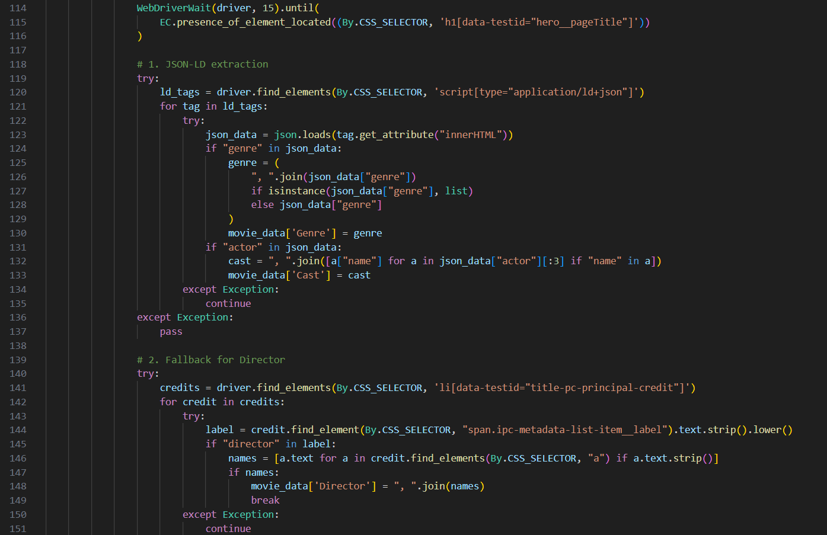

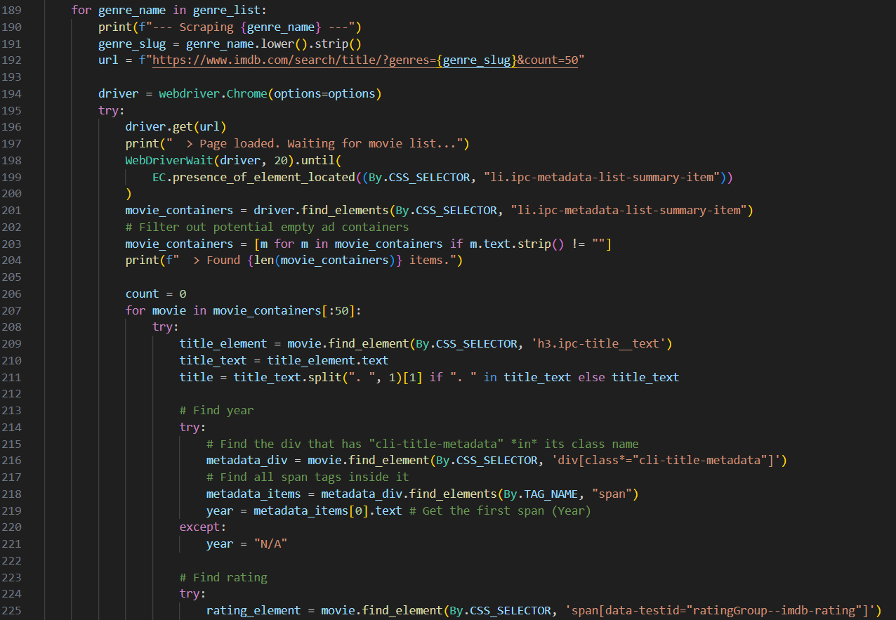
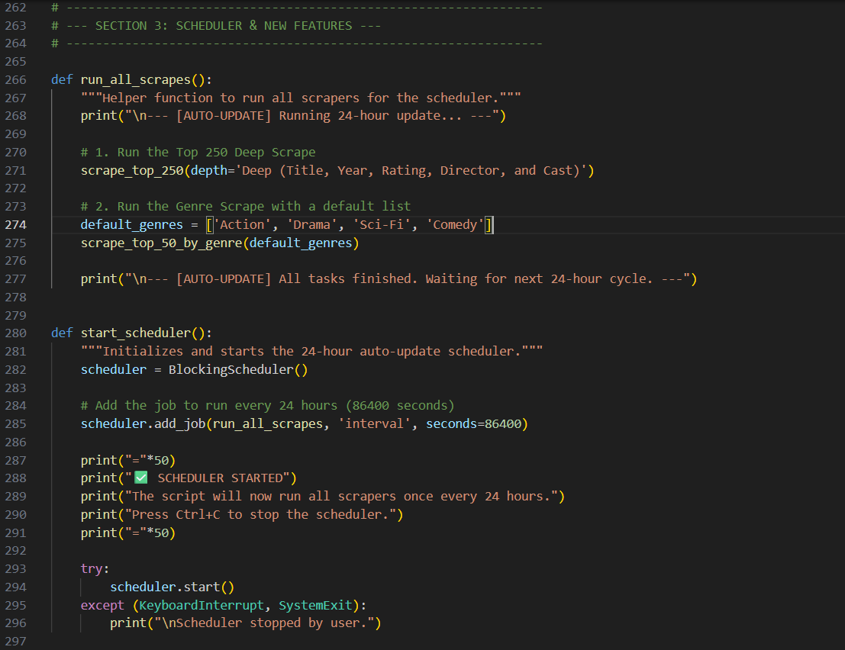
OUTPUT
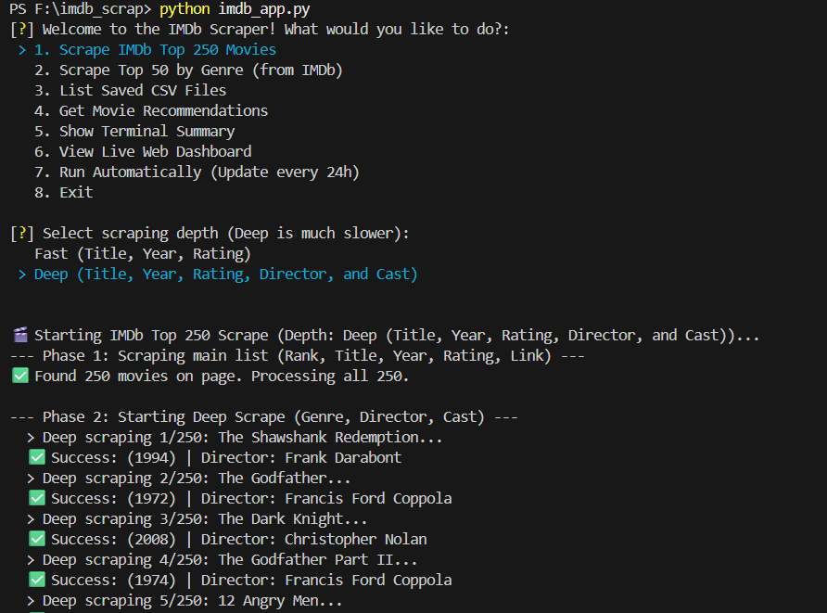
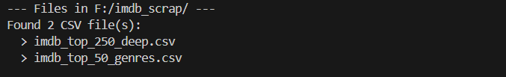
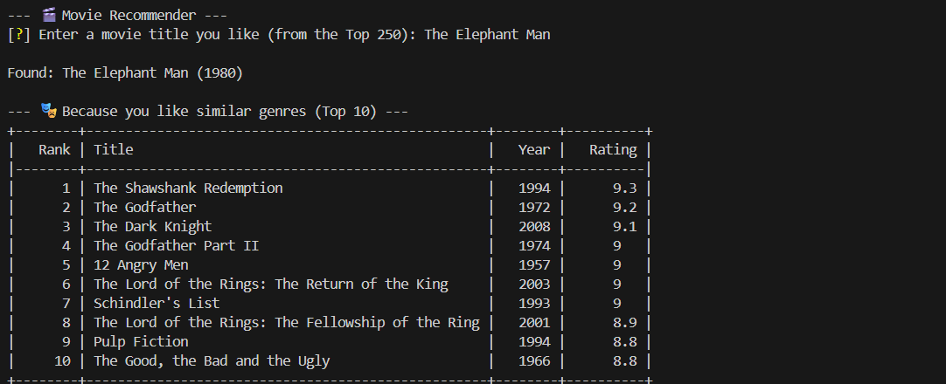
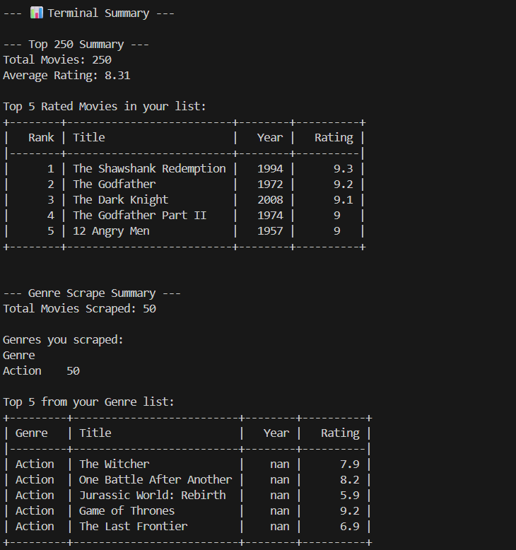

LIST OF THE 250 MOVIES :
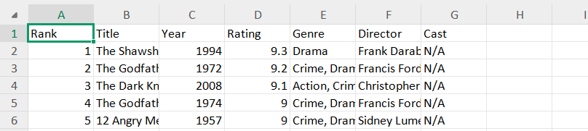

RESULTS AND DISCUSSION
The IMDb Movie Rating Scraper successfully extracts real-time data from IMDb’s Top 250 Movies list using Selenium and Chrome WebDriver. The tool efficiently retrieves movie titles, release years, IMDb ratings, and rankings, even from dynamically loaded pages. The collected data is organized and saved in CSV format, making it ready for further analysis, such as identifying movie trends or building recommendation models. The scraper demonstrates reliable performance, automation accuracy, and adaptability for future extensions like genre or cast analysis.

CONCLUSION
The IMDb Movie Rating Scraper project effectively automates the extraction of movie information from IMDb, eliminating the need for manual data collection. By integrating Python, Selenium, and WebDriver automation, it ensures accurate and up-to-date retrieval of movie ratings and rankings. The structured data output enhances usability for analytics, research, and machine learning applications. Overall, the project showcases the power of web automation and data handling in simplifying data-driven tasks within the entertainment domain.

