Visualization Tool for Electric Vehicle Charge and Range Analysis
Project Documentation
Prepared by: T Gowtham Reddy
SkillWallet — Data Analytics with Tableau
July 2026

1. Problem Statement & Objective
Electric vehicles (EVs) are seeing rapid adoption, but decisions around which vehicle to buy and how to plan charging are still difficult without clear, data-backed comparisons. Buyers and fleet planners need to understand how battery capacity relates to real-world range, which charging infrastructure is fastest and most reliable, and how external factors like temperature affect charging performance.
This project builds an end-to-end visualization tool that analyzes EV specifications alongside charging session behavior, using Tableau to surface insights on range, efficiency, charging speed, and geographic charging patterns. The objective is to demonstrate a complete data analytics pipeline: from raw data collection, through database design and SQL analysis, to interactive Tableau visualizations, and finally web integration via Flask.

2. Dataset Description

2.1 vehicles.csv (25 records)
Contains specifications for 25 EV models across major manufacturers including Tata, MG, Hyundai, Mahindra, BYD, Tesla, Kia, BMW, Mercedes, Audi, and others.
Field | Description
vehicle_id | Unique identifier (primary key)
make, model, year | Vehicle identity
vehicle_type | SUV, Sedan, Hatchback, MPV
battery_capacity_kwh | Battery size in kWh
rated_range_km | Manufacturer-rated range
efficiency_wh_per_km | Energy consumption per km
price_inr | Price in Indian Rupees

2.2 charging_sessions.csv (60 records)
Contains charging session records linked to vehicles via vehicle_id, capturing real-world charging behavior.
Field | Description
session_id | Unique identifier (primary key)
vehicle_id | Foreign key to vehicles table
charger_type | AC Slow, AC Fast, DC Fast, DC Rapid
charging_power_kw | Charger's power rating
start_percent, end_percent | Battery % at start/end of session
charge_time_mins | Duration of the charging session
temperature_c | Ambient temperature during charging
city, session_date | Location and date of session

3. Database Schema
Data was stored in a relational database (SQLite/MySQL) using two related tables, joined on vehicle_id.
CREATE TABLE vehicles (
vehicle_id INTEGER PRIMARY KEY,
make TEXT, model TEXT, year INTEGER,
vehicle_type TEXT,
battery_capacity_kwh REAL,
rated_range_km REAL,
efficiency_wh_per_km REAL,
price_inr REAL
);

CREATE TABLE charging_sessions (
session_id INTEGER PRIMARY KEY,
vehicle_id INTEGER,
charger_type TEXT,
charging_power_kw REAL,
start_percent INTEGER, end_percent INTEGER,
charge_time_mins INTEGER,
temperature_c INTEGER,
city TEXT, session_date TEXT,
FOREIGN KEY (vehicle_id) REFERENCES vehicles(vehicle_id)
);

4. SQL Operations Performed

4.1 Join — vehicle details with charging sessions
SELECT v.make, v.model, c.charger_type, c.charge_time_mins
FROM vehicles v JOIN charging_sessions c ON v.vehicle_id = c.vehicle_id;
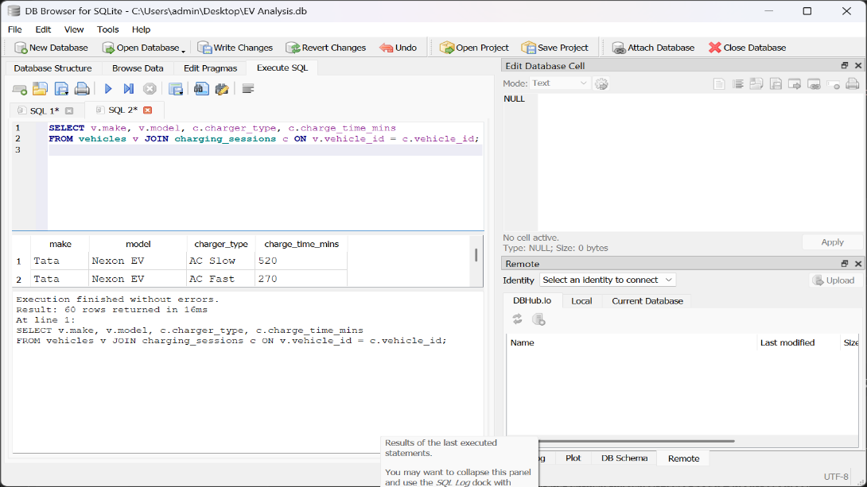

4.2 Aggregate — average charge time by charger type
SELECT charger_type, AVG(charge_time_mins) AS avg_charge_time_mins
FROM charging_sessions GROUP BY charger_type;
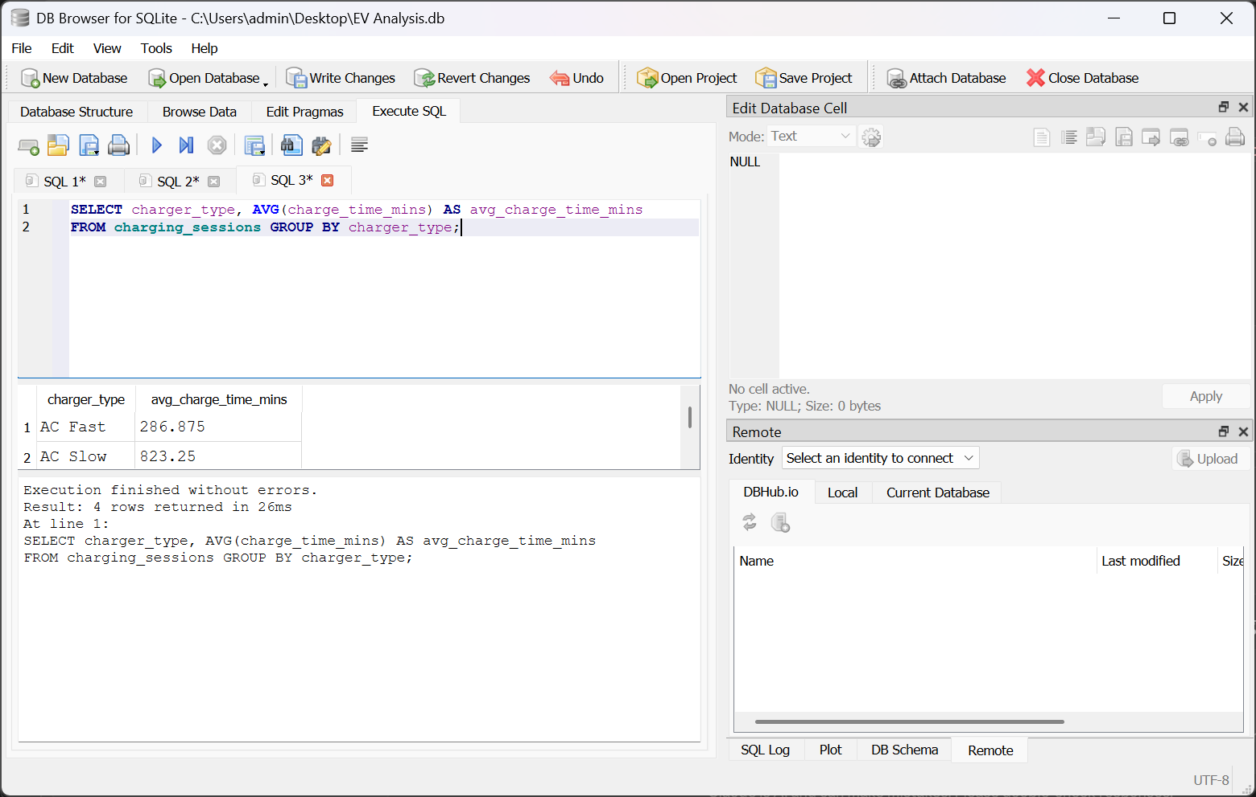

4.3 Filter + Sort — SUVs by rated range
SELECT make, model, rated_range_km FROM vehicles
WHERE vehicle_type = 'SUV' ORDER BY rated_range_km DESC;

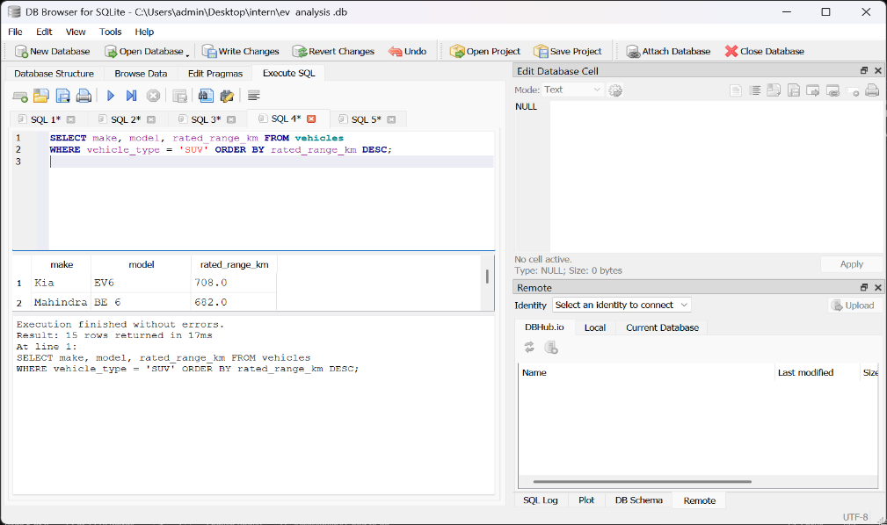

4.4 Subquery — vehicles more efficient than average
SELECT make, model, efficiency_wh_per_km FROM vehicles
WHERE efficiency_wh_per_km < (SELECT AVG(efficiency_wh_per_km) FROM vehicles);

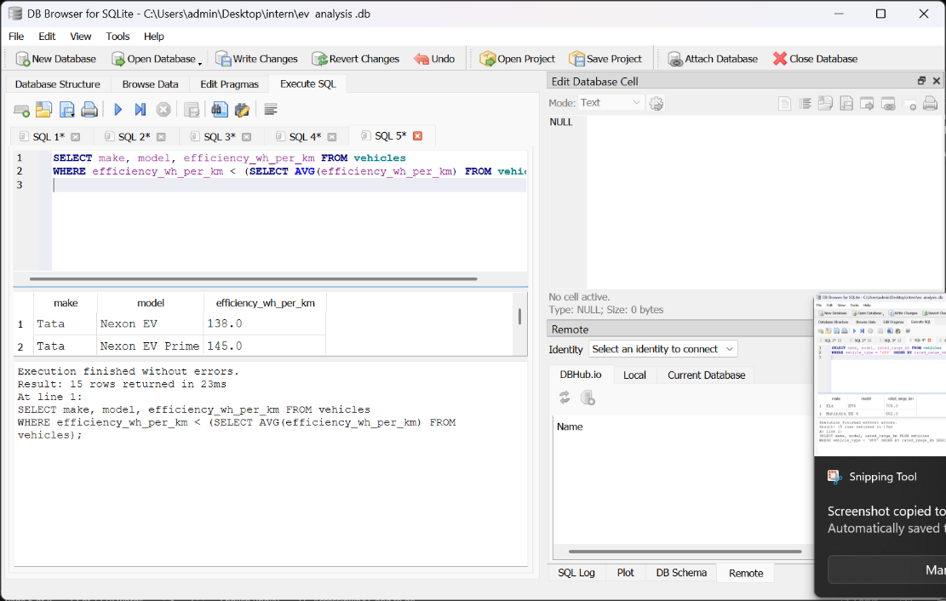

5. Tableau Data Preparation
Before visualization, the following calculated field was created in Tableau:

Temp Bucket
IF [Temperature C] < 25 THEN "Cool (<25°C)"
ELSEIF [Temperature C] < 35 THEN "Moderate (25-35°C)"
ELSE "Hot (>35°C)"
END
Used to group charging sessions into temperature bands for the charge-time heat map analysis.
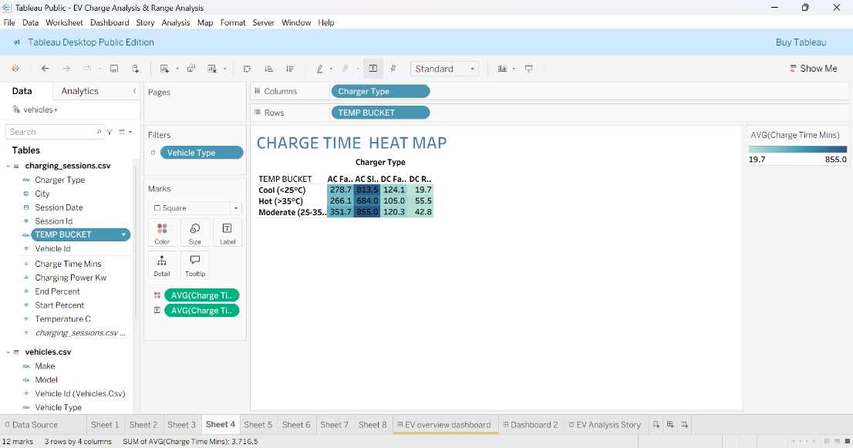

6. Visualizations
Eight distinct chart types were built, each targeting a different analytical question.

6.1 Bar Chart — Range by Model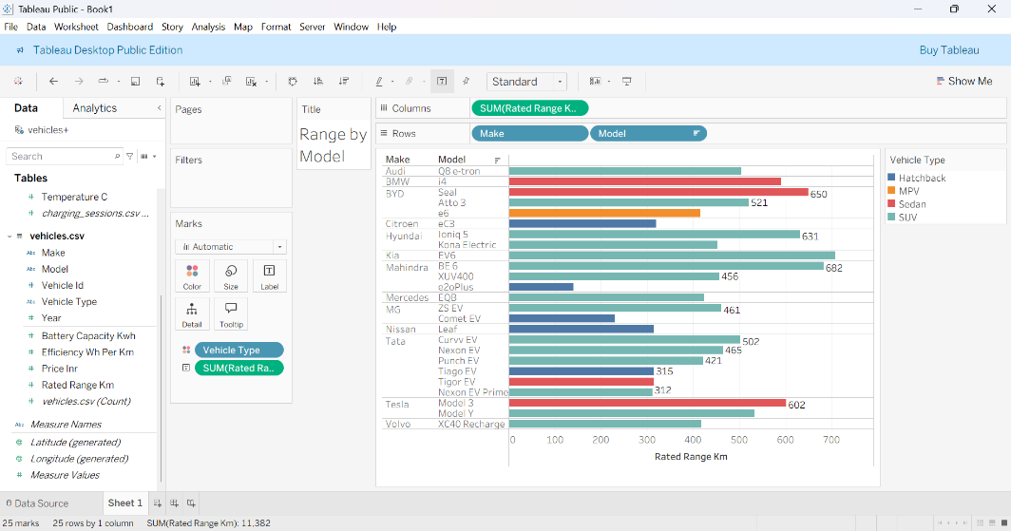
Insight: Tesla, Kia, and Mahindra lead their segments in rated range, while smaller hatchbacks trail behind.

6.2 Scatter Plot — Battery vs Range

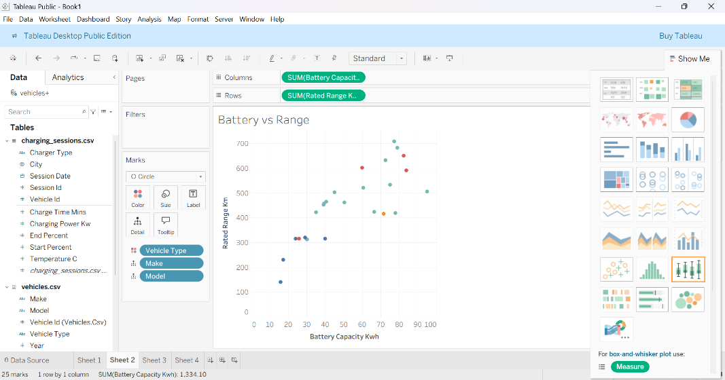
Insight: Larger batteries generally mean longer range, with a few efficient outliers deviating from the trend.

6.3 Box Plot — Charge Time Distribution

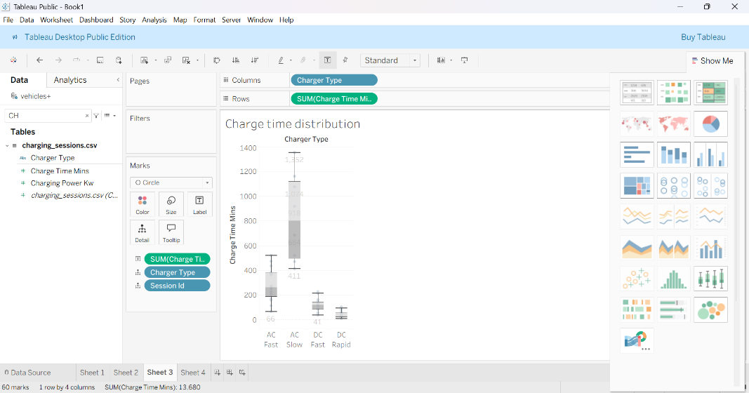
Insight: DC Rapid and DC Fast chargers show the lowest median charge times; AC charging shows greater variability.

6.4 Heat Map — Charge Time by Temperature

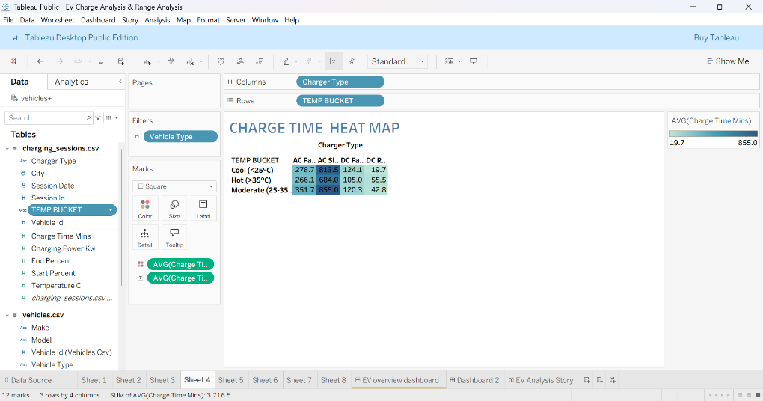
Insight: Charging tends to take longer in hotter conditions across most charger types.

6.5 Line Chart — Sessions Over Time

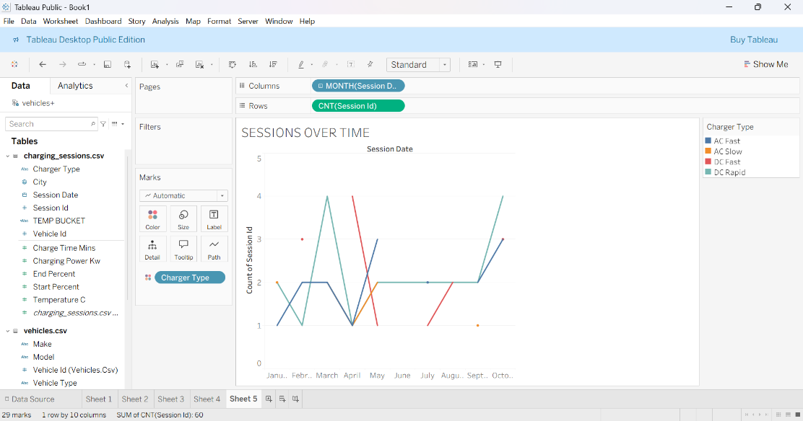
Insight: Session volume shifts month to month, with no single charger type consistently dominating.

6.6 Map — Sessions by City

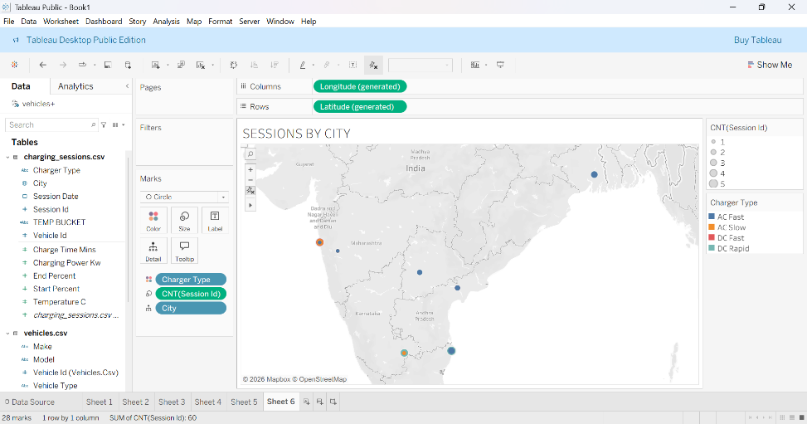
Insight: Charging activity is concentrated in a handful of cities.

6.7 Dual-Axis Chart — Battery vs Efficiency

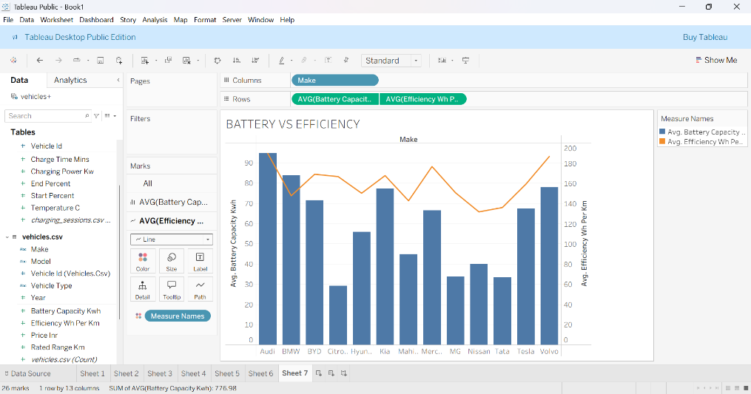
Insight: Bigger batteries don't always mean better efficiency — some makes achieve good efficiency despite smaller packs.

6.8 Treemap — Vehicle Count by Make

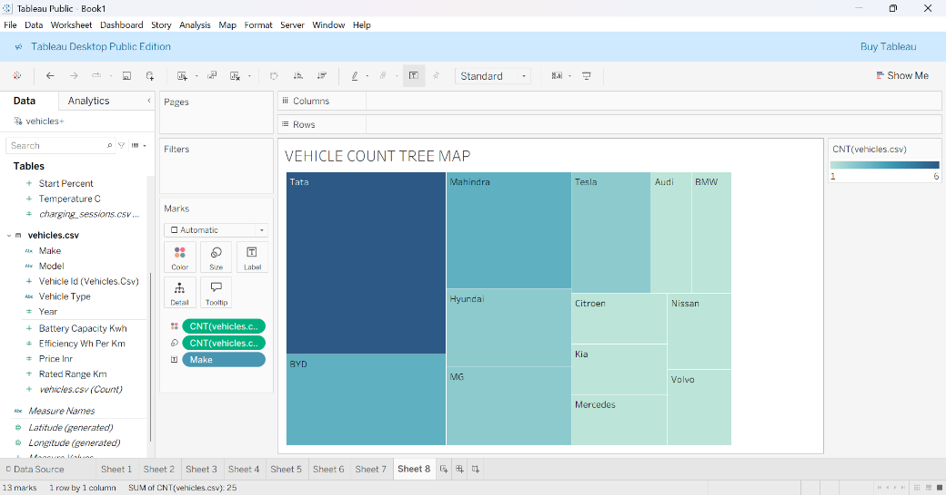
Insight: Tata and BYD make up the largest share of vehicles represented in this dataset.

7. Dashboard

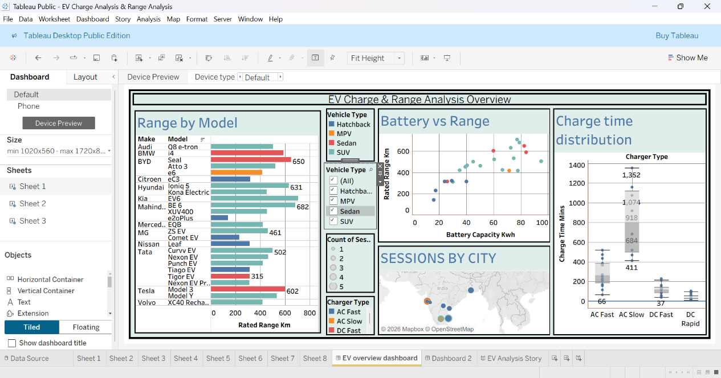
The dashboard combines four charts — Range by Model, Battery vs Range, Charge Time Distribution, and Sessions by City — into a single interactive view.
- Interactive filters added for Vehicle Type and Charger Type, applied across all sheets using the same data source.
- Consistent colour palette applied across all charts (Vehicle Type / Charger Type colouring).
- Responsiveness verified using Tableau's Device Preview for Desktop, Tablet, and Phone layouts.
- Tiled container layout used (rather than floating) to support proper resizing across devices.

8. Story
A 9-scene story was built to walk through the full analysis narrative:
Scene | Chart | Caption
1 | Range by Model | Tesla, Kia, and Mahindra lead their segments in range; smaller hatchbacks trail behind.
2 | Battery vs Range | Larger batteries generally mean longer range, with a few efficient outliers.
3 | Battery vs Efficiency | Bigger batteries don't always mean better efficiency — some makes do more with less.
4 | Charge Time Distribution | DC Rapid and DC Fast charge quickest; AC charging shows more variability.
5 | Heat Map | Charging takes longer in hotter conditions across most charger types.
6 | Sessions Over Time | Session volume shifts month to month, with no single charger type dominating.
7 | Sessions by City | Charging activity is concentrated in a handful of cities.
8 | Treemap | Tata and BYD make up the largest share of vehicles in this dataset.
9 | Dashboard | All insights combined into one interactive dashboard for exploring EV performance.

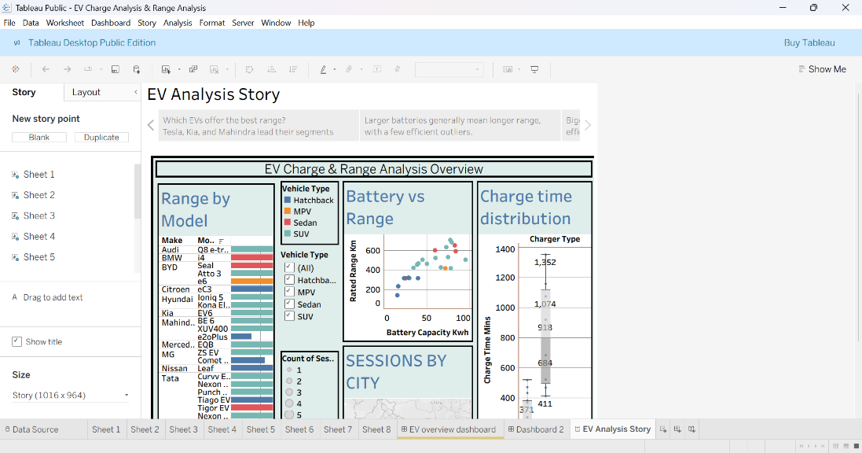

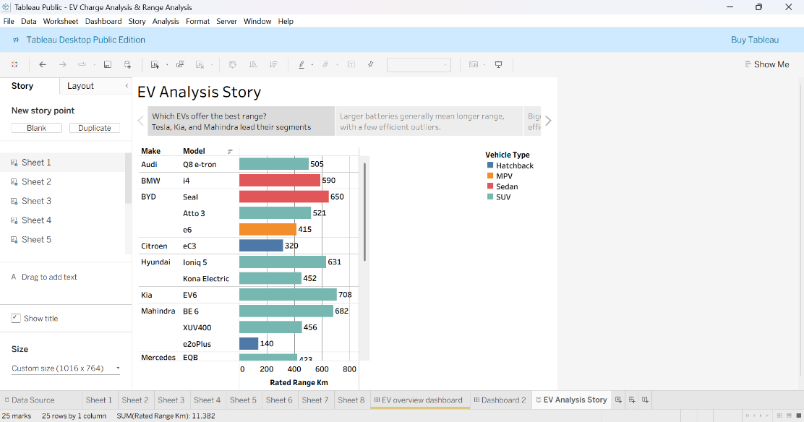

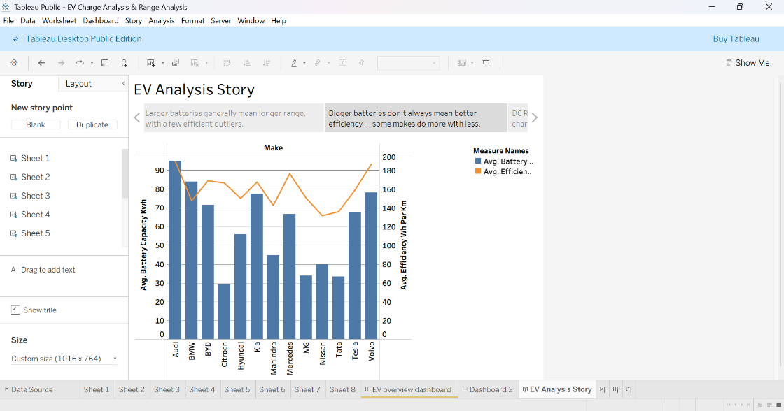

9. Performance Testing Metrics

Metric | Value
Amount of data rendered to DB | 25 vehicle records, 60 charging session records, 2 related tables
Utilization of data filters | 2 filters (Vehicle Type, Charger Type), applied dashboard-wide
No. of calculation fields | Temp Bucket (plus any additional fields created during data prep)
No. of visualizations/graphs | 8 individual sheets + 1 dashboard + 9 story scenes

10. Web Integration

10.1 Publishing
The completed workbook was published to Tableau Public, making the Dashboard and Story accessible via a shareable link:

10.2 Flask Embedding
A minimal Flask application was built to embed the published Tableau visualization inside a custom webpage, demonstrating how the dashboard could be delivered through a standalone web application.
from flask import Flask, render_template
app = Flask(__name__)

@app.route("/")
def home():
return render_template("index.html")

if __name__ == "__main__":
app.run(debug=True)
[Insert screenshot: Flask app running at localhost:5000 with embedded dashboard]

11. Conclusion & Learnings
This project demonstrates a complete data analytics workflow — from dataset creation and relational database design, through SQL-based analysis, to Tableau visualization, dashboarding, and storytelling, finished with a web-integrated delivery via Flask.
Key learnings included handling data relationships correctly to avoid fan-out/duplication issues in Tableau, designing dashboards for responsiveness across devices, and structuring a narrative-driven Tableau Story to communicate insights clearly to a non-technical audience.

Links
- GitHub Repository: [add your repo link]
- Tableau Public Demo: [add your published link]
- Project Video: [add your video link]

