GIT ;

Is a distributed version control system, also has local repository   
  
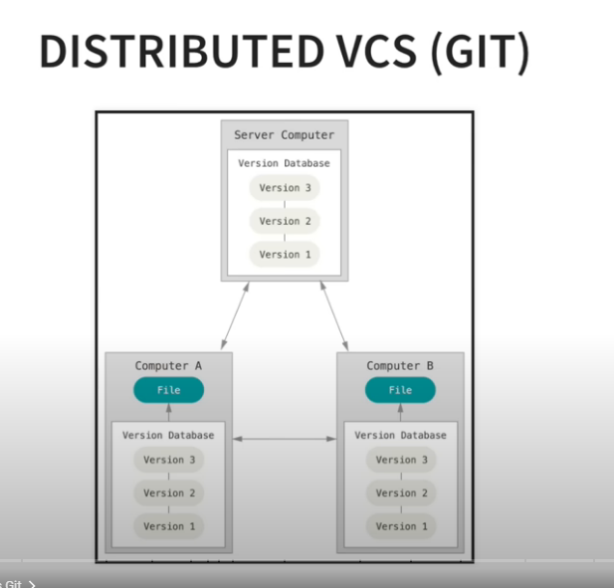

Install git bash

open git bash and enter   
git –version to confirm the installation

two scenarios..  
1 , will clone the existing repo and do changes

2, create a repo from local and push it to git

We will do second one , we create a local repo first   
  
open git bash from the folder which you want to maintain in git

-git init – will create .git file and it will start recording the changes in the folder

- ls -la – which will list all the file and we can see the .git file also

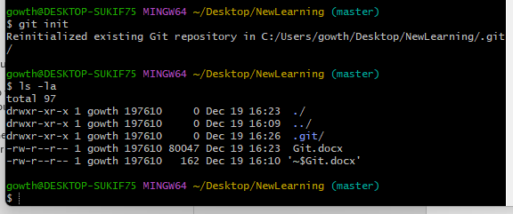

* To remove tracking , we can remove the .git file with the remove command
* Rm -rf .git(filename) – rm stands for remove and r for recursive delete with the sub folder and directory f for force deleted even when warning pop’s up , even in write mode
* 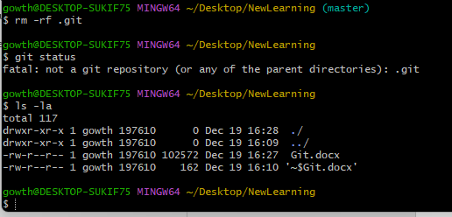

Next to ignore the files , which we don’t want to track by repository

Example : pycache and log files

Touch .gitignore

This will create a .ignore file and we can add the file name which needs to be ignored

We can use the wild cards also in the file

\*.log – which will ignore all the log files

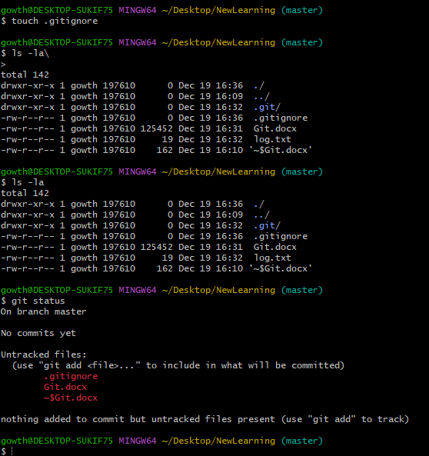

Imagine where we are now: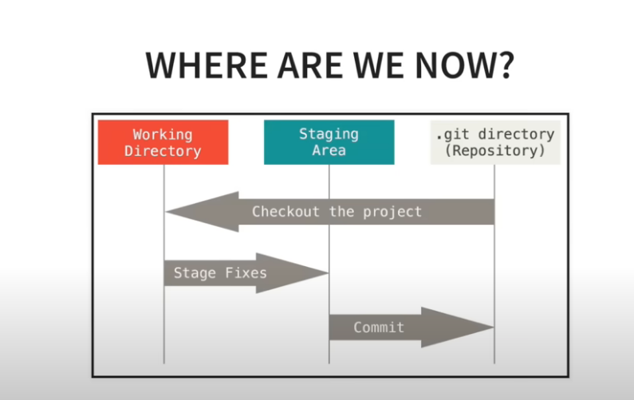

Untracked files and changes will be in the working directory

Git status will return the status of the working directory of untracked files

Why staging area, so we can choose what needs to be committed, make sure u commit the clean code because the report is the history of the final work

Staging the code :

Git add . will add all the untracked files to thestaging area

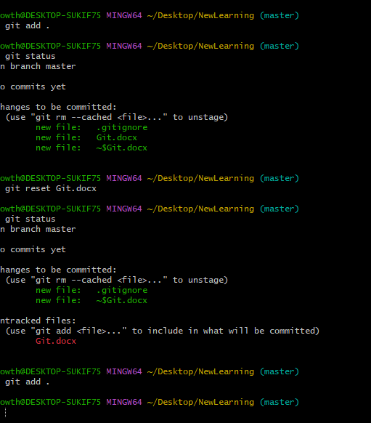

Git reset. Will unstage all the changes and make it as untracked file again

Now .. we commit the code to repo

Git commit -m “this is message ”

This will commit all the code from staging area to repository

We can see the commit log by

Git log

