**Locator strategies**

Ways to identify one or more specific elements in the DOM.

A locator is a way to identify elements on a page. It is the argument passed to the [Finding element](https://www.selenium.dev/documentation/webdriver/elements/finders/) methods.

Selenium provides support for these 8 traditional location strategies in WebDriver:

| **Locator** | **Description** |
| --- | --- |
| **class name** | Locates elements whose class name contains the search value (compound class names are not permitted) |
| **css selector** | Locates elements matching a CSS selector |
| **id** | Locates elements whose ID attribute matches the search value |
| **name** | Locates elements whose NAME attribute matches the search value |
| **link text** | Locates anchor elements whose visible text matches the search value |
| **partial link text** | Locates anchor elements whose visible text contains the search value. If multiple elements are matching, only the first one will be selected. |
| **tag name** | Locates elements whose tag name matches the search value |
| **xpath** | Locates elements matching an XPath expression |

1. Xpath:

**XPath in Selenium** is an XML path used for navigation through the HTML structure of the page. It is a syntax or language for finding any element on a web page using XML path expression

1. **XPath Syntax**

XPath contains the path of the element situated at the web page. Standard XPath syntax for creating XPath is.

Xpath=//tagname[@attribute='value']

The basic format of XPath in selenium is explained below with screen shot.

[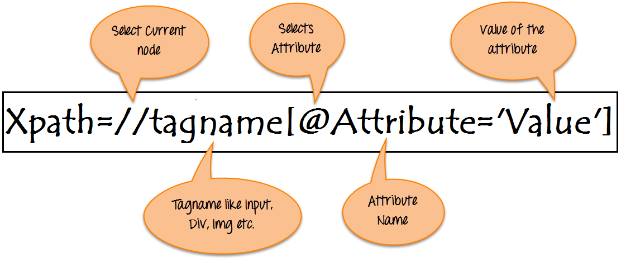](https://www.guru99.com/images/3-2016/032816_0758_XPathinSele1.png)Basic Format of XPath

* **// :** Select current node.
* **Tagname:**Tagname of the particular node.
* **@:** Select attribute.
* **Attribute:** Attribute name of the node.
* **Value:** Value of the attribute.

1. **Types of X-path**

There are two types of XPath:

**1) Absolute XPath**

**2) Relative XPath**

**Absolute XPath**

It is the direct way to find the element, but the disadvantage of the absolute XPath is that if there are any changes made in the path of the element then that XPath gets failed.

/html/body/div[2]/div[1]/div/h4[1]/b/html[1]/body[1]/div[2]/div[1]/div[1]/h4[1]/b[1]

**Relative Xpath**

**Relative Xpath** starts from the middle of HTML DOM structure. It starts with double forward slash (//). It can search elements anywhere on the webpage, means no need to write a long xpath and you can start from the middle of HTML DOM structure. Relative Xpath is always preferred as it is not a complete path from the root element.

Relative XPath: //div[@class='featured-box cloumnsize1']//h4[1]//b[1]

1. **What are XPath axes.**

XPath axes search different nodes in XML document from current context node. XPath Axes are the methods used to find dynamic elements, which otherwise not possible by normal XPath method having no ID , Classname, Name, etc.

Axes methods are used to find those elements, which dynamically change on refresh or any other operations. There are few axes methods commonly used in [Selenium Webdriver](https://www.guru99.com/introduction-webdriver-comparison-selenium-rc.html) like child, parent, ancestor, sibling, preceding, self, etc.

1. **How To Write Dynamic XPath In Selenium WebDriver**

* Basic xpath :

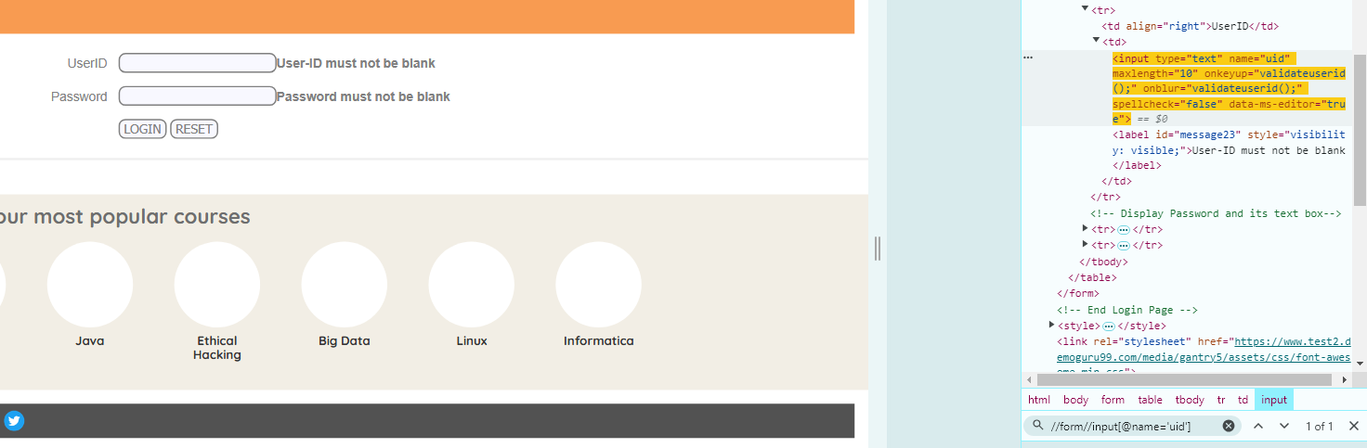

Instead of //* I have used form and the then input , it a right way to code

* **Contains()**

Contains() is a method used in XPath expression. It is used when the value of any attribute changes dynamically, for example, login information.

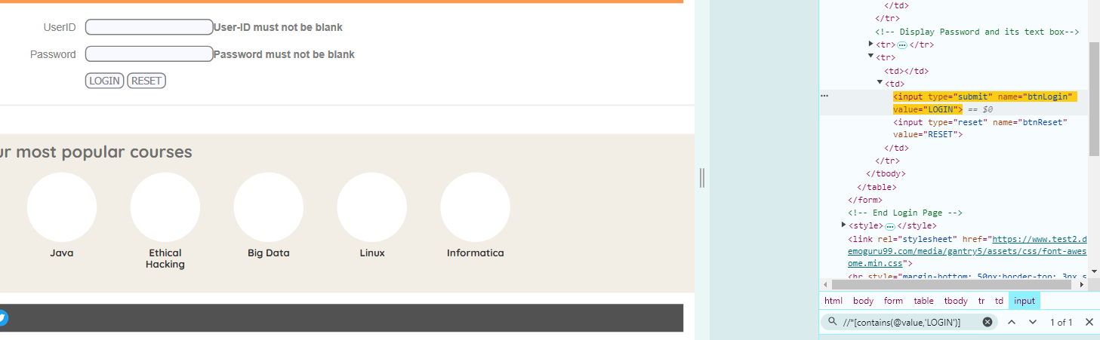

Xpath=//*[contains(@value,LOGIN)]

* **Using OR & AND**

In OR expression, two conditions are used, whether 1st condition OR 2nd condition should be true. It is also applicable if any one condition is true or maybe both. Means any one condition should be true to find the element.

In the below XPath expression, it identifies the elements whose single or both conditions are true.

Xpath=//*[@type='submit' or @name='btnReset']

Highlighting both elements as “LOGIN ” element having attribute ‘type’ and “RESET” element having attribute ‘name’.

[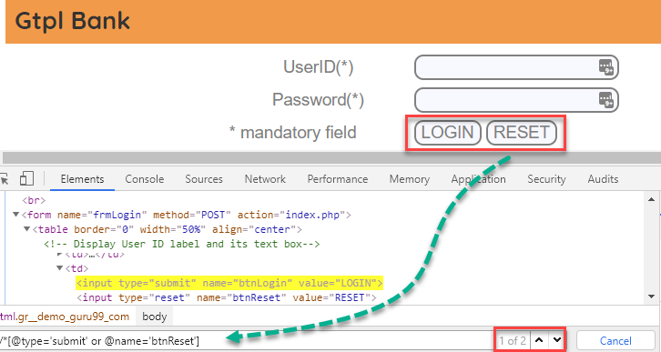](https://www.guru99.com/images/3-2016/032816_0758_XPathinSele8.png)

In AND expression, two conditions are used, both conditions should be true to find the element. It fails to find element if any one condition is false.

Xpath=//input[@type='submit' and @name='btnLogin']

**In below expression, highlighting ‘LOGIN’ element as it having both attribute ‘type’ and ‘name’.**

[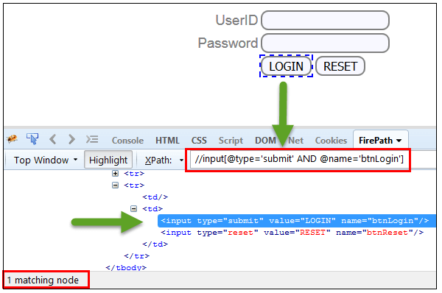](https://www.guru99.com/images/3-2016/032816_0758_XPathinSele9.png)

* **Xpath Starts-with**

**XPath starts-with()** is a function used for finding the web element whose attribute value gets changed on refresh or by other dynamic operations on the webpage. In this method, the starting text of the attribute is matched to find the element whose attribute value changes dynamically. You can also find elements whose attribute value is static (not changes).

For example -: Suppose the ID of particular element changes dynamically like:

Id=” message12″

Id=” message345″

Id=” message8769″

and so on.. but the initial text is same. In this case, we use Start-with expression.

In the below expression, there are two elements with an id starting “message”(i.e., ‘User-ID must not be blank’ & ‘Password must not be blank’). In below example, XPath finds those element whose ‘ID’ starting with ‘message’.

Xpath=//label[starts-with(@id,'message')]

[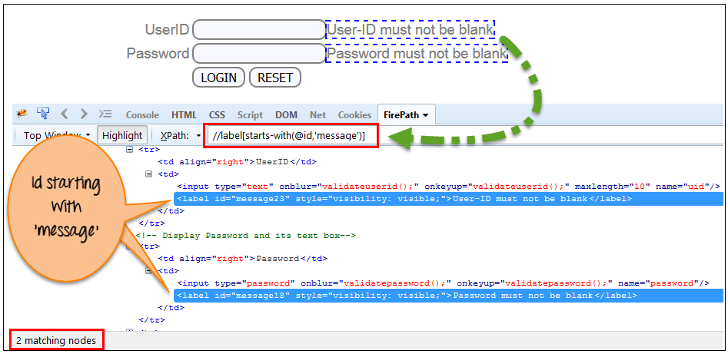](https://www.guru99.com/images/3-2016/032816_0758_XPathinSele10.png)

* **XPath Text() Function**

The **XPath text() function** is a built-in function of selenium webdriver which is used to locate elements based on text of a web element. It helps to find the exact text elements and it locates the elements within the set of text nodes. The elements to be located should be in string form.

In this expression, with text function, we find the element with exact text match as shown below. In our case, we find the element with text “UserID”.

Xpath=//td[text()='UserID']

[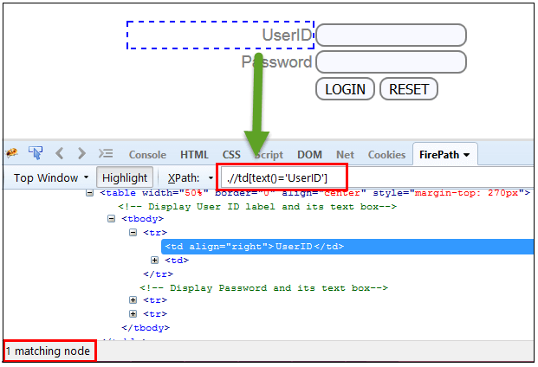](https://www.guru99.com/images/3-2016/032816_0758_XPathinSele11.png)

1. **XPath axes methods**

These XPath axes methods are used to find the complex or dynamic elements. Below we will see some of these methods.

For illustrating these XPath axes method, we will use the Guru99 bank demo site.

**1) Following**

Selects all elements in the document of the current node( ) [ UserID input box is the current node] as shown in the below screen.

Xpath=//*[@type='text']//following::input

[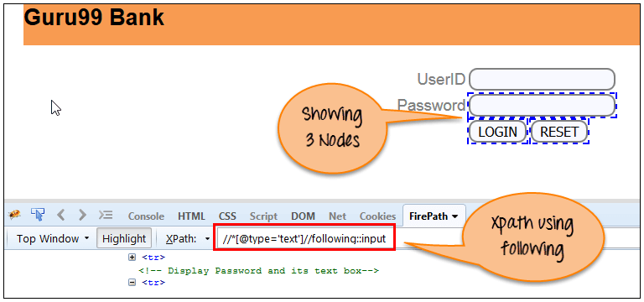](https://www.guru99.com/images/3-2016/032816_0758_XPathinSele12.png)

There are 3 “input” nodes matching by using “following” axis- password, login and reset button. If you want to focus on any particular element then you can use the below XPath method:

Xpath=//*[@type='text']//following::input[1]

You can change the XPath according to the requirement by putting [1],[2]…………and so on.

With the input as ‘1’, the below screen shot finds the particular node that is ‘Password’ input box element.

[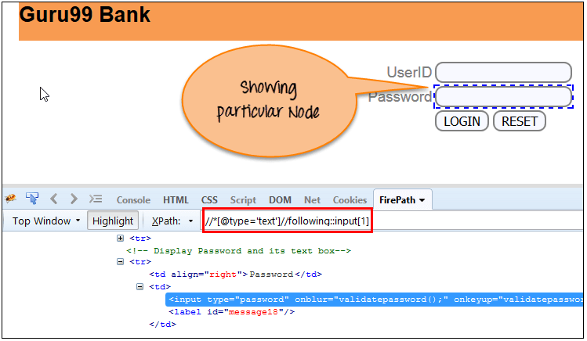](https://www.guru99.com/images/3-2016/032816_0758_XPathinSele13.png)

**2) Ancestor**

The ancestor axis selects all ancestors element (grandparent, parent, etc.) of the current node as shown in the below screen.

In the below expression, we are finding ancestors element of the current node(“ENTERPRISE TESTING” node).

Xpath=//*[text()='Enterprise Testing']//ancestor::div

[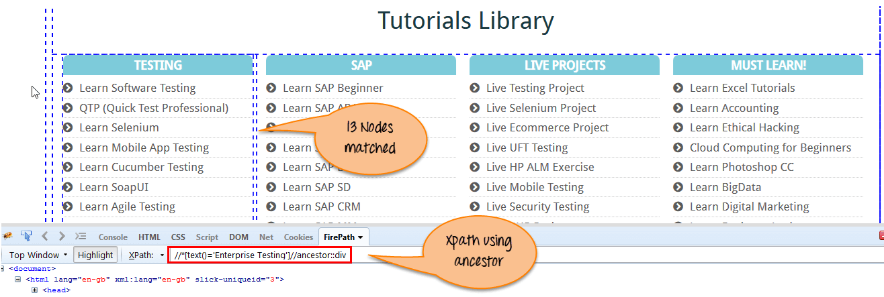](https://www.guru99.com/images/3-2016/032816_0758_XPathinSele14.png)

There are 13 “div” nodes matching by using “ancestor” axis. If you want to focus on any particular element then you can use the below XPath, where you change the number 1, 2 as per your requirement:

Xpath=//*[text()='Enterprise Testing']//ancestor::div[1]

You can change the XPath according to the requirement by putting [1], [2]…………and so on.

**3) Child**

Selects all children elements of the current node (Java) as shown in the below screen.

Xpath=//*[@id='java_technologies']//child::li

[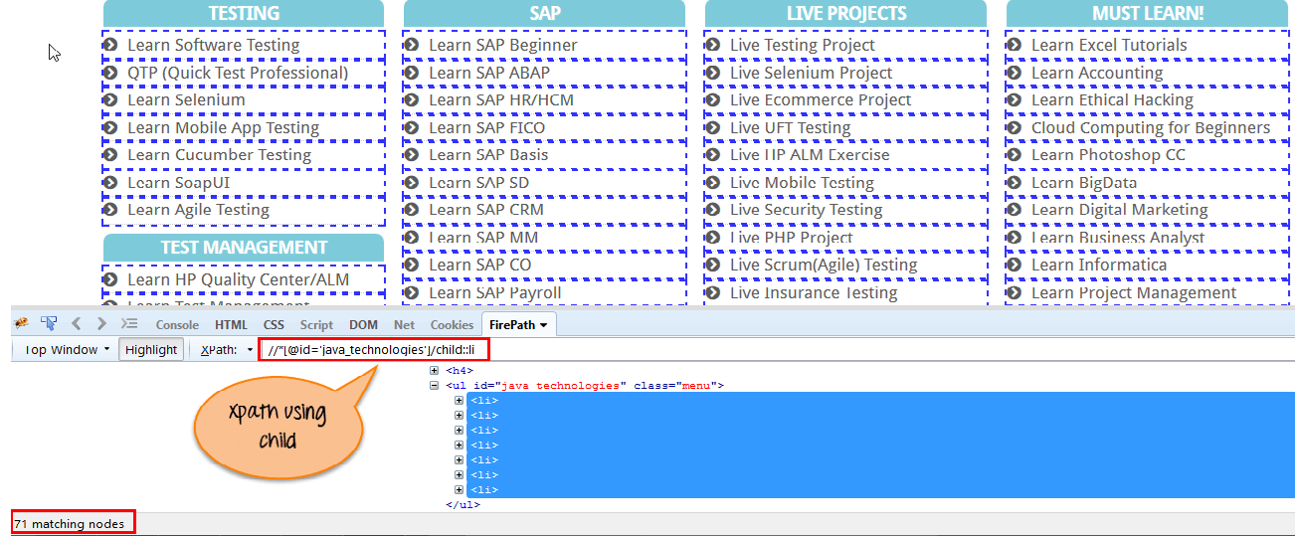](https://www.guru99.com/images/3-2016/032816_0758_XPathinSele15.png)

There are 71 “li” nodes matching by using “child” axis. If you want to focus on any particular element then you can use the below xpath:

Xpath=//*[@id='java_technologies']//child::li[1]

You can change the xpath according to the requirement by putting [1],[2]…………and so on.

**4) Preceding**

Select all nodes that come before the current node as shown in the below screen.

In the below expression, it identifies all the input elements before “LOGIN” button that is **Userid** and **password** input element.

Xpath=//*[@type='submit']//preceding::input

[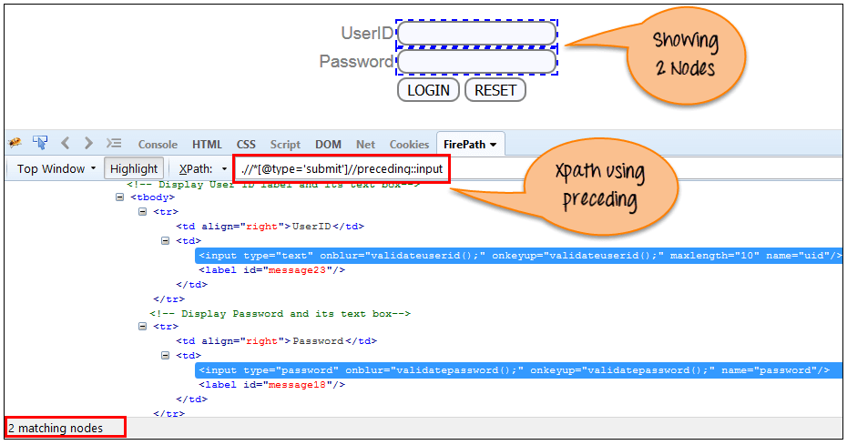](https://www.guru99.com/images/3-2016/032816_0758_XPathinSele16.png)

There are 2 “input” nodes matching by using “preceding” axis. If you want to focus on any particular element then you can use the below XPath:

Xpath=//*[@type='submit']//preceding::input[1]

You can change the xpath according to the requirement by putting [1],[2]…………and so on.

**5) Following-sibling**

Select the following siblings of the context node. Siblings are at the same level of the current node as shown in the below screen. It will find the element after the current node.

xpath=//*[@type='submit']//following-sibling::input

[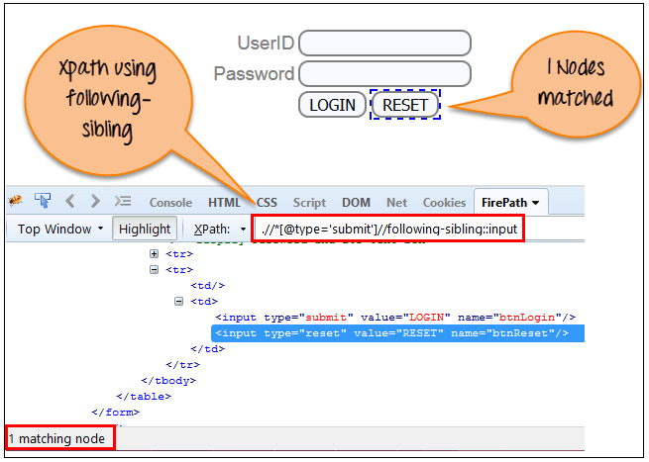](https://www.guru99.com/images/3-2016/032816_0758_XPathinSele17.png)

One input nodes matching by using “following-sibling” axis.

**6) Parent**

Selects the parent of the current node as shown in the below screen.

Xpath=//*[@id='rt-feature']//parent::div

[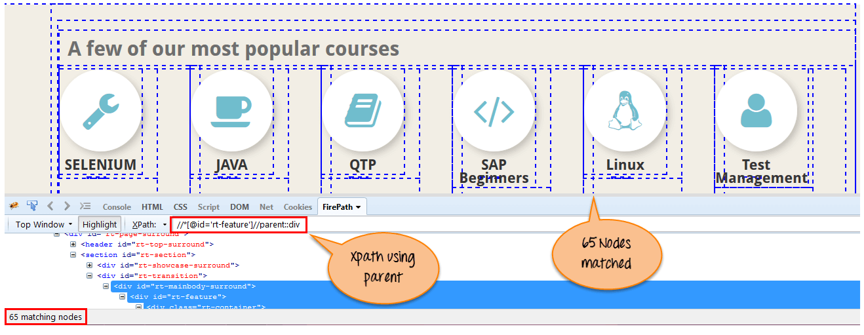](https://www.guru99.com/images/3-2016/032816_0758_XPathinSele18.png)

There are 65 “div” nodes matching by using “parent” axis. If you want to focus on any particular element then you can use the below XPath:

Xpath=//*[@id='rt-feature']//parent::div[1]

You can change the XPath according to the requirement by putting [1],[2]…………and so on.

**7) Self**

Selects the current node or ‘self’ means it indicates the node itself as shown in the below screen.

[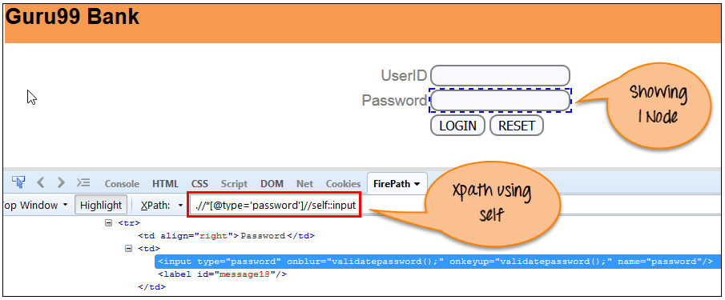](https://www.guru99.com/images/3-2016/032816_0758_XPathinSele19.png)

One node matching by using “self ” axis. It always finds only one node as it represents self-element.

Xpath =//*[@type='password']//self::input

**8) Descendant**

Selects the descendants of the current node as shown in the below screen.

In the below expression, it identifies all the element descendants to current element ( ‘Main body surround’ frame element) which means down under the node (child node , grandchild node, etc.).

Xpath=//*[@id='rt-feature']//descendant::a

[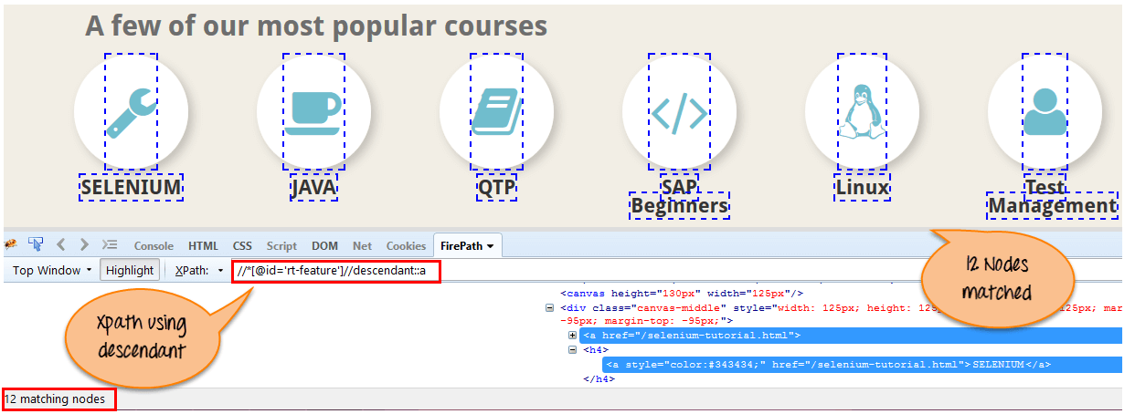](https://www.guru99.com/images/3-2016/032816_0758_XPathinSele20.png)

There are 12 “link” nodes matching by using “descendant” axis. If you want to focus on any particular element then you can use the below XPath:

Xpath=//*[@id='rt-feature']//descendant::a[1]

You can change the XPath according to the requirement by putting [1],[2]…………and so on