**OBJECT ORIENTED ANALYSIS AND DESIGN**

**CIA1 COMPONENT 1**

**HOTEL MANAGEMENT SYSTEM**

USE CASE DIAGRAM:

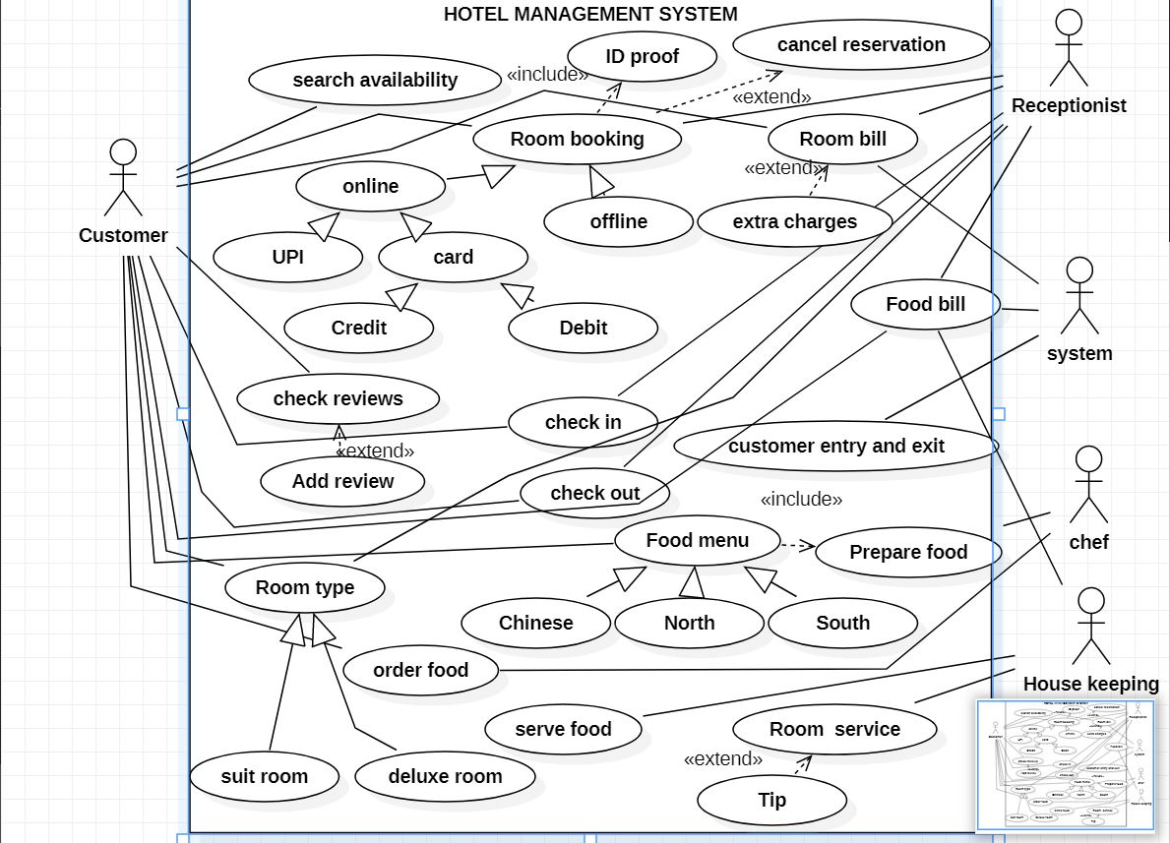

SEQUENCE DIAGRAM:

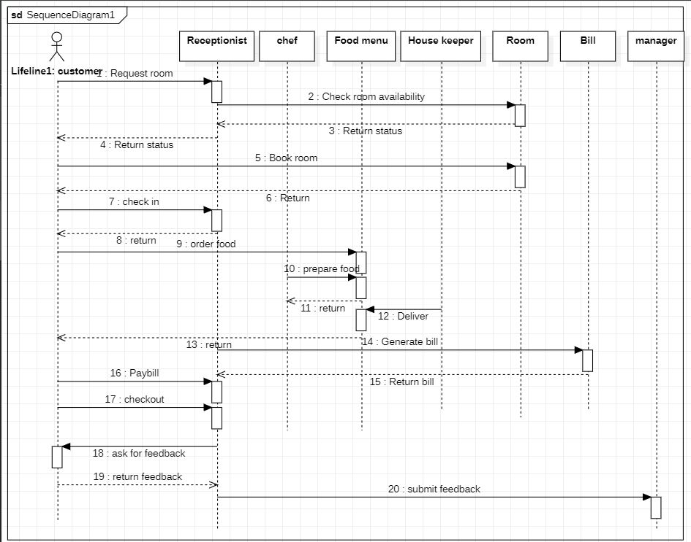

COLLABRATION DIAGRAM:

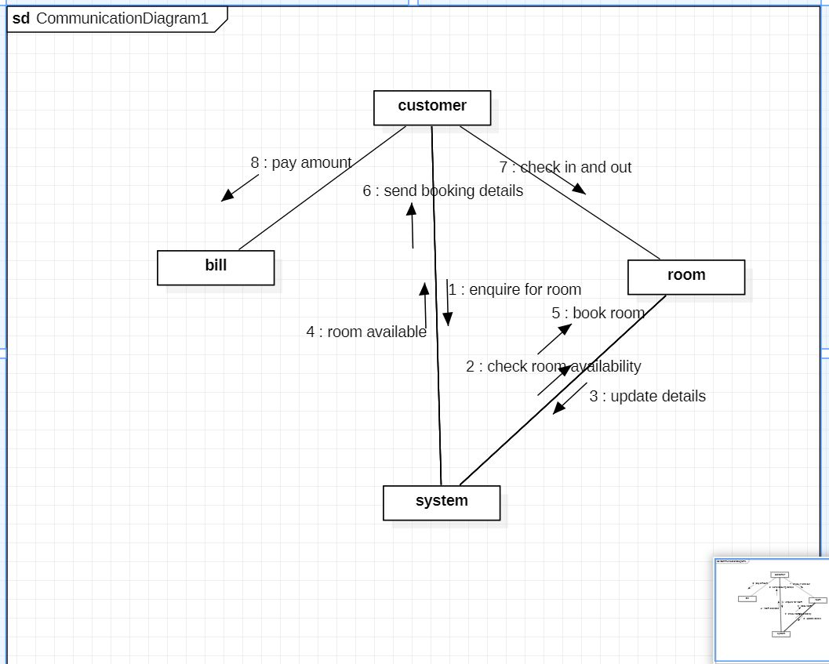

SUBMITTED BY :

N.GOWTHAM

1860339

6BTCSA