

DEPARTMENT OF COMPUTER SCIENCE AND ENGINEERING

**CIA-III**

**HOTEL MANAGEMNENT SYSTEM**

**B. Tech Computer Science and Engineering**

**N.GOWTHAM 1860339**

**6BTCSA**

**School of Engineering and Technology, CHRIST (Deemed to be University),Kumbalagodu, Bengaluru-560 074**

# Class Diagram

**Use noun phrase approach to identify the classes and write the step- by- step procedure to list the final classes**

# Step 1. Listing All Nouns and Noun Phrases

bookrooms

receptionist

manager

owner

database

manage room customer

check-in checkout

name

phno

email

address

roomnumber online payment payment

bill

chef

food

# Step 2. Eliminating Duplicate Classes

room

receptionist database

customer

checkin

checkout

search room name

phno

email

address

room number payment

bill

chef

food

**Step 3. Eliminating attributes**

room

receptionist

owner

manager

database

customer

search room

payment

bill

chef

food

**Step 4. Eliminating adjectives**

room

receptionist

manager

owner database customer

payment

bill

chef

food

# Step 5. Eliminating irrelevant classes

Room

manager customer

owner

receptionist

payment

The final classes are- Room, Manager, Customer,Owner, Receptionist,Payment.

# Class Diagram

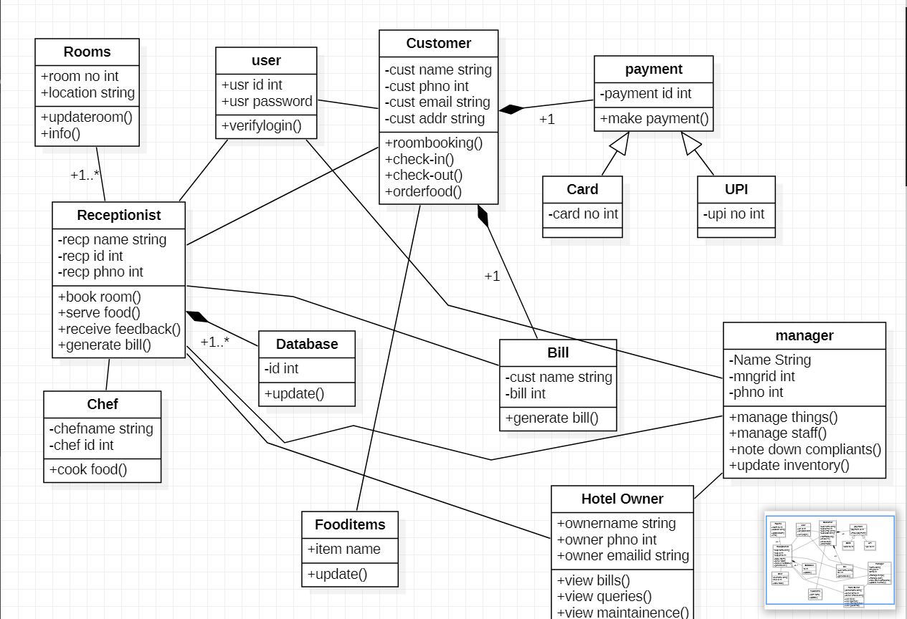

1. **Database Design - Design the table for the classes that needs persistent Storage.**

**Table – Class Mapping**

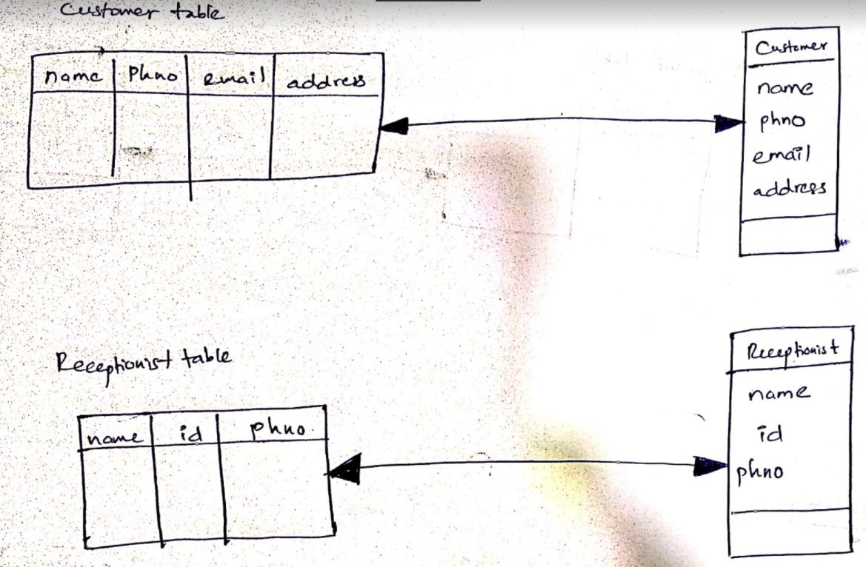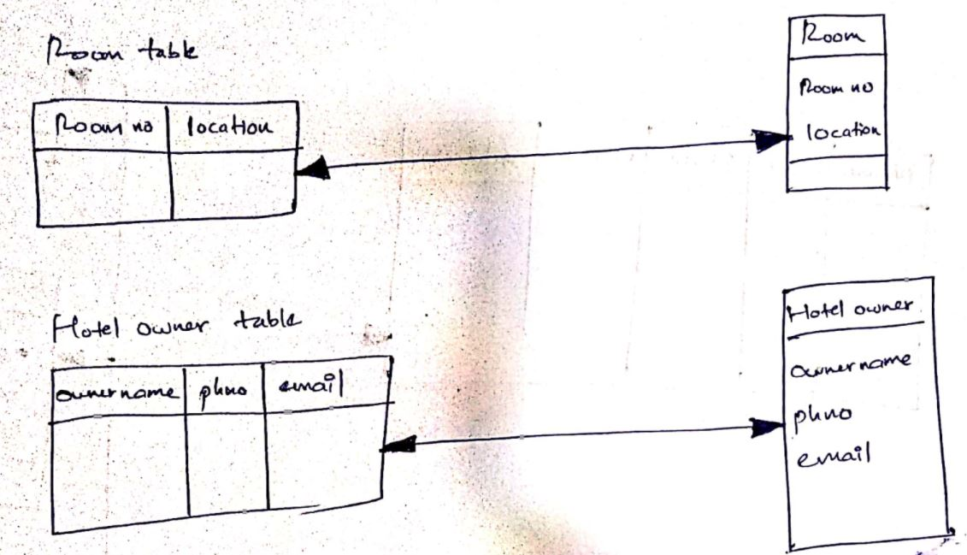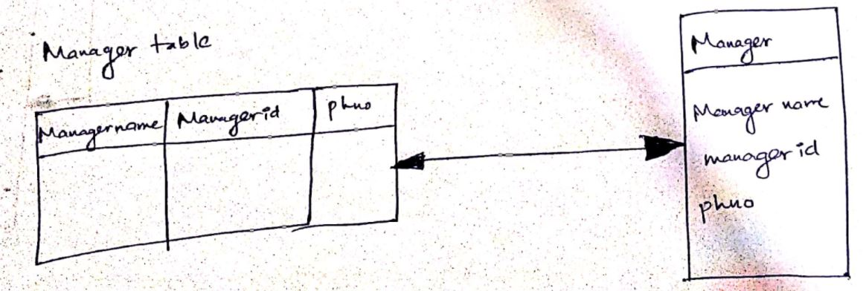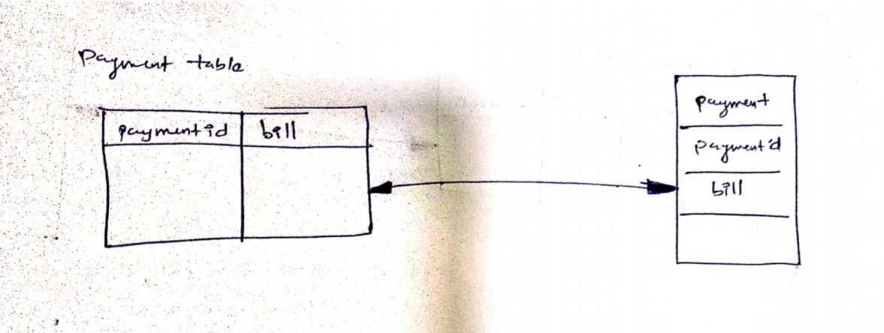

**Table – Mutiple Class Mapping**

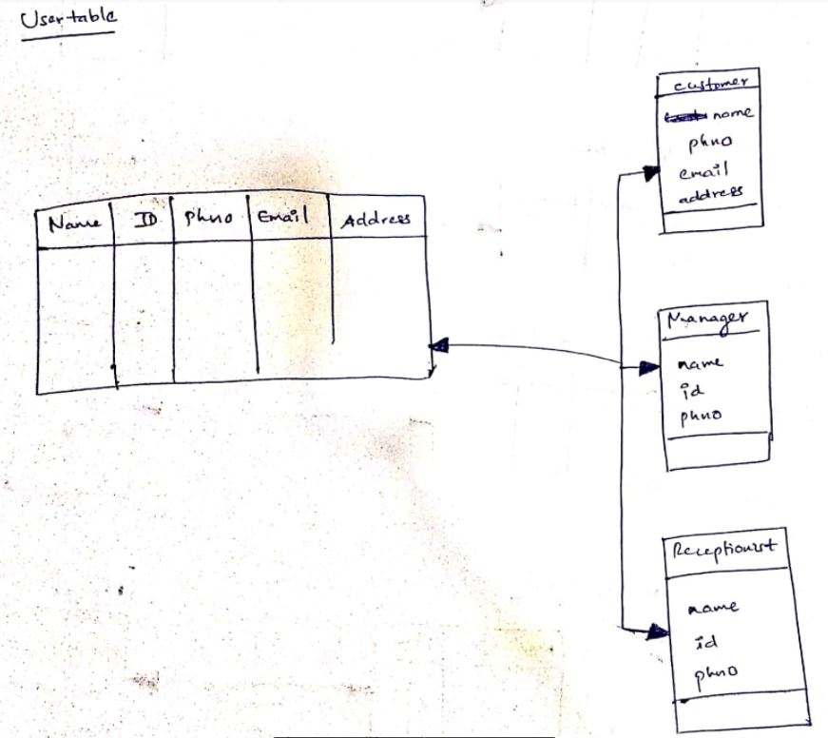

1. **Implementation/Front End Design-**

