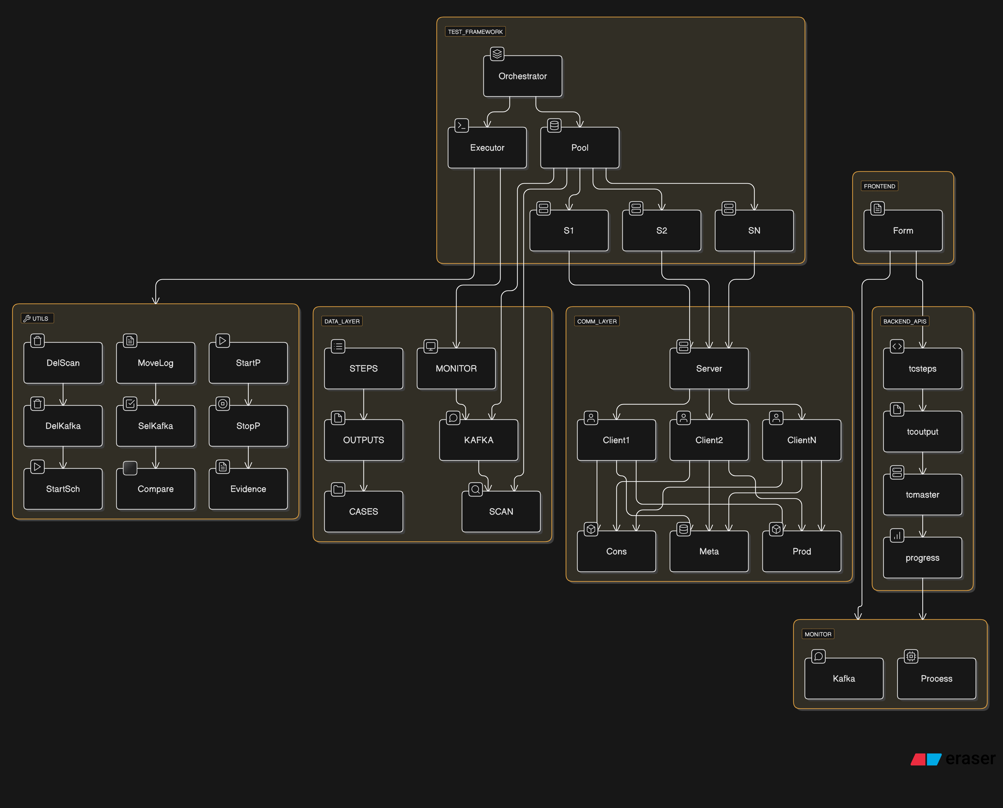

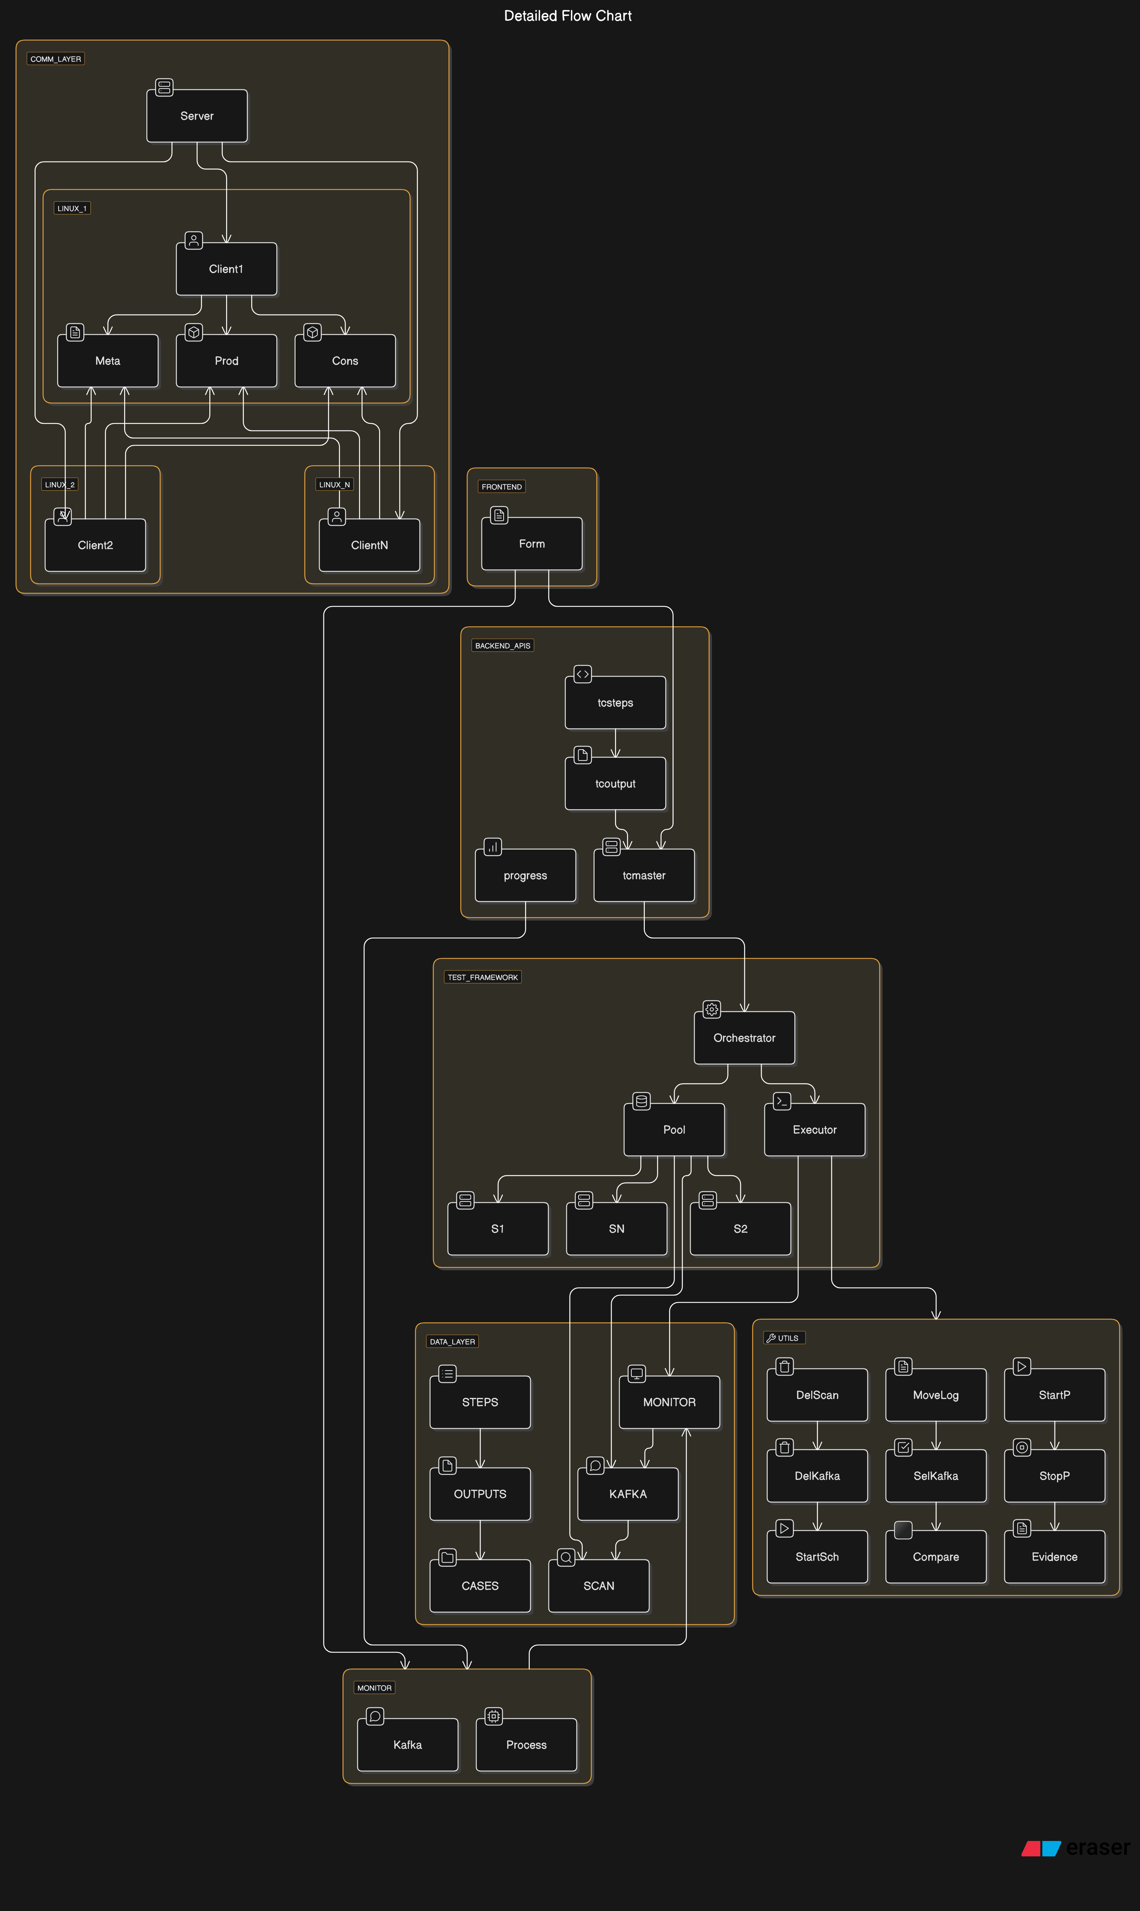

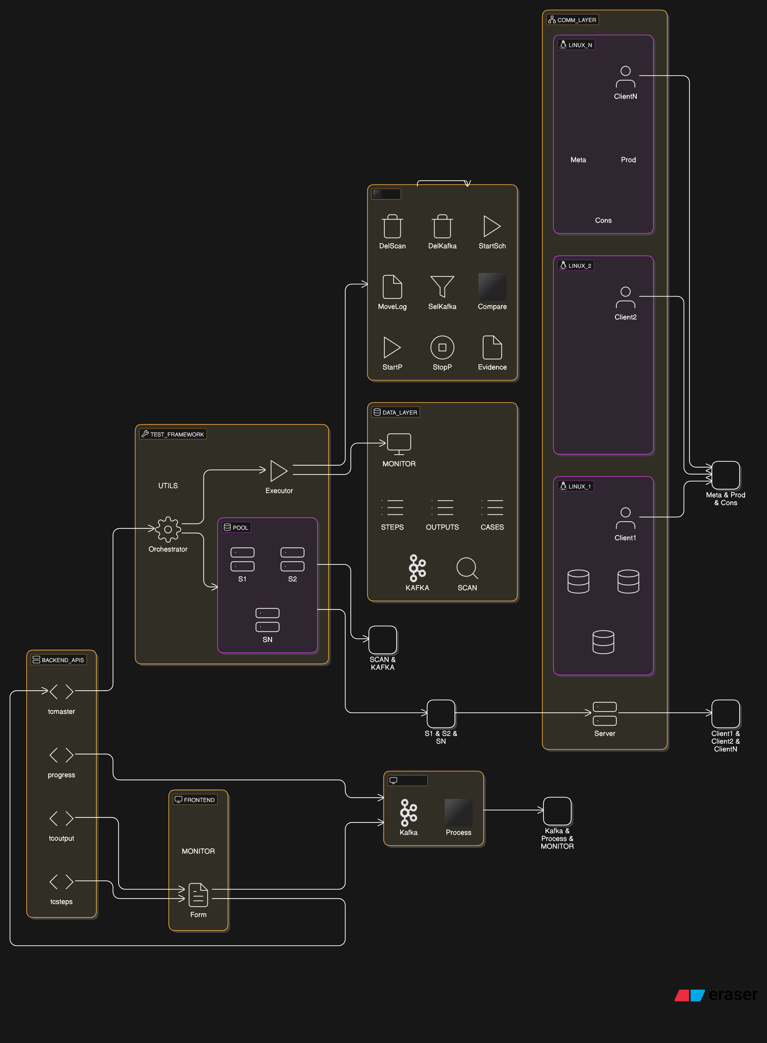

**Why I choose Golang (Go) for Our Test Case Automation Framework**

**1. Performance Metrics:**

* **Execution Speed**: Golang executes **30% faster** than Java and **10x faster** than Python. This high performance is crucial for executing multiple test cases efficiently.
* **Memory Usage**: Go uses only **30MB** of memory, while Java and Python use **140MB** and **90MB** respectively. Lower memory usage ensures our framework runs smoothly even with high concurrent loads.
* **Startup Time**: Golang starts up in **0.1 seconds**, significantly faster than Java (**1.5 seconds**) and Python (**0.3 seconds**). Quick startup times are essential for rapid test execution cycles.
* **Bench mark data**

Java vs Python

<https://benchmarksgame-team.pages.debian.net/benchmarksgame/fastest/python.html>

go vs python

<https://benchmarksgame-team.pages.debian.net/benchmarksgame/fastest/python3-go.html>

go vs java

<https://benchmarksgame-team.pages.debian.net/benchmarksgame/fastest/go.html>

**2. Concurrency Benefits:**

* **Goroutines vs. Java Threads**: Golang’s native goroutines are lightweight, consuming only **2KB** of memory compared to Java threads, which use **1MB** each. This allows us to efficiently run **1000+ concurrent test executions**.
* **Efficient Communication**: Channel-based communication in Go is more efficient than Python’s queues, ensuring smooth data transfer between concurrent processes.
* **Built-in Race Detection**: During development, Go’s built-in race detection helps catch and resolve concurrency issues like dead lock and race condition, enhancing reliability and stability.

**3. Cross-Platform Advantages:**

* **Single Binary Deployment**: Golang compiles into a single binary, eliminating the need for JVM or Python runtime dependencies. This simplifies deployment across different environments.
* **Native Linux Support**: Golang offers native support for Linux, aligning perfectly with our distributed architecture.
* **Smaller Deployment Footprint**:
  + Go binary: **15MB**
  + Java JAR + JRE: **200MB**
  + Python + dependencies: **100MB**
  + A smaller footprint reduces deployment complexity and resource usage.

**4. Framework-Specific Benefits:**

* **Socket Programming**: Go’s native concurrency features make socket programming efficient and straightforward, crucial for our framework’s communication needs.
* **File Operations**: Go excels in file operations, essential for handling test evidence efficiently.
* **Strong Type System**: Go’s strong type system catches errors at compile time, reducing runtime errors and improving code quality.
* **Built-in Testing Framework**: Go provides a robust built-in testing framework, facilitating the development and execution of tests.
* **Fast Compilation**: Go’s fast compilation speeds up the development process, enabling rapid iteration and testing.

**5. Real Metrics from Our Implementation:**

* **Test Execution Time**: Reduced by **90%** due to Go’s high performance and efficient concurrency.
* **Resource Utilization**: Improved by **70%**, allowing us to handle more test cases with the same resources.
* **Runtime Dependency Issues**: Zero issues, thanks to Go’s single binary deployment and minimal dependencies.
* **Linux Integration**: Seamless integration with our Linux-based infrastructure.
* **Maintenance and Updates**: Easier and faster due to Go’s simplicity and strong typing.

**6. Scalability Results:**

* **Concurrent Test Cases**: Handles **100+ concurrent test cases** efficiently.
* **Distributed Nodes**: Manages **10+ distributed Linux nodes** without issues.
* **Process Startup Time**: Less than **100ms**, ensuring quick test execution cycles.
* **Real-time Monitoring**: Minimal overhead, allowing real-time monitoring of test executions.
* **Memory Management**: Efficient memory management during peak loads, preventing bottlenecks and ensuring smooth operation.

**Conclusion:**

Golang stands out as the most suitable language for our test case automation framework due to its superior performance, efficient concurrency management, simplicity, and deployment advantages. Its ability to handle high concurrency with low memory usage, combined with a strong type system and fast compilation, makes it the ideal choice over Java and Python.

**Current State (Manual SIT):**

* 8 team members × 10 weeks
* Manual test execution and validation
* Sequential test runs
* Limited coverage due to time constraints
* Resource-intensive coordination
* Documentation delays

**With New Framework:**

1. **Speed Improvements:**

* Reduced from 10 weeks to 1 week (90% time reduction)
* 24/7 automated test runs
* Multiple test scenarios run simultaneously
* Instant test result availability

1. **Resource Optimization:**

* Only 1 team member needed for monitoring
* Automated scheduling and execution
* Better resource utilization
* Focus shifts to analysis rather than execution

1. **Quality Enhancement:**

* 100% consistent test execution
* Comprehensive test coverage
* Real-time monitoring and alerts
* Automated evidence collection
* Zero human errors in execution
* Reproducible results
* Early defect detection

1. **Additional Benefits:**

* Test results available within hours
* Reusable test components
* Scalable architecture
* Historical data for analytics
* Automated reporting
* Minimal manual intervention
* Quick regression testing

**1. Test Case Creation & Validation**

**Frontend Input**

* User accesses Test Case Entry Form
* Enters test parameters:
  + Test case ID
  + Test description
  + Test steps ( will be fetched from backednd API (api/tcsteps ) and shown as searchable
  + Expected outputs(( will be fetched from backednd API (api/tcoutput) and shown as searchable
  + Scheduling preferences

**API Processing**

* api/tcmaster receives POST request
* Validates input format
* Checks dependencies
* Stores in TEST_CASES with

**2. Test Orchestration**

**Initial Processing**

* Test Orchestrator picks up **ENABLED** cases
* Validates test environment
* Checks resource availability
* Creates execution strategy

**Test case Scheduling**

* Each test case will be assigned to independent goroutine(equivalent to thread in java but uses less memory in Golang) for processing
* Map the steps entered by users to available utility methods
* We will have utility methods for every task like moving file from one location to another, updating a table, to perform ssh connection, start the scheduler.
* We can keep adding these methods as required and display in the UI for user selection.
* Start executing the methods in sequential manner
* For each test case the first step will be cleaning the existing data to avoid any data discrepancies.
* Capture all the required evidences like log, DB results on every TC method completion
* Scheduler will be invoked to schedule only the particular AIT involved in this test case other AITs won’t be disturbed which enables us to execute test cases in parallel.
* We can even Spin 100s of goroutines in parallel without causing memory issue but we are planning to keep Num_of_processors * 4 (i.e 18 core * 4 = 72 go routines) for optimal processing, this means that we can execute 72 test cases in parallel in 18 core cpu.
* This goroutine pool will be created dynamically based on machine capacity.
* Lookup map will be maintained to keep track of already used port numbers

**Monitoring & Control**

**Real-time Monitoring**

We will provide a dashboard to monitor our testcase execution progress in real time.

* Test Monitor:
  + Execution progress
  + Success/failure rates
  + Performance metrics
  + Resource utilization

**Some Utility Operations**

**Cleanup Operations**

* DeleteScanWindow:
  + Cleans completed windows
  + Updates scheduler status
  + Releases resources

**Log Management**

* MoveLog(files):
  + Archives execution logs
  + Maintains audit trail
  + Enables traceability

**Evidence Collection**

* CaptureEvidence:
  + Query the db and save the results
  + Performance graphs
  + Error traces

**Process Control**

* StartProcess/StopProcess:
  + Graceful startup/shutdown
  + Resource cleanup
  + State persistence
  + Health checks

**Memory Usage:**

* **Golang**: Typically known for its low memory footprint. A simple Go program can indeed use around **30MB** of memory, especially in scenarios with efficient concurrency management using goroutines.
* **Java**: Java applications generally have a higher memory footprint due to the overhead of the JVM and its garbage collection process. It is common for even simple Java applications to use **140MB** or more.
* **Python**: Python falls somewhere in between, with typical memory usage around **90MB** for simple scripts. The higher memory usage is attributed to its dynamic nature and interpreted execution.

**Explanation:**

* **Golang’s Efficiency**: The lower memory usage of Go is due to its design, which includes efficient garbage collection, native concurrency with low-overhead goroutines, and the compilation to a single binary.
* **Java’s Overhead**: Java's memory usage is higher because of the Java Virtual Machine (JVM) and the need to manage memory through garbage collection, which consumes additional resources.
* **Python’s Interpretation**: Python’s interpreted nature and dynamic typing contribute to its relatively higher memory consumption compared to Go, though it’s typically less than Java.