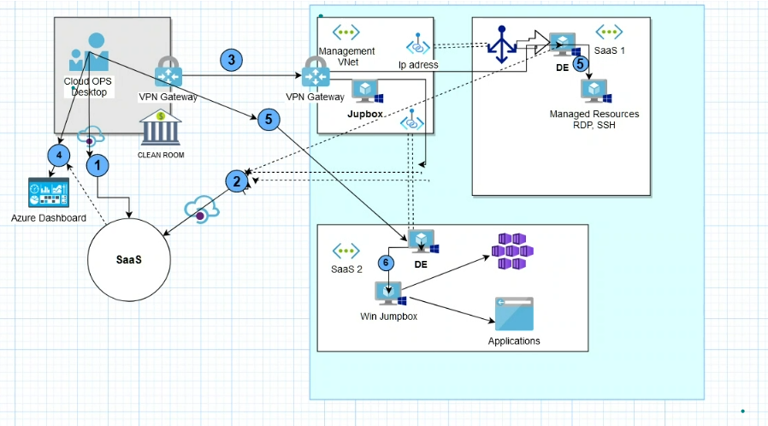

**Total flow:**

Jumpbox in management VNET --> Private End Point --> private Link Service --> Load Balancer --> DE

**Right to left**:

1.0 Environment with DE, load balancer and Private link service.

**Testing 1.0 SAAS VNET**

RSG

VNET (10.8.0.0/16)

Subnet

2 Windows server -- 1 for DE and other for application mounting

Load balancer - private load balancer

Private link service

**Management VNET Centralized VNET:**

RSG

VNET (10.10.0.0/22)

2 Subnets - 1 for windows jumphost and other to host VPN gateway

Windows Jumphost

Private end point -- end point as Jumphost.

Terraform:

RSG -- Manage-rsg

Location -- west-europe

Vnet -- Manage-vnet

Subnet - manage-sub-1

VM - manage-vm

Private Endpoint - manage-pvt-endpoint

**Variables:**

Manage-Rsg-name: manage-rsg

Manage-Rsg-Location: west-europe

Manage-Vnet-name: manage-vnet

Manage-Sub-1: manage-subnet-1

Manage-Vm1: manage-vm1

Manage

Create RSG, Vnet and subnet as Map variable

**Senario -1:**

RSG -- application-rsg

Location -- east-europe

Vnet -- application-vnet

Subnet -- application-sub

2Vm -- DE-vm and application-vm

Load balancer -- application-lb --

Private link service -- application-pvt-link

LB backend -- DE-vm

**Variables:**

