**INDEX PAGE:**

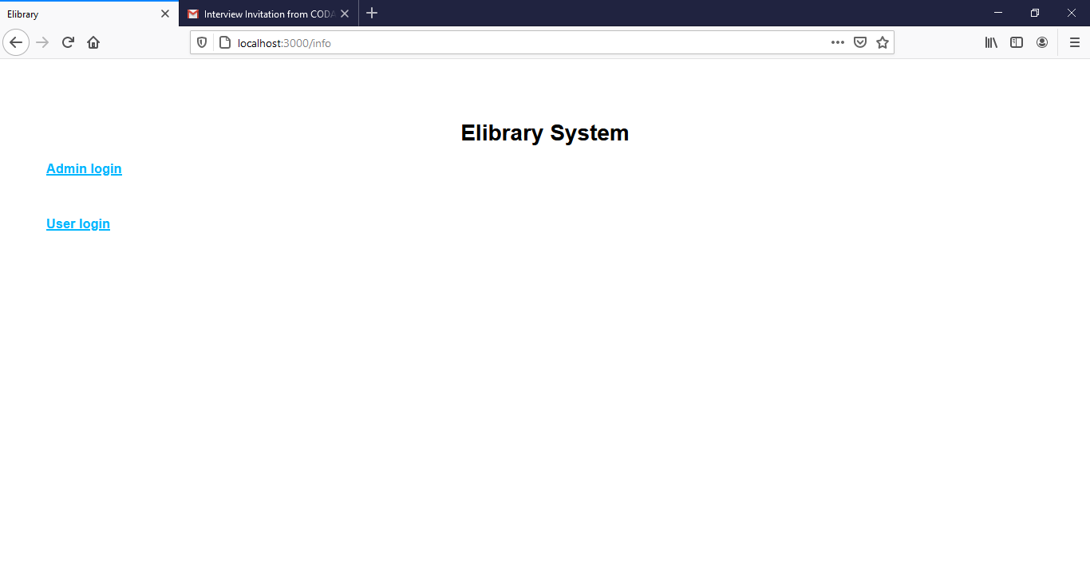

**ADMIN LOGIN FORM:**

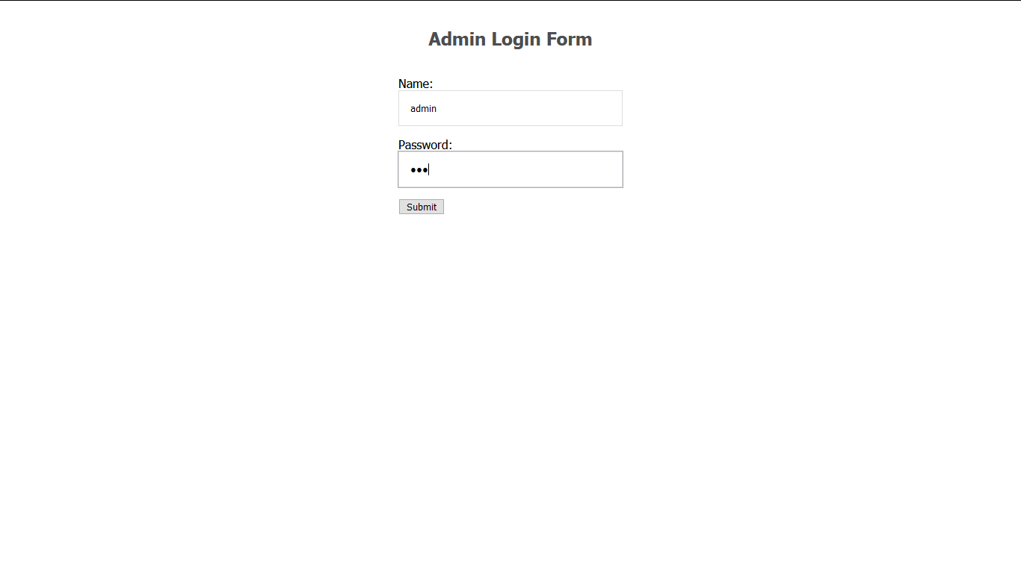

**ADMIN VIEW FORM:**

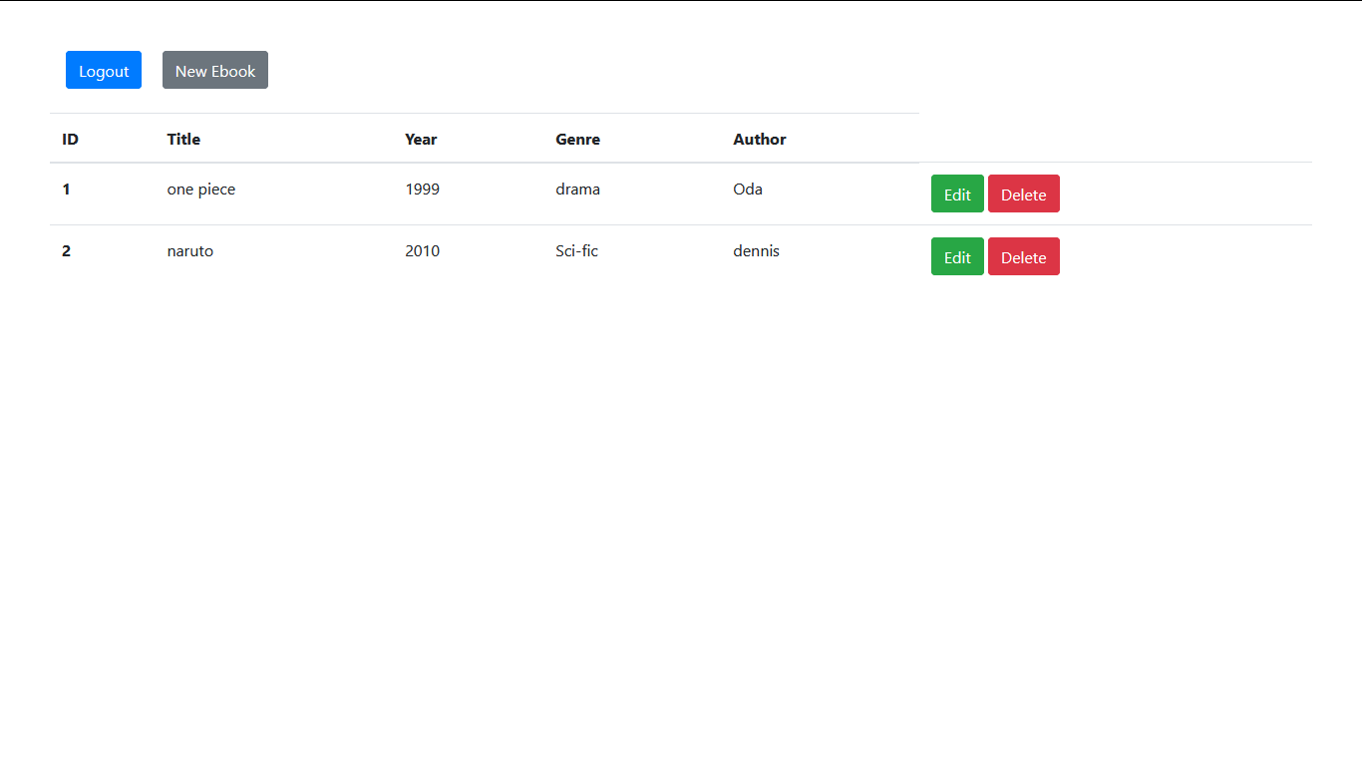

**UPDATE FORM:**

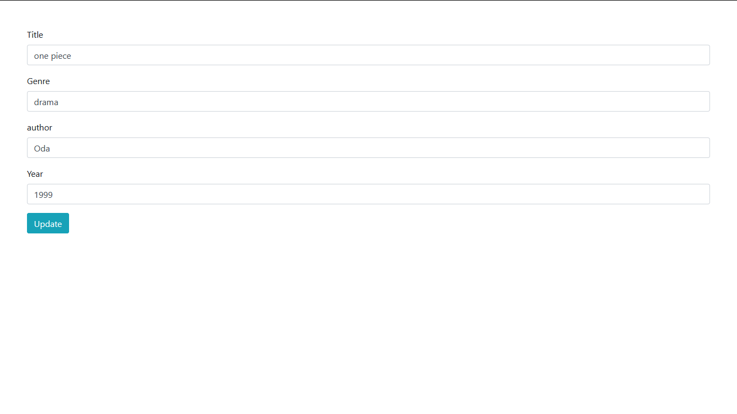

**INSERT BOOK FORM:**

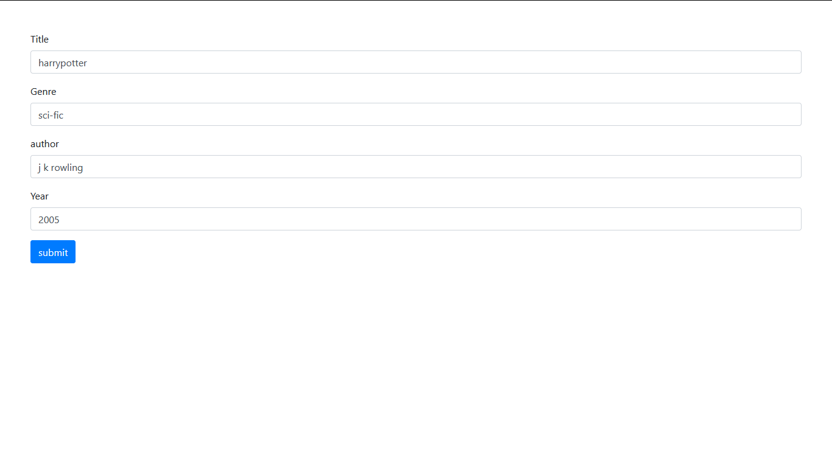

**USER LOGIN FORM:**

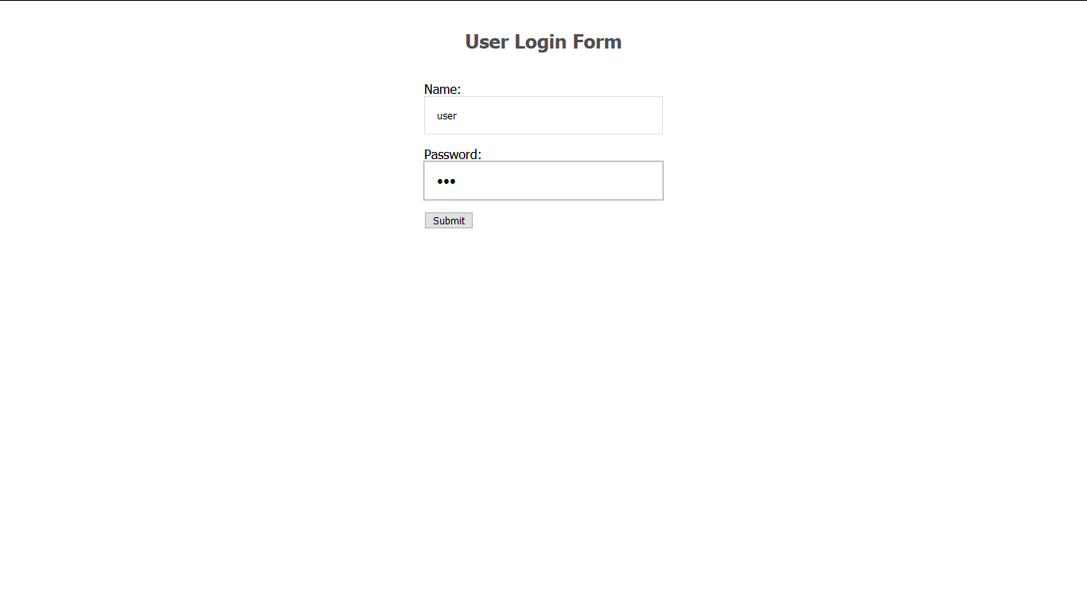

**USER VIEW FORM:**

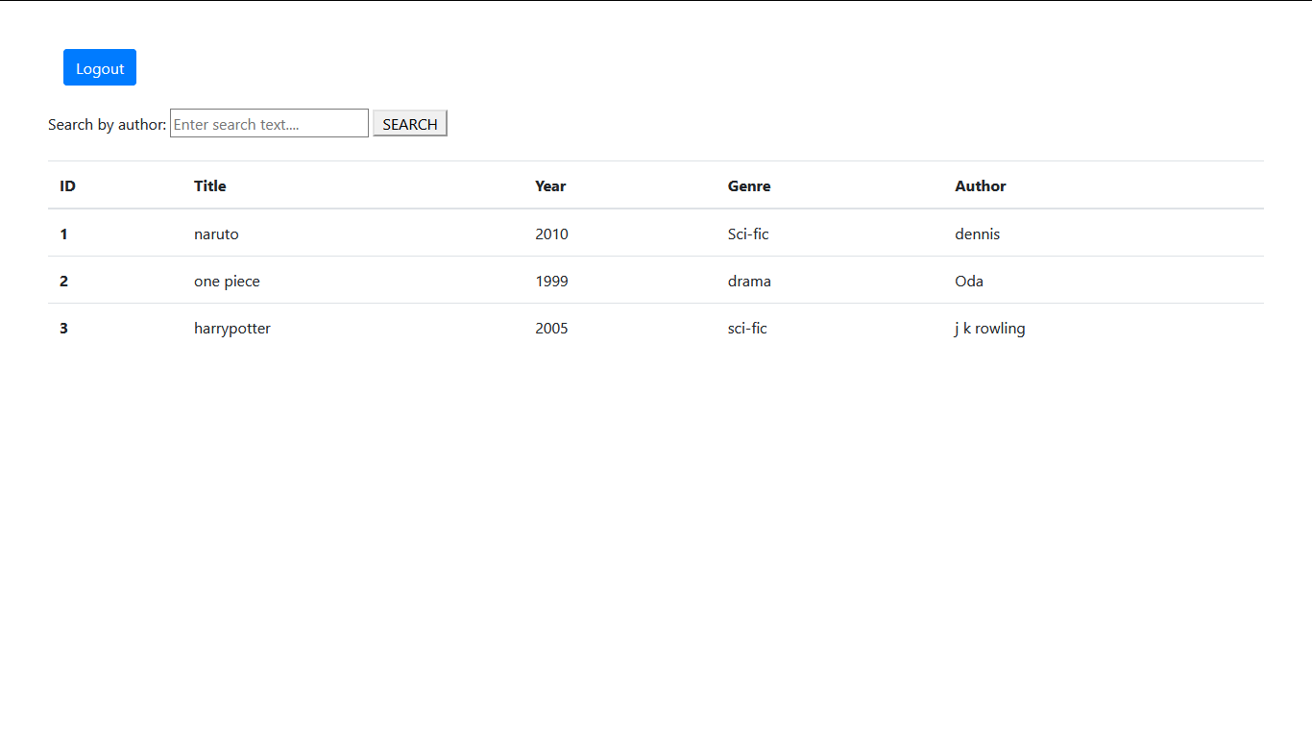

**SEARCH RESULT FORM:**

