***ESTIMATION OF BUSINESS EXPENSES***

**Introduction:**

Estimating business expenses is an important step in determining how much money you need to start and keep your business running without encountering cash flow problems. Every business has different requirements, depending on the type of products or services it sells, the size of the company, and the stage of growth of the business. Even so, most business expenses are either one-time costs or ongoing expenses required to keep operations going. Forming an official, legal business means estimating the one-time expense of obtaining your business license. If you want to incorporate your business, allow for the expense of hiring an attorney to do it for you or the cost of filing if you handle the details yourself. You also need ongoing liability insurance to protect yourself and your employees. Add on automobile insurance if you deliver products or services.

**Equipment and Supplies:**The type of space in which you set up your business needs to be estimated as an ongoing expense. If you plan to lease space, calculate the cost based on the current price for square footage in your area. Buying the building in which you plan to run your business takes a considerable sum of money, and ongoing monthly payments if you take out a loan. If you open a home office, your expenses are considerably lower, but still need to keep an eye on the costs for turning an area or room into a suitable office. Include the cost of the various utilities you need in your office space, such as electricity, water, garbage, phone and any janitorial services required. The type of equipment you need depends on the type of business you open. Most businesses need to buy computers, a printer, fax machine, copier and a phone for each desk. Furniture includes desks, chairs and filing cabinets. If you plan to manufacture and ship products, evaluate the process and supplies required to create and assemble your products before you ship them out the door. Various types of software, such as basic accounting, word processing, customer relationship management, and specialized programs required as part of your business, also need to be included in your expense estimate.

**Brainstorming Map:**

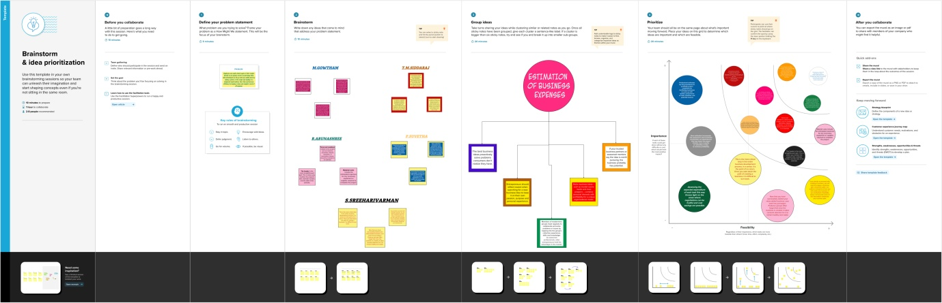

**Empathy Map:**

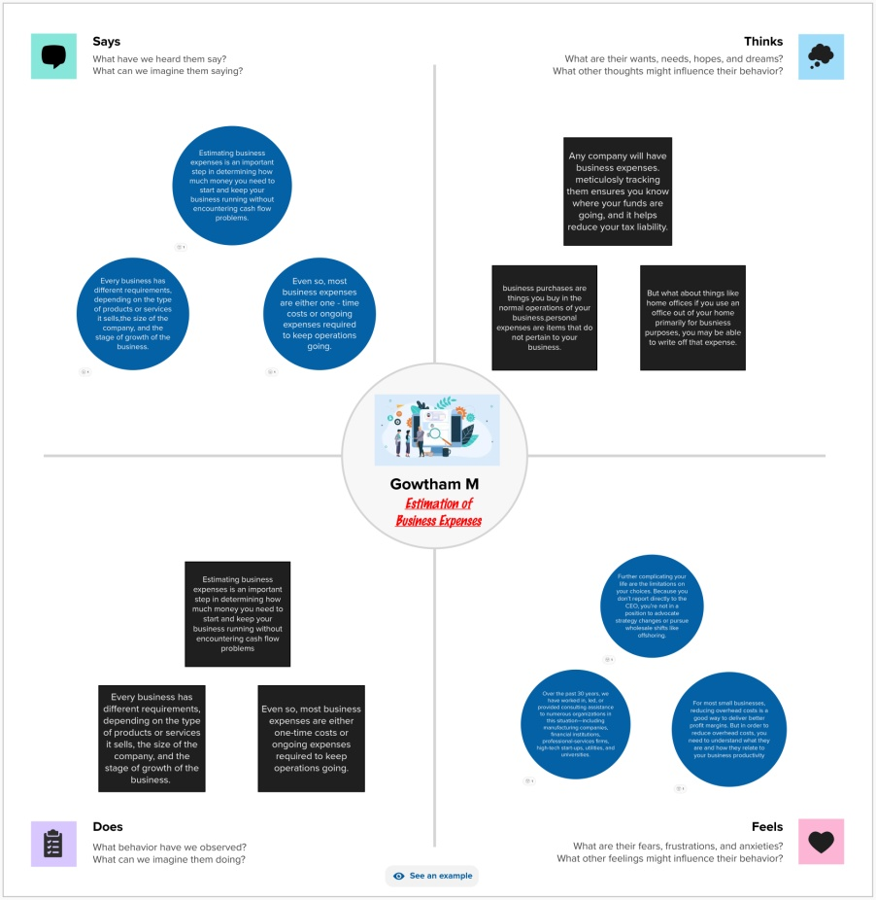

**Result:**

**1. Sheets**

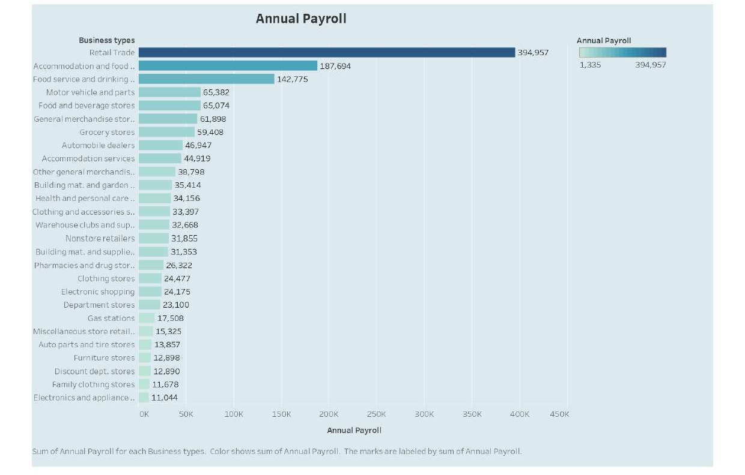

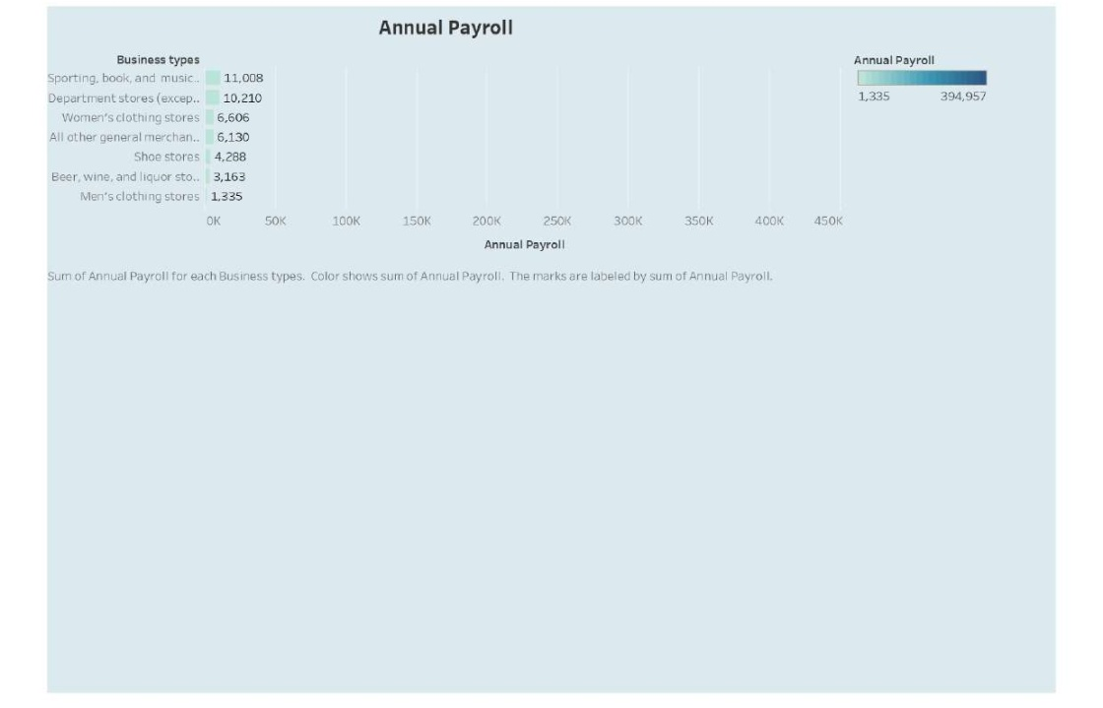

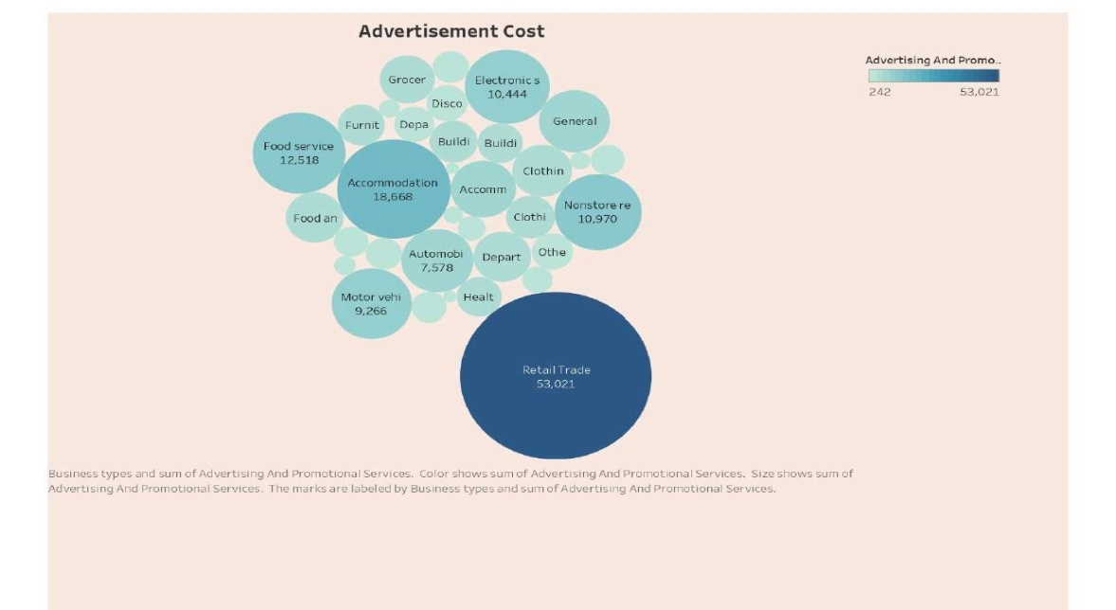

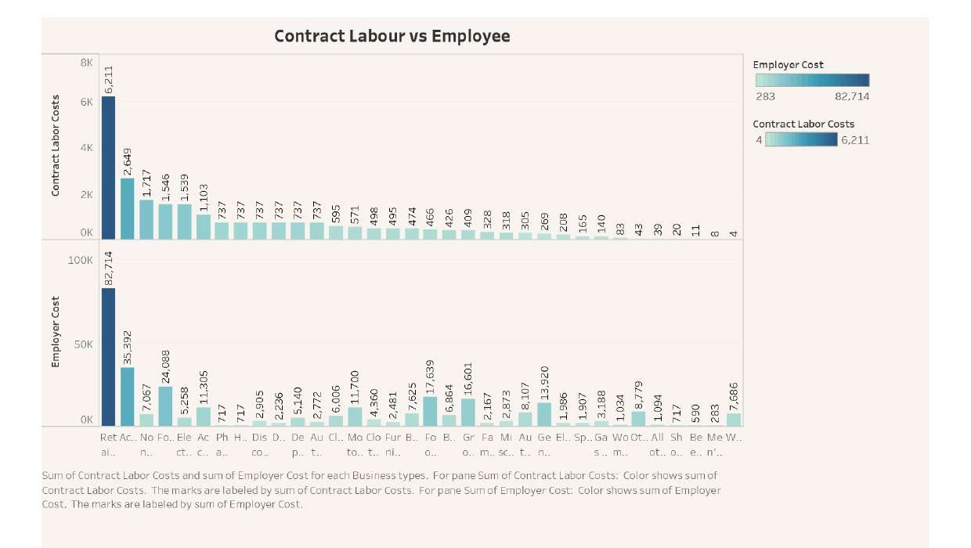

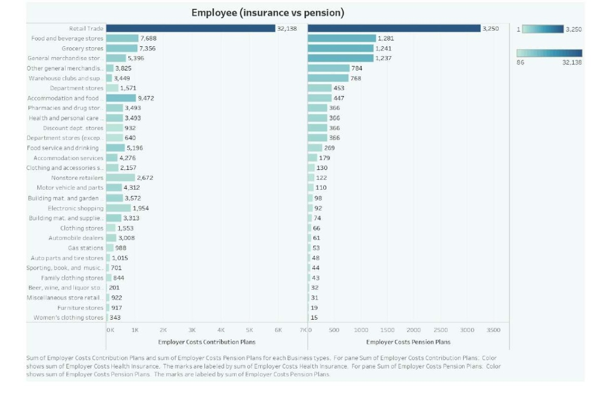

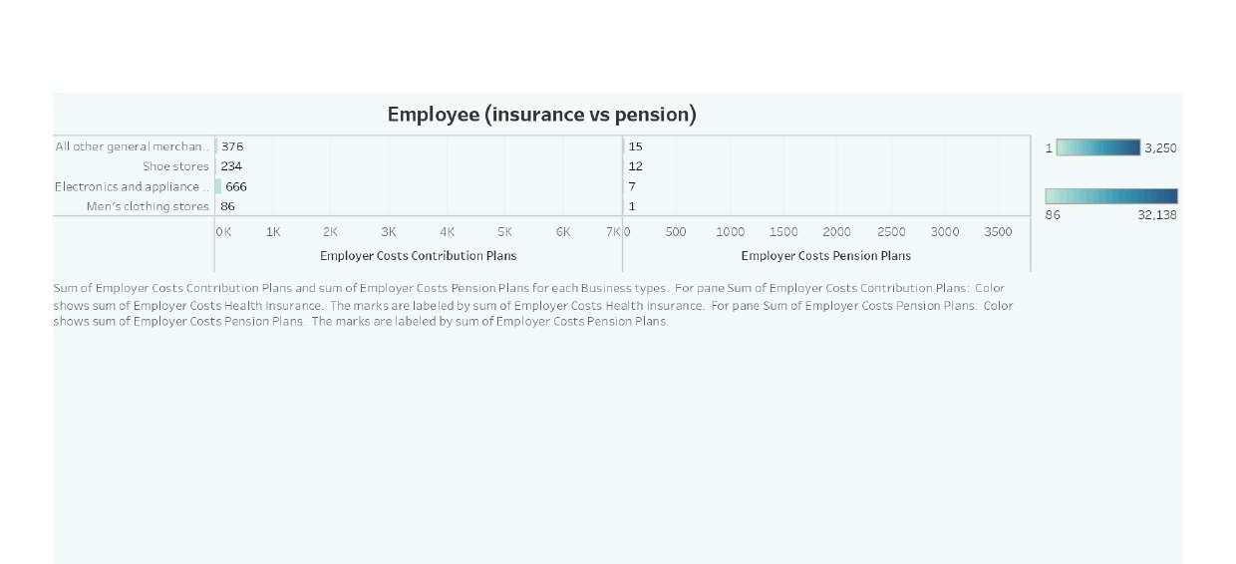

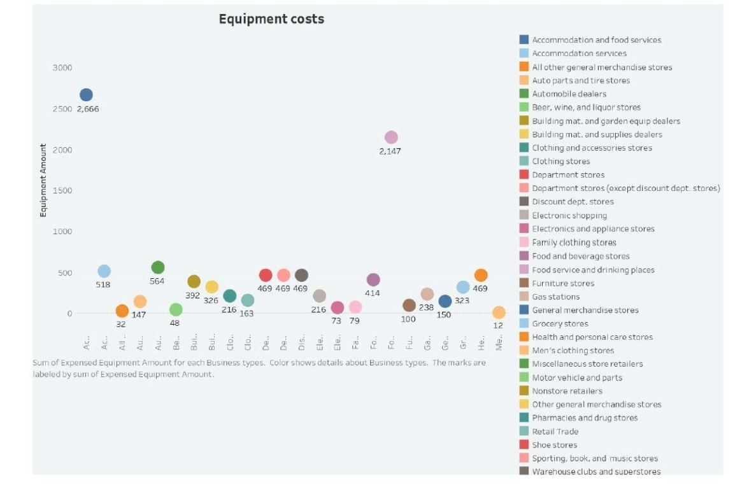

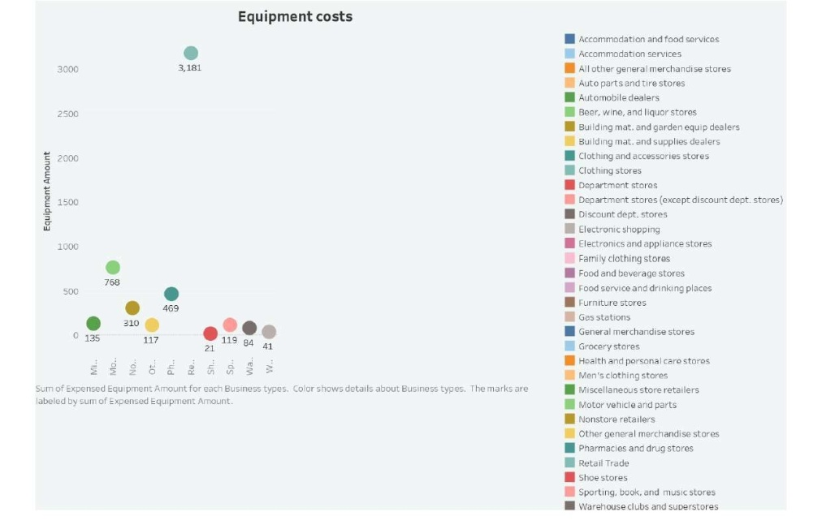

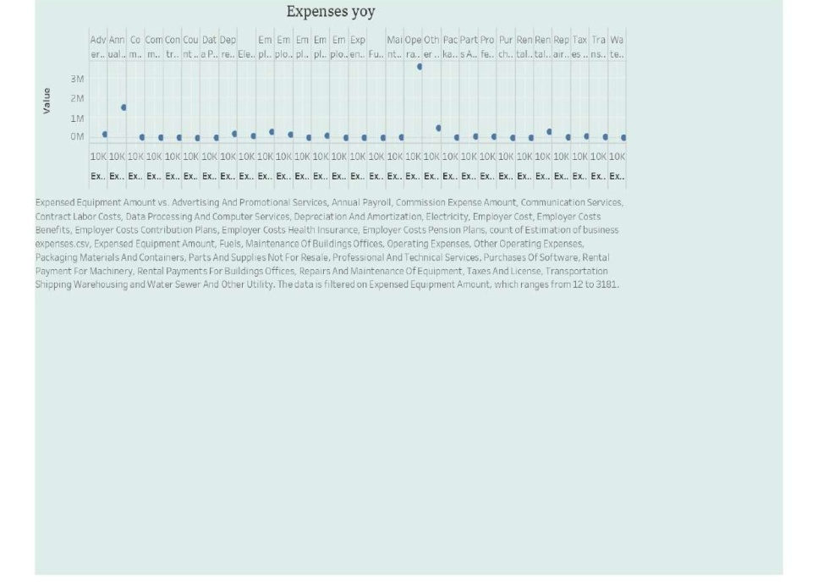

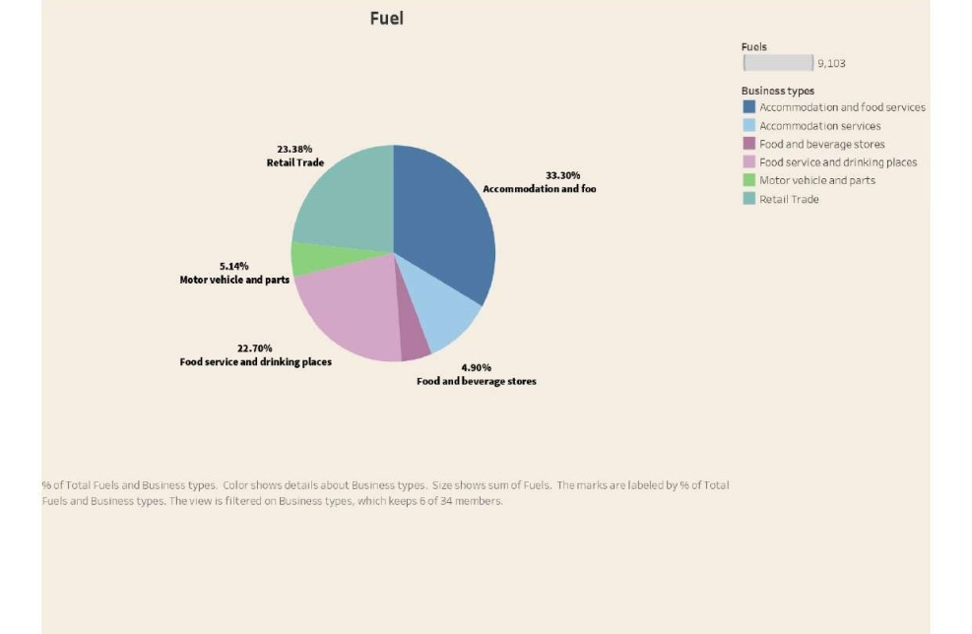

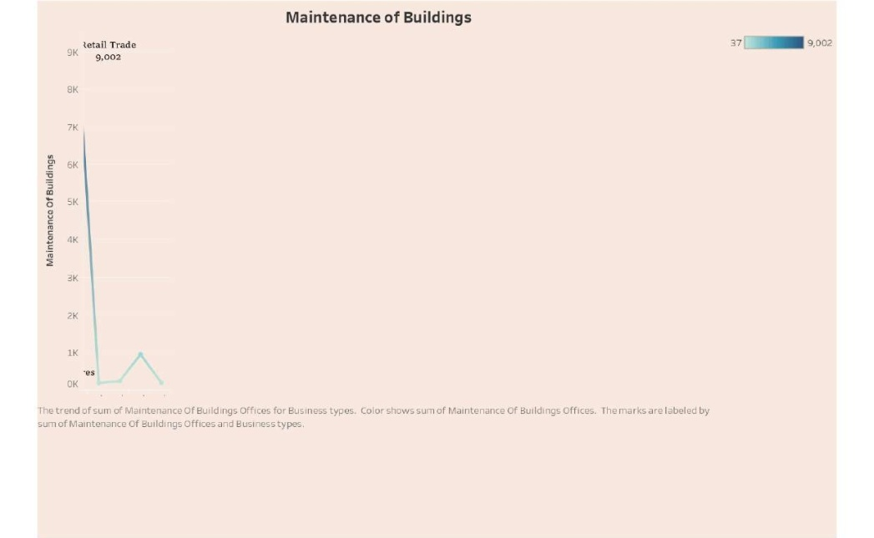

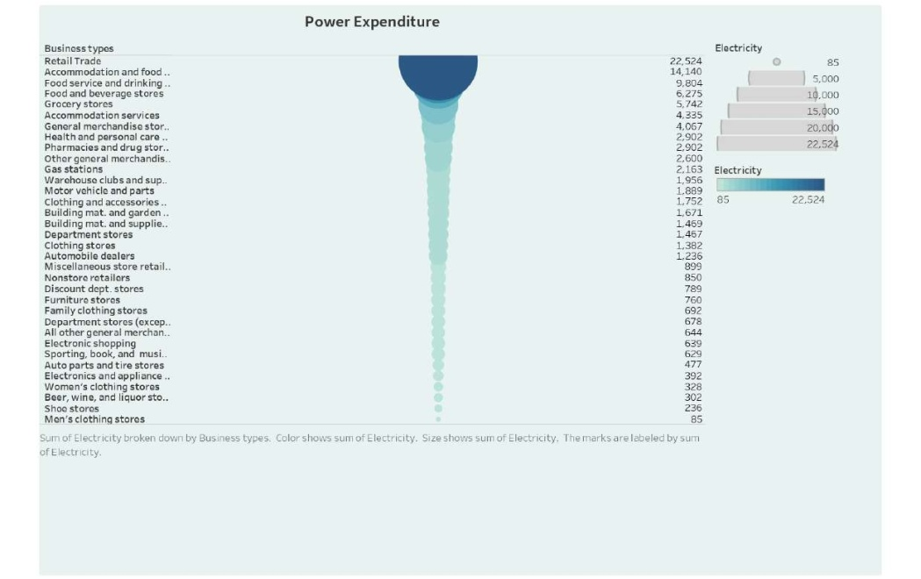

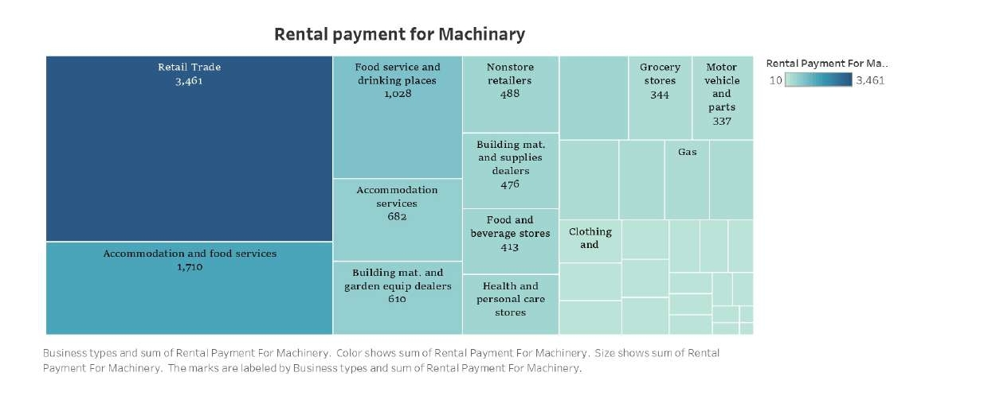

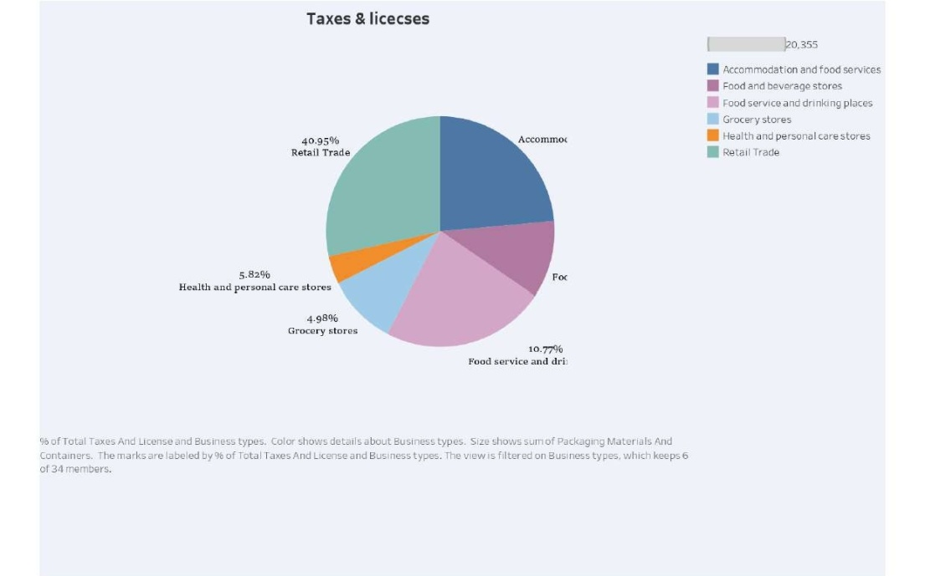

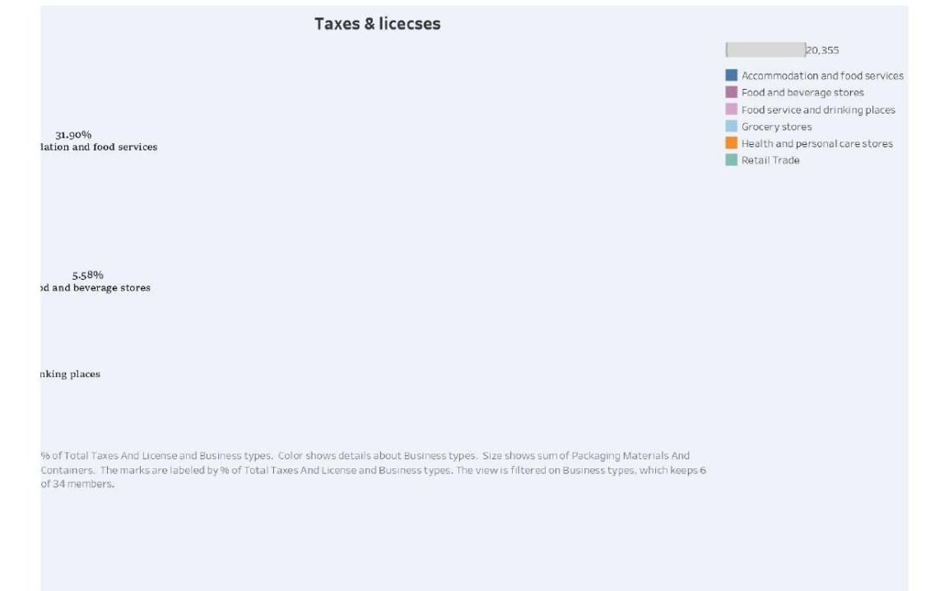

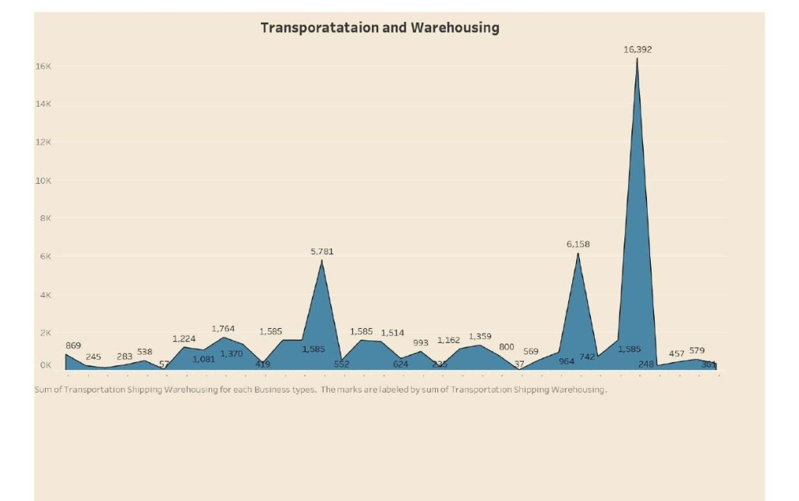

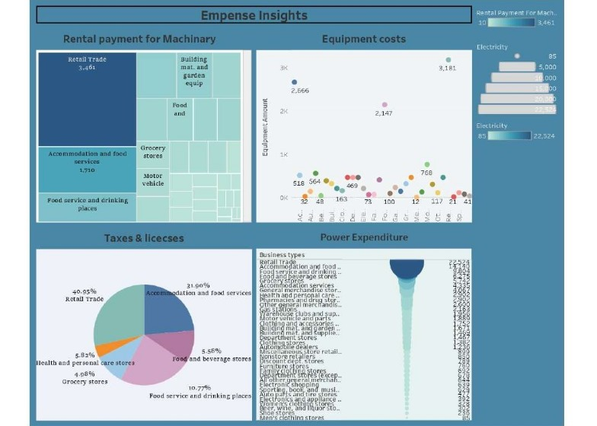**2. Dashboards**

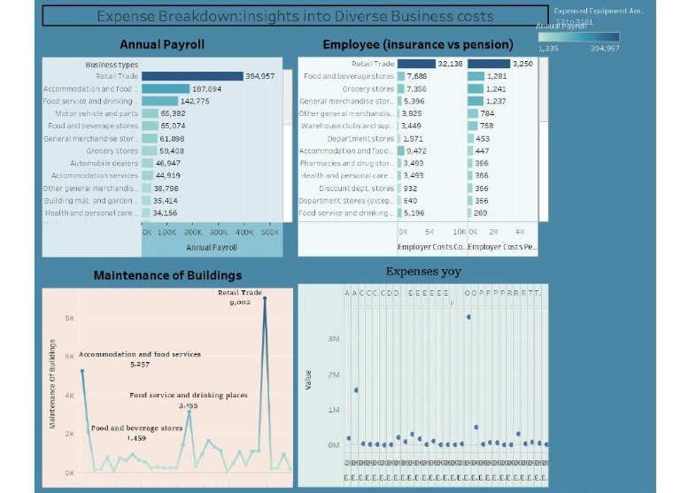

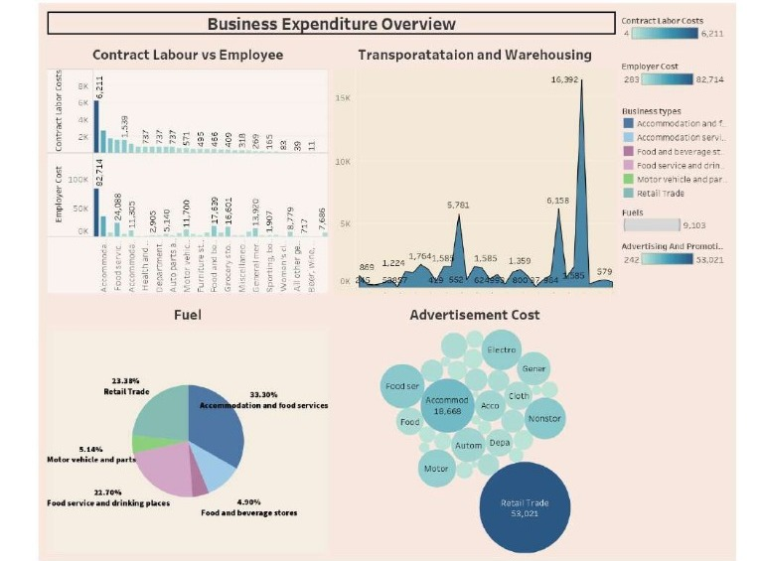

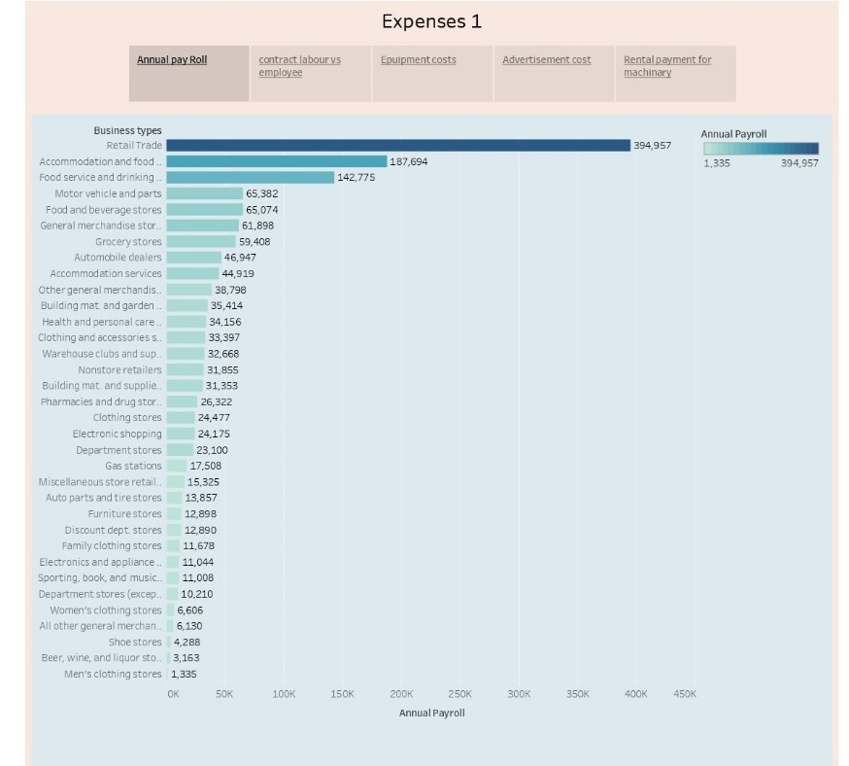**3. Story**