1. GIT CONFIGURATION
- To check if Git client is installed properly: Open Git bash shell and execute
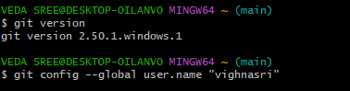
- user level configuration of user ID and email ID execute

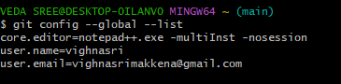
- check if the configuration is properly set

- Install notepad++ if not installed and set the path in environment variables
- After setting environment variables close your previous git bash and open it again

- Type in git bash notepad++

- create an alias command for notepad++.exe
- configure the editor
- verify if notepad++ is the default editor
- Open Git bash shell and create a new project “GitDemo”
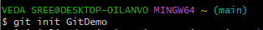

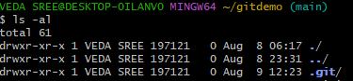
- Git bash initializes the “GitDemo” repository

- create a file “welcome.txt”

- to see text in welcome.txt
cat welcome.txt
- check status
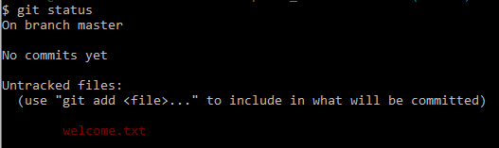
git status

- make the file to be tracked by Git repository

- add multi line comments, we are opening default editor to comment. Execute the command

- To check if local and “Working Directory” git repository are same, execute git status

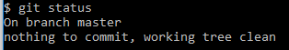

- Sign up with gitlab and create remote repository “GitDemo”
- To pull remote repository
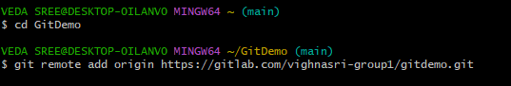

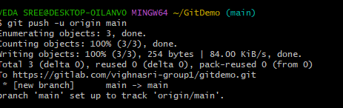
- To push the local to remote repository

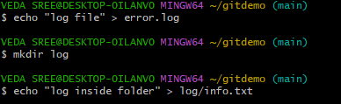
2. Git Ignore

1. move to project folder

2. create a folder to ignore and add file in to it and check over comments

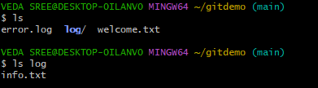

3. create .gitignore
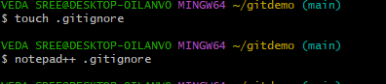

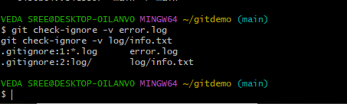

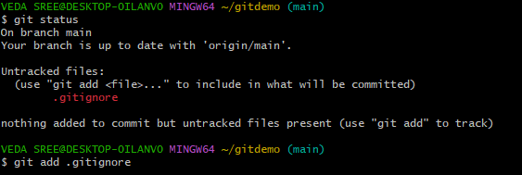
4. check status

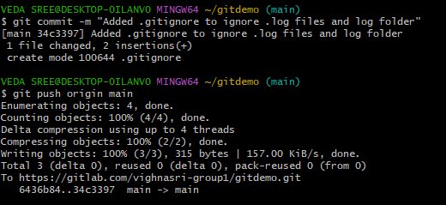
5. commit to gitlab

3.Branching and Merging

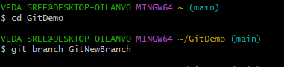
1.move to gitdemo and create a new branch

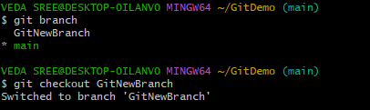
2. list all local and remote branches available in current trunck and move to new branch

3. add files in new branch with contents and commit them
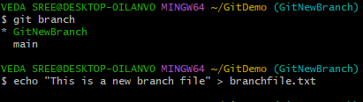

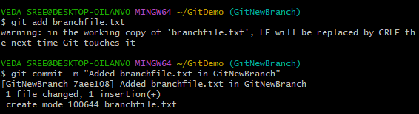

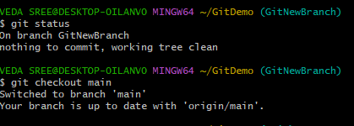
4. check status and checkout to main(switch to master)

MERGING
5. list out differences between trunck and branch and merge branch and trunck
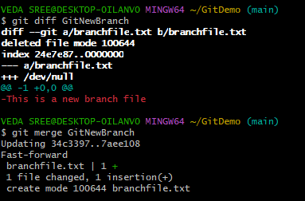

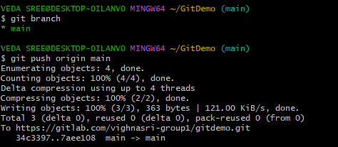
6. logging after merging and delete branch
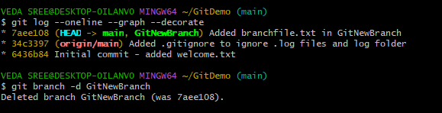

4. Git Conflicts
- Move to project folder
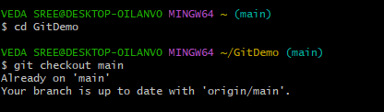

- Create a branch “GitWork”. Add a file “hello.xml”.
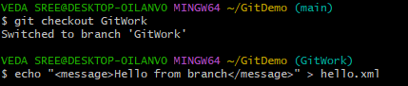

- Update the content of “hello.xml” and observe the status
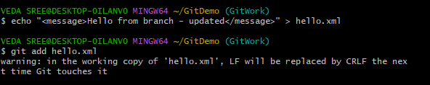
- Commit the changes to reflect in the branch and switch to master
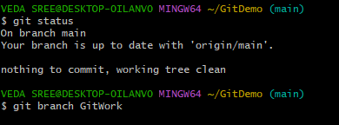

- Add a file “hello.xml” to the master and add some different content than previous and commit the changes to master
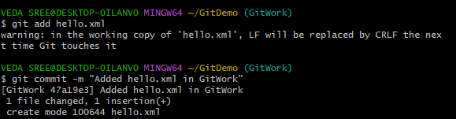
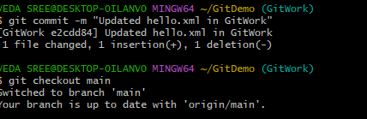

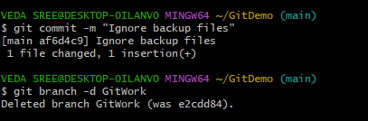

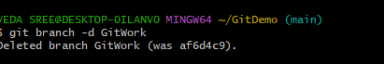
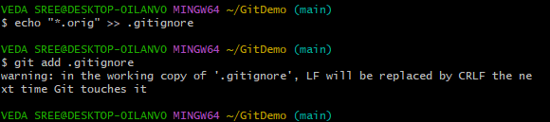
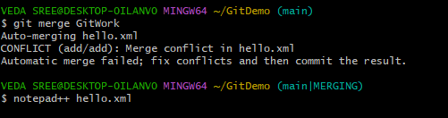
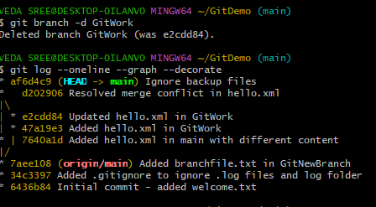

- Commit the changes to the master, once done with conflict
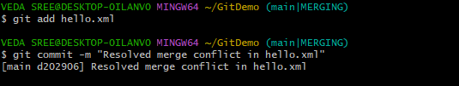
- Observe the git status and add backup file to the .gitignore file.
Commit the changes to the .gitignore
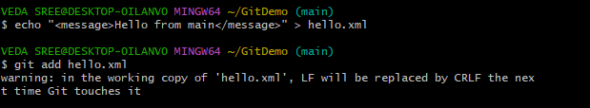
- List out all the available branches
- Delete the branch, which merge to master.
- Observe the log by executing “git log –oneline –graph –decorate”
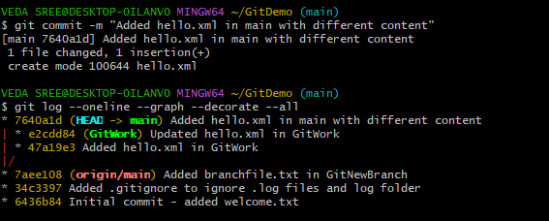

5. Git Clean and Push

- Move to project folder

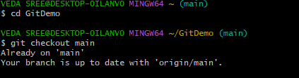

- List out all the available branches.

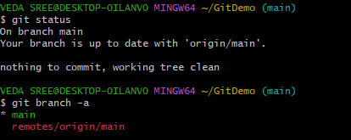

- Pull the remote git repository to the master
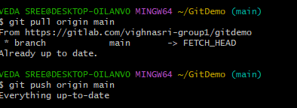
- Push the changes, which are pending from “Git-T03-HOL_002” to the remote repository.

