1) Find 10 different model providers and their models released in last 12 months

Model Provider | Model | Release Date | Cut-off Date | Cost of Tokens | Context Window | Type | When to Use
Model Provider | Model | Release Date | Cut-off Date | Cost of Tokens | Context Window | Type | When to Use
OpenAI | GPT-5.6 Sol | 7/9/2026 | Early 2026 | ~$5 per 1M tokens | 2M tokens | General reasoning | Enterprise-grade reasoning, long-context workflows
OpenAI | GPT-5.6 Terra | 7/9/2026 | Early 2026 | ~$3 per 1M tokens | 2M tokens | General reasoning | Automation, RAG pipelines
OpenAI | GPT-5.6 Luna | 7/9/2026 | Early 2026 | ~$1.5 per 1M tokens | 2M tokens | General reasoning | Cost-efficient reasoning tasks
OpenAI | GPT-5.5 | 2026 | Late 2025 | ~$1 per 1M tokens | 1M tokens | General-purpose LLM | Coding, structured generation
Anthropic | Claude Opus 5 | 7/24/2026 | Early 2026 | ~$15 per 1M tokens | 1M tokens | High-end reasoning | Deep analysis, legal reasoning
Anthropic | Claude Sonnet 5 | 6/30/2026 | Early 2026 | ~$3 per 1M tokens | 1M tokens | Mid-tier reasoning | Fast, cost-efficient reasoning
Google DeepMind | Gemini 3.5 Flash Cyber | 7/21/2026 | Early 2026 | ~$0.30 per 1M tokens | 2M tokens | Cybersecurity-tuned | Threat detection, secure code review
Google DeepMind | Gemini 3.5 Flash | 2026-07 | Early 2026 | ~$0.20 per 1M tokens | 2M tokens | Lightweight model | High-volume tasks, chatbots
xAI | Grok 4.5 | 7/8/2026 | Early 2026 | ~$1 per 1M tokens | 1M tokens | General-purpose LLM | Real-time tasks, conversational AI
Zhipu AI | GLM-5.2 | 6/13/2026 | Early 2026 | ~$0.50 per 1M tokens | 1M tokens | Multilingual LLM | Chinese/English bilingual tasks
Moonshot AI | Kimi K3 | 7/16/2026 | Early 2026 | ~$0.40 per 1M tokens | 2M tokens | Long-context reasoning | Research, document-heavy workflows
Moonshot AI | Kimi K2.7 Code | 6/12/2026 | Early 2026 | ~$0.25 per 1M tokens | 1M tokens | Code-specialized | Code generation, debugging
DeepSeek | V4 Flash (0731) | 7/31/2026 | Early 2026 | ~$0.14 per 1M tokens | 1M tokens | High-speed inference | Large-scale automation
Alibaba | Qwen3.8-Max Reasoning | 8/3/2026 | Early 2026 | ~$0.60 per 1M tokens2. | 2M tokens | Reasoning-optimized | Enterprise logic tasks
Alibaba | Qwen3.7-Flash | 7/27/2026 | Early 2026 | ~$0.20 per 1M tokens | 1M tokens | Lightweight model | Rapid generation, automation
ByteDance | Doubao Seed 2.1 Pro | 6/24/2026 | Early 2026 | ~$0.15 per 1M tokens | 1M tokens | General-purpose | High-volume consumer apps
ByteDance | Doubao Seed 2.1 Turbo | 6/24/2026 | Early 2026 | ~$0.10 per 1M tokens | 1M tokens | General-purpose | Multilingual tasks
Meituan | LongCat-2.0 | 6/29/2026 | Early 2026 | ~$0.25 per 1M tokens | 2M tokens | Long-context model | Summarization, RAG

2. Read 2–3 articles about how transformer works?
Goal to understand:
(a) Self-attention mechanism
(b) Vector embedding
(c) Feed forward Nueral Network

Article #1
Article: "How Attention Works in Transformers | AP Lab Academy"
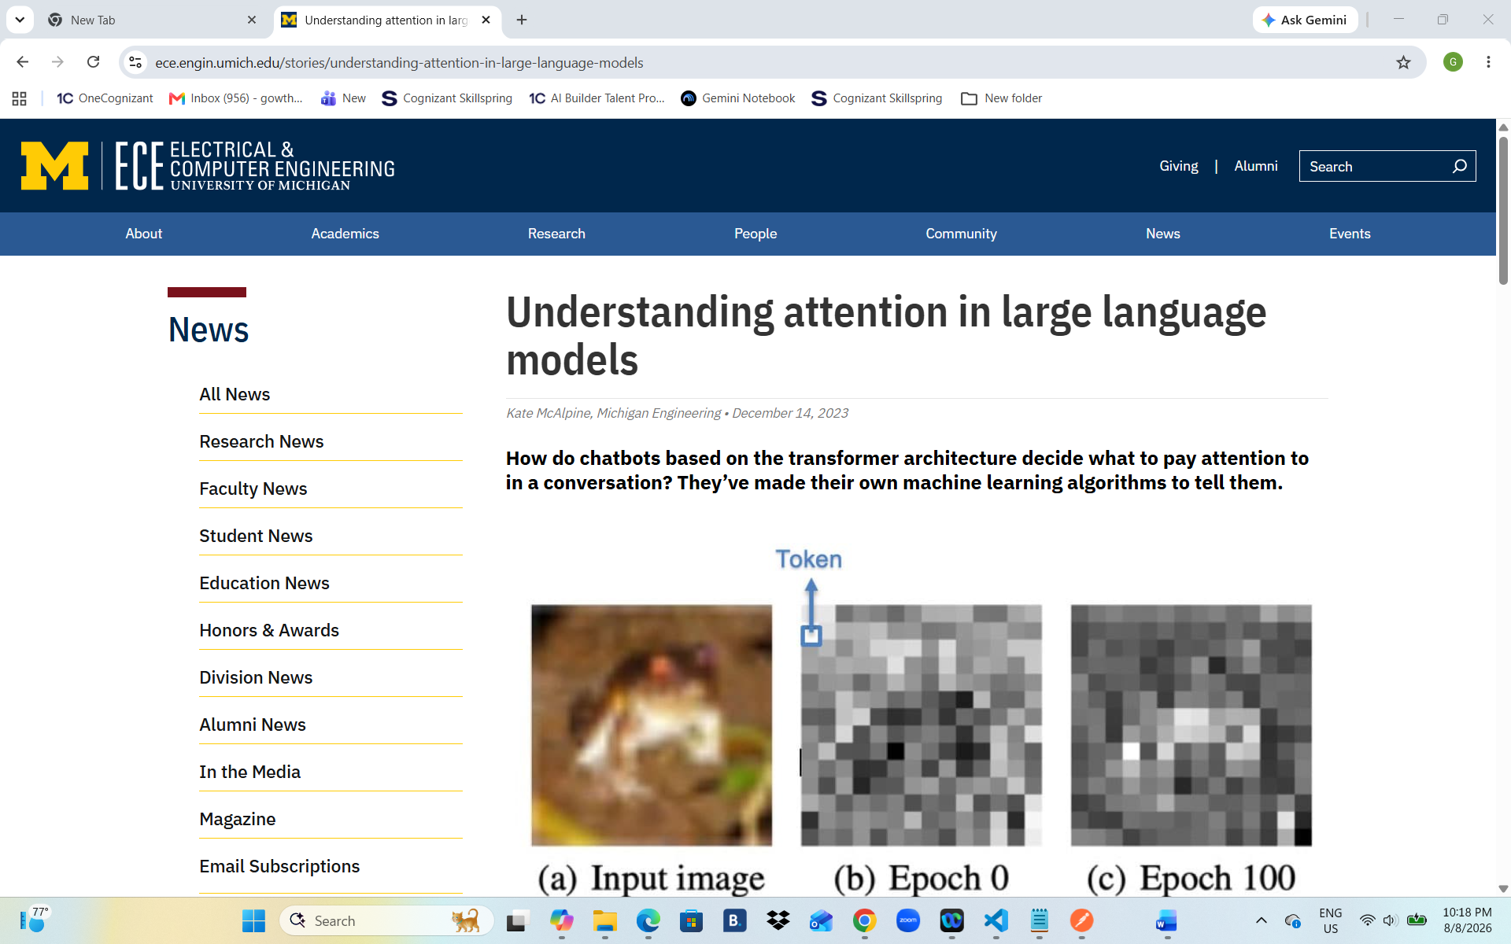
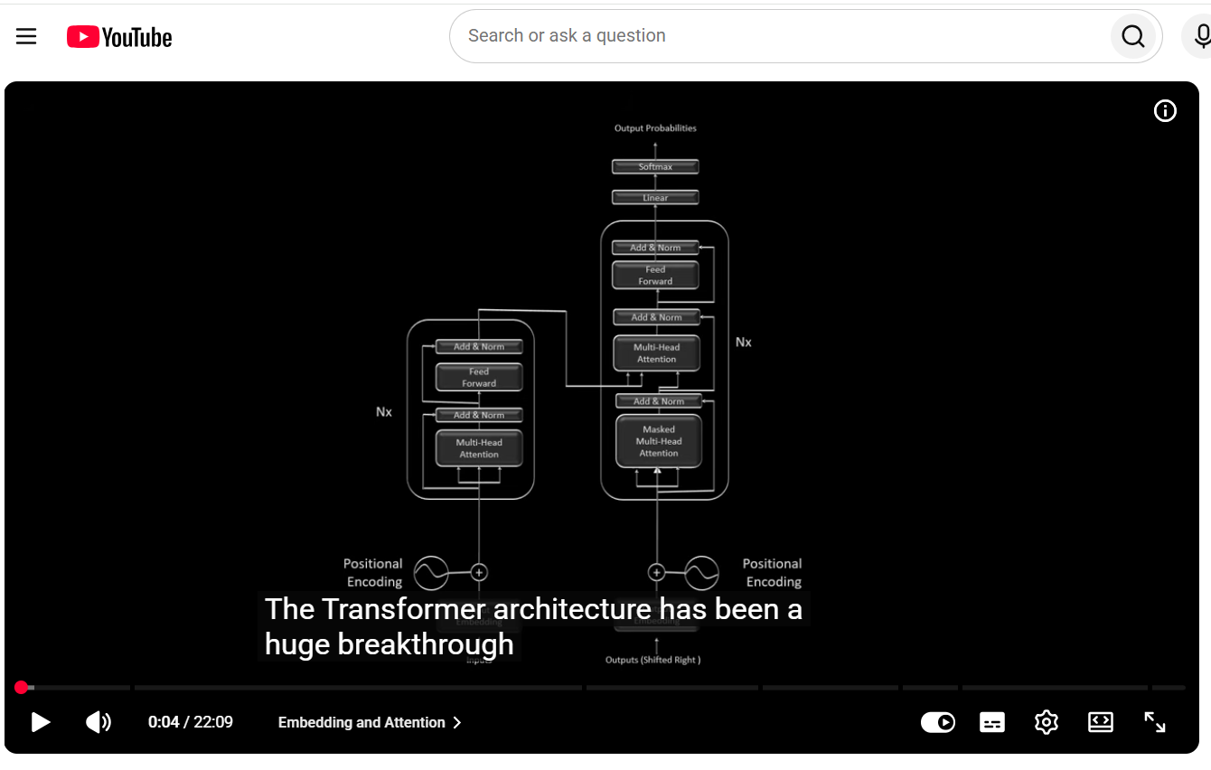
Article #2
Article: "Transformers from First Principles: Part 2 - Embeddings | Matías Battaglia"

