**CREATE A CHATBOT USING PYTHON**

**BATCH MEMBER**

**910521104004 : GOWTHAM.M**

Phase 1 submission document

**Project Title: Create a Chatbot Using Python**

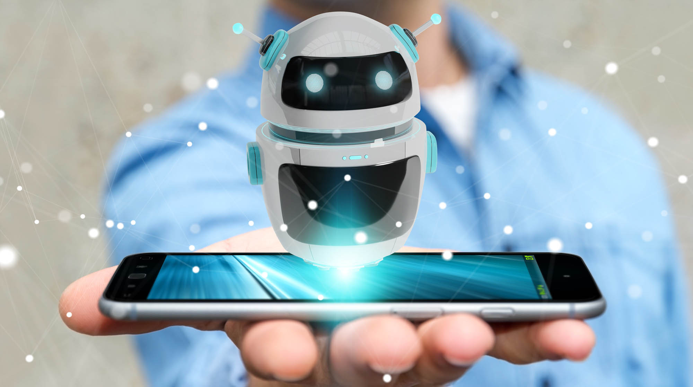

**Abstract:**

The rapid advancement of Natural Language Processing (NLP) and Artificial Intelligence (AI) technologies has ushered in a new era of human-computer interaction, with chatbots playing a pivotal role in various industries. This abstract outlines a modular approach to create a chatbot using Python, facilitating a structured and flexible development process. The proposed modules are designed to streamline chatbot development, enhancing its functionality, scalability, and adaptability.

**Module 1: Data Preprocessing**

* Data Gathering: Collect and preprocess data from various sources, including text corpora, FAQs, and existing chat logs.
* Text Cleaning: Remove noise, special characters, and irrelevant information from the text.
* Tokenization: Break down text into individual words or tokens for further analysis.

**Module 2: Natural Language Processing (NLP)**

* Language Understanding: Utilize NLP techniques like Named Entity Recognition (NER) and Part-of-Speech (POS) tagging to extract meaningful information.
* Intent Recognition: Implement algorithms to identify user intents and extract key entities.
* Sentiment Analysis: Analyze user sentiment to provide appropriate responses.

**Module 3: Dialogue Management**

* Dialogue Flow: Create a conversation flow, defining the bot's responses based on user inputs and intents.
* State Management: Maintain context and conversation history to provide context-aware responses.
* User Interaction: Handle user queries, requests, and prompts effectively.

**Module 4: Knowledge Base**

* Knowledge Retrieval: Build a knowledge base using databases, FAQs, or external APIs.
* Information Retrieval: Implement algorithms for retrieving relevant information from the knowledge base.
* Knowledge Update: Continuously update and expand the knowledge base to stay current.

**Module 5: Response Generation**

* Response Templates: Create response templates for common user queries.
* Natural Language Generation (NLG): Employ NLG techniques to generate human-like responses.
* Personalization: Tailor responses based on user preferences and history.

**Module 6: Integration**

* Platform Integration: Deploy the chatbot on various platforms, such as websites, messaging apps, or voice interfaces.
* API Integration: Connect external APIs for additional functionalities or data retrieval.
* Security: Implement security measures to protect user data and ensure privacy.

**Module 7: Testing and Evaluation**

* Unit Testing: Test individual modules for functionality and correctness.
* User Testing: Conduct user testing to gather feedback and improve the chatbot's performance.
* Evaluation Metrics: Assess the chatbot's performance using metrics like accuracy, response time, and user satisfaction.

**Module 8: Continuous Improvement**

* Feedback Loop: Collect user feedback and use it to iteratively improve the chatbot.
* Model Fine-tuning: Continuously update NLP models and algorithms to enhance accuracy and relevance.
* Scalability: Ensure the chatbot can handle increased loads and adapt to changing requirements.

This modular approach provides a structured framework for building a chatbot using Python, enabling developers to create versatile and efficient chatbots tailored to specific use cases. The flexibility of this approach ensures adaptability to evolving user needs and technological advancements in the field of AI and NLP.